컴퓨터학부 20142468 허경영

1. 소스코드

#include <stdio.h>

#include <stdlib.h>

#include <unistd.h>

#include <fcntl.h>

#include <sys/types.h>

#include <sys/time.h>

#define SEC_TO_MICRO 1000000

#define CREAT_MODE (S_IRUSR | S_IWUSR | S_IRGRP | S_IROTH)

char buf1[] = "1234567890";

char buf2[] = "ABCDEFGHIJ";

int main(int argc, char** argv){

struct timeval begin_t, end_t;

char *fname = "ssu_hole.txt";

int fd;

gettimeofday(&begin_t, NULL);

if((fd = creat(fname, CREAT_MODE)) < 0){

fprintf(stderr, "Creat error for %s\n",fname);

exit(1);

}

if(write(fd, buf1, 12) != 12){ // fd 를 12바이트만큼 읽고 buf1에 저장

fprintf(stderr, "buf1 write error\n");

exit(1);

}

if(lseek(fd, 15000, SEEK_SET) < 0){ // fd를 15000만큼 lseek

fprintf(stderr, "lseek error\n");

exit(1);

}

if(write(fd, buf2, 12) != 12){ // fd 를 12바이트만큼 읽고 buf2에 저장

fprintf(stderr, "buf2 write error\n");

exit(1);

}

gettimeofday(&end_t, NULL);

end_t.tv_sec -= begin_t.tv_sec;

if(end_t.tv_usec < begin_t.tv_usec){

end_t.tv_sec--;

end_t.tv_usec += SEC_TO_MICRO;

}

end_t.tv_usec -= begin_t.tv_usec;

printf("Runtime: %ld:%ld\n",end_t.tv_sec, end_t.tv_usec);

exit(0);

}

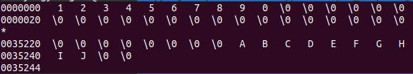2. 실행결과