컴퓨터학부 20142468 허경영

1. 소스코드

<ssu_execl_1.c>

#include <stdio.h>

#include <stdlib.h>

#include <unistd.h>

int main(void){

printf("this is the original program\n");

execl("./ssu_execl_test_1", "ssu_execl_test_1", "param1", "param2", "param3", (char *)0);

printf("%s\n", "this line should never get printed");

exit(0);

}

<ssu_execl_test_1.c>

#include <stdio.h>

#include <stdlib.h>

int main(int argc, char ** argv){

extern char **environ;

char ** str;

int i;

for(i = 0; i < argc; i++)

printf("argv[%d]: %s\n", i, argv[i]);

for(str = environ; *str != 0; str++)

printf("%s\n", *str);

exit(0);

}

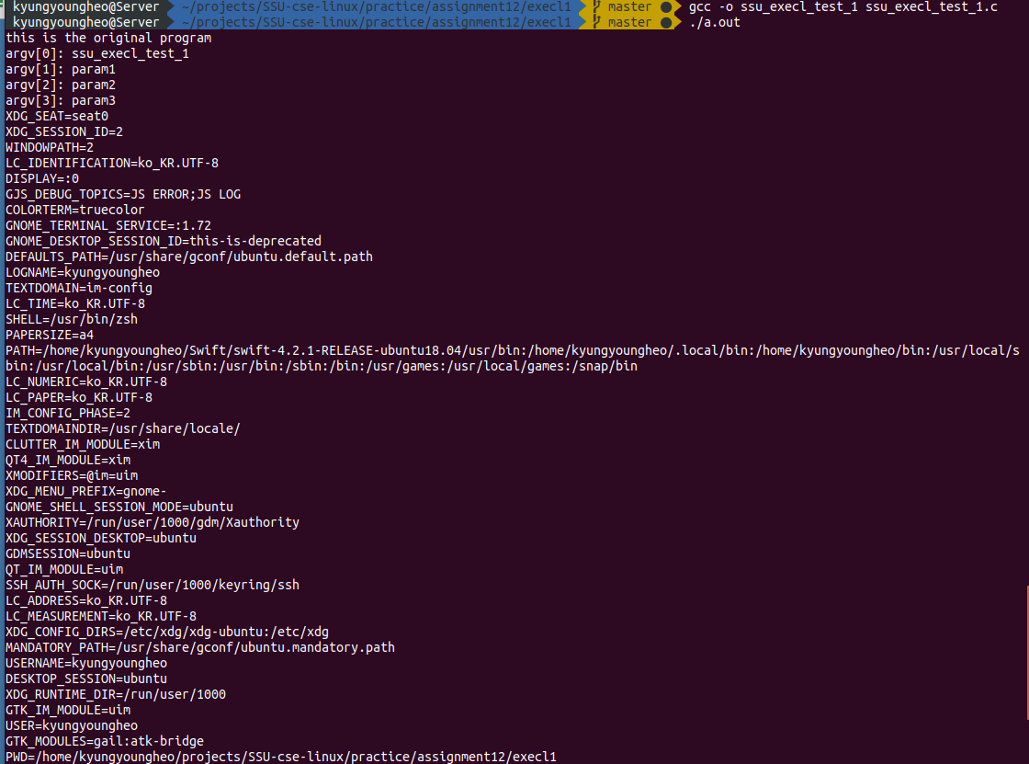2. 실행결과