컴퓨터학부 20142468 허경영

1. 소스코드

#include <stdio.h>

#include <stdlib.h>

#include <unistd.h>

#include <errno.h>

#include <sys/resource.h>

#include <sys/wait.h>

double ssu_maketime(struct timeval *time);

void term_stat(int stat);

void ssu_print_child_info(int stat, struct rusage *rusage);

int main(void){

pid_t pid;

int status;

struct rusage rusage;

if((pid = fork()) == 0){

char *args[] = {"find", "/", "-maxdepth", "4", "-name", "stdio.h", NULL};

if(execv("/usr/bin/find", args) < 0){

fprintf(stderr, "execv error\n");

exit(1);

}

}

if(wait3(&status, 0, &rusage) == pid)

ssu_print_child_info(status, &rusage);

else{

fprintf(stderr, "wait3 error\n");

exit(1);

}

exit(0);

}

double ssu_maketime(struct timeval *time){

return ((double)time -> tv_sec + (double)time -> tv_usec/1000000.0);

}

void term_stat(int stat){

if(WIFEXITED(stat))

printf("normally terminated. exit status = %d\n", WEXITSTATUS(stat));

else if(WIFSIGNALED(stat))

printf("abnormal termination by signal %d. %s\n", WTERMSIG(stat),

#ifdef WCOREDUMP

WCOREDUMP(stat) ? "core dumped" : "no core"

#else

NULL

#endif

);

else if(WIFSTOPPED(stat))

printf("stopped by signal %d\n", WSTOPSIG(stat));

}

void ssu_print_child_info(int stat, struct rusage *rusage){

printf("Termination info follows\n");

term_stat(stat);

printf("user CPU time : %.2f(sec)\n", ssu_maketime(&rusage->ru_utime));

printf("system CPU time : %.2f(sec)\n", ssu_maketime(&rusage->ru_stime));

}

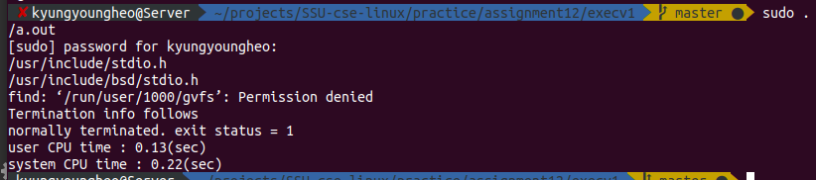2. 실행결과