컴퓨터학부 20142468 허경영

1. 소스코드

#include <stdio.h>

#include <stdlib.h>

#include <unistd.h>

#include <pthread.h>

#include <string.h>

#define THREAD_NUM 8

struct thread_data {

int thread_index;

int sum;

char *message;

};

void *ssu_printhello(void *arg);

struct thread_data thread_data_array[THREAD_NUM];

char *messages[THREAD_NUM];

int main(void){

pthread_t tid[THREAD_NUM];

int sum, i;

sum = 0;

messages[0] = "English: Hello World!";

messages[1] = "French: Bonjour, le monde!";

messages[2] = "Spanish: Hola al mundo!";

messages[3] = "Klingon: Nuq neH!";

messages[4] = "German: Guten Tag, Welt!";

messages[5] = "Russian: Zdravstvytye, mir!";

messages[6] = "Japan: Sekai e konnichiwa!";

messages[7] = "Latin: Orbis, te saluto!";

for(i=0; i<THREAD_NUM; i++){

sum = sum += i;

thread_data_array[i].thread_index = i;

thread_data_array[i].sum = sum;

thread_data_array[i].message = messages[i];

printf("Creating thread %d\n", i);

if(pthread_create(&tid[i], NULL, ssu_printhello, (void *)&thread_data_array[i]) != 0){

fprintf(stderr, "pthread_Create error\n");

exit(1);

}

}

sleep(5);

exit(0);

}

void *ssu_printhello(void *arg){ // 쓰레드에서 실행하는 함수

struct thread_data *data;

char *message;

int thread_index;

int sum;

sleep(1);

data = (struct thread_data*)arg;

thread_index = data->thread_index;

sum = data->sum;

message = data->message;

printf("Thread %d: %s Sum=%d\n", thread_index, message, sum);

return NULL;

}

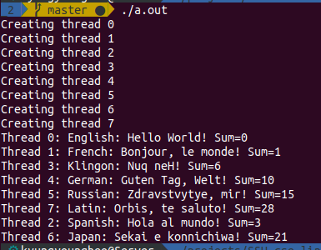2. 실행결과