컴퓨터학부 20142468 허경영

1. 소스코드

#include <stdio.h>

#include <stdlib.h>

#include <unistd.h>

#include <time.h>

void ssu_timestamp(char *str);

int main(void){

unsigned int ret;

ssu_timestamp("before sleep()");

ret = sleep(10); // 10초 sleep

ssu_timestamp("after sleep()");

printf("sleep() returned %d\n");

exit(0);

}

void ssu_timestamp(char *str){

time_t time_val;

time(&time_val);

printf("%s th time is %s\n", str, ctime(&time_val));

}

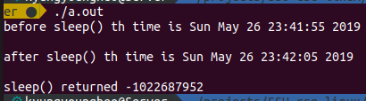2. 실행결과