컴퓨터학부 20142468 허경영

1. 소스코드

#include <stdio.h>

#include <stdlib.h>

#include <pthread.h>

#define THREAD_NUM 5

void *ssu_printhello(void *arg);

int main(void){

pthread_t tid[THREAD_NUM];

int i;

for(i=0; i<THREAD_NUM; i++){

printf("In main: creating thread %d\n", i);

if(pthread_create(&tid[i], NULL, ssu_printhello, (void *)&i) != 0){ // 쓰레드 생성

fprintf(stderr, "pthread_create error\n");

exit(1);

}

}

pthread_exit(NULL); // 쓰레드 종료

exit(0);

}

void *ssu_printhello(void *arg){

int thread_index;

thread_index = *((int *)arg);

printf("Hello World! It's me, thread #%d!\n", thread_index);

pthread_exit(NULL);

return NULL;

}

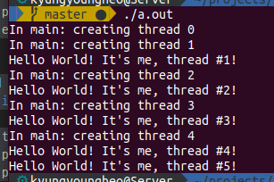2. 실행결과