컴퓨터학부 20142468 허경영

1. 소스코드

<ssu_write_3.c>

#include <stdio.h>

#include <stdlib.h>

#include <unistd.h>

#include <fcntl.h>

#include <sys/time.h>

#include "ssu_employee.h"

#define SEC_TO_MICRO 1000000

int main(int argc, char *argv[]){

struct timeval begin_t, end_t;

struct ssu_employee record;

int fd;

gettimeofday(&begin_t, NULL);

if(argc < 2){

fprintf(stderr, "Usage : %s filein fileout\n", argv[0]);

exit(1);

}

if((fd = open(argv[1], O_WRONLY | O_CREAT | O_EXCL, 0640)) < 0){

fprintf(stderr, "open error for %s\n",argv[1]);

exit(1);

}

while(1){

printf("Enter employee name <SPACE> salary: ");

scanf("%s",record.name);

if(record.name[0] == '.') // .이 입력되면 break

break;

scanf("%d",&record.salary);

record.pid = getpid(); // pid를 저장

write(fd, (char *)&record, sizeof(record)); // record를 fd에 저장

}

close(fd);

gettimeofday(&end_t, NULL);

end_t.tv_sec -= begin_t.tv_sec;

if(end_t.tv_usec < begin_t.tv_usec){

end_t.tv_sec--;

end_t.tv_usec += SEC_TO_MICRO;

}

end_t.tv_usec -= begin_t.tv_usec;

printf("Runtime: %ld:%ld\n",end_t.tv_sec, end_t.tv_usec);

exit(0);

}

<ssu_employee.h>

#define NAME_SIZE 64

struct ssu_employee {

char name[NAME_SIZE];

int pid;

int salary;

};

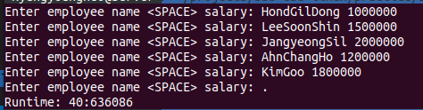2. 실행결과