컴퓨터학부 20142468 허경영

1. 소스코드

#include <stdio.h>

#include <stdlib.h>

#include <unistd.h>

#include <errno.h>

#include <fcntl.h>

int main(int argc, char **argv){

struct flock lock;

int fd;

char command[100];

if((fd = open(argv[1], O_RDWR)) == -1){ // open

perror(argv[1]);

exit(1);

}

lock.l_type = F_WRLCK; //write lock

lock.l_whence = 0;

lock.l_start = 0L;

lock.l_len = 0L;

if(fcntl(fd, F_SETLK, &lock) == -1){ // 락 설정

if(errno == EACCES){

printf("%s busy --try later\n", argv[1]);

exit(2);

}

perror(argv[1]);

exit(3);

}

sprintf(command, "vim %s\n", argv[1]);

system(command);

lock.l_type = F_UNLCK; // unlock

fcntl(fd, F_SETLK, &lock); // lock

close(fd);

return 0;

}

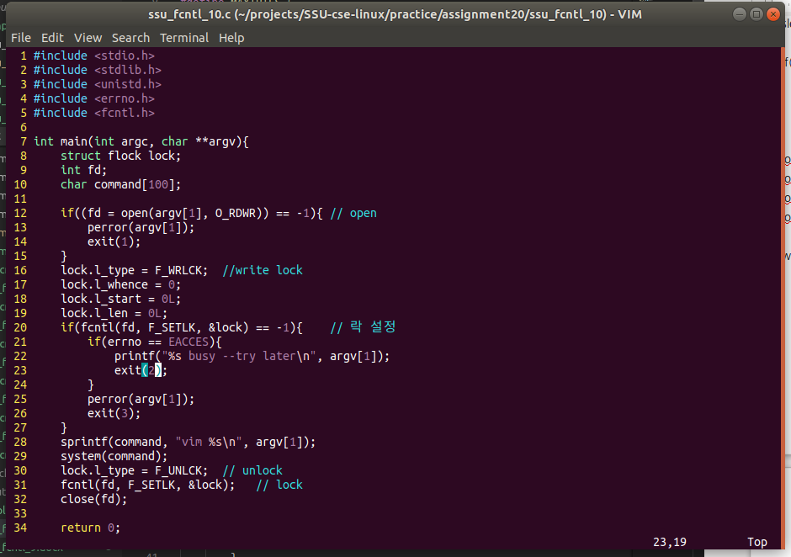2. 실행결과