컴퓨터학부 20142468 허경영

1. 소스코드

#include <stdio.h>

#include <stdlib.h>

#include <unistd.h>

#include <fcntl.h>

#define NAMESIZE 50

struct employee{

char name[NAMESIZE];

int salary;

int pid;

};

int main(int argc, char **argv){

struct flock lock;

struct employee record;

int fd, recnum, pid;

long position;

if((fd = open(argv[1],O_RDWR)) == -1 ){ // open

perror(argv[1]);

exit(1);

}

pid = getpid();

for(;;){

printf("\nEnter record number: ");

scanf("%d", &recnum);

if(recnum<0)

break;

position = recnum * sizeof(record);

lock.l_type = F_WRLCK; //write lock

lock.l_whence = 0; // 파일의 일부만 락 설정

lock.l_start = position;

lock.l_len = sizeof(record);

if(fcntl(fd, F_SETLKW, &lock) == -1){ // lock

perror(argv[1]);

exit(2);

}

lseek(fd, position, 0);

if(read(fd, (char*)&record, sizeof(record)) == 0){ //read

printf("record %d not found\n", recnum);

lock.l_type = F_UNLCK;

fcntl(fd, F_SETLK, &lock);

continue;

}

printf("Employee: %s, salary: %d\n", record.name, record.salary);

record.pid = pid;

printf("Enter new salary: ");

scanf("%d", &record.salary);

lseek(fd, position, 0);

write(fd, (char *)&record, sizeof(record));

lock.l_type = F_UNLCK; // unlock

fcntl(fd, F_SETLK, &lock); // lock check

}

close(fd);

}

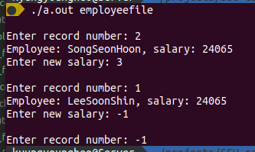2. 실행결과