컴퓨터학부 20142468 허경영

1. 소스코드

#include <stdio.h>

#include <stdlib.h>

#include <unistd.h>

#include <errno.h>

#include <fcntl.h>

#define NAMESIZE 50

#define MAXTRIES 5

struct employee{

char name[NAMESIZE];

int salary;

int pid;

};

int main(int argc, char **argv){

struct flock lock;

struct employee record;

int fd, sum=0, try=0;

sleep(10);

if((fd = open(argv[1], O_RDONLY)) == -1){ // open

perror(argv[1]);

exit(1);

}

lock.l_type = F_RDLCK; // read lock

lock.l_whence = 0;

lock.l_start = 0l;

lock.l_len = 0l;

while(fcntl(fd, F_SETLK, &lock) == -1){ // 락 설정

if(errno == EACCES){

if(try++ < MAXTRIES){ // 계속 시도

sleep(1);

continue;

}

printf("%s busy -- try later\n", argv[1]);

exit(2);

}

perror(argv[1]);

exit(3);

}

sum = 0;

while(read(fd, (char *)&record, sizeof(record)) > 0){ // read

printf("Employee: %s, Salary: %d\n", record.name, record.salary);

sum += record.salary;

}

printf("\nTotal salary: %d\n", sum);

lock.l_type = F_UNLCK; // unlock

fcntl(fd, F_SETLK, &lock);

close(fd);

}

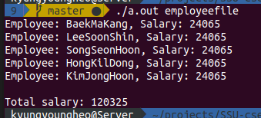2. 실행결과