컴퓨터학부 20142468 허경영

1. 소스코드

#include <stdio.h>

#include <string.h>

#include <stdlib.h>

#include <unistd.h>

#include <fcntl.h>

#include <sys/mman.h>

#include <sys/stat.h>

#ifndef MAP_FILE

#define MAP_FILE 0

#endif

void serror(char *str){ // 에러 출력 함수

fprintf(stderr, "%s\n", str);

exit(1);

}

int main(int argc, char **argv){

int fdin, fdout;

void *inp, *outp;

struct stat statbuf;

if(argc != 3)

serror("usage: a.out [source file] [target file]");

if((fdin = open(argv[1], O_RDONLY)) < 0) // fdin open

serror("can't open file for reading");

if((fdout = open(argv[2], O_RDWR | O_CREAT | O_TRUNC, S_IRUSR | S_IWUSR | S_IRGRP | S_IROTH)) < 0){ // fdout open

serror("can't creat file for reading");

}

if(fstat(fdin, &statbuf) < 0) // statbuf 저장

serror("fstat error");

if(lseek(fdout, statbuf.st_size - 1, SEEK_SET) == -1) //파일의 마지막으로 이동

serror("lseek() error");

if(write(fdout, "", 1) != 1) //공백 추가

serror("write() error");

if((inp = mmap(0, statbuf.st_size, PROT_READ, MAP_SHARED, fdin, 0)) == (caddr_t)-1) //mmap으로 read, shared memory

serror("mmap error for input");

if((outp = mmap(0, statbuf.st_size, PROT_READ | PROT_WRITE, MAP_SHARED, fdout, 0)) == (caddr_t)-1) // mmap으로 read, write, shared memory

serror("mmap error for output");

memcpy(outp, inp, statbuf.st_size);

return 0;

}

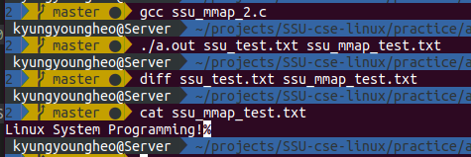2. 실행결과