컴퓨터학부 20142468 허경영

1. 소스코드

#include <stdio.h>

#include <stdlib.h>

#include <unistd.h>

#include "calTime.h"

int main(int argc, char * argv[]){

struct timeval begin_t, end_t;

gettimeofday(&begin_t, NULL);

if(argc !=3 ){

fprintf(stderr, "usage: %s <actualname> <symname>\n",argv[0]);

exit(1);

}

if(symlink(argv[1], argv[2]) < 0){

fprintf(stderr, "symlink error\n");

exit(1);

}

else

printf("symlink: %s -> %s\n",argv[2], argv[1]);

gettimeofday(&end_t, NULL);

ssu_runtime(&begin_t, &end_t);

exit(0);

}

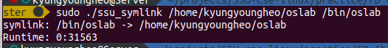2. 실행결과