컴퓨터학부 20142468 허경영

1. 소스코드

#include <stdio.h>

#include <stdlib.h>

#include <unistd.h>

#include <fcntl.h>

#include <sys/stat.h>

#include <utime.h>

#include "calTime.h"

int main(int argc, char * argv[]){

struct timeval begin_t, end_t;

struct utimbuf time_buf;

struct stat statbuf;

int fd, i;

gettimeofday(&begin_t, NULL);

for(i = 1; i < argc; i++){

if(stat(argv[i], &statbuf) < 0){

fprintf(stderr, "stat error for %s\n",argv[i]);

continue;

}

if((fd = open(argv[i], O_RDWR | O_TRUNC)) < 0){

fprintf(stderr, "open error for %s\n",argv[i]);

continue;

}

close(fd);

time_buf.actime = statbuf.st_atime;

time_buf.modtime = statbuf.st_mtime;

if(utime(argv[i], &time_buf) < 0){

fprintf(stderr, "utime error for %s\n",argv[i]);

continue;

}

}

gettimeofday(&end_t, NULL);

ssu_runtime(&begin_t, &end_t);

exit(0);

}

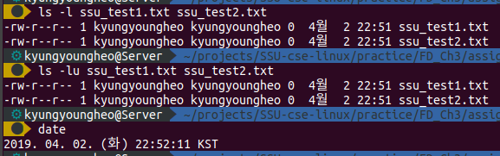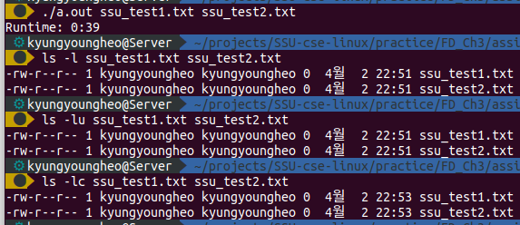2. 실행결과