1. **一个已经备案的域名**
2. 配置ssl证书
   1. 申请证书
      1. <https://console.cloud.tencent.com/ssl>
      2. 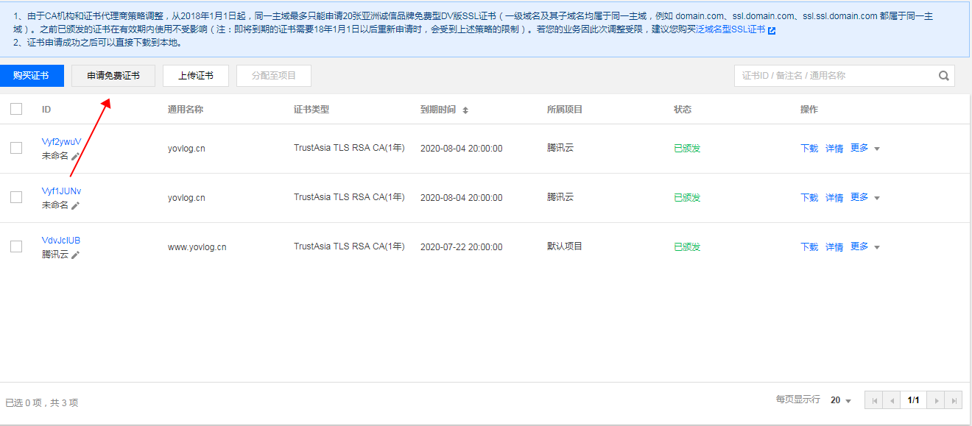
      3. 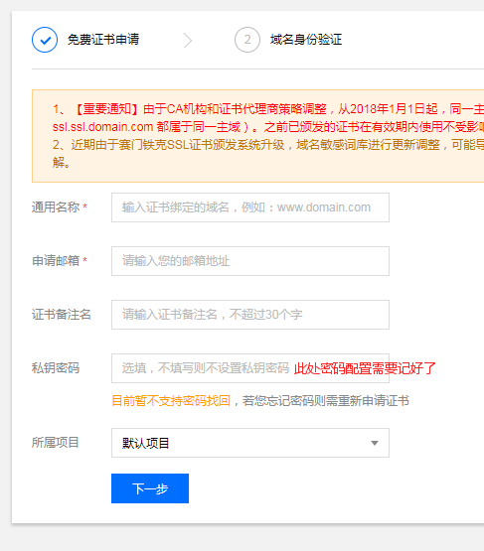
   2. 安装
      1. <https://cloud.tencent.com/document/product/400/4143>
3. 此时直接访问应为500
   1. 解决：配置域名解析
      1. <https://console.cloud.tencent.com/cns>
      2. 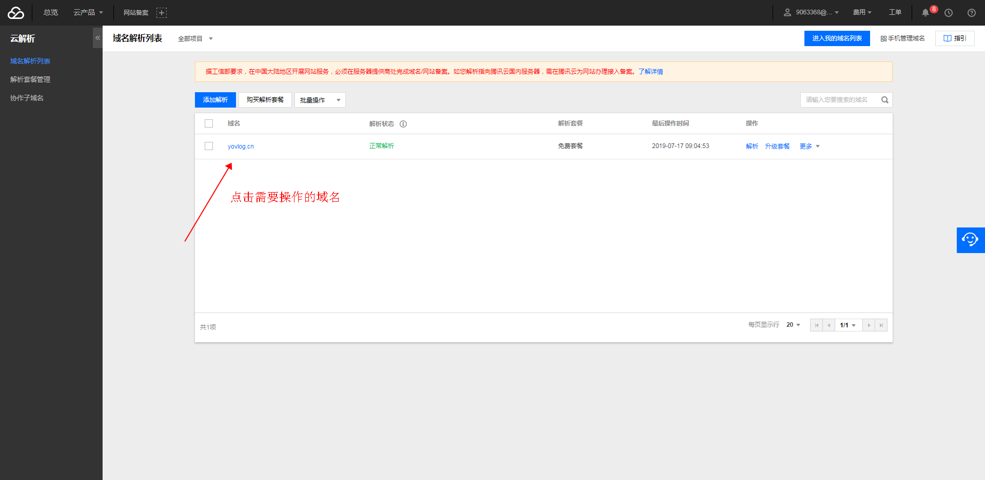
      3. 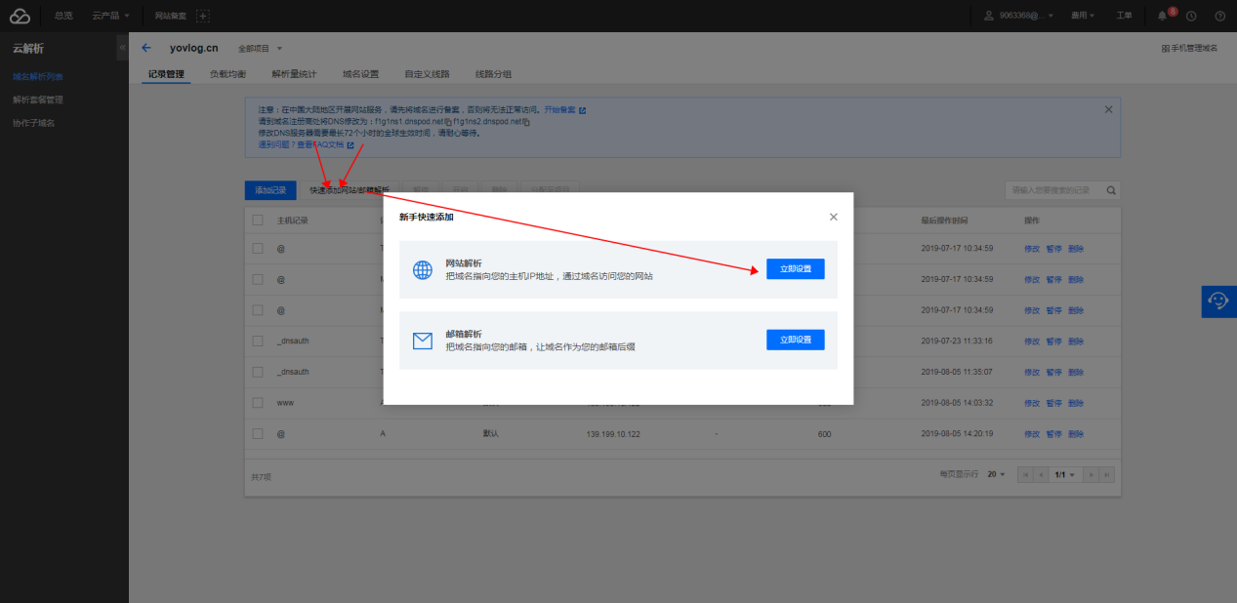
      4. 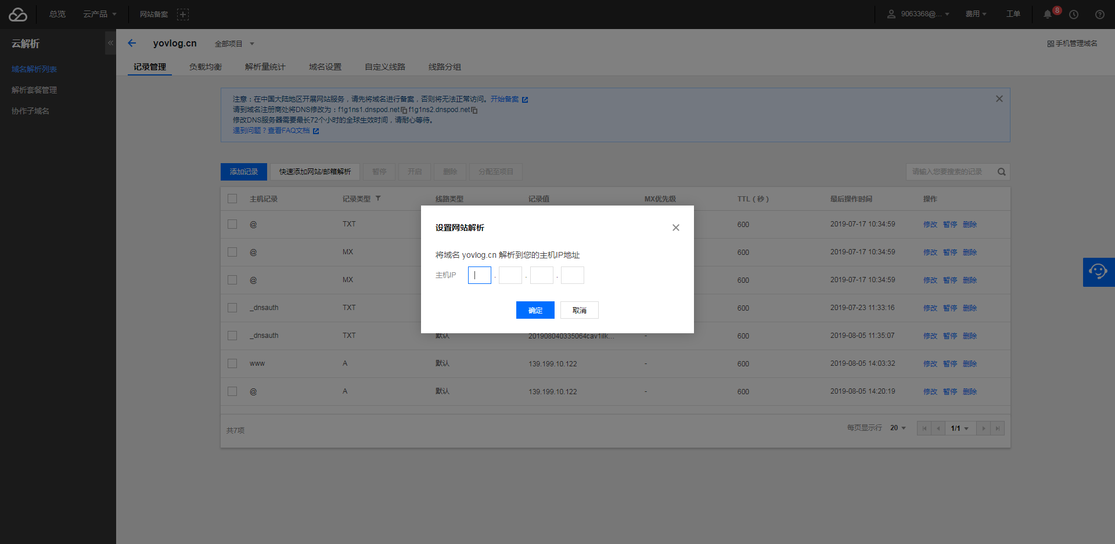
4. 目前没遇到其他问题
5. web.xml中，在<welcome-file-list>标签后配置

<login-config>

<!-- Authorization setting for SSL -->

<auth-method>CLIENT-CERT</auth-method>

<realm-name>Client Cert Users-only Area</realm-name>

</login-config>

<security-constraint>

<!-- Authorization setting for SSL -->

<web-resource-collection>

<web-resource-name>SSL</web-resource-name>

<url-pattern>/*</url-pattern>

</web-resource-collection>

<user-data-constraint>

<transport-guarantee>CONFIDENTIAL</transport-guarantee>

</user-data-constraint>

</security-constraint>