1. 申请证书
   1. [https://yundunnext.console.aliyun.com/?spm=5176.12818093.my.dcas.488716d0kP3SQS&p=cas#/overview/cn-hangzhou](https://yundunnext.console.aliyun.com/?spm=5176.12818093.my.dcas.488716d0kP3SQS&p=cas" \l "/overview/cn-hangzhou)

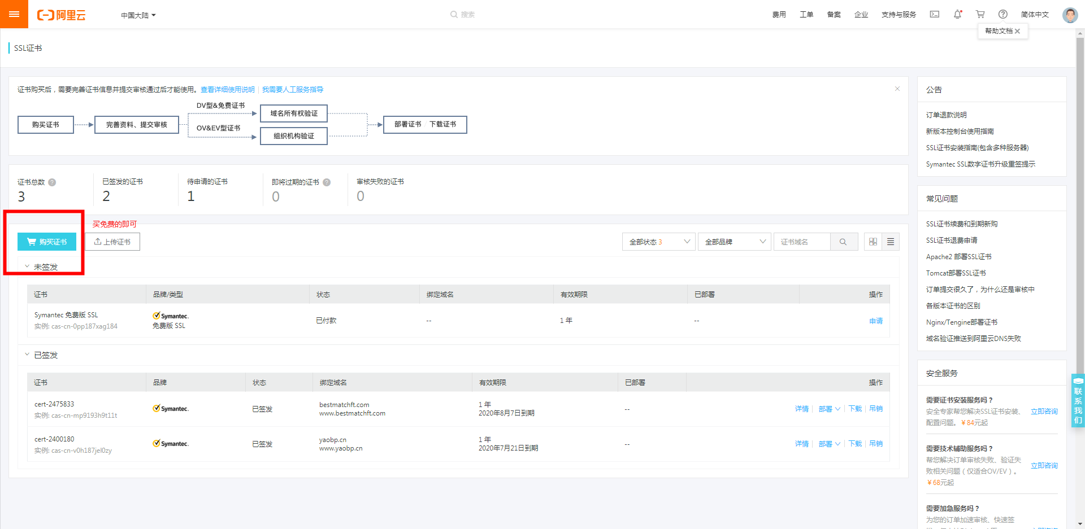

* 1. 下载及安装

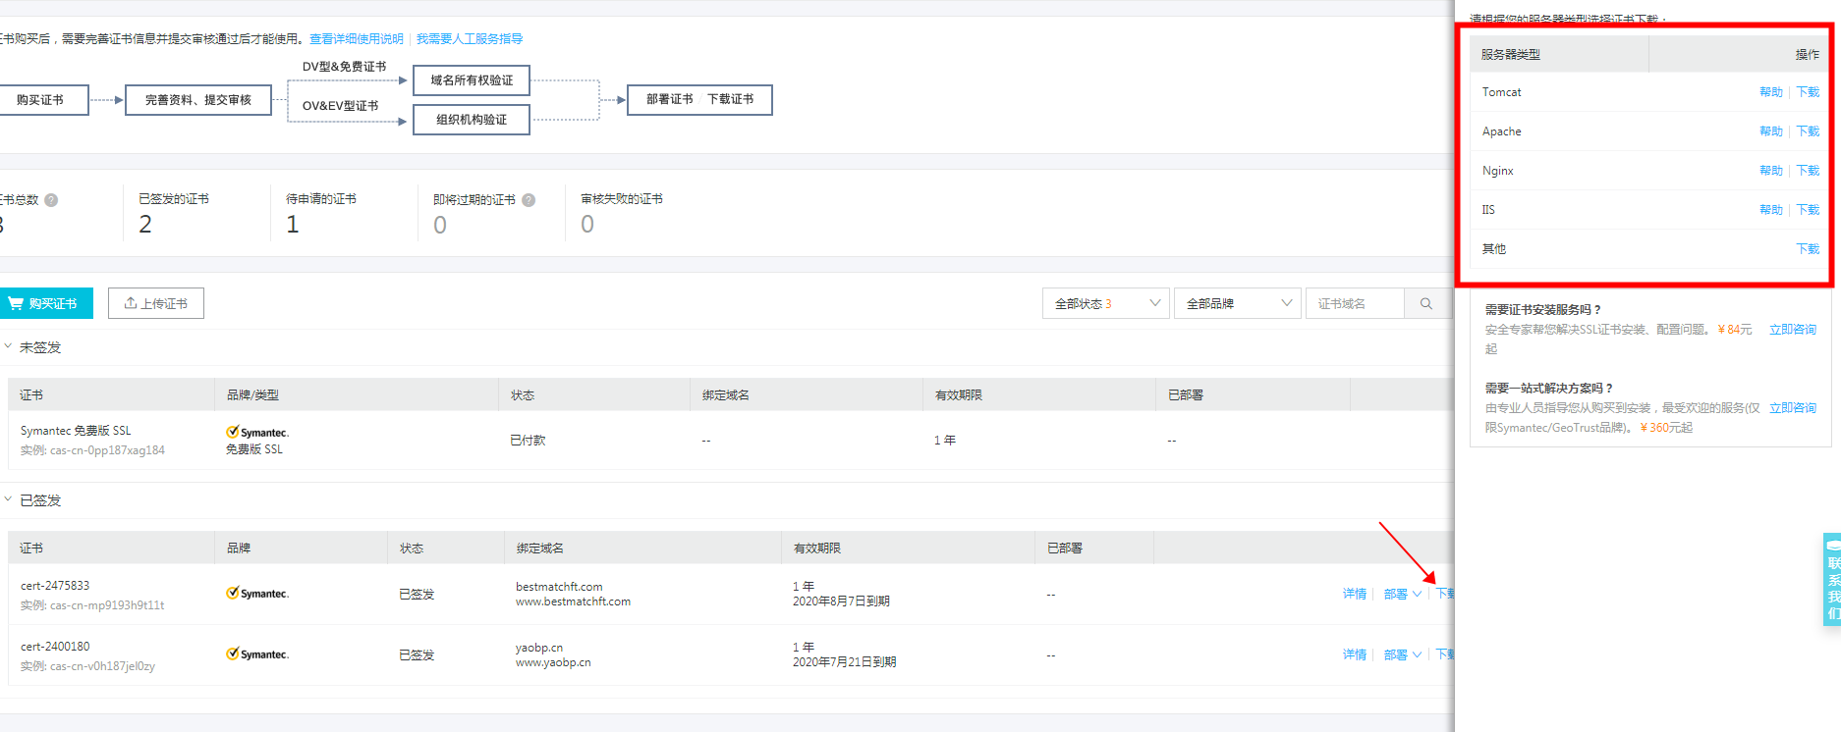

* 1. 例：tomcat配置
     1. <https://help.aliyun.com/knowledge_detail/95496.html>
     2. 根据教程走

1. 记得配置端口
2. web.xml中，在<welcome-file-list>标签后配置 - 如果是tomcat

<login-config>

<!-- Authorization setting for SSL -->

<auth-method>CLIENT-CERT</auth-method>

<realm-name>Client Cert Users-only Area</realm-name>

</login-config>

<security-constraint>

<!-- Authorization setting for SSL -->

<web-resource-collection>

<web-resource-name>SSL</web-resource-name>

<url-pattern>/*</url-pattern>

</web-resource-collection>

<user-data-constraint>

<transport-guarantee>CONFIDENTIAL</transport-guarantee>

</user-data-constraint>

</security-constraint>