### 微信小程序配置

0.1、进入微信公众平台

<https://mp.weixin.qq.com/>

0.2、申请支付

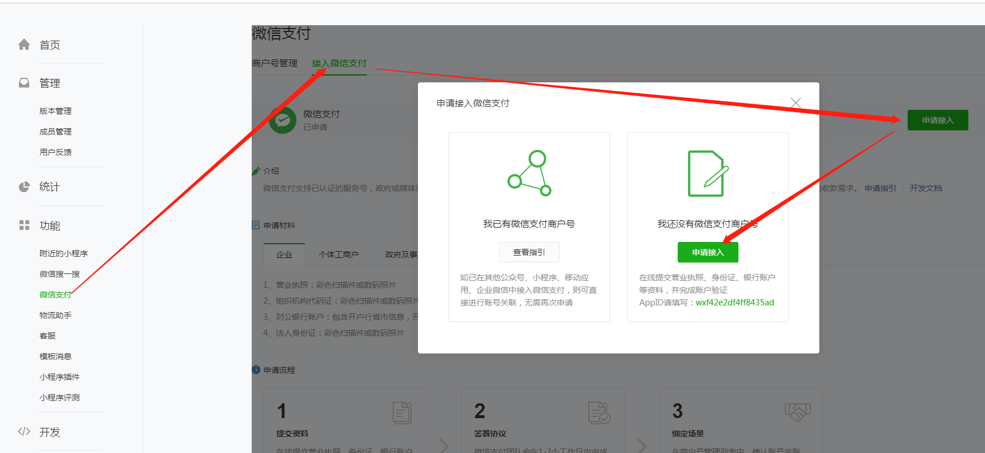

0.3、填写资料申请

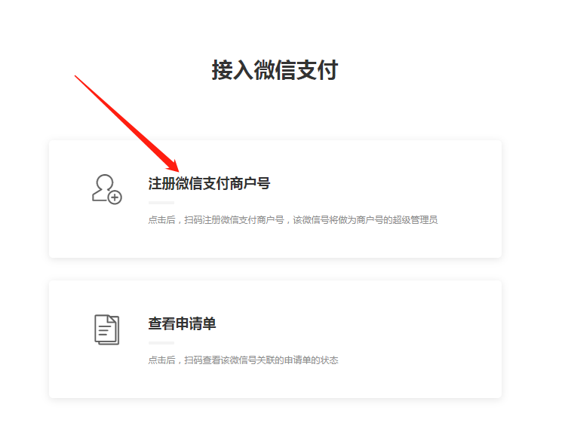

0.4、需等待几个工作日（三天）

0.5、过审后进入微信商户平台

[https://pay.weixin.qq.com/index.php/core/home/login?return_url=%2Findex.php%2Fcore%2Fcert%2Fapi_cert](https://pay.weixin.qq.com/index.php/core/home/login?return_url=/index.php/core/cert/api_cert)

0.6、查看是否关联小程序成功

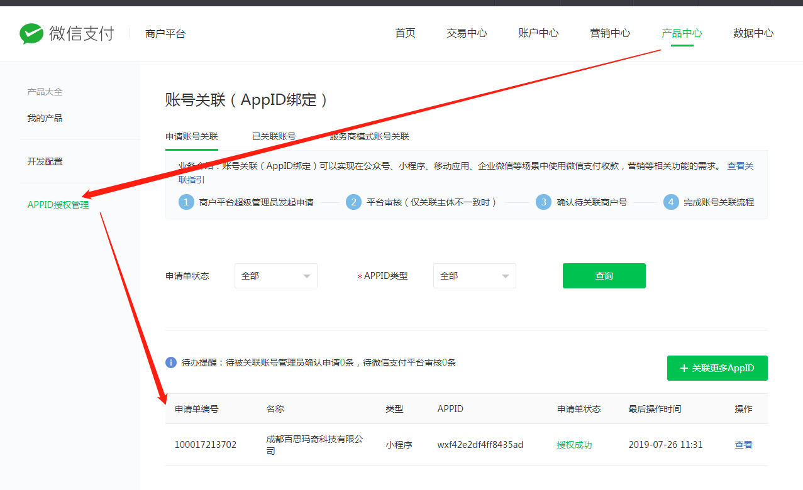

0.7、微信配置获取

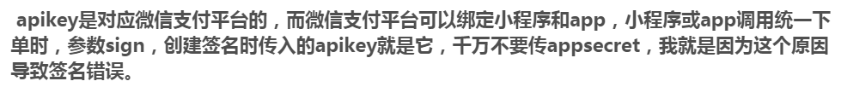

1. AppID、AppSecret - 微信公众平台

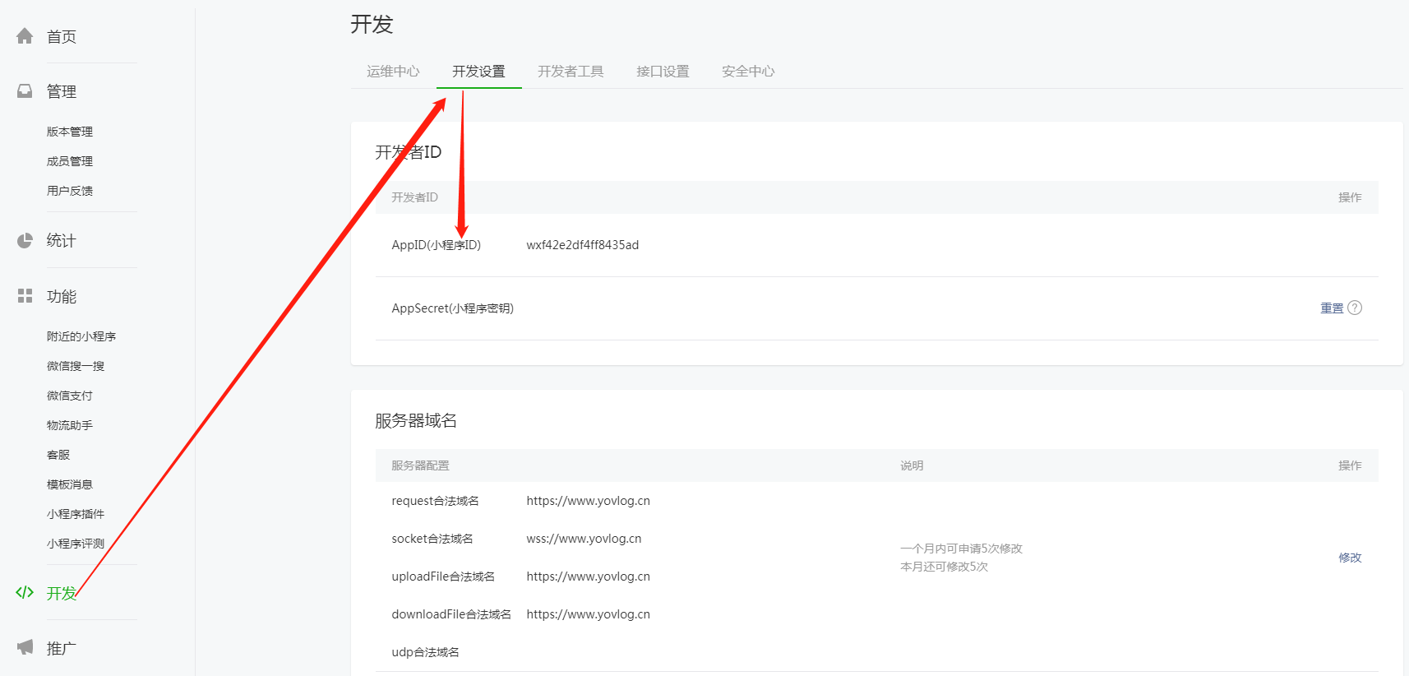

1. 商户号 - 微信商户平台

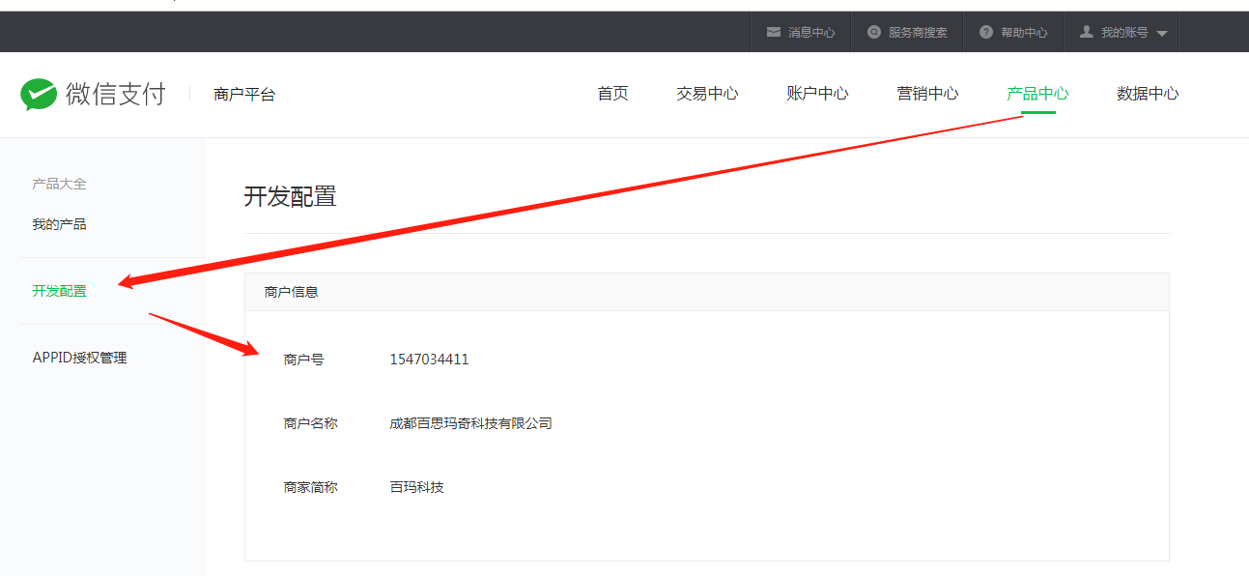

1. 微信API秘钥

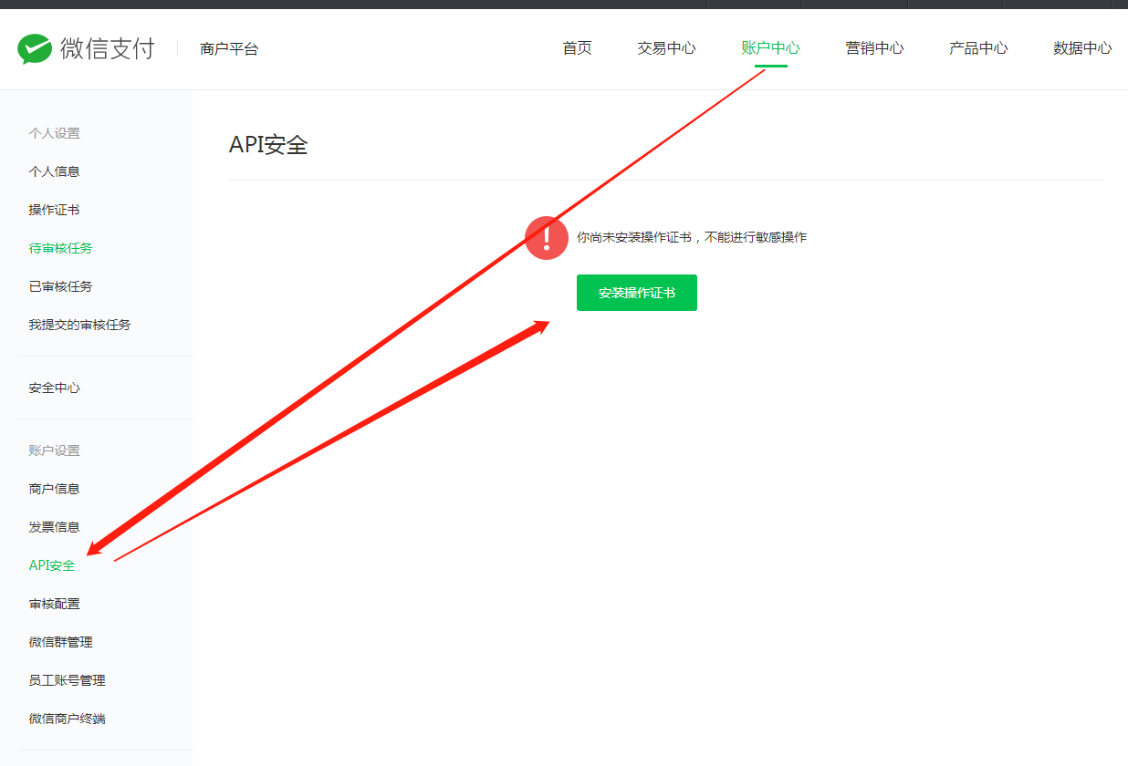

### 支付

### 调用下单接口

思路：

1. Api：<https://pay.weixin.qq.com/wiki/doc/api/app/app.php?chapter=9_1>
2. 需要的是xml格式的数据，组装xml格式数据
3. 签名sign需要使用到前面的参数来生成
4. 最后使用这个xml作为参数去请求微信服务商即可返回结果

*/**  
 * 调用微信下单，下单后返回的参数至前端，前端使用此参数即可调用支付  
 * 支付成功后可执行回调函数  
 \** ***@param*** *openId 小程序openId  
 \** ***@param*** *totalFee 总价格  
 \** ***@param*** *orderNo 订单号  
 \** ***@param*** *body 订单名称或其他信息  
 \** ***@return*** *\** ***@throws*** *Exception  
 */*public Map<Object, Object> payForOrder(String openId, Double totalFee, String orderNo, String body) throws Exception {  
 //时间戳  
 String times = System.*currentTimeMillis*() + "";  
   
 SortedMap<Object, Object> packageParams = new TreeMap<Object, Object>();  
 //微信小程序ID  
 packageParams.put("appid", appId);  
 //商户ID  
 packageParams.put("mch_id", mchId);  
 //JSAPI必须要openid  
 packageParams.put("openid", openId);  
 //随机字符串（32位以内）  
 //*todo: 随机生成nonce_str* packageParams.put("nonce_str", "ejnshgum39igp6qwpvzwb5jbwk8yigqz");  
 //支付主体名称 自定义  
 packageParams.put("body", body);  
 //订单编号 - 没问题  
 packageParams.put("out_trade_no", orderNo);  
 //价格 自定义 单位为分  
 packageParams.put("total_fee", totalFee.doubleValue() * 100 + "");  
 //支付返回地址要外网访问的到， localhost不行，调用下面buy方法。（订单存入数据库）  
 packageParams.put("notify_url", notifyUrl);  
 //这个api有，固定的  
 packageParams.put("trade_type", "JSAPI");  
 //获取sign - 这个是自己在微信商户设置的32位密钥  
 String sign = PayCommonUtil.*createSign*("UTF-8", packageParams, key);  
 packageParams.put("sign", sign);  
 System.*out*.println(sign);  
 //将参数转成XML  
 String requestXML = PayCommonUtil.*getRequestXml*(packageParams);  
 System.*out*.println(requestXML);  
 //得到含有prepay_id的XML  
 String resXml = HttpUtil.*postData*(unifiedOrderUrl, requestXML);  
 System.*out*.println(resXml);  
 //解析XML存入Map  
 Map map = XMLUtil.*doXMLParse*(resXml);  
 System.*out*.println(map);  
 //得到prepay_id  
 String prepay_id = (String) map.get("prepay_id");  
 SortedMap<Object, Object> packageP = new TreeMap<>();  
 //！！！注意，这里是appId,上面是appid  
 packageP.put("appId", appId);  
 //时间戳  
 packageP.put("nonceStr", times);  
 //必须把package写成 "prepay_id="+prepay_id这种形式  
 packageP.put("package", "prepay_id=" + prepay_id);  
 //paySign加密  
 packageP.put("signType", "MD5");  
 packageP.put("timeStamp", (System.*currentTimeMillis*() / 1000) + "");  
 //得到paySign  
 String paySign = PayCommonUtil.*createSign*("UTF-8", packageP, key);  
 packageP.put("paySign", paySign);  
 return packageP;  
}

### 1.2、工具类

#### 1.2.1、 PayCommonUtil（目前只有前两个有用）

import java.text.SimpleDateFormat;  
import java.util.ArrayList;  
import java.util.Collections;  
import java.util.Date;  
import java.util.Iterator;  
import java.util.List;  
import java.util.Map;  
import java.util.Set;  
import java.util.SortedMap;  
  
public class PayCommonUtil {  
  
 */**  
 \** ***@author*** *\** ***@Description：将请求参数转换为xml格式的string*** *\** ***@param*** *parameters  
 * 请求参数   
 \** ***@return*** *\*/* public static String getRequestXml(SortedMap<Object, Object> parameters) {  
 StringBuffer sb = new StringBuffer();  
 sb.append("<xml>");  
 Set es = parameters.entrySet();  
 Iterator it = es.iterator();  
 while (it.hasNext()) {  
 Map.Entry entry = (Map.Entry) it.next();  
 String k = entry.getKey().toString();  
 String v = entry.getValue().toString();  
 if ("attach".equalsIgnoreCase(k) || "body".equalsIgnoreCase(k) || "sign".equalsIgnoreCase(k)) {  
 sb.append("<" + k + ">" + v + "</" + k + ">");  
 } else {  
 sb.append("<" + k + ">" + v + "</" + k + ">");  
 }  
 }  
 sb.append("</xml>");  
 return sb.toString();  
 }  
   
 */**  
 \** ***@author*** *\** ***@Description：sign签名*** *\** ***@param*** *characterEncoding  
 * 编码格式   
 * 请求参数   
 \** ***@return*** *\*/* public static String createSign(String characterEncoding, SortedMap<Object, Object> packageParams, String API_KEY) {  
 StringBuffer sb = new StringBuffer();  
 Set es = packageParams.entrySet();  
 Iterator it = es.iterator();  
 while (it.hasNext()) {  
 Map.Entry entry = (Map.Entry) it.next();  
 String k = entry.getKey().toString();  
 String v = entry.getValue().toString();  
 if (null != v && !"".equals(v) && !"sign".equals(k) && !"key".equals(k)) {  
 sb.append(k + "=" + v + "&");  
 }  
 }  
 sb.append("key=" + API_KEY);  
 String sign = MD5.*MD5Encode*(sb.toString(), characterEncoding).toUpperCase();  
 return sign;  
 }  
 public static String createLinkString(Map<String, String> params) {  
 List<String> keys = new ArrayList<String>(params.keySet());  
 Collections.*sort*(keys);  
 String prestr = "";  
 for (int i = 0; i < keys.size(); i++) {  
 String key = keys.get(i);  
 String value = params.get(key);  
 if (i == keys.size() - 1) {// 拼接时，不包括最后一个&字符   
 prestr = prestr + key + "=" + value;  
 } else {  
 prestr = prestr + key + "=" + value + "&";  
 }  
 }  
 return prestr;  
 }  
  
 */**  
 * 是否签名正确,规则是:按参数名称a-z排序,遇到空值的参数不参加签名。   
 \** ***@return*** *boolean  
 */* public static boolean isTenpaySign(String characterEncoding, SortedMap<Object, Object> packageParams, String API_KEY) {  
 StringBuffer sb = new StringBuffer();  
 Set es = packageParams.entrySet();  
 Iterator it = es.iterator();  
 while(it.hasNext()) {  
 Map.Entry entry = (Map.Entry)it.next();  
 String k = (String)entry.getKey();  
 String v = (String)entry.getValue();  
 if(!"sign".equals(k) && null != v && !"".equals(v)) {  
 sb.append(k + "=" + v + "&");  
 }  
 }  
  
 sb.append("key=" + API_KEY);  
  
 //算出摘要   
 String mysign = MD5.*MD5Encode*(sb.toString(), characterEncoding).toLowerCase();  
 String tenpaySign = ((String)packageParams.get("sign")).toLowerCase();  
  
 //System.out.println(tenpaySign + " " + mysign);   
 return tenpaySign.equals(mysign);  
 }  
  
 */**  
 * 取出一个指定长度大小的随机正整数.   
 *  
 \** ***@param*** *length  
 * int 设定所取出随机数的长度。length小于11   
 \** ***@return*** *int 返回生成的随机数。   
 */* public static int buildRandom(int length) {  
 int num = 1;  
 double random = Math.*random*();  
 if (random < 0.1) {  
 random = random + 0.1;  
 }  
 for (int i = 0; i < length; i++) {  
 num = num * 10;  
 }  
 return (int) ((random * num));  
 }  
  
 */**  
 * 获取当前时间 yyyyMMddHHmmss   
 *  
 \** ***@return*** *String  
 */* public static String getCurrTime() {  
 Date now = new Date();  
 SimpleDateFormat outFormat = new SimpleDateFormat("yyyyMMddHHmmss");  
 String s = outFormat.format(now);  
 return s;  
 }  
  
 public static boolean verify(String text, String sign, String key, String input_charset) {  
 text = text + key;  
 String mysign =MD5.*MD5Encode*(text, input_charset).toUpperCase();  
 System.*out*.println(mysign); System.*out*.println(mysign); System.*out*.println(mysign); System.*out*.println(mysign);  
 if (mysign.equals(sign)) {  
 return true;  
 } else {  
 return false;  
 }  
 }  
}

#### 1.2.2、 XMLUtil（解析XML）

import java.io.ByteArrayInputStream;  
import java.io.InputStream;  
import java.util.HashMap;  
import java.util.Iterator;  
import java.util.List;  
import java.util.Map;  
  
import org.jdom2.Document;  
import org.jdom2.Element;  
import org.jdom2.input.SAXBuilder;  
  
public class XMLUtil {  
 public static Map doXMLParse(String strxml) throws Exception {  
 strxml = strxml.replaceFirst("encoding=\".*\"", "encoding=\"UTF-8\"");  
  
 if(null == strxml || "".equals(strxml)) {  
 return null;  
 }  
  
 Map m = new HashMap();  
  
 InputStream in = new ByteArrayInputStream(strxml.getBytes("UTF-8"));  
 SAXBuilder builder = new SAXBuilder();  
 Document doc = builder.build(in);  
 Element root = doc.getRootElement();  
 List list = root.getChildren();  
 Iterator it = list.iterator();  
 while(it.hasNext()) {  
 Element e = (Element) it.next();  
 String k = e.getName();  
 String v = "";  
 List children = e.getChildren();  
 if(children.isEmpty()) {  
 v = e.getTextNormalize();  
 } else {  
 v = XMLUtil.*getChildrenText*(children);  
 }  
  
 m.put(k, v);  
 }  
  
 //关闭流  
 in.close();  
  
 return m;  
 }  
  
 */**  
 * 获取子结点的xml  
 \** ***@param*** *children  
 \** ***@return*** *String  
 */* public static String getChildrenText(List children) {  
 StringBuffer sb = new StringBuffer();  
 if(!children.isEmpty()) {  
 Iterator it = children.iterator();  
 while(it.hasNext()) {  
 Element e = (Element) it.next();  
 String name = e.getName();  
 String value = e.getTextNormalize();  
 List list = e.getChildren();  
 sb.append("<" + name + ">");  
 if(!list.isEmpty()) {  
 sb.append(XMLUtil.*getChildrenText*(list));  
 }  
 sb.append(value);  
 sb.append("</" + name + ">");  
 }  
 }  
  
 return sb.toString();  
 }  
}

#### 1.2.3、HttpUtil（发送请求）

import java.io.BufferedReader;  
import java.io.IOException;  
import java.io.InputStreamReader;  
import java.io.OutputStreamWriter;  
import java.net.URL;  
import java.net.URLConnection;  
  
public class HttpUtil {  
 //private static final Log logger = Logs.get();  
 private final static int *CONNECT_TIMEOUT* = 5000; // in milliseconds  
 private final static String *DEFAULT_ENCODING* = "UTF-8";  
  
 public static String postData(String urlStr, String data){  
 return *postData*(urlStr, data, null);  
 }  
  
 public static String postData(String urlStr, String data, String contentType){  
 BufferedReader reader = null;  
 try {  
 URL url = new URL(urlStr);  
 URLConnection conn = url.openConnection();  
 conn.setDoOutput(true);  
 conn.setConnectTimeout(*CONNECT_TIMEOUT*);  
 conn.setReadTimeout(*CONNECT_TIMEOUT*);  
 if(contentType != null)  
 conn.setRequestProperty("content-type", contentType);  
 OutputStreamWriter writer = new OutputStreamWriter(conn.getOutputStream(), *DEFAULT_ENCODING*);  
 if(data == null)  
 data = "";  
 writer.write(data);  
 writer.flush();  
 writer.close();  
  
 reader = new BufferedReader(new InputStreamReader(conn.getInputStream(), *DEFAULT_ENCODING*));  
 StringBuilder sb = new StringBuilder();  
 String line = null;  
 while ((line = reader.readLine()) != null) {  
 sb.append(line);  
 sb.append("\r\n");  
 }  
 return sb.toString();  
 } catch (IOException e) {  
 //logger.error("Error connecting to " + urlStr + ": " + e.getMessage());  
 } finally {  
 try {  
 if (reader != null)  
 reader.close();  
 } catch (IOException e) {  
 }  
 }  
 return null;  
 }  
}

### 授权

*/**  
 * 授权  
 \** ***@param*** *map 包含code  
 \** ***@return*** *\*/*public JSONObject oauth2GetOpenid(Map<String, String> map) {  
 String code = map.get("code");

//https://api.weixin.qq.com/sns/jscode2session?appid=APPID&secret=SECRET&js_code=CODE&grant_type=authorization_code  
 String requestUrl = getPageAccessTokenUrl.replace("APPID", appId).replace("SECRET", secret).replace("CODE", code);  
 HttpClient client = null;  
 JSONObject object = null;  
 try {  
 client = new DefaultHttpClient();  
 HttpGet httpget = new HttpGet(requestUrl);  
 ResponseHandler<String> responseHandler = new BasicResponseHandler();  
 String response = client.execute(httpget, responseHandler);  
 object = JSONObject.*parseObject*(response);  
 } catch (Exception e) {  
 e.printStackTrace();  
 } finally {  
 client.getConnectionManager().shutdown();  
 }  
 return object;

### 获取手机号

import org.bouncycastle.jce.provider.BouncyCastleProvider;  
import org.bouncycastle.util.Arrays;  
import org.bouncycastle.util.encoders.Base64;  
  
import javax.crypto.Cipher;  
import javax.crypto.spec.IvParameterSpec;  
import javax.crypto.spec.SecretKeySpec;  
import java.security.Key;  
import java.security.Security;  
*/**  
 * <p>  
 *  
 * </p>  
 *  
 \** ***@author*** *郭海斌  
 \** ***@since*** *2019/8/12  
 */*public class DecryptDataUtil {  
  
 public static String decryptData(String encryptDataB64, String sessionKeyB64, String ivB64) {  
 return new String(  
 *decryptOfDiyIV*(  
 Base64.*decode*(encryptDataB64),  
 Base64.*decode*(sessionKeyB64),  
 Base64.*decode*(ivB64)  
 )  
 );  
 }  
  
 private static final String *KEY_ALGORITHM* = "AES";  
 private static final String *ALGORITHM_STR* = "AES/CBC/PKCS7Padding";  
 private static Key *key*;  
 private static Cipher *cipher*;  
  
 private static void init(byte[] keyBytes) {  
 // 如果密钥不足16位，那么就补足. 这个if 中的内容很重要  
 int base = 16;  
 if (keyBytes.length % base != 0) {  
 int groups = keyBytes.length / base + (keyBytes.length % base != 0 ? 1 : 0);  
 byte[] temp = new byte[groups * base];  
 Arrays.*fill*(temp, (byte) 0);  
 System.*arraycopy*(keyBytes, 0, temp, 0, keyBytes.length);  
 keyBytes = temp;  
 }  
 // 初始化  
 Security.*addProvider*(new BouncyCastleProvider());  
 // 转化成JAVA的密钥格式  
 *key* = new SecretKeySpec(keyBytes, *KEY_ALGORITHM*);  
 try {  
 // 初始化cipher  
 *cipher* = Cipher.*getInstance*(*ALGORITHM_STR*, "BC");  
 } catch (Exception e) {  
 e.printStackTrace();  
 }  
 }  
  
 */**  
 * 解密方法  
 *  
 \** ***@param*** *encryptedData 要解密的字符串  
 \** ***@param*** *keyBytes 解密密钥  
 \** ***@param*** *ivs 自定义对称解密算法初始向量 iv  
 \** ***@return*** *解密后的字节数组  
 */* public static byte[] decryptOfDiyIV(byte[] encryptedData, byte[] keyBytes, byte[] ivs) {  
 byte[] encryptedText = null;  
 *init*(keyBytes);  
 try {  
 *cipher*.init(Cipher.*DECRYPT_MODE*, *key*, new IvParameterSpec(ivs));  
 encryptedText = *cipher*.doFinal(encryptedData);  
 } catch (Exception e) {  
 e.printStackTrace();  
 }  
 return encryptedText;  
 }  
  
}

### 微信小程序授权无法使用postman，因为code会变化

### 5、