Sample installation
- download and install anaconda python 2.7 [64bit]-[32bit]
- install opencv in through anaconda(In CMD)
conda install -c https://conda.binstar.org/menpo opencv
- open CMD and run idle then in idle click open and locate the sample file
- in the file go to line 90 and put a valid video filename in the file's folder
- close the windows of the video by hitting esc key

Used principles

- distance transform(further reading link)

Working Principle
Distance transform is an operator that transforms the values of pixels in an image according to their distance from the boundary of the object. The farther a pixel is from the image boundary, the higher a value it gets. This would result in a transformed image where the area near and within the boundary will be dark whereas the area near the center of the image will be white.
To put it in different words, a pixel in an image can have a value equal to the number of erosions required to be performed to make it disappear.
Distance transform operations can be classified into several types, depending upon the way the distance of a pixel from the boundary has been calculated (Distance metrics)
- canny edge detection (further reading link)
theory
to put it in simple words it uses the following processes
- Apply Gaussian filter to smooth the image in order to remove the noise
- Find the intensity gradients of the image
- Apply non-maximum suppression to get rid of spurious response to edge detection
- Apply double threshold to determine potential edges
- Track edge by hysteresis; Finalize the detection of edges by suppressing all the other edges that are weak and not connected to strong edges.

For an insight when you give it an image it produce a binary (black and white) image showing edges of the objects in the image
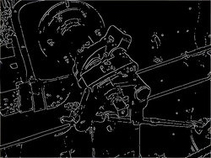
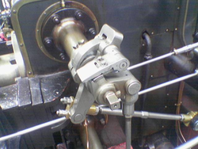
- video backgroung substractor (further reaading link)

BackgroundSubtractorGMG(theory based on opencv)
This algorithm combines statistical background image estimation and per-pixel Bayesian segmentation. It was introduced by Andrew B. Godbehere, Akihiro Matsukawa, Ken Goldberg in their paper "Visual Tracking of Human Visitors under Variable-Lighting Conditions for a Responsive Audio Art Installation" in 2012. As per the paper, the system ran a successful interactive audio art installation called “Are We There Yet?” from March 31 - July 31 2011 at the Contemporary Jewish Museum in San Francisco, California.
It uses first few (120 by default) frames for background modelling. It employs probabilistic foreground segmentation algorithm that identifies possible foreground objects using Bayesian inference. The estimates are adaptive; newer observations are more heavily weighted than old observations to accommodate variable illumination. Several morphological filtering operations like closing and opening are done to remove unwanted noise. You will get a black window during first few frames.It would be better to apply morphological opening to the result to remove the noises.
Basically when given a video with object moving and the background static it gives you a binary image(black and white) of the moving objects
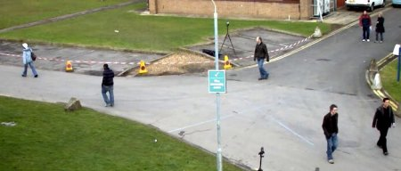

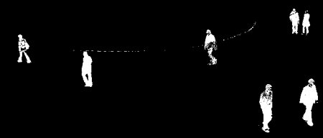

- Otsu’s Binarization(further reading link)
In computer vision and image processing named after Nobuyuki Otsu(大津展之), is used to automatically perform clustering-based image thresholding or, the reduction of a graylevel image to a binary image. The algorithm assumes that the image contains two classes of pixels following bi-modal histogram (foreground pixels and background pixels), it then calculates the optimum threshold separating the two classes so that their combined spread (intra-class variance) is minimal, or equivalently (because the sum of pairwise squared distances is constant), so that their inter-class variance is maximal
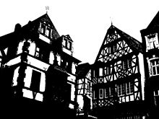
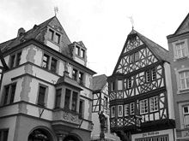

- morphological transformations(further reading link)

1. Erosion
The basic idea of erosion is just like soil erosion only, it erodes away the boundaries of foreground object (Always try to keep foreground in white). So what it does? The kernel slides through the image (as in 2D convolution). A pixel in the original image (either 1 or 0) will be considered 1 only if all the pixels under the kernel is 1, otherwise it is eroded (made to zero).


So what happens is that, all the pixels near boundary will be discarded depending upon the size of kernel. So the thickness or size of the foreground object decreases or simply white region decreases in the image

2. Dilation
It is just opposite of erosion. Here, a pixel element is '1' if atleast one pixel under the kernel is '1'. So it increases the white region in the image or size of foreground object increases. Normally, in cases like noise removal, erosion is followed by dilation. Because, erosion removes white noises, but it also shrinks our object. So we dilate it. Since noise is gone, they won't come back, but our object area increases. It is also useful in joining broken parts of an object.


3. Opening
Opening is just another name of erosion followed by dilation. It is useful in removing noise, as we explained above.


4. Closing
Closing is reverse of Opening,Dilation followed by Erosion. It is useful in closing small holes inside the foreground objects, or small black points on the object.

DETECTING OBJECTS WITH DISTANCE TRANSFORMS ON EDGES
- Theory
if we have the edges of objects in an image it is like we can identify which pixels are connected by looking at edges making contours or in other words continuous connected lines
but then usually there are broken edges so we find the edges and then transform the image according to the distance between each connected pixels what it gives as is it shows us close and connected edges and clear out weakly close but connected objects which maybe noises or very indistinct objects what we remain with are strongly noticeable and closely distinct shapes after we can draw the contours on those identified objects or make bounding rectangles or just identify what that object is from some database
DETECTING OBJECTS BY MORPHOLOGICALLY TRANSFORMING THE FOREGROUND
- Theory
given a video we remove the static objects from the dynamic ones and the result is the foreground we use a background subtractor algorithm afore mentioned on the top
which gives us a binary(black and white) image of the objects that moved which is the foreground with that in mind we make a morphological opening to remove the noise
at this point the binary image is composed of many small contours so we apply otsu binarization or thresholding to obtain binary image which is plain and most of the objects are connected and it further removes much of the noise or connect them to the picture which makes it indistinguishable so now that most of our contours are connected we further remove little objects and noise by morphologically opening and closing and then since we have most of the little objects and noise removed we morphologically dilate the image to make edge connection stronger after this you can draw the contours on those edges or create bounding rectangles of the countours

