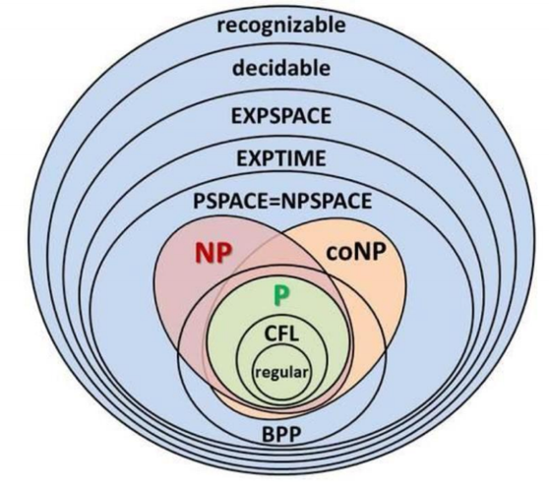
NP completeness
Decision Problem: answer yes/ no
PSPACE: decision problems solvable in polynomial space
P: decision problems for which there is a poly-time algorithm
NP: …… there is a poly-time algorithm certifier
Certifier: Algorithm C(s,t) is a Certifier for problem X if $∀$ string s, s$∈X$ if there exists a string t such that C(s,t) = yes
Co-NP: complements of decision problems in NP
EXP: …… there is an exponential-time algorithm
Reduction $X ≤_{p} Y$ if arbitrary instances of problem X can be solved using 用X实例构造Y
• Polynomial number of standard computational steps, plus
• Polynomial number of calls to oracle that solves problem Y
NP-complete: A problem Y in NP with the property that for every problem X in NP, $X ≤_{p} Y$
Independent set：Given a graph G = (V, E) and an integer k, is there a subset of vertices $S⊆V$ such that $|S|≥k$, and for each edge at most one of its endpoints is in S.
Vertex cover: …… such that $|S|≤k$, and for each edge at least one of its endpoints is in S.
Set cover: Given a set U of elements, a collection $S_{1}$, $S_{2}$,…, $S_{m}$,of subsets of U, and an integer k, does there exist a collection of ≤ k of these sets whose union is equal to U
CIRCUIT-SAT: Given a combinational circuit built out of AND, OR, and NOT gates, is there a way to set the circuit inputs so that the output is 1?
3-SAT: Literal：布尔变量或其否定，$x_{i}$或${¬x}_{i}$。Clause：文字的析取（逻辑或）。CNF：由子句的合取（逻辑与）构成的命题公式。 SAT：Given CNF formula $ϕ$, does it have a satisfying truth assignment?
Subset-sum：Given natural numbers $w_{1}$, $w_{2}$,…, $w_{n}$ and an integer W, is there a subset that adds up to exactly W?
Recipe to establish NP-completeness of problem Y
Show that Y is in NP Choose an NP-complete problem X Prove that $X ≤_{p} Y$
Vertex-cover $≡_{p}$Independent-set Pf. We show S is an independent set iff V-S is a vertex cover
→ Let S be any independent set. Consider an arbitrary edge (u,v). S independent→ u$∉$S or v$∉$S→u∈V-S or v∈V-S
Thus,V-S covers (u,v)
← Let V -S be any vertex cover ·Consider two nodes u∈S and v∈S .Observe that (u,v) $∉$E since V -S is a vertex cover Thus, no two nodes in S are joined by an edge S independent set
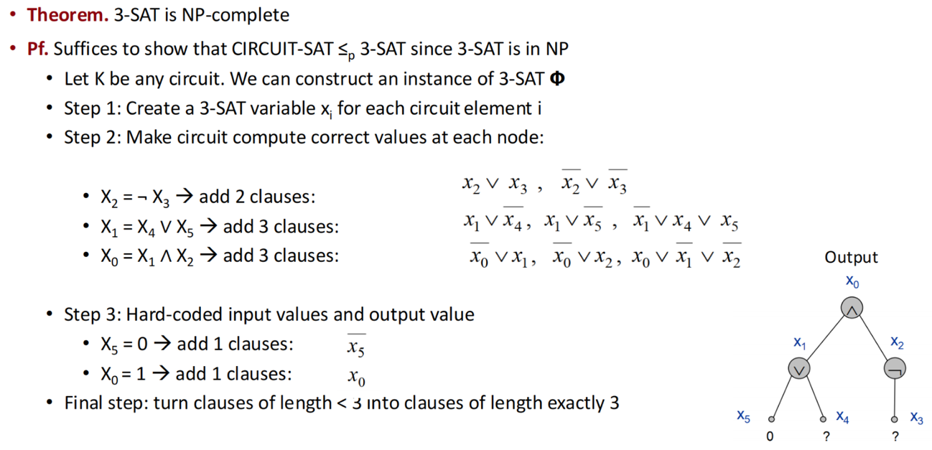
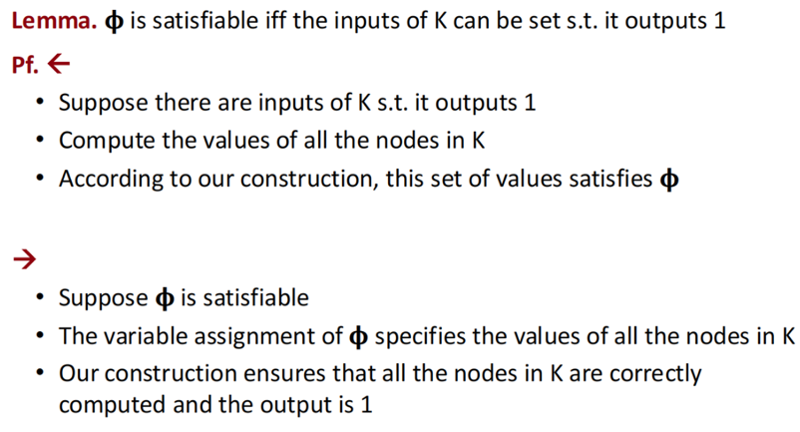

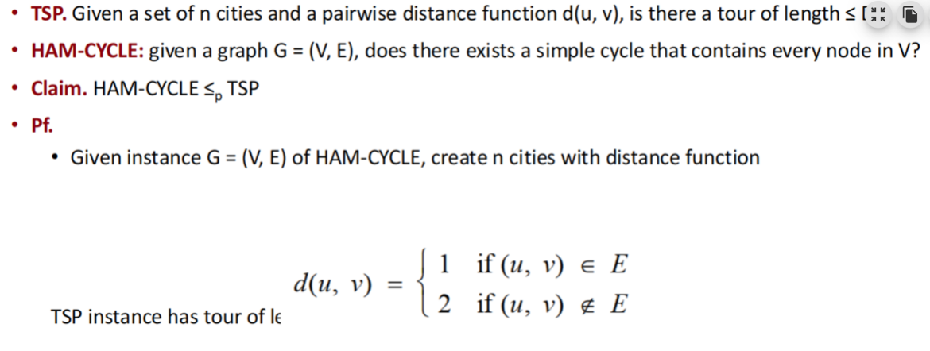
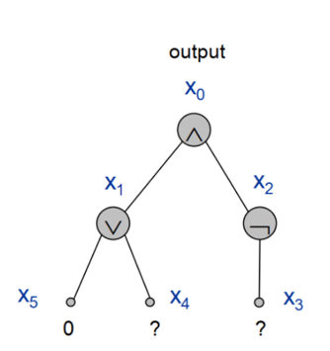

FPT Brute force 难以求解，顶点覆盖问题$O(kn^{k+1})$=$n^{k}∙nk$ limit to $O(2^{k}n)$
fixed parameter tractable with respect to some parameter k is the class of problems solvable in time $f(k)∙poly(n)$.
Circular Arc Covering brute force:$O(k^{m})$ 现有算法 $O(k!∙n)$ m 路径数，k 着色数, n 节点数
见考试总结
Nash Equilibria
Social optimum: Minimizes total cost to all agents.
Observation: there may be many Nash equilibria. Even if it's unique, it does not necessarily equal the social optimum.
Price of stability: Ratio of best Nash equilibrium to social optimum.
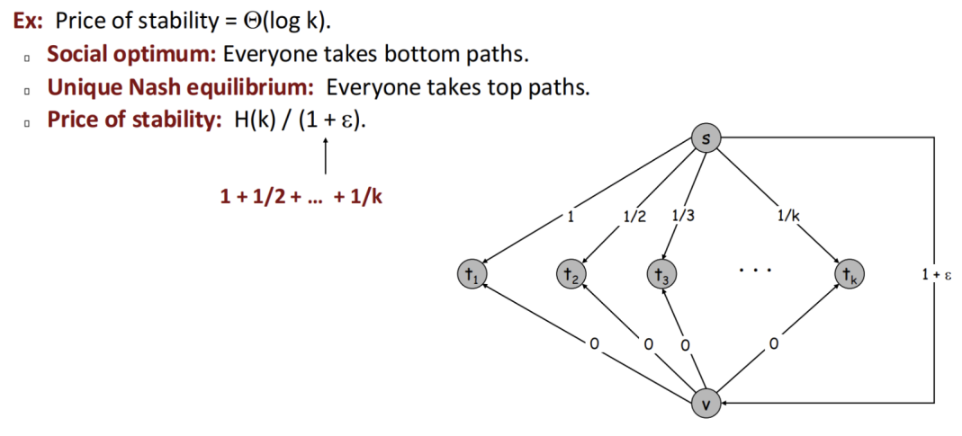
Amortized Analysis
Stack operations: PUSH(S, x) O(1) , POP(S) O(1), MULTIPOP(S, k) $O(min |S|,k)$
Aggregate Analysis calculates 操作总成本and amortizes it evenly across each operation to derive the amortized cost.
1.For $n_{push}$ PUSH operations, each has a cost of O(1)，so the total cost is O($n_{push}$) 2. ……3. For $n_{MULTIPOP}$ MULTIPOP operations: although the actual cost of each operation is $O(min |S|,k)$, the total number of elements popped by these operations cannot exceed the number of elements pushed by previous PUSH operations. Thus, the total cost is still bounded by $n_{push}$. Since the total number of operations =$n_{push}$+$n_{pop}$+$n_{MULTIPOP}≤$2*$n_{push}$, the total cost is O($n_{push}$)= O(n), ,and the amortized cost per operation is O(n)/n= O(1)
Potential for a stack := the number of objects in the stack. So Φ(D0 )=0, and Φ(Di ) ≥0
PUSH: Potential change: Φ(Di ) - Φ(Di-1 ) = 1. Amortized cost: ci ' = ci + Φ(Di ) - Φ(Di-1 ) = 1 + 1 = 2.
POP: Potential change: Φ(Di ) - Φ(Di-1 ) = -1. Amortized cost: ci ' = ci + Φ(Di ) - Φ(Di-1 )= 1 + (-1) = 0.
MULTIPOP(S, k): Potential change: Φ(Di ) - Φ(Di-1 ) = –k. Amortized cost: ci ' = ci + Φ(Di ) - Φ(Di-1) = k + (-k) = 0.
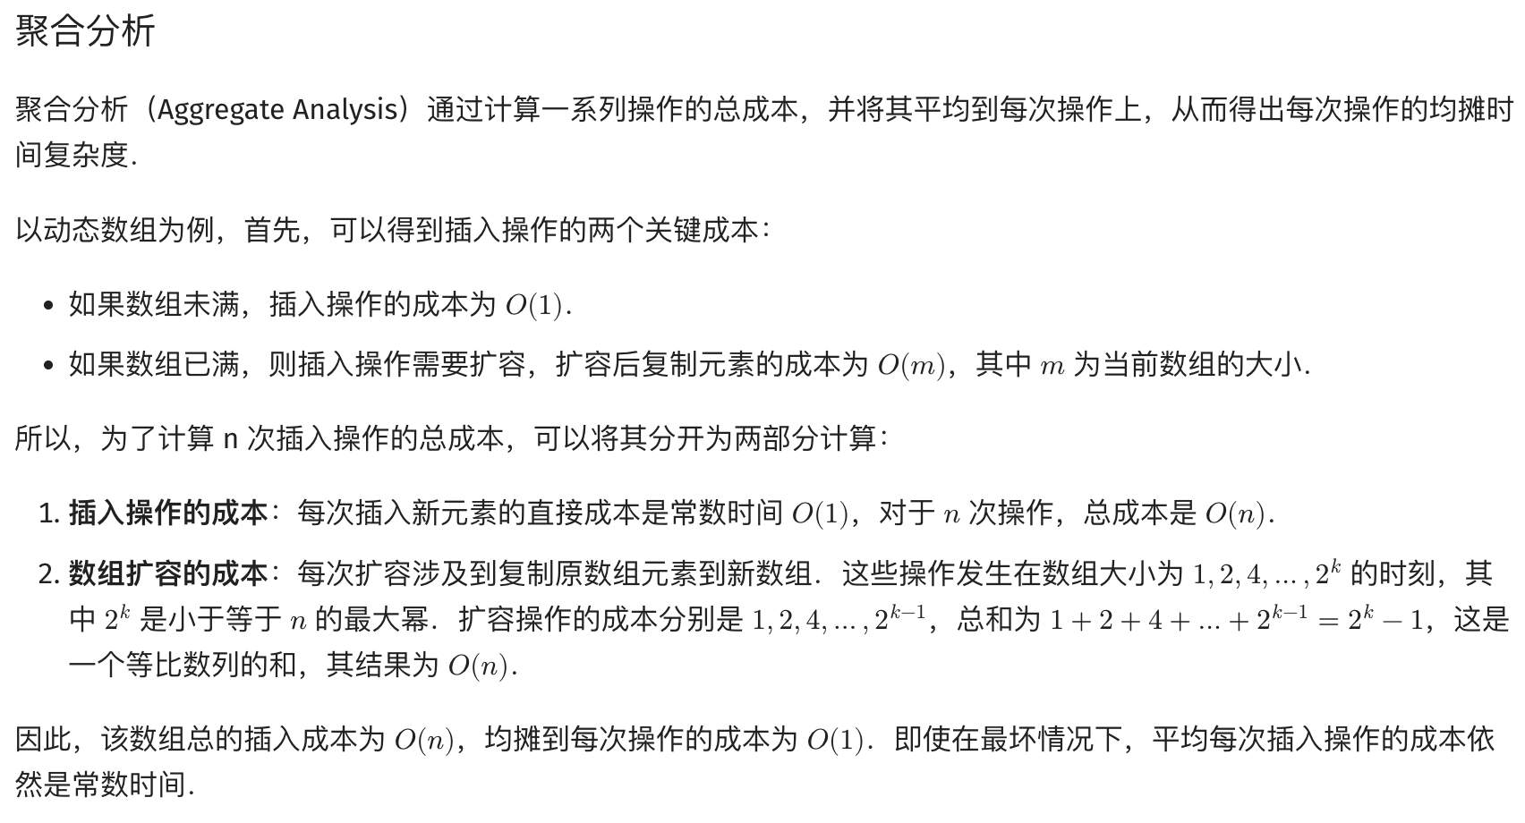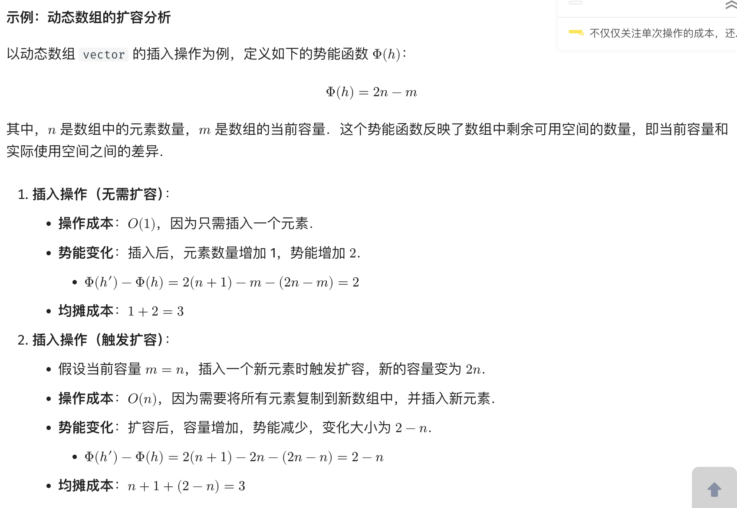

Approximation Algorithms

Set cover: A collection F of sets. $S∈F$, cost(S), $\bigcup_{S∈F}{S}=X$, choose $\bigcup_{S∈G}{S}=X$,$G⊆F$,make $min Cost(S⊆G)$
Greedy approximation algorithm: U = X, C = ∅; choose $S∈F-C$ with min |cost (S)|/|S∩U|; C = C∪{S} U = U – S
Proof of Correctness: We always output a set cover, because the while loop continues till X is covered.
Proof of Approximation Ratio: $L=\sum_{k}{cost}(e_{k})=\sum_{k}{\frac{OPT}{n-k+1}}≈\ln{(}n)*OPT$
Makespan Scheduling (LS) n independent jobs. m processors. Assign to minimize the last processor finishes all its jobs
1. List the jobs in any order. 只要有 unfinished jobs. If any processor 没 a job now, give it the next job in the list.
3. Suppose LS gives makespan of M. optimal schedule have makespan M*. We prove that M ≤ 2M*
M* ≥ t，M* ≥ T (length of opt schedule is ≥ (total work)/m ≥ mT/m = T), M* ≥ max(T,t). M = T + t
LPT Scheduling: 1. Let’s try to schedule longest jobs first. 3. Let X be the last job to finish. Assume it starts at time T and has size t. Assume that X is the last job to start. a）X is the smallest job. 1 LPT’s makespan M = T+t ≤ M*+t
Case 1 t ≤ M*/3. M ≤ M* + t ≤4/3 M*. Case 2 t > M*/3. all tasks have size > M*/3. the opt has at most 2 tasks per processor. So n≤2m. 1≤ n≤ m, both put one task per processor, m < n≤ 2m… LPT is optimal. M ≤ 4/3 M*.
The Knapsack Problem: (PTAS) 背掉
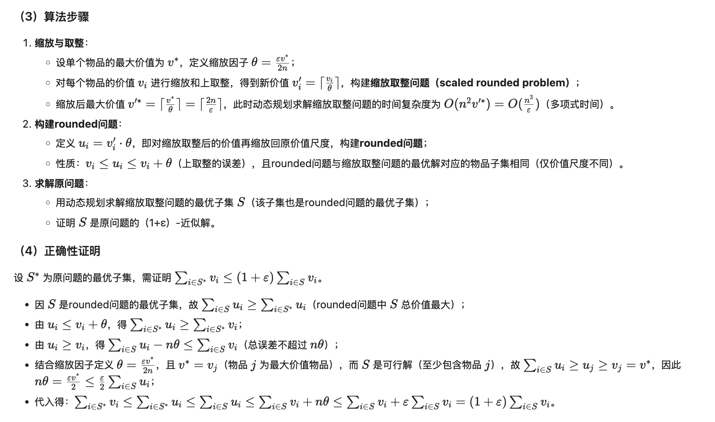
Vertex Cover：1. D = {E}, C = ∅; Repeat as long as there are edge left in D{ Take any edge (u,v) in D; Add {u,v} to C.;Remove all the edges adjacent to u or v from D}; Output C. 2. We keep adding vertices till all edges are covered.
3. a) None of the edges in A touch each other. B) each vertex in C* covers at most one edge in A. |C*| ≥ |A|.
The number of vertices the algorithm uses is 2|A|. |C|/|C*| = 2|A| / |C*| ≤ 2|A| / |A| = 2.
Pricing Method：$\sum_{e=(i,j)}{p_{e}}≤w_{i}$(for vi), $\sum_{e∈E}{p_{e}}=\sum_{e∈E}{\sum_{i∈S,e=(i,j)}{p_{e}}}≤\sum_{i∈S}{\sum_{e=(i,j)}{p_{e}}}≤\sum_{i∈S}{w_{i}}=w(S)$
1. $p_{e}$= 0; while ($∃$edge i-j such that neither i nor j are tight) select such an edge e, increase $p_{e}$ without violating fairness) S set of all tight nodes 2. S is a vertex cover: if some edge i-j is uncovered, then neither i nor j is tight. But then while loop would not terminate.3.$w(S)=\sum_{i∈S}{w_{i}}=\sum_{i∈S}{\sum_{e=(i,j)}{p_{e}}}≤\sum_{i∈V}{\sum_{e=(i,j)}{p_{e}}}=2\sum_{e∈E}{p_{e}}≤2w(S^{*})$
LP Rounding(ILP->LP): 2. Consider an edge (i, j) $∈$ E. Since $x_{i}^{*}$+$x_{j}^{*}$≥1, either $x_{i}^{*}$≥1/2 or $x_{j}^{*}$≥1/2 (i, j) covered.
3. Let S* be optimal vertex cover. $\sum_{i∈S^{*}}{w_{i}}≥\sum_{i∈S}{w_{i}}x_{i}^{*}≥1/2\sum_{i∈S}{w_{i}}$

