NP completeness
PSPACE: decision problems solvable in polynomial space Co-NP: complements of decision problems in NP NP: …… there is a poly-time algorithm certifier P(EXP): ……for which there is a poly(exponential )-time algorithm
Reduction $X ≤_{p} Y$ if arbitrary instances of problem X can be solved using 用X实例构造Y
• Polynomial number of standard computational steps, plus • Polynomial number of calls to oracle that solves problem Y
NP-complete: A problem Y in NP with the property that for every problem X in NP, $X ≤_{p} Y$
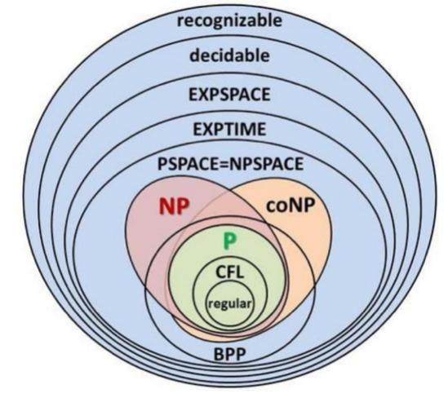
Independent set：Given a graph G = (V, E) and an integer k, is there a subset of vertices $S⊆V$ such that $|S|≥k$, and for each edge at most one of its endpoints is in S. Vertex cover: … such that $|S|≤k$, and for each edge at least one of its endpoints is in S.
Subset-sum：Given natural numbers $w_{1}$, $w_{2}$,…, $w_{n}$ and an integer W, is there a subset that adds up to exactly W?
Set cover: Given a set U of elements, a collection $S_{1}$, $S_{2}$,…, $S_{m}$,of subsets of U, and an integer k,
does there exist a collection of ≤ k of these sets whose union is equal to U
CIRCUIT-SAT: Given a combinational circuit built out of AND, OR, and NOT gates,
is there a way to set the circuit inputs so that the output is 1?
3-SAT: Literal：$x_{i}$或${¬x}_{i}$。Clause：（$∨$）。CNF：由子句的合取（$∧$）构成的命题公式。
SAT：Given CNF formula $ϕ$, does it have a satisfying truth assignment?
Recipe Y is NPC Y is in NP Choose an NP-complete problem X Prove that $X ≤_{p}Y$
Vertex-cover $≡_{p}$Independent-set Pf. We show S is an independent set if V-S is a vertex cover
→ Let S be any independent set. Consider an arbitrary edge (u,v). S independent→ u$∉$S or v$∉$S→
u∈V-S or v∈V-S Thus,V-S covers (u,v) ← Let V -S be any vertex cover ·Consider two nodes u∈S and v∈S .
Observe that (u,v) $∉$E since V -S is a vertex cover Thus, no two nodes in S are joined by an edge S independent set.
3-SAT is NPC Suffices to show that CIRCUIT-SAT ≤p 3-SAT since 3-SAT is in NP.
Let K be any circuit. We can construct an instance of 3-SAT. Step 1: Create a 3-SAT variable $x_{1}$for each circuit element i. Step 2: Make circuit compute correct values at each node. A) $x_{2}=¬x_{3}$ → add 2 clauses: $x_{2}∨x_{3}$,$\overline{x_{2}} ∨\overline{x_{3}}$ B) ${x_{1}=x}_{4}∨x_{5}$ → add 3 clauses: $x_{1} ∨\overline{x_{4}}$, $x_{1} ∨\overline{x_{5}}$ , $\overline{x_{1}} ∨x_{4}∨x_{5}$ C) ${x_{0}=x}_{2}∧x_{3}$→ add 3 clauses: $\overline{x_{0}}∨x_{1}$, $\overline{x_{0}}∨x_{2}$, $x_{0}∨\overline{x_{1}} ∨\overline{x_{2}}$ Step 3: Hard-coded input values and output value $x_{5}$= 0 → add 1 clauses: $\overline{x_{5}}$, $x_{0}$= 1 →add 1 clauses: $x_{0}$ Final step: turn clauses of length < 3 into clauses of length exactly 3
• Lemma. 𝛟 is satisfiable iff the inputs of K can be set s.t. it outputs 1 ←Suppose there are inputs of K s.t. it outputs 1 • Compute the values of all the nodes in K • According to our construction, this set of values satisfies. → Suppose 𝛟 is satisfiable • The variable assignment of 𝛟 specifies the values of all the nodes in K • Our construction ensures that all the nodes in K are correctly computed and the output is 1
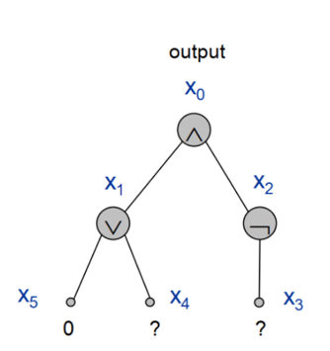
Nash Equilibria Social optimum: Minimizes total cost to all agents. Price of stability: Ratio of best Nash equilibrium to social optimum.
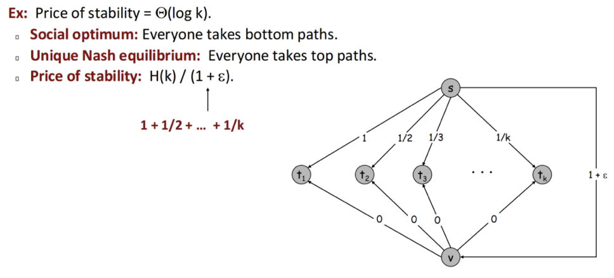
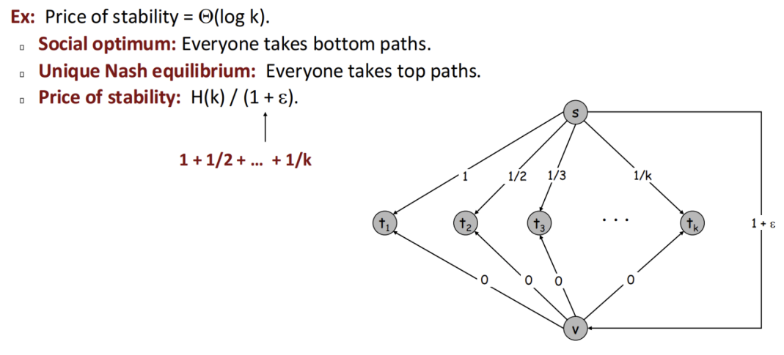
Observation: there may be many Nash equilibria. Even if it's unique, it does not necessarily equal the social optimum.

FPT Brute force 难以求解，顶点覆盖问题$O(kn^{k+1})$=$n^{k}∙nk$ limit to $O(2^{k}n)$
fixed parameter tractable with respect to some parameter k is the class of problems solvable in time $f(k)∙poly(n)$.
Circular Arc Covering brute force:$O(k^{m})$ 现有算法 $O(k!∙n)$ m 路径数，k 着色数, n 节点数 This is poly(n) time if k =lgn/lglg n
想$O\left(k!n\right)↔poly\left(n\right)∵k!=O(k^{k})→$想 O$\left(k^{k}\right)=O(n^{c})$取对数O$\left(klog k\right)=O(clog n)$ 取对数O$\left(logk+loglog k\right)=O(loglog n)$ 除
Amortized Analysis
Stack operations: PUSH(S, x) O(1) , POP(S) O(1), MULTIPOP(S, k) $O(min |S|,k)$
Aggregate Analysis calculates 操作总成本and amortizes it evenly across each operation to derive the amortized cost.
1.For $n_{push}$ PUSH operations, each has a cost of O(1)，so the total cost is O($n_{push}$) 2. ……3. For $n_{MULTIPOP}$ MULTIPOP operations: although the actual cost of each operation is $O(min |S|,k)$, the total number of elements popped by these operations cannot exceed the number of elements pushed by previous PUSH operations. Thus, the total cost is still bounded by $n_{push}$. Since the total number of operations =$n_{push}$+$n_{pop}$+$n_{MULTIPOP}≤$2*$n_{push}$, the total cost is O($n_{push}$)= O(n), ,and the amortized cost per operation is O(n)/n= O(1)
Potential Method $c_{i}$' = $c_{i}$+ $ϕ(D_{i})$ - $ϕ(D_{i-1})$
for a stack := the number of objects in the stack. So $ϕ(D_{0})$=0, and $ϕ(D_{i})$ ≥0
PUSH: Potential change: $ϕ(D_{i})$ - $ϕ(D_{i-1})$= 1. Amortized cost:$c_{i}$' = $c_{i}$+ $ϕ(D_{i})$ - $ϕ(D_{i-1})$ = 1 + 1 = 2. POP: …= -1. Amortized cost: …= 1 + (-1) = 0. MULTIPOP(S, k): … –k. Amortized cost: …= 0. So amortized cost of each operation is O(1)
Dynamic Table: Aggregate analysis: The cost of insertion O(1);The cost of rebuild: 𝑂(𝑚), m is current size of table. Total cost of n insertions themselves: O(n)；Total cost of all rebuilds:1 + 2 + 4 + 8 + … + n ,copy log2n times =2n= O(n). Amortized cost = 3n/n=3O(1)
Define the potential of the table after the i th insertion by $ϕ(D_{i}$)=$2n_{i}-m_{i},n 是数组中的元素数量，m 是数组的当前容量,So ϕ\left(D_{0}\right)=0, and ϕ\left(D_{i}\right).$插入操作（无需扩容）：操作成本：𝑂(1),势能变化：$ϕ(D_{i})$ - $ϕ(D_{i-1})$ =($2n_{i}-m_{i})-(2(n_{i}-1)-m_{i})$=2均摊成本：1 +2 =3. 插入操作（触发扩容）操作成本：𝑂(𝑛),因为需要将所有元素复制到新数组中，并插入新元素．势能变化：扩容后，容量增加，势能减少，变化大小为 $ϕ(D_{i})$ - $ϕ(D_{i-1})$ = ($2n_{i}-2{(n}_{i}-1))-(2(n_{i}-1)-{(n}_{i}-1))$=2-${(n}_{i}-1)$=3-$n_{i}$ 均摊成本：$n_{i}+$3-$n_{i}$=3

Approximation Algorithms
Approximation Ratio：If X is a maximization problem, A is an a-approximation algorithm for X if $A≥OPT/a$ (a>1)
If X is a minimization problem, A is an a-approximation algorithm for X if $A≤a∙OPT$ (a>1)
Set cover: A collection F of sets. $S∈F$, cost(S), $\bigcup_{S∈F}{S}=X$, choose $\bigcup_{S∈G}{S}=X$,$G⊆F$,make $min Cost(S⊆G)$
Greedy approximation algorithm: U = X, C = ∅; choose $S∈F-C$ with min |cost (S)|/|S∩U|; C = C∪{S} U = U – S
Proof of Correctness: We always output a set cover, because the while loop continues till X is covered.
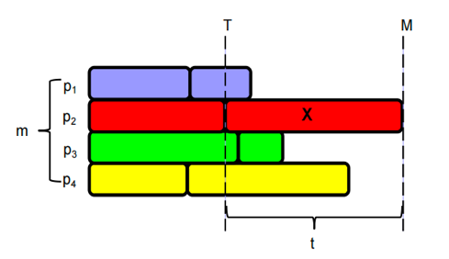
Proof of Approximation Ratio: $L=\sum_{k}{cost}(e_{k})=\sum_{k}{OPT/(n-k+1)}≈\ln{(}n)*OPT$
Makespan Scheduling (LS) n independent jobs. m processors. Assign to minimize the last processor finishes all its jobs
1. List the jobs in any order. 只要有 unfinished jobs. If any processor 没 a job now, give it the next job in the list.
3. Suppose LS gives makespan of M. optimal schedule have makespan M*. We prove that M ≤ 2M*
M* ≥ t，M* ≥ T (length of opt schedule is ≥ (total work)/m ≥ mT/m = T), M* ≥ max(T,t). M = T + t
LPT Scheduling: 1. Let’s try to schedule longest jobs first. 3. Let X be the last job to finish.
Assume it starts at time T and has size t. Assume that X is the last job to start. a）X is the smallest job. 1 LPT’s makespan M = T+t ≤ M*+t Case 1 t ≤ M*/3. M ≤ M* + t ≤4/3 M*. Case 2 t > M*/3. all tasks have size > M*/3. the opt has at most 2 tasks per processor. So n≤2m. 1≤ n≤ m, both put one task per processor, m < n≤ 2m… LPT is optimal. M ≤ 4/3 M*.
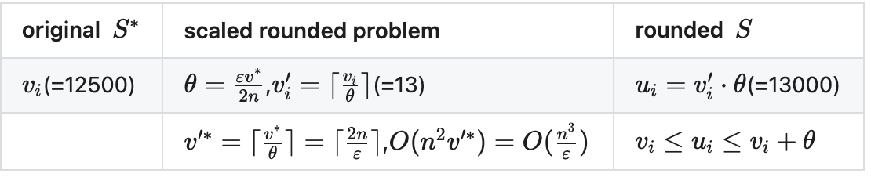
The Knapsack Problem: (PTAS) we want $\sum_{i∈S^{*}}{v_{i}}≤(1+ε)\sum_{i∈S}{v_{i}}$
- $\sum_{i∈S^{*}}{v_{i}}≤\sum_{i∈S^{*}}{u_{i}}≤\sum_{i∈S}{u_{i}}≤\sum_{i∈S}{(}v_{i}+θ)≤\sum_{i∈S}{v_{i}}+nθ$
过渡 $≤\sum_{i∈S}{v_{i}}+ε\sum_{i∈S}{v_{i}}=\left(1+ε\right)\sum_{i∈S}{v_{i}}$
- $nθ=εv^{*}/2=εv_{j}/2≤εu_{j}/2≤ε/2\sum_{i∈S}{u_{i}}$
- $\sum_{i∈S}{v_{i}}≥\sum_{i∈S}{u_{i}}-nθ≥\left(2/ε-1\right)nθ；ϵ≤1，nθ≤ϵ\sum_{i∈s}{v_{i}}$
Vertex Cover：1. D = {E}, C = ∅; Repeat as long as there are edge left in D{ Take any edge (u,v) in D; Add {u,v} to C.;Remove all the edges adjacent to u or v from D}; Output C. 2. We keep adding vertices till all edges are covered.
3. a) None of the edges in A touch each other. B) each vertex in C* covers at most one edge in A. |C*| ≥ |A|.
The number of vertices the algorithm uses is 2|A|. |C|/|C*| = 2|A| / |C*| ≤ 2|A| / |A| = 2.
Pricing Method WVC：$\sum_{e=(i,j)}{p_{e}}≤w_{i}$(for vi), $\sum_{e∈E}{p_{e}}=\sum_{e∈E}{\sum_{i∈S,e=(i,j)}{p_{e}}}≤\sum_{i∈S}{\sum_{e=\left(i,j\right)}{p_{e}}}≤\sum_{i∈S}{w_{i}}=w\left(S\right)总价格不超V总权重$
1. $p_{e}$= 0; while ($∃$edge i-j such that neither i nor j are tight) select such an edge e, increase $p_{e}$ without violating fairness) S set of all tight nodes 2. S is a vertex cover: if some edge i-j is uncovered, then neither i nor j is tight. But then while loop would not terminate.
3.$w(S)=\sum_{i∈S}{w_{i}}=\sum_{i∈S}{\sum_{e=(i,j)}{p_{e}}}≤\sum_{i∈V}{\sum_{e=(i,j)}{p_{e}}}=2\sum_{e∈E}{p_{e}}≤2w(S^{*})$
LP Rounding(ILP->LP): 2. Consider an edge (i, j) $∈$ E. Since $x_{i}^{*}$+$x_{j}^{*}$≥1, either $x_{i}^{*}$≥1/2 or $x_{j}^{*}$≥1/2 (i, j) covered.
3. Let S* be optimal vertex cover. $\sum_{i∈S^{*}}{w_{i}}≥\sum_{i∈S}{w_{i}}x_{i}^{*}≥1/2\sum_{i∈S}{w_{i}}$ 每条边被两个顶点关联，因此总价格被计算两次
Randomized Algorithms
A Las Vegas randomized algorithm always produces the right answer. But it’s running time can vary depending on its random choices.
A Monte Carlo algorithm always has the same running time. But it may produces the wrong answer, depending on its random choices.
Max Cut: Put each node in a random side with probability 1/2. Lemma In a graph with e edges, the algorithm produces a cut with expected size e/2. Proof a) Let X be a random variable equal to the size of the cut. (i.e., Xe=1 if e is in the cut and 0 otherwise) We want to bound E[X]. b) $X= \sum_{e}{X_{e}}$ c) Given an edge e=(i,j), e is in the cut if i and j are on different sides. u和v分属不同子集的概率为$Pr[(u∈A∩v∈B)+(u∈B∩v∈A)]=1/4+1/4=1/2$, So $E[X_{e}]=1/2$. d) $E[X]=\sum_{e∈E}{E}[X_{e}]=e×1/2=e/2$
Contention Resolution: n个进程竞争访问一个共享信道, Each process requests access to the channel at time t with probability p = 1/n.
单个进程的成功概率Let S[i, t] = event that process i succeeds in accessing the database at time t. By independence,
$\text{Pr}\text{[}\text{S}\text{[}\text{i}\text{,}\text{t}\text{]]=}\text{p}\text{×(1-}\text{p}{\text{)}}^{\text{n}\text{-1}}\text{==}\frac{\text{1}}{\text{n}}\text{×}{\left(\text{1-}\frac{\text{1}}{\text{n}}\right)}^{\text{n}\text{-1}}$ $\text{1/}\text{en}\text{≤}\text{Pr}\text{[}\text{S}\text{[}\text{i}\text{,}\text{t}\text{]]≤1/2n}$ 单个进程的失败概率 Let F[i, t] = event that process i fails to access database in rounds 1 through t. $\text{Pr}\text{[}\text{F}\text{[}\text{i}\text{,}\text{t}\text{]]≤}{\left(\text{1-1/}\text{e}\text{⋅}\text{n}\right)}^{\text{t}}$,$\text{Pr}\text{[}\text{F}\text{[}\text{i}\text{,}\text{t}\text{]]≤}{\left(\text{1/}\text{e}\right)}^{\text{c}\text{⋅}\text{ln}{\text{n}}}\text{=}{\text{n}}^{\text{-}\text{c}}$ 所有进程的成功概率. Let F[t] = event that at least one of the n processes fails to access database in any of the rounds 1 through t : $\text{F}\text{[}\text{t}\text{]=}\bigcup_{\text{i}\text{=1}}^{\text{n}}{\text{F}}\text{[}\text{i}\text{,}\text{t}\text{]}$, $\text{Pr}\text{[}\text{F}\text{[}\text{t}\text{]]≤}\sum_{\text{i}\text{=1}}^{\text{n}}{\text{P}}\text{r}\text{[}\text{F}\text{[}\text{i}\text{,}\text{t}\text{]]}$
Global Mini Cut: Contract edge e.– replace u and v by a single new supernode w –preserve edges, updating endpoints of u and v to w –keep parallel edges, but delete selfloops  Repeat until graph has just two supernodes v1 and v2  Return the cut (between the two supernodes).
Claim. The contraction algorithm returns a min cut with prob $2/n^{2}$ Proof Consider a global min-cut C*(A*, B*) of G. Let F* be edges with one endpoint in A* and the other in B*. Let k = |F*| = size of min cut. 算法成功的关键：在所有收缩步骤中，始终不收缩F*中的边, 由于C*是最小割，当前图中每个超级节点的度数至少为k（否则存在更小的割），因此当前图的总边数$\text{|}\text{E}\text{'|≥}\frac{\text{1}}{\text{2}}\text{kn}\text{'}$（每个边贡献2个度数，总度数≥k n'）。收缩F*中边的概率为algorithm contracts an edge in F* with probability $\text{|}{\text{F}}^{\text{*}}\text{|}\text{/}\text{|}\text{E}\text{'|}\text{=}\text{k}\text{/}\text{|}\text{E}\text{'}\text{| }\text{≤}\text{k/(}\frac{\text{1}}{\text{2}}\text{kn}\text{'}\text{)}\text{=}\text{2/}\text{n}\text{'}$
总成功概率（所有n-2轮均不收缩）$\text{Pr}\text{[}\text{成功}\text{]=}\text{Pr}\text{[}{\text{E}}_{\text{1}}\text{]×}\text{Pr}\text{[}{\text{E}}_{\text{2}}\text{|}{\text{E}}_{\text{1}}\text{]×...×}\text{Pr}\text{[}{\text{E}}_{\text{n}\text{-2}}\text{|}{\text{E}}_{\text{1}}\text{∩...∩}{\text{E}}_{\text{n}\text{-3}}\text{]}\left(\text{1-}\frac{\text{2}}{\text{n}}\right)\text{×≥}\left(\text{1-}\frac{\text{2}}{\text{n}\text{-1}}\right)\text{×...×}\left(\text{1-}\frac{\text{2}}{\text{3}}\right)\text{=2/}\text{n}\text{(}\text{n}\text{-1)≥2/}{\text{n}}^{\text{2}}$
