ASE Graphical Programming Language – Dipesh BC (77202612)

Assignment Component 1 and Component 2nd December 2020, 24th December 2020

Contents

Graphical Programming language 2

Commit history 3

Application 6

UML Diagram 6

UI and working 6

Unit Tests 9

Sample test for ShapeFactory 9

Sample test for ShapeCompiler 10

Sample test for Lexer 14

# Graphical Programming language

A custom programming language made using C# that demonstrates the basics of sequence, selection and iteration and allows a student programmer to explore them using graphics.

# Commit history

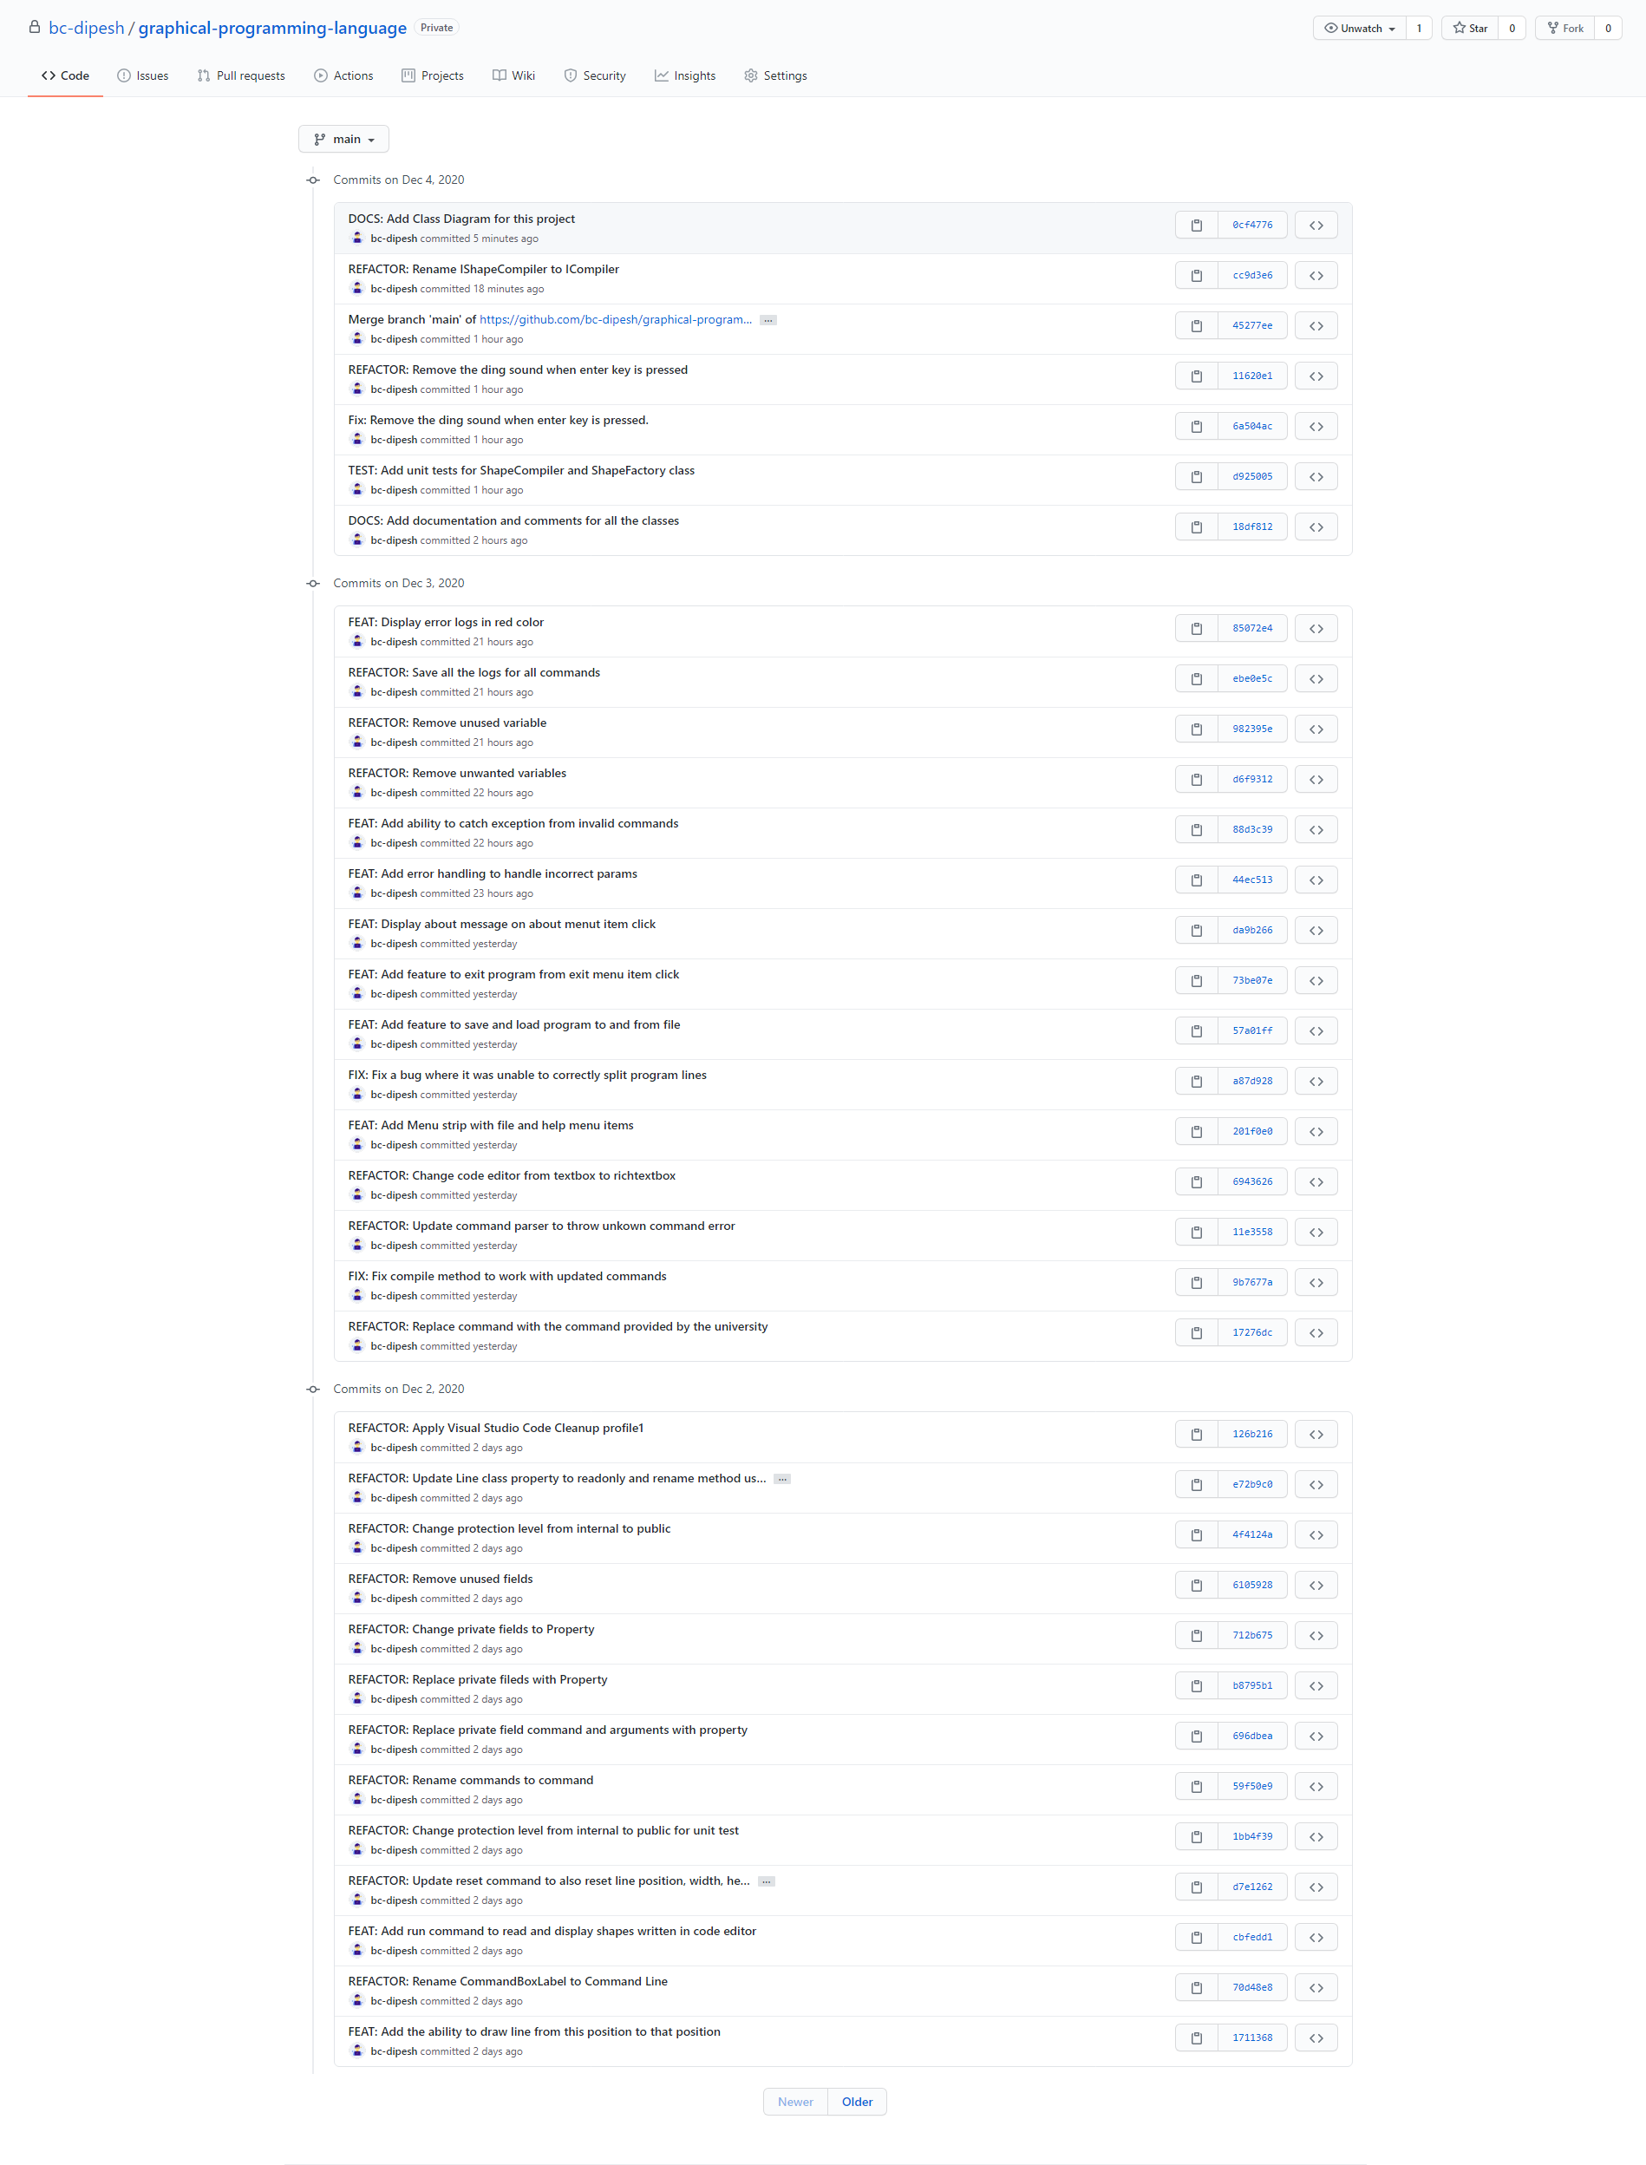

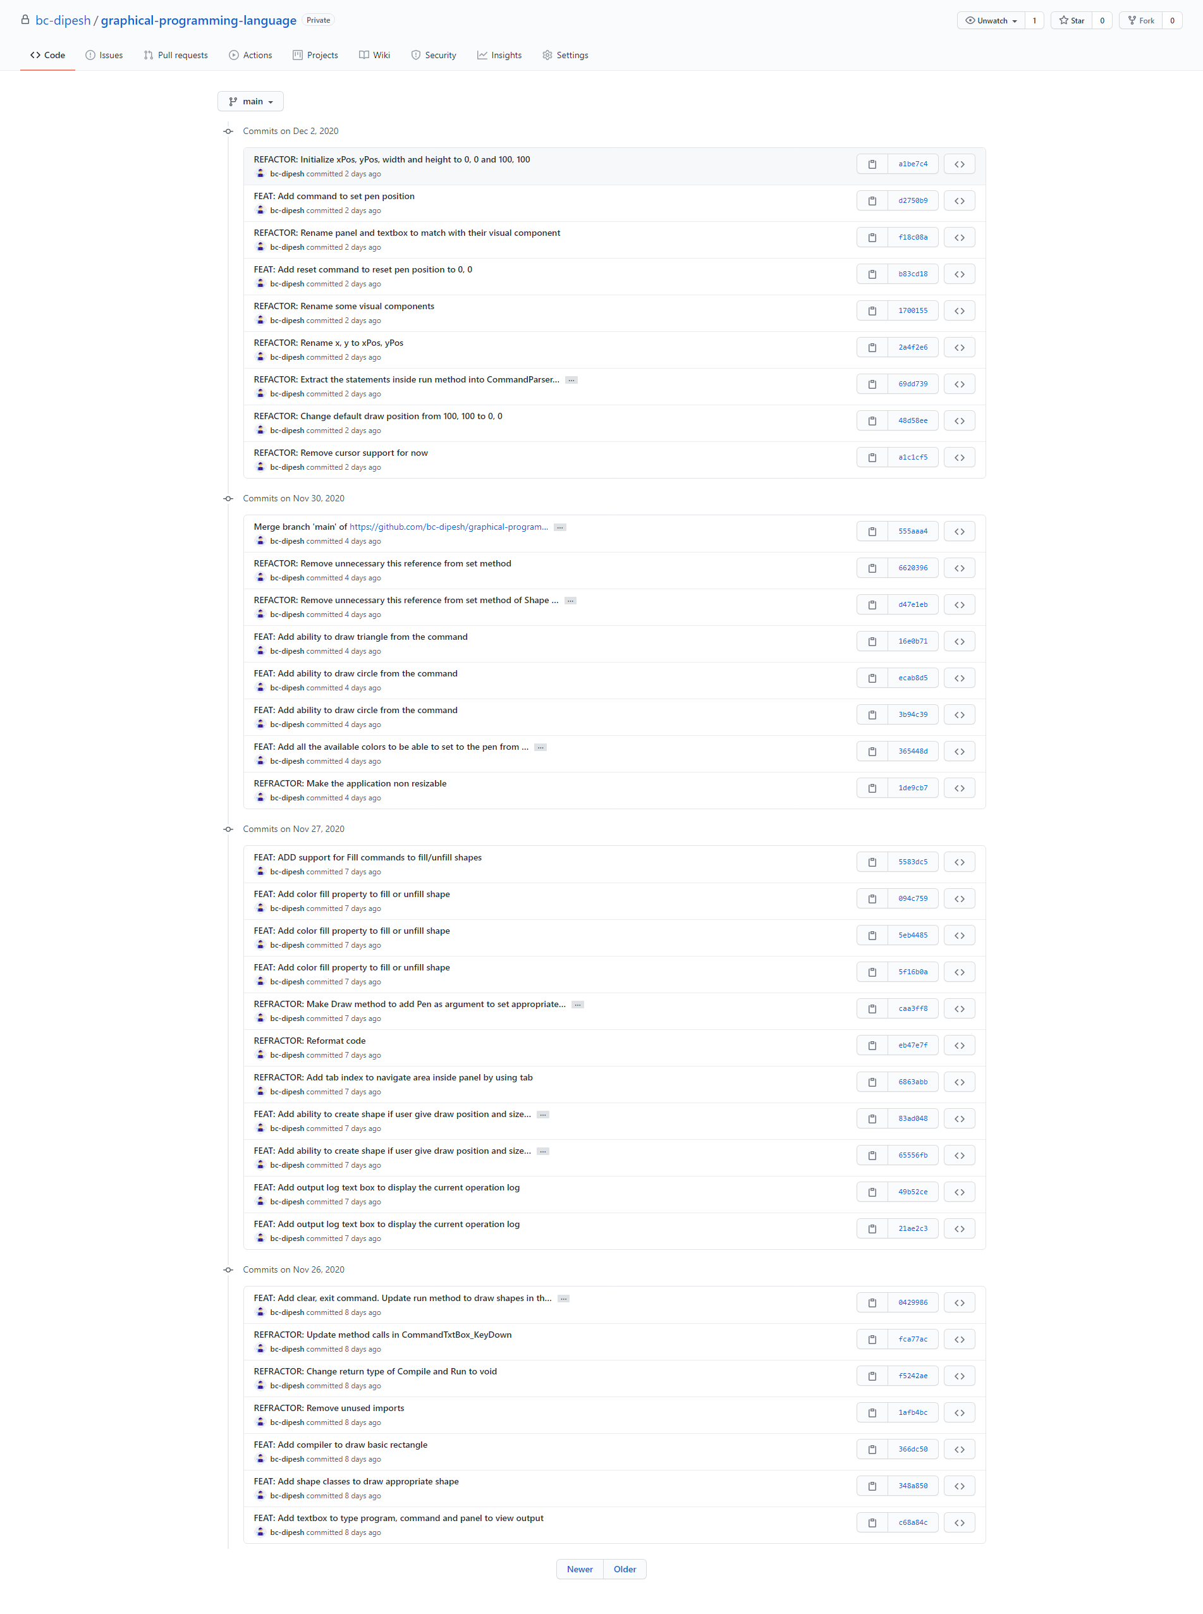

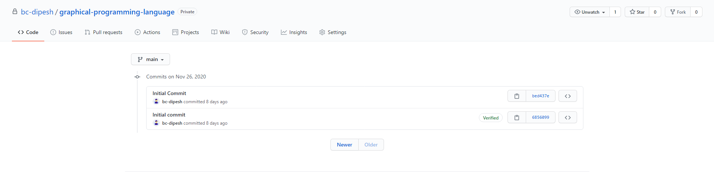

# Application

## UML Diagram

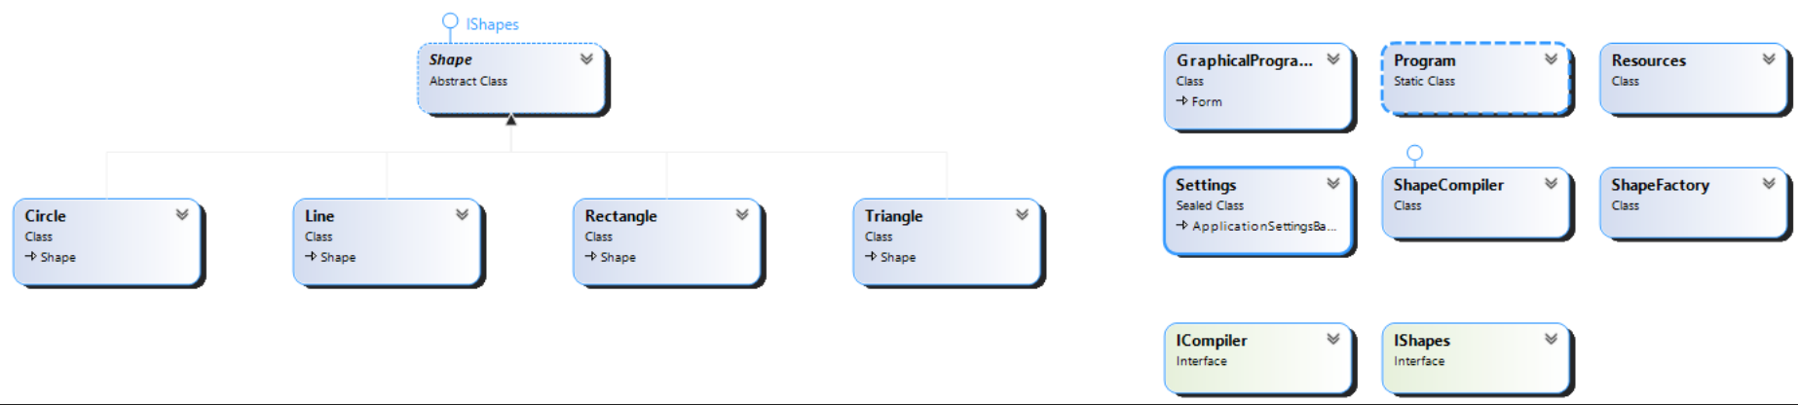

## UI and working

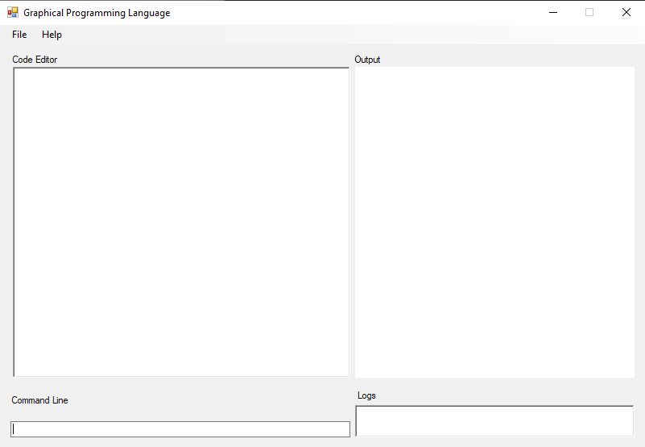

* This is the UI for the program. There are four area – Code Editor, Command Line, Output and Logs.
* The code editor window lets you enter commands. Each command must be on a new line.
* The Command Line runs command written in the command line. Here, is a list of commands for the command line.
  + **run** – Runs the code from the Code Editor.
  + **shape** **arg1**, **arg2** – Draws rectangle where arg1 is width and arg2 is height. Shape can rect, circle, triangle. NOTE: circle does not require arg2.
  + **moveto** **arg1**, **arg2** – Moves cursor or pointer from current position to arg1, arg2. arg1 is x-coordinate and arg2 is y-coordinate.
  + **drawto** **arg1**, **arg2** – Draw a line from current position to arg1, arg2. arg1 is x-coordinate and arg2 is y-coordinate.
  + **pen** **arg1** – Sets the color of the pen. arg1 is the color.
  + **fill arg1** – Sets the color fill of the shape. arg1 is a Boolean flag, it can be either on or off.
  + **clear** – Clears the drawing area (Output window).
  + **reset** – Moves the pen position from current position to top left of the screen.
* The Output window displays the output of the command.
* The Logs displays all logs while executing the command.
* Menu Strip has File and Help menu. File has open, save, exit options. Help has about option.

# Unit Tests

## Sample test for ShapeFactory









## Sample test for ShapeCompiler













## Sample test for Lexer

