## **How to Configure Proxmox Additional Storage** video link: <https://youtu.be/zIoDXWKsorg>

I added SAS 900 GB X 2 Drives into the H P Server, created RAID 10 in Hardware. Now this is available to me to use. How to add this to PVE. Storage details of proxmox can be found here <https://pve.proxmox.com/wiki/Storage>

## LVM Storage

LVM storage is used to store images, backups etc. This is great option and it is much reliable. Only one problem is that if I assign 100GB storage to a VM, the Physical Volume (PV) assigns 100% of 100 GB to that VM, which is not efficient way. However, LVM-Think is the Solution.

## Proxmox LVM Thinpool

If You create 100GB VM Disk and it occupies only 10GB, from physical storage only 10GB will be used. Isn’t it efficient, this is done in LVM-Thinpool.

I will explain you how to create the Proxmox LVM Thinpool. Thinpool also stores snapshot images.

So let us see how we can create LVMThin-pool. I have added 900GB into my Proxmox VE 7.0 Node. Below is step by step guide what I did.

### Format Disk

This will for sure remove all the data from the Disk, which I am sure about. My Disk name is sdb and the path is /dev/sdb so I will used below command to clean to create partition table

sgdisk -N 1 /dev/sdb

### Create Physical Volume and Volume Group within Disk

Now PV is Physical Volume and VG is Volume Group. I created both using the below commands in my disk named sdb

pvcreate --metadatasize 1024M -y -ff /dev/sdb1  
vgcreate --metadatasize 1024M proxvg /dev/sdb1

### Create LVM Thin Pool

LVM (Logical Volume Manager) Think pool is the option that we need to create. Out of 900 GB I want to assign 400 GB to Thin pool. So I will use below commands to create the Thinpool

lvcreate -l 100%FREE --poolmetadatasize 1024M --chunksize 256 -T -n proxthin proxvglvcreate -n proxvz -V 400G proxvg/proxthin

### Create EXT4 File System

mkfs.ext4 /dev/proxvg/proxvz

### Mount new Logical Volume (LV)

Now mount the new Logical Volume to Proxmox Node so we will create a new directory

mkdir /media/vz  
echo '/dev/proxvg/proxvz /media/vz ext4 defaults,errors=remount-ro 0 2' >> /etc/fstab  
mount -a  
lvs -a

### Now Add the Directory in the Web User

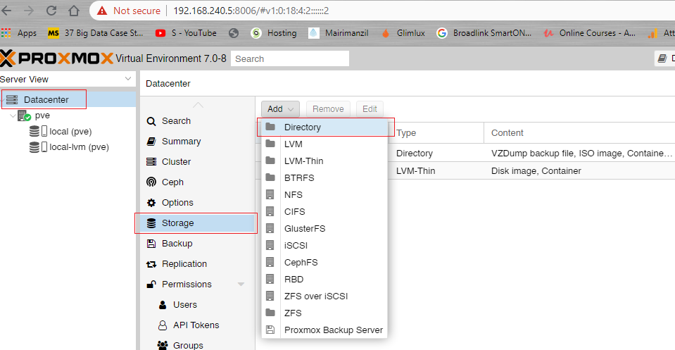You can simply follow below screeshot, first click on Data Center, then Storage and then add directory.

The ID will be or any name you want and Directory path will be the one that we created on top.

ID : vz

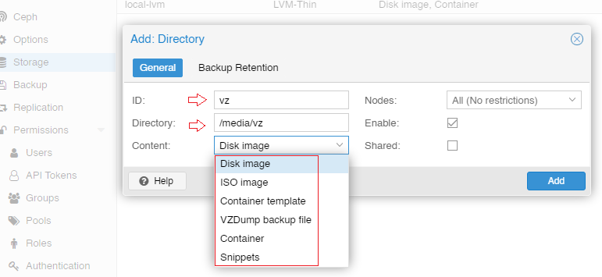Path : /media/vz

Add LVM Thin

Now you can create LVM Thin as per the below screenshot.

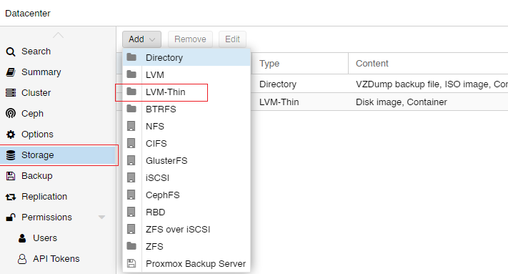

Use the below Information for in the box.

id:proxthin

Volume group:proxvg

Thin Pool:proxthin

# Proxmox Discord Dark Theme: bash <(curl -s https://raw.githubusercontent.com/Weilbyte/PVEDiscordDark/master/PVEDiscordDark.sh ) install

Proxmox VE 7 Post Install: bash -c "$(wget -qLO - https://github.com/tteck/Proxmox/raw/main/misc/post-pve-install.sh)"