**Final Project Report**

**Food Waste Reduction System**



**Project Supervisor**

Muhammad Hassaan

**Submitted By**

S240265DF4

Hassan Zahid BC220403459

**Software Projects & Research Section,**

**Department of Computer Sciences,**

**Virtual University of Pakistan**

|  |
| --- |
|  |



**CERTIFICATE**

This is to certify that Hassan Zahid (BC220403459) has worked on and completed their Software Project at Software & Research Projects Section, Department of Computer Sciences, Virtual University of Pakistan in partial fulfillment of the requirement for the degree of BS in Computer Sciences under my guidance and supervision.

In our opinion, it is satisfactory and up to the mark and therefore fulfills the requirements of BS in Computer Sciences.

**Supervisor / Internal Examiner**

Muhammad Hassaan

Supervisor,

Software Projects & Research Section,

Department of Computer Sciences

Virtual University of Pakistan

___________________

(Signature)

**External Examiner/Subject Specialist**

Muhammad Hassaan

___________________

(Signature)

**Accepted By:**

**_____________**

(For office use)

**EXORDIUM**

**In the name of Allah, the Compassionate, the Merciful.**

**Praise be to Allah, Lord of Creation,**

**The Compassionate, the Merciful,**

**King of Judgment-day!**

**You alone we worship, and to You alone we pray for help,**

**Guide us to the straight path**

**The path of those who You have favored,**

**Not of those who have incurred Your wrath,**

**Nor of those who have gone astray.**

**DEDICATION**

I dedicate my work to my parents and brothers.

**ACKNOWLEDGEMENT**

First of all, I am grateful to Almighty Allah the most Merciful and Benficent, who gives me light in darkness. His blessings enabled me to complete this project.

However, I also can not deny the unwavering support of my family, friends and fellows during working phase of this project. I would like to extend my sincere thanks to all of them for being supportive.**PREFACE**

Food waste is a significant global challenge, contributing to environmental degradation and economic inefficiency. To address this, a Food Waste Reduction System (FWRS) is proposed.

This system empowers users by offering intelligent recipe recommendations based on their inventory and preferences. The FWRS provides personalized expiration reminders and optimized food storage guidance, minimizing waste throughout the food storage and consumption cycle.

Users can create profiles, manage their food inventory through manual entry or QR code scanning, and leverage search and filter functions to simplify meal planning. Furthermore, a feedback mechanism allows users to contribute to the system's continuous improvement.

By integrating these features, FWRS empowers users to become active participants in reducing food waste, promoting informed decision-making, and contributing to a more sustainable food system.

**TABLE OF CONTENTS**

|  |
| --- |
|  |

CHAPTER NO. 1

Software requirements specification (SRS Document)

1.1 scope

1.2 Functional & non-fucntional)

1.3 Use Case Diagram

1.4 Work Plan (Use MS Project to create Schedule/Work Plan)

CHAPTER NO. 2

designing the project (Design Document)

2.1 Introduction of Design Document

2.2 Entity Relationship Diagram (ERD)

2.3 Database Design

2.4 Interface Design

**<<Dear Students, before starting each chapter the following would be the title page for each chapter on a separate page>>**

**CHAPTER 1**

SOFTWARE REQUIREMENTS SPECIFICATION (SRS DOCUMENT)

1.1 Scope of Project:

Food waste management system is a complete system to minimize the food wastage to maximum possible level.

In this system, users can create & manage their profiles and food inventory. Inventory could be entered by two means i.e., manual entry or QR code scanning. The system will suggest the food recipe to the user based on various factors such as availability of ingredients, user’s preference, cooking time, user’s cuisine & meal type. Also, the system can suggest those recipes to those users whose ingredient’s expiration date is approaching.

System provides the user with notification of ingredients who are expected to expire soon. The frequency and timing of notification could be adjusted by the user. Users can also search from inventory and filter the searched results based on his personal preferences and conditions. In the end, users can provide the system with their precious feedback in the form of comments.

1.2 Functional and non Functional Requirements:

**Functional Requirements**

* **User Registration and Profile Management:**
* Users should be able to create accounts and manage their profiles within the system.
* Profile management features should include options to update personal information, dietary preferences, and allergy information.
* **Food Inventory Management:**
* Users should be able to input and manage their food inventory within the system.
* The system should support manual input of food items OR barcode scanning for convenience.
* Each food item entry should include details such as name, quantity, expiration date, and storage location.
* **Recipe Suggestions for Leftover Ingredients:**
* The system should analyze the user's food inventory and suggest recipes based on available ingredients.
* Recipe suggestions should consider the user's dietary preferences, allergies, and cooking skill level.
* Users should be able to filter recipe suggestions by cuisine, meal type, and cooking time.
* **Expiration Date Reminders:**
* The system should provide reminders for approaching expiration dates of food items in the user's inventory.
* Users should be able to customize notification settings for expiration date reminders, including frequency and timing.
* **Food Storage Tips and Guidelines:**
* The app should offer tips and guidelines for storing various types of food to prolong freshness and prevent spoilage.
* **Search and Filter Functionality:**
* Users should be able to search for specific recipes, ingredients, or storage tips within the system.
* The system should support filtering of search results based on various criteria such as ingredient availability, dietary restrictions, and cooking difficulty.
* **User Feedback and Rating System:**
* The system should allow users to provide feedback on recipe suggestions, storage tips, and overall user experience.
* Users should be able to rate recipes they have tried and share comments or suggestions for improvement.

**Non-Functional Requirements**

* **Performance:**
* The system should respond to user actions within a reasonable time frame, even under peak loads.
* For efficient inventory management, the barcode scanning feature should have as little latency as possible.
* For a flawless user experience, response times for search queries and recipe recommendations should be optimized.
* **Scalability**:
* The system should be able to handle an increasing number of users and data without compromising performance.
* Front-end and back-end of the app must be kept upgrading to advance technologies.
* **Compatibility**:
* The system should be compatible with a wide range of devices and web browsers to ensure accessibility for users.
* **Usability**:
* The user interface should be easy to use for every level of user.
* The user interface should be easy-to-use specially for new users.
* **Reliability**:
* The system should be highly available, with minimal downtime of servers for maintenance.
* Regular backups of user data should be taken to prevent data loss in case of any system failure.

1.3 Use Case Diagram

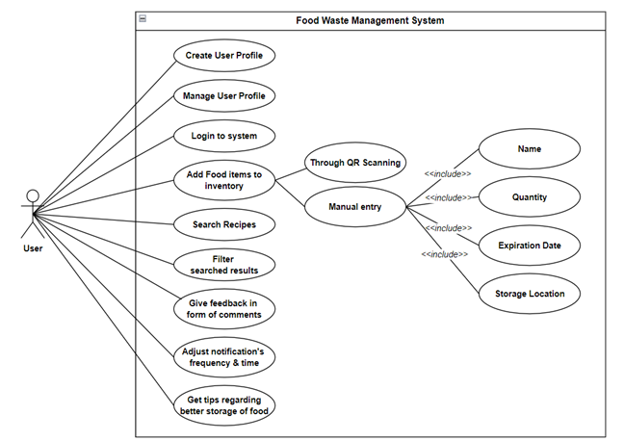

1.4 Work Plan (Use MS Project to create Schedule/Work Plan)

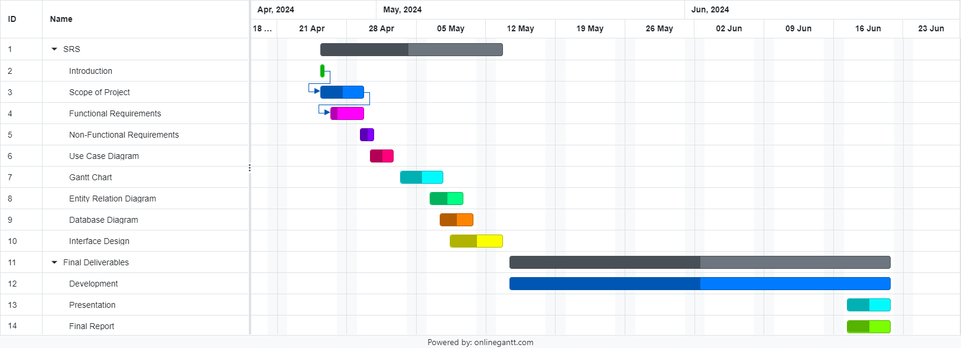

**CHAPTER 2**

Designing the Project

(Design Document)

* 1. Introduction of Design Document

Design document serves the purpose of understanding flow of data within a system. It usually consists of all the helping and support tools which make the process of understanding flow more effective.

I have included:

* ***ERD*** – This will create a better understanding of relation between different tables.
* ***Database Design*** – This is further elaborate the exact details to be stored in different tables as per requirements.
* ***GUI Screenshots*** – To get a basic perception and visualization of actual system, I have added some screenshots of GUI of project.
  1. Entity Relationship Diagram (ERD) (To be developed using Microsoft Visio or any other drawing software of your choice)

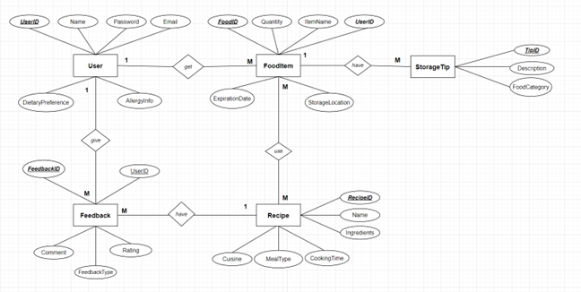

* 1. Database Design

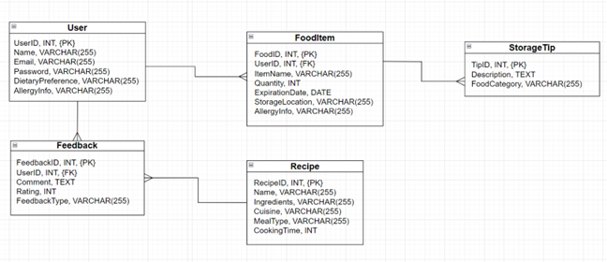

* 1. Interface Design (Optional)

Login Page:

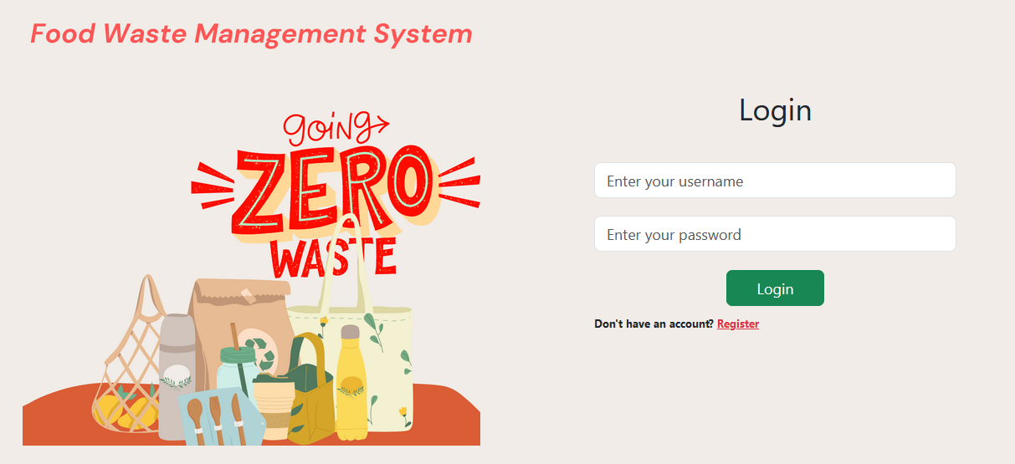

Sign-up Page:

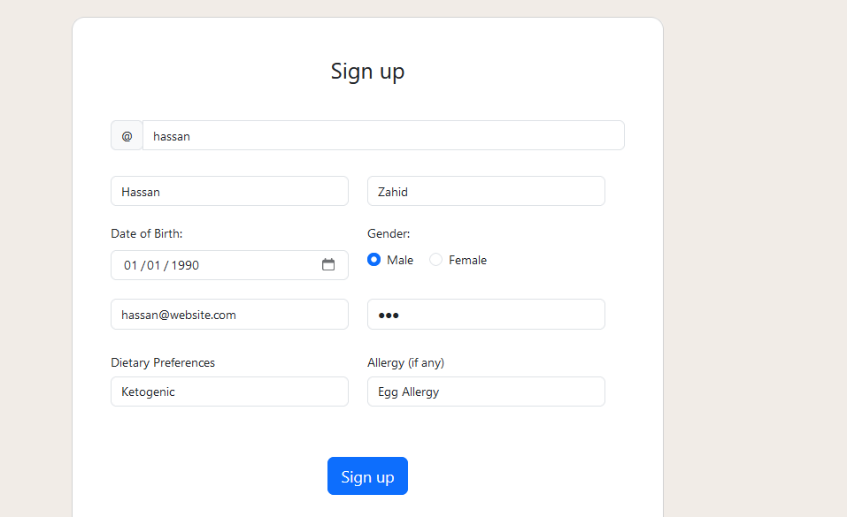

Main Dashboard Page:

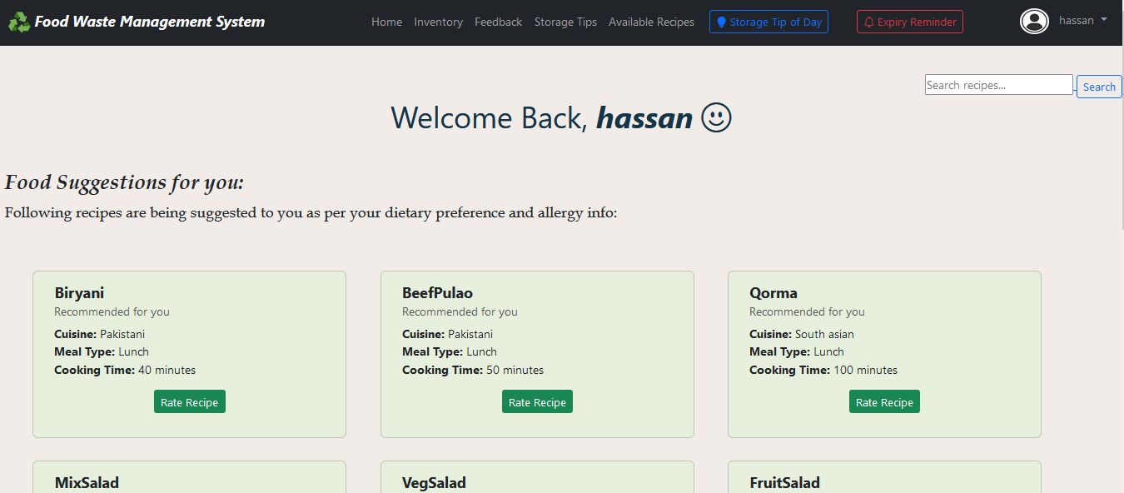

Manage Profile Interface:

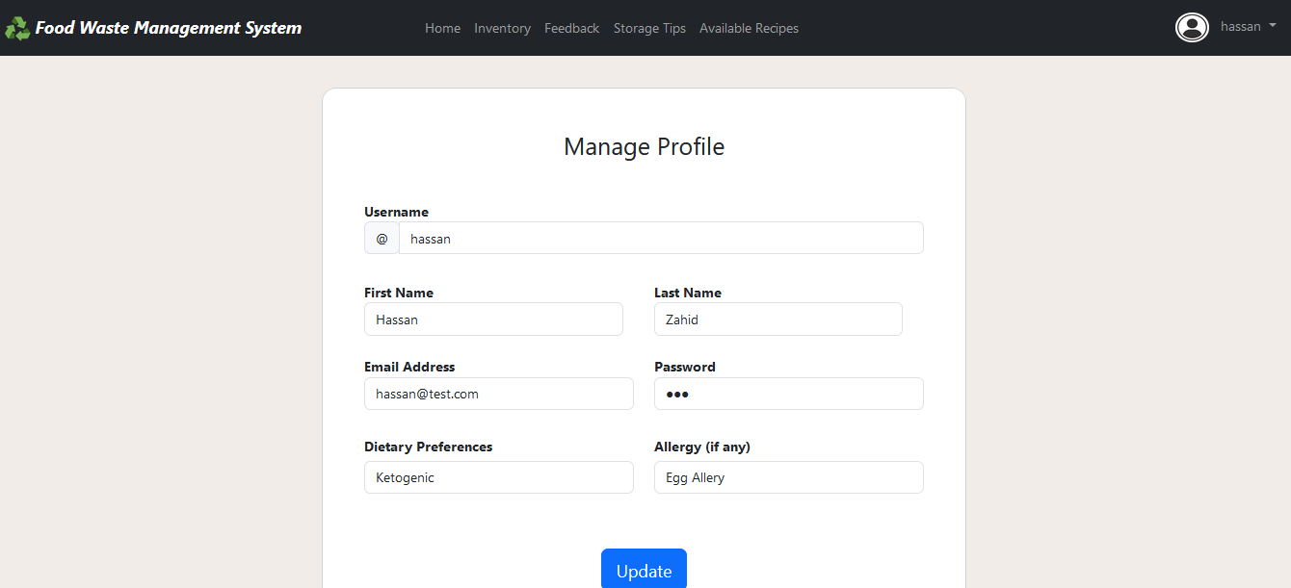

Inventory Management Page:

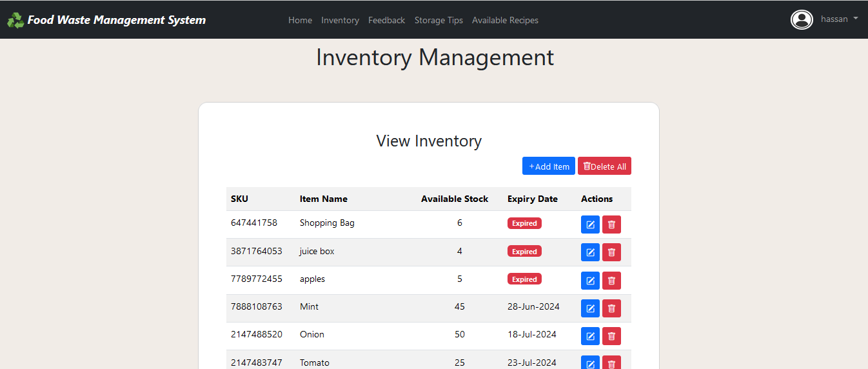

Add Inventory Page:

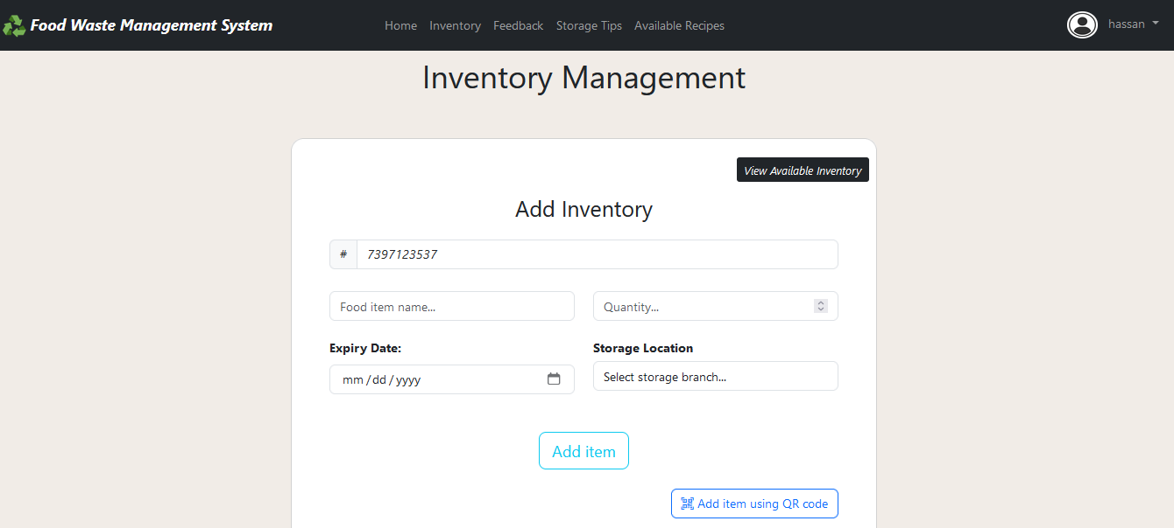

Recipe Suggestions Interface:

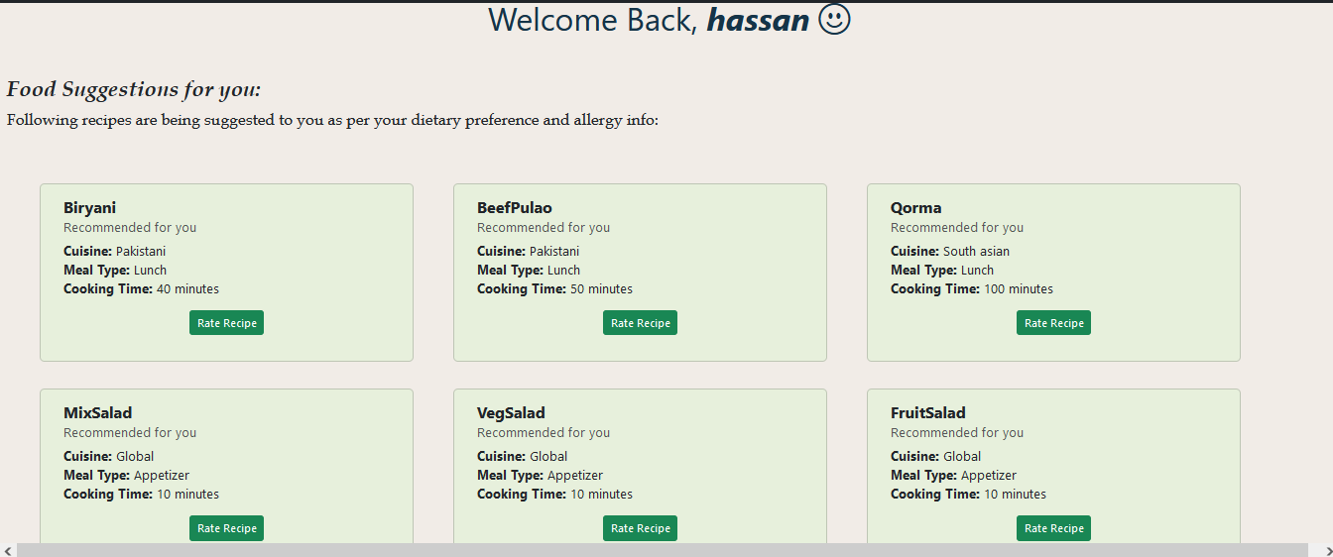

Expiry Reminder Interface:

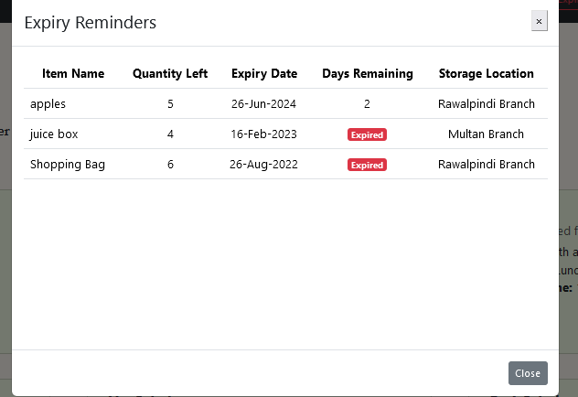

Available Recipe Page:

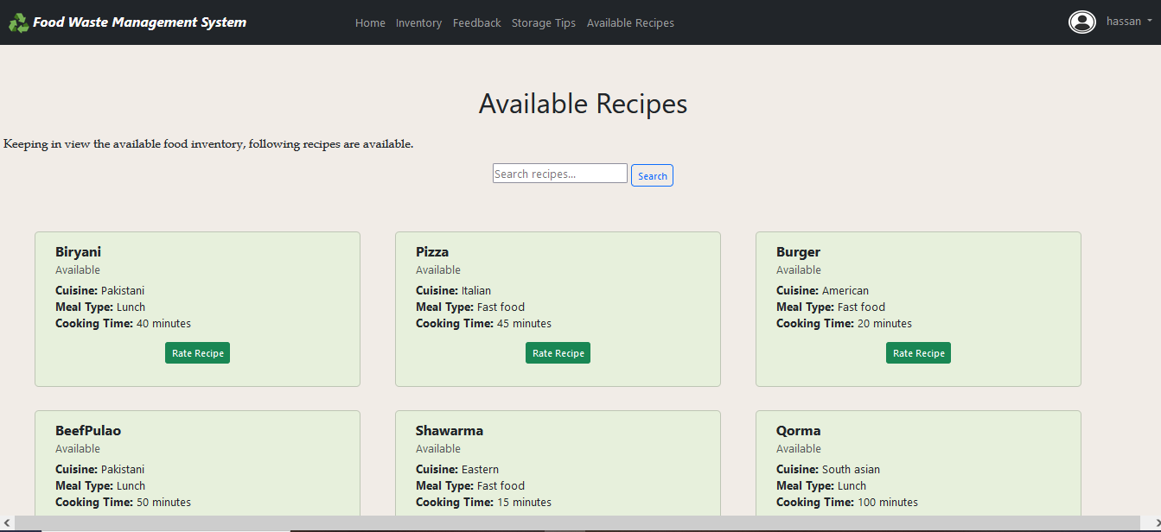

Storage Tips Page:

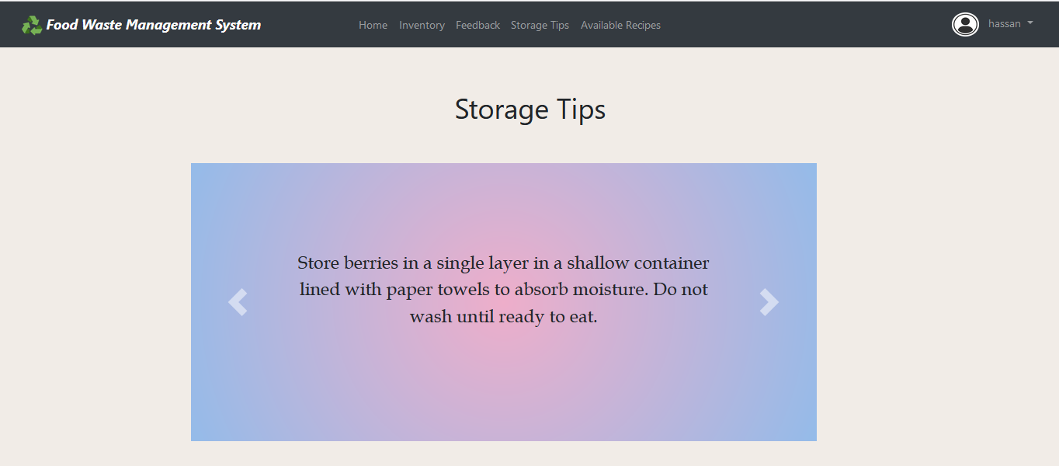

Tip of the day Interface:

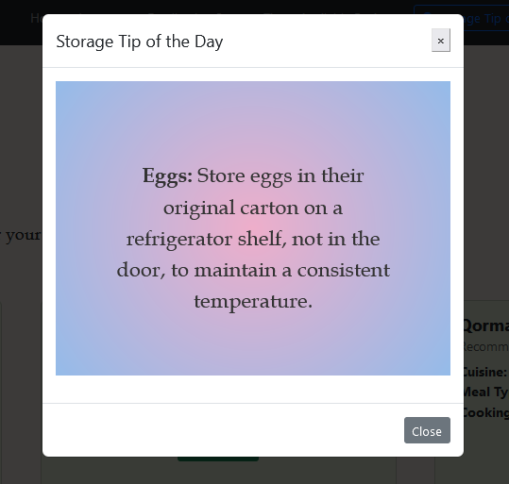

Feedback Page

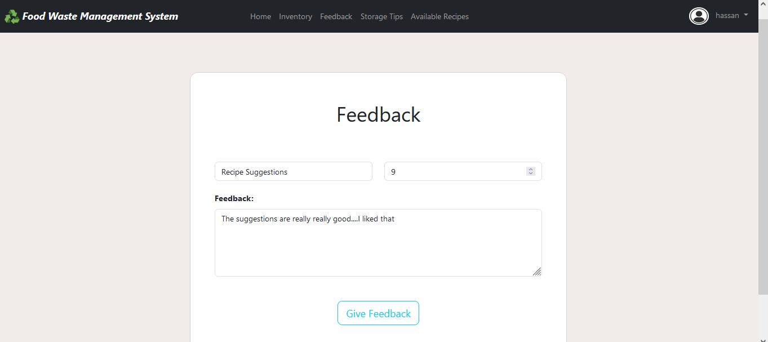

**REFERENCES**

As help material I have consulted the CS202 (Fundamentals of Front End Development) & CS403 (Database Management Systems) published by VU.

Moreover, I also have taken guidance from Internet using different available resources like Google, Stack Overflow, Youtube & W3Schools.

**APPENDIX**

|  |  |
| --- | --- |
| **Terms** | **Definitions** |
| **FWRS** | Food Waste Reduction System |
| **VU** | Virtual University of Pakistan |
| **GUI** | Graphical User Interface |
| **ERD** | Entity-Relationship Diagram |
| **CS202** | Fundamentals of Front End Development |
| **CS403** | Database Management Systems |