TITLE:Climate change data analysis based on World Bank data

# Name: BHASKAR CHERUKU

# Student ID#: 22003064

**Abstract**: China over the years has become the largest producer CO2 and methane gas emission. On the other hand, industrialised nations have reduced both CO2 and methane gas production. The dependence of China on production of electricity from coal-based sources has increased from 1990 to 2014. This can be attributed to more than 105.2% increase in the urban population. France, Germany have increased their production of electricity from nuclear sources, thus contributing towards reduction in climate change.

**EXPLANATION**: To explore the causes of climate change we examined data from 9 countries spread across the world. We selected three third world countries and six first world countries to examine the effects of factors influencing climate change. Data from 1990 to 2014 was collected, since the information for the period was complete. In addition, data for every 5 years was taken for the analysis.

**CO2 emissions**

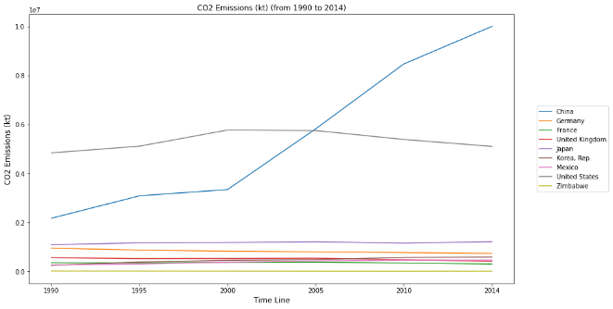

In the above chart we study CO2 emissions of countries from 1990 to 2014. In 1990, CO2 emission from China was 0.2kt while in 2014 it has increased to 1.0kt. CO2 emissions of USA has remained constant for the given period. For the rest of the countries, it can seen that CO2 emissions has been below 0.2kt.

**Electricity Production**

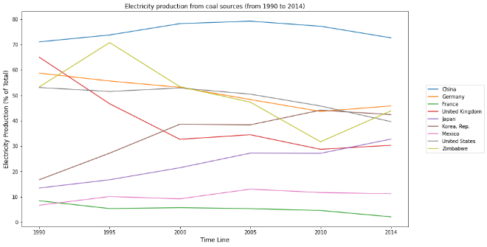

CO2 emissions to a certain extent can be attributed to electricity production. China is the largest producer of electricity from coal sources. More than 70% of its total electricity is produced from coal-based source. Less than 10% of France’s electricity is generated from Coal. In addition, UK has reduced its dependence on coal from above 60% to less than 40%. Similarly, USA, Germany and Zimbabwe have reduced their dependence of Coal for production of electricity.

**Methane gas production**

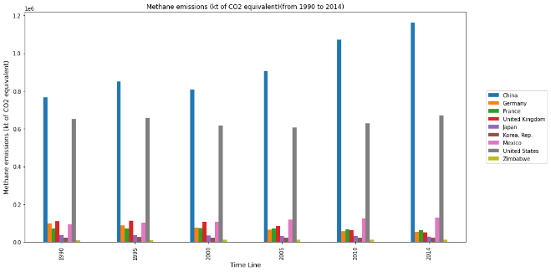

Further, it is found that methane gas produced maximum by China and USA. Methane is a major source of greenhouse gas effect and contributes to global warming. China has increased its release of methane to 1.2kt of CO2 equivalent in 2014. The other countries of the world in the study do not produce more than 0.2kt equivalent of CO2.

**Population Growth**

The next table presents the % change in urban population as a part of total population from 1990 to 2014. From the chart, of urban population growth it can be seen that in 1990 less than 30% of the urban population in both of China and Zimbabwe was a part of the total population. However, in 2014, China's urban population grew by 105.2% as compared to 1990. The growth in urban population for the developed countries of the world, Germany, France, UK and USA, the growth has been less than 10%.

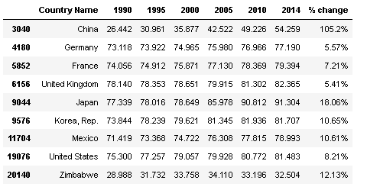

**Nuclear Power Production:**

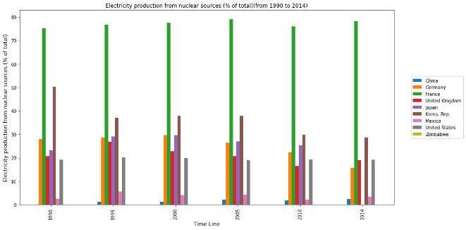

Nuclear power is a clean form of electricity, which has enabled decrease in CO2 emission. France has been a leader of nuclear power production. Approximately, 80% of France’s total electricity production is due to nuclear power, which has enabled it to reduce not only CO2 emission but also methane gas emission. France is closely followed by other industrialised countries in production of nuclear power. Mexico has also increased its dependence on nuclear power to decrease electricity production from CO2 based sources. From the countries in our study, China reliance on nuclear power is the least for electricity production.

**Correlation maps**

For China, CO2 production is positively correlated with its urban population, although it is negatively related to growth in population. Moreover, the CO2 production is highly correlated with methane gas production and production of electricity from nuclear power plant. In addition, we find that there exists a poor correlation between CO2 production and production of electricity from coal.

**China**

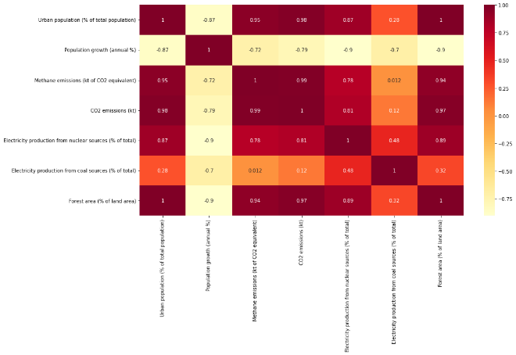

**Mexico**

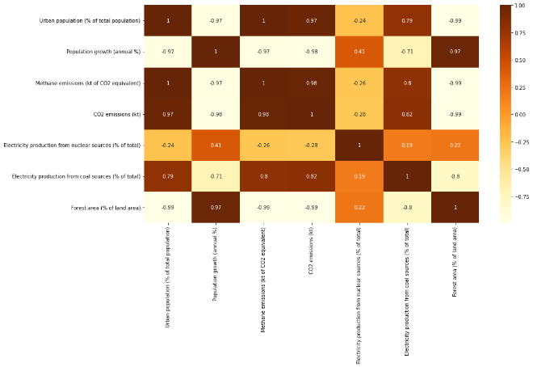

CO2 production for Mexico is highly correlated with urban population growth and negatively with population growth. Moreover, electricity production from coal-based sources if highly correlated with CO2 production in Mexico. In addition, it is also found that there exists a strong negative correlation of CO2 production with forest land area in the country.

**GitHub Repository Link:** <https://github.com/bc22aba/Applied_Data_Science/tree/main/Assignment_2>.

**Data Source link:**

<https://data.worldbank.org/topic/climate-change>.