**CALAHEX (Caribbean and Latin America Hybrid Exchange System) Development Plan**

1. *Technical Staff*

* **Technical Stack**
* Hosting

GoDaddy hosting - Suite Level

<https://ru.godaddy.com/hosting/web-hosting>

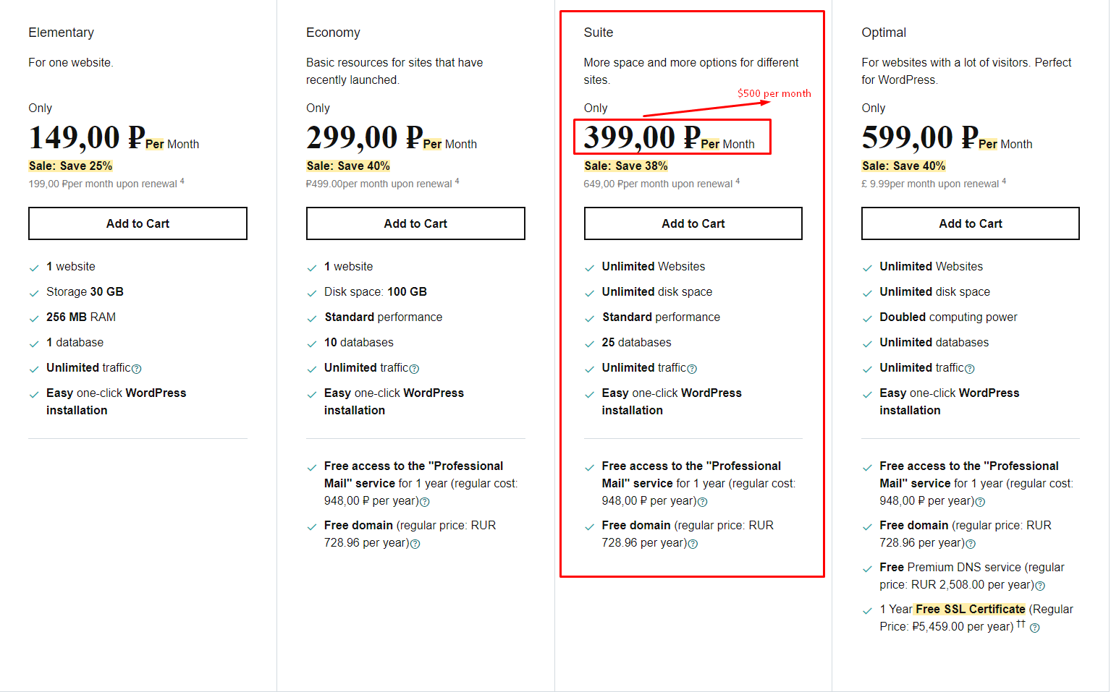

* Database

Bigchain Database

<https://www.bigchaindb.com/features/>

* Frameworks

React.js

* Frontend contracts

Web3.js

* Contracts Programming language:

Solidity

* APIs:

Exchange API: Poloniex API

* + If you want to use Third Party API for exchange tokens, I suggest to use.

<https://poloniex.com/>

Trading View API: Tradingview API

* + <https://www.tradingview.com/>

Create new token API:

* + <https://api.blockcypher.com/>

Deposit & Withdraw cryptocurrency API: Poloniex API

* + <https://poloniex.com/>
* Development server:

GoDaddy hosting – Elementary Level

<https://ru.godaddy.com/hosting/web-hosting>

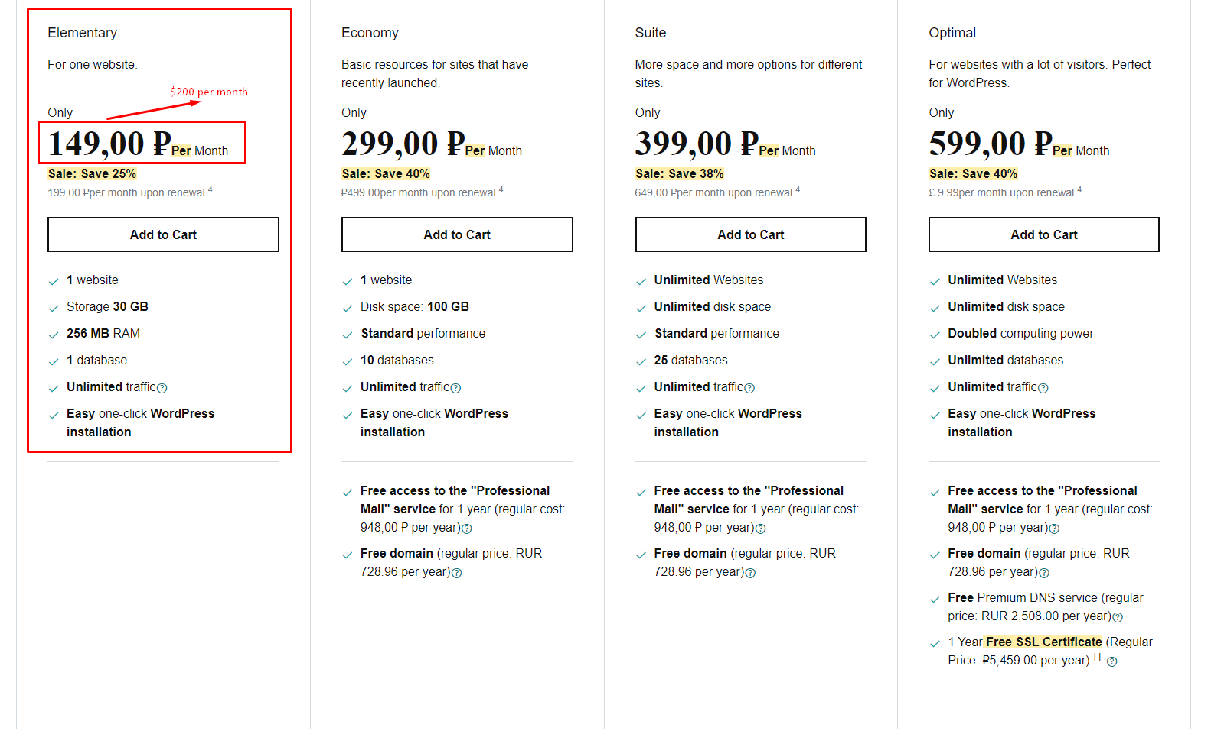

* **Technical Team** (3 members)

Project Manager, Financial Supporter, Frontend Developer.

All team members are high-level and responsible experts and well experienced with group working.

**Task definition**

* Project Manager & Engineer & DApp Developer: $40/hr

This is Me.

I have been being a project manager for 4+ years and software engineer for 8+ years on several projects until now.

I am going to manage this project and make engines based on financial business work flow and blockchain technology – Ethereum.

And I am also going to make smart contracts using Solidity and web3.js myself.

* Financial Supporter & Front-End Tester: $10/hr

This is well experienced talented financier who has lots of knowledge about blockchain.

He is being connected to our team for 2+ years and be very close with us.

* Frontend Developer & UI/UX designer: $20/hr

This is senior frontend developer and UI/UX designer who has rich experience with React.js.

His major skills are modern, beautiful, clean UI/UX design and user-friendly frontend development.

**Environment**

* Trello: Project Management System

Design, Engine, Backend, Frontend boards

* GitHub: Source Control

Design, Engine, Backend, Frontend repos

* Slack: Group Chat

Designer, Engineer, Backend & Frontend, Tester channels

1. *Workflow*

* **Total**

Deadline: 9 weeks (2 months)

Budget: $ 16.2k

* **Milestones**

1st milestone: Define Requirement List and make architecture design

Deadline: 1 week

Budget: $ 2k

Participations: PM, Financial Supporter

PM: $40 per hour, 40hrs per week (full-time)

Financial Supporter: $10 per hour, 40hrs per week (full-time)

2nd milestone: Complete detailed architecture design and make UI/UX design

Deadline: 1 week

Budget: $ 2.6k

Participations: PM, Financial Supporter, Frontend developer

PM: $40 per hour, 40hrs per week (full-time)

Financial Supporter: $10 per hour, 20hrs per week (part-time)

Frontend developer: $20 per hour, 40hrs per week (full-time)

3rd milestone: Develop Frontend integrating APIs

Deadline: 4 weeks

Budget: $ 6.4k

Participations: PM, Frontend developer

PM: $40 per hour, 20hrs per week (part-time)

Frontend developer: $20 per hour, 40hrs per week (full-time)

4th milestone: Complete Frontend with Frontend contracts

Deadline: 2 weeks

Budget: $ 4K

Participations: PM, Frontend developer

PM: $40 per hour, 40hrs per week (full-time)

Frontend developer: $20 per hour, 20hrs per week (part-time)

5th milestone: Test and live website, maintenance

Deadline: 1 week

Budget: $ 1.2k

Participations: PM, Financial Supporter, Frontend developer

PM: $40 per hour, 20hrs per week (part-time)

Financial Supporter: $10 per hour, 20hrs per week (part-time)

Frontend developer: $20 per hour, 20hrs per week (part-time)