Dynamic Memory Allocation in C: malloc(), calloc() and free()
Oct 17, 2026 · @Krishna

What you will learn
By the end of this lesson, you will be able to:
- Explain why fixed-size arrays are not always enough.
- Say what dynamic memory allocation means, in your own words.
- Use malloc() and calloc() to ask for memory while the program is running.
- Use free() to give that memory back.
- Spot the most common beginner mistakes.
Before you start: you should already know what a pointer is and how arrays work in C.

Why do we need it? The fixed-size array problem
When you write int marks[50];, the size 50 is fixed when you write the program. It cannot change while the program runs.
Imagine a program that stores the marks of students in a class:
int marks[50]; // space for exactly 50 students
This causes two problems:
- Too small: if the class has 70 students, there is no room for the last 20.
- Too big: if the class has only 10 students, the space for the other 40 is wasted.
What we really want is: ask the user how many students there are, then create an array of exactly that size. Dynamic memory allocation lets us do this.

What is dynamic memory allocation?
Dynamic memory allocation means asking for memory while the program is running, instead of fixing the size when you write the code.
- Static (or automatic) allocation: size decided at compile time. Example: int a[50];
- Dynamic allocation: size decided at run time. Example: ask the user for n, then get space for n integers.

Two areas of memory: stack and heap
Your program uses two main areas of memory:
 | Stack | Heap
What goes there | Normal local variables, e.g. int x; int a[50]; | Memory you ask for with malloc() / calloc()
Who manages it | C does it automatically | You do it
When it is freed | Automatically, when the function ends | Only when you call free()
Size | Fixed when you write the code | Decided while the program runs

An everyday analogy: booking a hotel room
- malloc() / calloc() = booking a room. You tell the hotel how big a room you need, and they give you the room number (the address).
- The pointer = the room key that holds the room number.
- free() = checking out. You give the room back so someone else can use it.
- If you never check out, the room stays blocked forever. In C this is called a memory leak.
Remember: in dynamic allocation, you always get back an address, so you always store it in a pointer.

malloc(): memory allocation
malloc() gives you one block of memory of the size you ask for, in bytes. The values inside it are garbage (random leftovers) until you put your own values in.
All three functions in this lesson live in the header <stdlib.h>, so always add #include <stdlib.h>.
Syntax
pointer = (type *) malloc(number_of_bytes);
Example: space for 5 integers
int *p;
p = (int *) malloc(5 * sizeof(int));
Let us read this line piece by piece:
- sizeof(int) gives the size of one int (usually 4 bytes).
- 5 * sizeof(int) means "enough bytes for 5 ints" (usually 20 bytes).
- malloc(...) reserves that many bytes on the heap and returns the starting address.
- (int *) tells the compiler to treat that address as pointing to ints. In C this cast is optional, but many textbooks write it.
- p now holds the address, so you can use it just like an array: p[0], p[1] ... p[4].
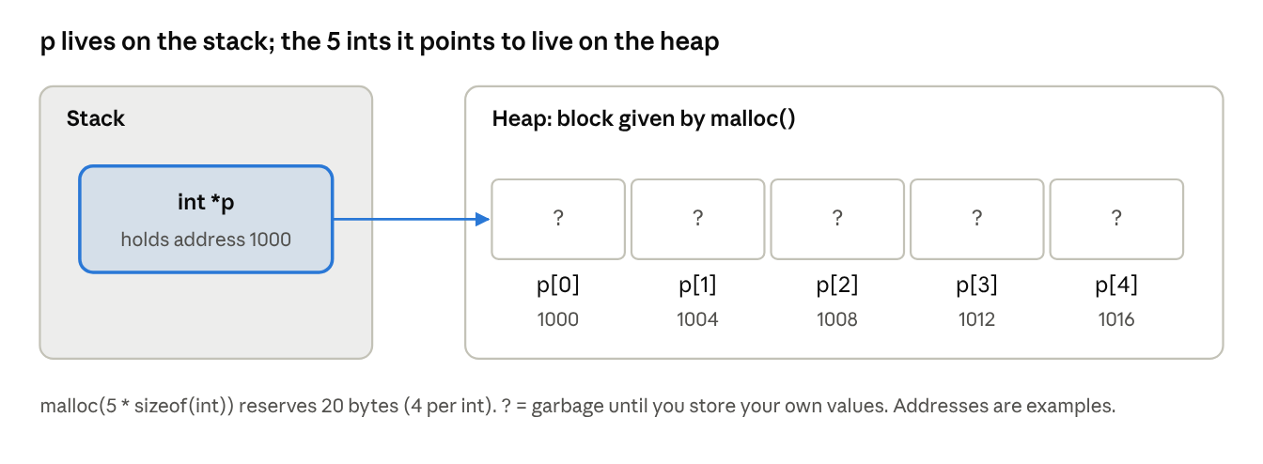
what malloc(5 * sizeof(int)) looks like in memory
The pointer p is only a key: it sits on the stack and stores the address of the first box on the heap.
Always check for NULL. If there is not enough memory, malloc() returns NULL. Using a NULL pointer crashes the program, so check first:
if (p == NULL) {
printf("Memory not allocated!\n");
return 1;
}
Why use sizeof instead of writing 4? The size of an int can differ between computers. sizeof always gives the correct size, so your program works everywhere.

calloc(): contiguous allocation
calloc() also gives you memory on the heap, with two differences: you pass the number of items and the size of one item separately, and every byte is set to zero.
Syntax
pointer = (type *) calloc(number_of_items, size_of_one_item);
Example: space for 5 integers, all starting at 0
int *p;
p = (int *) calloc(5, sizeof(int));
if (p == NULL) {
printf("Memory not allocated!\n");
return 1;
}
printf("%d", p[2]); // prints 0
Think of calloc() as "malloc() + clean the room". You get a fresh room with everything set to zero, which is handy for counters, totals and flags that must start at 0.

malloc() vs calloc() at a glance
 | malloc() | calloc()
Full form | Memory ALLOCation | Contiguous ALLOCation
Number of arguments | 1: total bytes | 2: number of items, size of one item
Example for 5 ints | malloc(5 * sizeof(int)) | calloc(5, sizeof(int))
Starting values | Garbage (random) | All zero
Speed | Slightly faster (no clearing) | Slightly slower (clears memory)
If memory is not available | Returns NULL | Returns NULL
Use malloc() when you will fill every value yourself straight away. Use calloc() when you need everything to start at zero.

free(): giving memory back
free() returns memory you got from malloc() or calloc() to the system, so it can be reused. Heap memory is never freed automatically while the program runs; that is your job.
Syntax
free(pointer);
Example
int *p = (int *) malloc(5 * sizeof(int));
/* ... use p ... */
free(p); // give the memory back
p = NULL; // good habit: the key no longer opens any room

Memory leak: forgetting to free
If you lose the address or never call free(), that memory stays booked but unused. Do this inside a loop and the program keeps eating memory until it slows down or crashes.
int *p = (int *) malloc(100 * sizeof(int));
p = (int *) malloc(50 * sizeof(int)); // LEAK! the first 100 ints are lost forever

Dangling pointer: using memory after freeing it
After free(p), the pointer p still holds the old address, but that memory no longer belongs to you. Using it is like walking into a hotel room after checking out.
free(p);
p[0] = 10; // WRONG! p is a dangling pointer
That is why we set p = NULL; right after free(p);.
Golden rule: every malloc() or calloc() must have exactly one matching free().

Putting it all together: average marks of n students
This program solves the problem from the start of the lesson: it creates an array of exactly the size the user asks for.
#include <stdio.h>
#include <stdlib.h> // for malloc, calloc, free
int main(void) {
int n, i;
int *marks;
float sum = 0;
printf("How many students? ");
scanf("%d", &n);
// Step 1: ask for memory for n integers
marks = (int *) malloc(n * sizeof(int));
// Step 2: check that we got it
if (marks == NULL) {
printf("Memory not allocated!\n");
return 1;
}
// Step 3: use it like a normal array
for (i = 0; i < n; i++) {
printf("Enter marks of student %d: ", i + 1);
scanf("%d", &marks[i]);
sum = sum + marks[i];
}
printf("Average = %.2f\n", sum / n);
// Step 4: give the memory back
free(marks);
marks = NULL;
return 0;
}
Sample run
How many students? 3
Enter marks of student 1: 80
Enter marks of student 2: 90
Enter marks of student 3: 70
Average = 80.00
Every dynamic memory program follows the same four steps: allocate → check for NULL → use → free.
Try it: replace the malloc() line with marks = (int *) calloc(n, sizeof(int));. The output is the same, because we fill every value ourselves.

Common beginner mistakes
Mistake | Wrong | Right
Forgetting sizeof | malloc(5) gives 5 bytes, not 5 ints | malloc(5 * sizeof(int))
Not checking for NULL | Using p straight after malloc() | if (p == NULL) { ... }
Forgetting free() | Memory leak | free(p); when done
Using memory after free() | free(p); p[0] = 5; | free(p); p = NULL; and stop using it
Freeing twice | free(p); free(p); | Free only once
Freeing normal variables | int a[5]; free(a); | Only free what malloc() / calloc() gave you
Forgetting the header | No #include <stdlib.h> | Always include <stdlib.h>
Going past the end | p[5] when you allocated 5 items | Valid indexes are p[0] to p[4]

Practice questions

Quick check
- In which header file are malloc(), calloc() and free() declared?
- What does malloc() return if memory is not available?
- What are the starting values in memory given by malloc()? By calloc()?
- How many arguments does calloc() take? Name them.
- What is a memory leak?
- Is malloc(10) enough for 10 integers? Why or why not?

Write a program
- Ask the user for n, allocate space for n floats with malloc(), read the values and print the largest one. Free the memory at the end.
- Use calloc() to create an array of 10 integers and print all values to prove they are zero.

Find the bug
int *p = (int *) malloc(3 * sizeof(int));
p[0] = 1; p[1] = 2; p[2] = 3; p[3] = 4;
free(p);
printf("%d", p[0]);
- This code has two mistakes. Find them.

Answers
- <stdlib.h>
- NULL
- malloc(): garbage (random) values. calloc(): all zeros.
- Two: the number of items, and the size of one item.
- Memory that was allocated but never freed, so it cannot be reused while the program runs.
- No. malloc(10) gives 10 bytes. 10 ints need 10 * sizeof(int) bytes (usually 40).
- and 8. Check that the program: includes <stdlib.h>, uses sizeof, checks for NULL, and calls free().
- p[3] goes past the end (only p[0] to p[2] exist), and p[0] is used after free(p) (dangling pointer).

