Structures in C
Oct 17, 2026 · @Krishna

What you will learn
By the end of this lesson, you will be able to:
- Explain what a structure is, in your own words.
- Decide when a new structure is needed.
- Define a structure and create structure variables.
- Initialize a structure variable.
- Read and change its members using the dot (.) operator.
Before you start: you should know the basic data types (int, float, char) and how arrays and strings work in C.

What is a structure?
A structure is a user-defined data type that groups related variables of different types under one name.

The problem
Suppose we want to store details of one student: roll number, name and marks. Without structures we need three separate variables:
int roll = 101;
char name[20] = "Asha";
float marks = 87.5;
For 3 students this becomes 9 variables, and nothing in the code says that roll, name and marks belong to the same student. An array cannot help either, because an array can only hold values of one type.

The solution
A structure lets us bundle these three items into one new type called struct student:
struct student {
int roll;
char name[20];
float marks;
};
The variables inside a structure (roll, name, marks) are called its members (or fields).

Array vs structure
 | Array | Structure
Holds | Many values of the same type | Values of different types
Items are called | Elements | Members
Access an item by | Index: a[0] | Name: s1.roll

An everyday analogy: a school ID card
An ID card is one card, but it holds several different details: a number, a name, a class, a photo. The card's layout is the same for every student; only the details change.
- The structure definition = the blank card design (what fields every card has).
- A structure variable = one filled-in card for one student.
- A member = one field on the card, like the name.

When should you create a new structure?
Create a structure when several pieces of data describe one real-world thing and you will use them together.
Ask yourself three questions:
- Do these values describe one thing (a student, a book, a point)?
- Are they of different types, or do they have different meanings?
- Will I store or pass them together many times, or need many such things?
If the answer is yes, make a structure.
Real-world thing | Members | Suggested structure
Student | roll (int), name (char[]), marks (float) | struct student
Book | title (char[]), author (char[]), price (float) | struct book
Date | day, month, year (all int) | struct date
Point on a graph | x, y (int or float) | struct point
Bank account | account number (long), holder name (char[]), balance (double) | struct account
Note the date and point rows: all members have the same type, but a structure is still better than an array, because d.month is far clearer than d[1].
Don't create a structure for a single value (like one counter) or for a list of the same kind of value (like 50 marks). Use a normal variable or an array instead.

How to define a structure and create variables

Step 1: define the structure (the template)
Syntax
struct structure_name {
data_type member1;
data_type member2;
...
};
Example
struct student {
int roll;
char name[20];
float marks;
}; // don't forget this semicolon!
Points to remember:
- struct is a keyword. student is the name we choose (called the tag).
- The definition only describes the shape. No memory is allocated yet, just as a blank ID card design is not a real card.
- The closing brace must be followed by a semicolon ;.
- Usually we write the definition above main(), so every function can use it.

Step 2: create structure variables (the real cards)
There are two common ways.
Way 1: declare variables later (most common)
struct student s1; // one student
struct student s1, s2, s3; // three students
The type name is the full phrase struct student, just like int in int x;.
Way 2: declare variables along with the definition
struct student {
int roll;
char name[20];
float marks;
} s1, s2;
Now memory is allocated: each variable gets its own copy of every member. s1 has its own roll, name and marks; s2 has its own separate set.

Size of a structure variable
A structure variable's size is at least the total of its members' sizes. For struct student: 4 (int) + 20 (char array) + 4 (float) = 28 bytes. Check it with:
printf("%zu", sizeof(struct student));
The compiler may add a few padding bytes, so the printed size can be larger than the sum. That is normal.

How to initialize a structure variable
Initializing means giving the members their values at the moment the variable is created.

Way 1: in order, inside braces
struct student s1 = {101, "Asha", 87.5};
Values are given to members in the same order as in the definition: 101 → roll, "Asha" → name, 87.5 → marks.

Way 2: by member name (designated initializers)
struct student s2 = {.name = "Ravi", .roll = 102, .marks = 91.0};
Here each value says which member it belongs to, so the order does not matter. This is clearer and safer, and is supported by all modern C compilers (C99 and later).

Partial initialization
struct student s3 = {103}; // roll = 103, name = "", marks = 0.0
If you give fewer values, the remaining members are automatically set to zero (an empty string for name).

Assigning after declaration
You can also create the variable first and fill the members later, one by one:
struct student s4;
s4.roll = 104;
strcpy(s4.name, "Meena"); // needs #include <string.h>
s4.marks = 78.0;
Note: brace initialization works only when declaring. This is an error:
struct student s5;
s5 = {105, "Kiran", 66.0}; // ERROR: not allowed after declaration

Copying one structure variable to another
Two variables of the same structure type can be copied with =. All members are copied at once:
struct student s6 = s1; // s6 is now 101, "Asha", 87.5

How to access structure members
We reach a member with the dot operator . (also called the member access operator).
Syntax
variable_name.member_name
Read s1.roll as "the roll of s1".
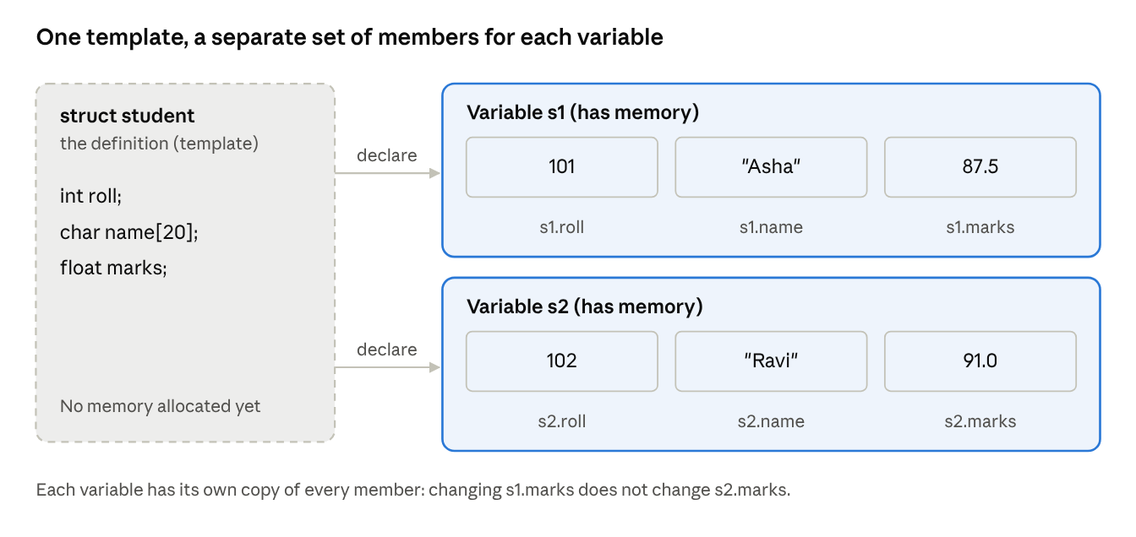
struct student, two variables and how each member is reached
The name under each box is exactly what you type in code to reach that value.

Reading members (printing)
struct student s1 = {101, "Asha", 87.5};
printf("Roll : %d\n", s1.roll);
printf("Name : %s\n", s1.name);
printf("Marks: %.1f\n", s1.marks);

Changing members
A member works exactly like a normal variable of its type:
s1.marks = 90.0; // change marks
s1.marks = s1.marks + 5; // use it in an expression
s1.roll++; // increment
For a string member, use strcpy(), not =:
strcpy(s1.name, "Asha K"); // correct
s1.name = "Asha K"; // ERROR: cannot assign to an array

Reading members from the keyboard
scanf("%d", &s1.roll); // & needed for int
scanf("%s", s1.name); // no & for a char array
scanf("%f", &s1.marks); // & needed for float
&s1.roll means "the address of s1.roll", because the dot operator is applied before &.

Remember
- Use the variable name, not the structure name: s1.roll is correct, student.roll is wrong.
- Each variable has its own members: changing s1.marks does not change s2.marks.

Putting it all together: student details
This program uses every idea from the lesson: define, declare, initialize, read input and access members.
#include <stdio.h>
#include <string.h>
// 1. Define the structure (above main)
struct student {
int roll;
char name[20];
float marks;
};
int main(void) {
// 2. Declare and initialize
struct student s1 = {101, "Asha", 87.5};
struct student s2;
// 3. Fill s2 from the keyboard
printf("Enter roll, name and marks: ");
scanf("%d %s %f", &s2.roll, s2.name, &s2.marks);
// 4. Change a member
s1.marks = s1.marks + 2; // grace marks
// 5. Access and print the members
printf("\n%-6s %-10s %s\n", "Roll", "Name", "Marks");
printf("%-6d %-10s %.1f\n", s1.roll, s1.name, s1.marks);
printf("%-6d %-10s %.1f\n", s2.roll, s2.name, s2.marks);
// Compare members to find the topper
if (s1.marks > s2.marks)
printf("Topper: %s\n", s1.name);
else
printf("Topper: %s\n", s2.name);
return 0;
}
Sample run
Enter roll, name and marks: 102 Ravi 91
Roll Name Marks
101 Asha 89.5
102 Ravi 91.0
Topper: Ravi
string.h isn't strictly needed in this program, but keep it in the habit: you will need it the moment you use strcpy() on a name.

Common beginner mistakes
Mistake | Wrong | Right
Missing semicolon after the definition | struct student { ... } | struct student { ... };
Leaving out struct when declaring | student s1; | struct student s1;
Using the structure name to access | student.roll = 5; | s1.roll = 5;
Assigning a string with = | s1.name = "Asha"; | strcpy(s1.name, "Asha");
Brace values after declaration | s1 = {101, "Asha", 87.5}; | Initialize when declaring, or assign members one by one
Wrong order in { } | {"Asha", 101, 87.5} | {101, "Asha", 87.5} (same order as the definition)
Initializing inside the definition | struct student { int roll = 0; }; | Give values only to variables, not in the definition
Missing & in scanf for numbers | scanf("%d", s1.roll); | scanf("%d", &s1.roll);
Comparing whole structures | if (s1 == s2) | Compare member by member: s1.roll == s2.roll

Practice questions

Quick check
- What is a structure? How is it different from an array?
- Which keyword is used to define a structure?
- Is memory allocated when a structure is defined? When is it allocated?
- Which operator is used to access a member of a structure variable?
- After struct student s3 = {103};, what are the values of s3.name and s3.marks?
- Which of these needs a structure: (a) marks of 60 students, (b) the title, author and price of a book? Why?

Write a program
- Define struct book with title, author and price. Create one book using initialization and one by reading input, then print both.
- Define struct date with day, month and year. Read two dates and print which one comes first.

Find the bugs
struct point {
int x;
int y;
}
int main(void) {
point p1 = {3, 4};
printf("%d", point.x);
return 0;
}
- This code has three mistakes. Find them.

Answers
- A user-defined type that groups related variables of different types under one name. An array holds many values of the same type, accessed by index; a structure holds values of different types, accessed by name.
- struct
- No. Memory is allocated only when a structure variable is declared.
- The dot operator .
- s3.name is an empty string "" and s3.marks is 0.0.
- (b). The title, author and price describe one book and have different types. (a) is a list of the same kind of value, so an array is better.
- and 8. Check that the program: ends the definition with ;, declares variables with the struct keyword, uses strcpy() for strings, and accesses members with ..
- Missing ; after the closing } of the definition; point p1 must be struct point p1; point.x must be p1.x.

