AI FitTrack
AI-Powered Fitness Management and Recommendation System
Technical Project Documentation
Backend REST API — Node.js · Express.js · MongoDB · Google Gemini AI
Prepared from the current AI FitTrack source code (server/ and client/).
Document Date: September 27, 2026

1. Project Title
AI FitTrack – AI-Powered Fitness Management and Recommendation System
This is the official project name declared in server/package.json ("ai-fittrack-server") and README.md ("AI FitTrack"). No alternate official title appears in the source code.

2. Project Description
AI FitTrack is a backend-focused, AI-augmented fitness and gym-membership management system built on Node.js, Express.js, MongoDB and Mongoose. It exposes a complete REST API that lets registered members securely authenticate, log workouts, define and track fitness goals, record gym check-in/check-out attendance, and view aggregated progress analytics. The backend integrates with Google Gemini (through the official @google/genai SDK) to provide two distinct AI capabilities: personalized AI workout recommendations and AI-generated fitness insights, both derived strictly from data the member has actually stored in the system. A React (Vite) single-page application in the client/ folder consumes this API using Axios, but every business rule — ownership, validation, role checks, and AI prompt construction — is enforced entirely on the backend, so the API can be exercised and verified independently using Thunder Client or Postman.
The backend follows a modular, layered MVC-style architecture (config, models, routes, controllers, services, middleware and utils) with JSON Web Token (JWT) authentication, bcrypt password hashing, role-based authorization (user/admin), centralized error handling and a dependency-free declarative request-validation layer. Beyond the member-facing feature set, the system includes a dedicated Admin module for system statistics, member management, and organization-wide visibility into every member's workouts, goals, progress and attendance. Automated tests (Node's built-in test runner) cover both pure calculation utilities and the live HTTP API end to end.

Technologies actually used (verified from package.json and source)
Layer | Technology | Verified from
Runtime | Node.js ≥ 20.0.0 | server/package.json "engines"
Web framework | Express.js ^4.19.2 | server/package.json, server.js
Database / ODM | MongoDB with Mongoose ^8.5.0 | server/config/db.js, models/*.js
Authentication | JSON Web Tokens — jsonwebtoken ^9.0.2 (HS256 only) | services/jwtService.js
Password security | bcryptjs ^2.4.3 (10 salt rounds) | services/passwordService.js
AI provider | Google Gemini via @google/genai ^2.23.0 | services/geminiService.js
Cross-origin access | cors ^2.8.5 | server.js
Environment config | dotenv ^16.4.5 | server.js, config/validateEnv.js
Dev tooling | nodemon ^3.1.4 (dev dependency) | server/package.json
Validation | Custom declarative middleware (no external library) | middleware/validate.js
Testing | Node's built-in "node:test" runner (node --test) | server/package.json scripts, tests/*.js
Frontend | React 19 + React Router 7 + Vite 8 + Axios (API consumer only) | client/package.json

The backend provides:
- Secure JWT-based authentication and bcrypt password hashing (register, login, profile)
- Full CRUD workout management with search and pagination
- Fitness goal management with server-calculated progress and status
- Gym attendance / check-in / check-out tracking with a single-open-visit rule
- Progress analytics: totals, category distribution, streaks, consistency, weekly breakdowns
- AI workout recommendations personalized to the member's profile, goals and history (Google Gemini)
- AI fitness insights generated from the member's own workout statistics (Google Gemini)
- An admin dashboard with system statistics, member management, role management and full data visibility
- A consistent, documented REST API for any client (Thunder Client, Postman, or the bundled React app)

3. Scenario / Case Study

Background
Priya is a member at a mid-sized fitness gym. She works out several times a week, tracks a handful of personal goals (running a certain number of times a month, building overall workout consistency), and checks in and out of the gym at every visit. The gym itself has dozens of active members, and its managers need a simple way to see who is actively training, how members are progressing, and who may need extra attention or encouragement. Historically, workout logs lived in notebooks or scattered spreadsheets, gym visits were tracked on a paper sign-in sheet, and no one — members or managers — had a consolidated, real-time view of fitness activity across the gym.

Problem
- Manual, notebook or spreadsheet-based workout tracking that is easy to lose or forget to update.
- Difficulty monitoring progress over time — there is no consistent way to see streaks, weekly trends, or category balance.
- No centralized or auditable record of who visited the gym and when (paper sign-in sheets).
- Fitness goals are tracked informally, with no automatic, tamper-proof way to calculate whether a goal has actually been met.
- Members receive no personalized guidance on how to structure their training around their own goals and experience level.
- Gym administrators have no single dashboard to see membership statistics, per-member activity, or attendance trends.

AI Solution
AI FitTrack addresses these problems with a REST API backed by MongoDB, and augments it with two Google Gemini-powered capabilities implemented in the backend's AI layer (services/geminiService.js, recommendationService.js and insightsService.js):

1. AI Workout Recommendation (POST /api/ai/recommendation)
The backend gathers the member's age, fitness goal and experience level (from the request body or their saved profile), their active fitness goals, their five most recent workouts, and their calculated progress summary (frequency, streak, consistency, category distribution). This structured data — never the member's name, email or database identifiers — is sent to Gemini with a system instruction that forbids medical claims and requires a structured JSON reply: a weekly schedule, suitable exercises, training tips, safety recommendations, a motivational message and an explicit non-medical disclaimer.

2. AI Fitness Insights (GET /api/ai/fitness-insights)
The backend calculates the member's total workouts, average workout duration and total calories burned (the same numbers shown on their Progress page), along with recent workout history and activity trends, and asks Gemini to produce a performance analysis, improvement suggestions, motivational advice and a progress summary — again, strictly from the numbers actually computed by the backend, with no invented statistics.

Outcome / Impact
Members get a single, always-up-to-date source of truth for their workouts, goals, attendance and progress, plus AI-assisted guidance that adapts to their own activity rather than generic advice. Gym administrators get a dashboard and member-management tools built directly from the same underlying data — no separate reporting system is needed. The system explicitly avoids making medical claims: every AI-generated response is required to include safety language and a disclaimer directing members to consult a qualified professional for health concerns.

4. System Requirements

Software Requirements
Requirement | Notes
Operating System | Windows 10/11, macOS, or Linux (Node.js is cross-platform)
Node.js ≥ 20.0.0 | Required by server/package.json "engines" field
npm | Bundled with Node.js; used to install both server/ and client/ dependencies
MongoDB (local) or MongoDB Atlas | Connection string supplied via MONGO_URI; both mongodb:// and mongodb+srv:// are supported by config/db.js
Visual Studio Code (or similar editor) | Recommended development environment
Thunder Client or Postman | Primary tools for exercising and verifying the REST API directly
Google Gemini API key | Required only for the two AI endpoints; obtained from https://aistudio.google.com/app/apikey
Web browser (Chrome/Firefox/Edge) | To run the React client, which consumes the API via Axios
Git | Recommended for version control (referenced in README.md workflow)

Hardware Requirements
Component | Minimum for Development
Processor | Intel Core i5 (8th Gen) / AMD Ryzen 5 or equivalent
RAM | 8 GB (16 GB recommended if MongoDB and both server/ and client/ run locally at once)
Storage | About 1–2 GB free (source, node_modules, and a local MongoDB data directory)
Internet Connection | Required to reach MongoDB Atlas (if used) and the Google Gemini API
Display | 1366 × 768 or higher

5. Project Architecture
AI FitTrack follows a layered, MVC-inspired backend architecture. Each concern is isolated into its own folder so that routes, business logic, database access and AI integration can change independently.

Client / API Consumer Layer
- React 19 + Vite single-page application (client/) consuming the API via Axios
- Thunder Client / Postman, used directly against the REST API for testing

Express Server Layer
- Express.js app configured in server/server.js
- CORS restricted to the origin(s) listed in CLIENT_ORIGIN
- express.json() / express.urlencoded() body parsing
- A public, database-independent GET /api/health endpoint
- requireDatabase middleware guarding every feature route group so requests fail fast (503) if MongoDB is down, instead of hanging
- Centralized 404 (notFound) and error-handling (errorHandler) middleware, registered last

Authentication Layer
- JWT issuance and verification (services/jwtService.js), signed and verified with HS256 only
- authenticate middleware — validates the Authorization: Bearer <token> header and attaches the current user document to req.user
- authorize("admin") middleware — restricts a route to a specific role, used on every /api/admin/* route
- Password hashing with bcryptjs (services/passwordService.js, 10 salt rounds)

Route Layer (server/routes/)
- authRoutes, workoutRoutes, goalRoutes, progressRoutes, attendanceRoutes, aiRoutes, adminRoutes

Controller Layer (server/controllers/)
- Thin request/response handlers that call into the service layer and format the standard JSON envelope

Service Layer (server/services/)
- adminService, attendanceService, goalService, progressService, recommendationService, insightsService, geminiService, jwtService, passwordService — all business logic and database queries live here

Model / Database Layer (server/models/)
- Mongoose schemas: User, Workout, FitnessGoal, Attendance

AI Layer
- services/geminiService.js — a single, shared wrapper around the @google/genai SDK that both AI features call. It owns model selection, request timeouts, retry-with-backoff for temporary failures, and translating every SDK failure mode into a clean, classified error

Utility Layer (server/utils/)
- AppError, asyncHandler, dateUtils, ids, pagination, progressCalc, response, text — shared, dependency-free helpers used across controllers and services

Request Flow — a standard authenticated request
Client (React / Thunder Client / Postman)
│ HTTP request + "Authorization: Bearer <JWT>"
▼
Express Server (server.js) — CORS, JSON body parsing
▼
requireDatabase middleware → 503 if MongoDB is not connected
▼
Route (e.g. workoutRoutes.js)
▼
authenticate middleware → 401 if the JWT is missing/invalid/expired
▼
validateBody / validateQuery / validateObjectId → 400 on bad input
▼
Controller (e.g. workoutController.js)
▼
Service (e.g. business logic + ownership checks)
▼
Model / MongoDB (Mongoose)
▼
Standardized JSON response { success, message, data }

Request Flow — an AI request
Client
▼
authenticate middleware (JWT required for both AI endpoints)
▼
AI Route (aiRoutes.js) → validateBody (recommendation only; partial/optional fields)
▼
AI Controller (aiController.js)
▼
recommendationService.js or insightsService.js
│ (gathers profile / active goals / recent workouts / progress summary
│ — builds a JSON-schema prompt with a strict system instruction)
▼
geminiService.js → Google Gemini API (@google/genai)
│ (timeout via AbortController, up to 3 attempts with backoff
│ for temporary failures, classifies every error type)
▼
Structured JSON response validated and returned to the client

6. Technical Architecture Diagram
The diagram below reflects only components verified in the current source code. No vector search, semantic search, RAG pipeline, or document-upload subsystem exists in this project, so none are shown.
┌─────────────────────────────┐ ┌───────────────────────────────┐
│ React Frontend (client/) │ │ Thunder Client / Postman │
│ Axios → REST calls │ │ (direct API testing) │
└──────────────┬────────────────┘ └───────────────┬───────────────┘
│ │
└───────────────────┬──────────────────────┘
▼
┌───────────────────────────────────┐
│ Express.js Server (server.js) │
│ CORS · JSON body parsing │
│ GET /api/health (public) │
└────────────────┬──────────────────┘
▼
┌───────────────────────────────────┐
│ requireDatabase middleware │
└────────────────┬──────────────────┘
▼
┌────────────────────────────────────────────────────────┐
│ Route Layer │
│ auth · workouts · goals · progress · attendance · │
│ ai · admin │
└───────────┬───────────────────────────┬────────────────┘
▼ ▼
┌───────────────────────────┐ ┌─────────────────────────────┐
│ Authentication Middleware │ │ Admin Authorization │
│ (JWT verify → req.user) │ │ authorize("admin") │
└─────────────┬──────────────┘ └───────────────┬─────────────┘
└───────────────┬──────────────────┘
▼
┌────────────────────────────────┐
│ Validation Middleware │
│ validateBody / validateQuery / │
│ validateObjectId │
└────────────────┬─────────────────┘
▼
┌────────────────────────────────┐
│ Controller Layer │
└────────────────┬─────────────────┘
▼
┌────────────────────────────────┐
│ Service Layer │
│ business logic, ownership, │
│ progress calculations │
└───────┬────────────────┬─────────┘
▼ ▼
┌──────────────────────┐ ┌──────────────────────────┐
│ MongoDB / Mongoose │ │ Gemini Service │
│ Users · Workouts · │ │ (@google/genai SDK) │
│ FitnessGoals · │ │ timeout + retry/backoff │
│ Attendance │ └─────────────┬──────────────┘
└──────────────────────┘ ▼
┌──────────────────────────┐
│ Google Gemini API │
└──────────────────────────┘

7. ER Diagram
Every model was verified directly in server/models/. There are exactly four collections; all relate back to User by ObjectId reference.
┌───────────────────┐
│ User │
│───────────────────│
│ _id │
│ name │
│ email (unique) │
│ password (hashed) │
│ role (user/admin) │
│ fitnessProfile{} │
└─────────┬─┬─┬───────┘
1:N ┌────────────────┘ │ └────────────────┐ 1:N
▼ ▼ ▼
┌───────────────────┐ ┌────────────────────┐ ┌───────────────────┐
│ Workout │ │ FitnessGoal │ │ Attendance │
│───────────────────│ │────────────────────│ │───────────────────│
│ _id │ │ _id │ │ _id │
│ user (ref User) │ │ user (ref User) │ │ user (ref User) │
│ workoutName │ │ title / description │ │ checkInTime │
│ category │ │ metric │ │ checkOutTime │
│ duration │ │ targetValue │ │ durationMinutes │
│ caloriesBurned │ │ currentValue │ │ isOpen │
│ workoutDate │ │ startDate/targetDate│ │ │
│ │ │ status / progress │ │ │
└───────────────────┘ └────────────────────┘ └───────────────────┘

Relationship Explanation
- User → Workout: one-to-many. Each workout stores a required user ObjectId reference; a workout can never exist without an owning user, and every workout query is scoped to req.user._id (workoutController.js).
- User → FitnessGoal: one-to-many. Goals are always created against the authenticated user; currentValue and progress are recalculated by the server, never trusted from the client, for any metric other than "manual" (goalService.js).
- User → Attendance: one-to-many. A partial unique index — { user: 1 } with partialFilterExpression: { isOpen: true } — guarantees at most one open ("currently checked in") visit per user at the database level, not just in application code (models/Attendance.js).
- There is no direct Workout ↔ FitnessGoal or Workout ↔ Attendance reference; goals of metric "workouts", "workout_minutes" or "calories" are computed on demand by aggregating Workout documents within the goal's date range, and a "visits" goal is computed by counting Attendance documents in the same range (services/goalService.js, computeCurrentValue).

8. Database Design
For every model below, fields, types, validation and defaults are taken directly from server/models/.

User (models/User.js)
Field | Type | Rules / Notes
name | String | required, 2–60 chars, trimmed
email | String | required, unique, lowercased, trimmed, regex-validated
password | String | required, min 6 chars, select: false (never returned by default queries)
role | String (enum) | "user" or "admin"; default "user"; only an admin (PUT /api/admin/users/:id/role) or the create-admin script can change it
fitnessProfile.age | Number | 10–100
fitnessProfile.heightCm | Number | 50–260
fitnessProfile.weightKg | Number | 20–400
fitnessProfile.experienceLevel | String (enum) | Beginner / Intermediate / Advanced
fitnessProfile.fitnessGoal | String | 2–100 chars
createdAt / updatedAt | Date | automatic (timestamps: true)
Security: the password field carries select: false so it is excluded from all normal queries by default; a toJSON transform additionally strips password and __v from any serialized document; and userSchema.methods.toSafeObject() defines the exact allow-listed shape (id, name, email, role, fitnessProfile, createdAt, updatedAt) that every API response actually returns — a hashed password can never leak through the API even by accident.

Workout (models/Workout.js)
Field | Type | Rules / Notes
user | ObjectId (ref User) | required, indexed
workoutName | String | required, 2–100 chars
category | String (enum) | required; one of Cardio, Strength, Flexibility, Balance, Sports, HIIT, Yoga, Other
duration | Number | required, must be > 0 (minutes)
caloriesBurned | Number | required, ≥ 0, finite
workoutDate | Date | required
createdAt / updatedAt | Date | automatic
Compound index { user: 1, workoutDate: -1 } speeds up per-user listing, search and progress queries.

FitnessGoal (models/FitnessGoal.js)
Field | Type | Rules / Notes
user | ObjectId (ref User) | required, indexed
title | String | required, 2–100 chars
description | String | optional, up to 500 chars
metric | String (enum) | manual, workouts, workout_minutes, calories, visits — default "manual"
targetValue | Number | required, > 0
currentValue | Number | ≥ 0, default 0 — manually set only for "manual" goals; server-calculated for every other metric
unit | String | up to 30 chars, defaulted per metric (e.g. "kcal", "visits")
startDate / targetDate | Date | both required
status | String (enum) | active, completed, cancelled, expired — default "active"; completed/expired are set only by the server
progress | Number | 0–100, default 0 — always calculated server-side; a value sent by the client is ignored
completedAt | Date | set automatically when progress reaches 100%
"manual" is the only metric where the client supplies currentValue directly. For workouts / workout_minutes / calories / visits, goalService.computeCurrentValue() aggregates the member's own Workout or Attendance documents between startDate and targetDate and overwrites currentValue every time the goal is read or listed (goalService.refreshGoal); progress and status (active → completed/expired) are derived from that value, never accepted from the client.

Attendance (models/Attendance.js)
Field | Type | Rules / Notes
user | ObjectId (ref User) | required
checkInTime | Date | required, defaults to now
checkOutTime | Date | set at check-out
durationMinutes | Number | ≥ 0, computed at check-out
isOpen | Boolean | default true; false once checked out
Single-open-visit rule: a unique partial index — { user: 1 } with partialFilterExpression: { isOpen: true } — allows at most one document with isOpen: true per user at the database level, so two simultaneous check-in requests cannot both succeed (attendanceService.js relies on the resulting duplicate-key error, code 11000, as a second line of defense behind its own application-level check). A visit left open for more than 12 hours (STALE_VISIT_HOURS) is treated as abandoned and silently closed on the member's next check-in, so a forgotten check-out never permanently blocks them.

9. Features

Core Backend Features
- User registration with server-enforced role (always "user" — a client can never register as admin)
- Login with JWT issuance (HS256, configurable expiry via JWT_EXPIRES_IN)
- bcrypt password hashing (10 salt rounds) — the hash is never returned by the API
- Protected routes via authenticate middleware; admin-only routes via authorize("admin")
- Declarative request validation and whitelisting (middleware/validate.js) for every body and query parameter
- Centralized error handling with a single, standardized JSON response shape
- Full REST CRUD for workouts, with ownership enforcement (403 on another member's workout)
- Workout search by free-text query, workout name, category and calendar date
- Fitness goal CRUD with server-calculated progress, status and (for non-manual metrics) currentValue
- Gym attendance check-in / check-out with a single-open-visit rule enforced at the database level
- Attendance history with date-range filtering and pagination
- Progress summary and weekly progress analytics (totals, streaks, consistency, category distribution)
- Pagination on every list endpoint (page / limit, capped at a maximum limit)
- Role-based access control (user / admin)
- Admin dashboard, member management, role management and user deletion (cascading to the member's own data)
- A public GET /api/health endpoint reporting server, database and Gemini configuration status

AI Features

AI Workout Recommendation — POST /api/ai/recommendation
- Endpoint: POST /api/ai/recommendation (JWT required)
- Inputs: age, fitnessGoal, experienceLevel — taken from the request body if sent, otherwise from the member's saved fitness profile; a 400 error lists exactly which fields are still missing
- Also gathered automatically: the member's active fitness goals, their five most recent workouts, and their calculated progress summary (frequency, streak, consistency, category distribution)
- Gemini integration: services/geminiService.generateStructuredContent(), called from services/recommendationService.js, with a system instruction that forbids medical diagnoses and requires safety language
- Response: a structured JSON object — workoutPlan, weeklySchedule (Monday–Sunday), suitableExercises, trainingTips, safetyRecommendations, motivationalMessage, and a mandatory disclaimer stating this is general fitness guidance, not medical advice

AI Fitness Insights — GET /api/ai/fitness-insights
- Endpoint: GET /api/ai/fitness-insights (JWT required, no body or query parameters)
- Inputs: total workouts, average workout duration, and total calories burned — computed by progressService.getSummary() (the same numbers shown on the member's own Progress page) — plus recent workout history and activity trends
- With zero workouts, Gemini is never called; the endpoint returns the zeroed statistics with insights: null
- Gemini integration: the same shared geminiService as the recommendation feature, via services/insightsService.js
- Response: performanceAnalysis, improvementSuggestions (3–5 items), motivationalAdvice, and fitnessProgressSummary — validated field-by-field before being returned; an incomplete Gemini reply becomes a clean 502 error instead of reaching the client
Neither AI feature implements, calls, or references semantic search, vector search, MongoDB Atlas Vector Search, Retrieval-Augmented Generation (RAG), document upload/analysis, or a conversational chatbot. These are template concepts that do not exist anywhere in the current AI FitTrack source code.

10. Roles and Responsibilities

Normal User (role: "user")
- Register and log in; every registration is forced to role "user" server-side
- View and update their own fitness profile (name, age, height, weight, experience level, fitness goal)
- Create, view, update, delete and search their own workouts only
- Create, view, update, delete their own fitness goals; progress/status are always server-calculated
- Check in and check out of the gym; view their own attendance history
- View their own progress summary and weekly progress
- Request an AI workout recommendation and AI fitness insights, based only on their own data
- Cannot access any other member's workouts, goals, attendance or profile (enforced with 403 Forbidden)
- Cannot access any /api/admin/* route (enforced with 403 Forbidden)

Admin (role: "admin")
- Everything a normal user can do, plus:
- View system-wide statistics and the admin dashboard (GET /api/admin/stats, /api/admin/dashboard)
- List, search and filter all registered users; view any single user's details and per-resource counts
- Change any user's role between "user" and "admin" (except their own — self-role-change is blocked)
- Delete any user account (except their own), cascading the deletion to that user's workouts, goals and attendance
- View a searchable Members Overview with real per-member statistics (workouts, goals, progress days, attendance, last activity, computed status)
- View full Member Details for any one member (fitness totals, recent workouts/goals/attendance)
- View every member's workouts, goals, progress and attendance across the whole gym, filterable by member, category, status, or date
Every admin route is protected by authenticate followed by authorize("admin") (adminRoutes.js: router.use(authenticate, authorize("admin"))). A request with no token receives 401; an authenticated non-admin receives 403. Nothing under /api/admin/* is reachable by anyone but an admin.

11. User Flow

Member Flow
- Register (POST /api/auth/register)
- Log in and receive a JWT (POST /api/auth/login)
- Use the JWT (Authorization: Bearer <token>) to access every protected endpoint
- View and update the fitness profile (GET/PUT /api/auth/profile)
- Add workouts (POST /api/workouts)
- Search, view, update and delete workouts
- Create and manage fitness goals (CRUD on /api/goals)
- Check in at the gym (POST /api/attendance/check-in)
- Check out at the gym (POST /api/attendance/check-out)
- View attendance history (GET /api/attendance)
- View progress summary and weekly progress (GET /api/progress/summary, /weekly)
- Request an AI workout recommendation (POST /api/ai/recommendation)
- Request AI fitness insights (GET /api/ai/fitness-insights)

Admin Flow
- Log in with an admin account (the same POST /api/auth/login — the response's role field is "admin")
- Use the admin JWT to access every /api/admin/* route
- View the admin dashboard and system statistics
- View the Members Overview and search/filter members
- View details for any single member
- View gym-wide workouts, goals, progress and attendance (optionally scoped to one member via ?userId=)
- Change a member's role, or delete a member's account, where permitted

12. MVC Architecture Pattern

Model Layer
Four Mongoose models define the entire persisted data shape: User, Workout, FitnessGoal, Attendance (server/models/). All schema validation, defaults and indexes live here.

View Layer
AI FitTrack is a REST backend project, so the "View" is the API response consumer rather than a server-rendered page. In practice this is: the React (Vite) frontend in client/, which renders the API's JSON via Axios calls, and Thunder Client / Postman, used directly to exercise and verify the API without any UI at all. Every response follows one consistent JSON envelope regardless of consumer: { success, message, data } or { success: false, message, errors }.

Controller Layer
Seven controllers (server/controllers/) — authController, workoutController, goalController, progressController, attendanceController, aiController, adminController — parse the request, call the matching service, and format the response using the shared sendSuccess/sendError helpers (utils/response.js). Controllers contain no business logic or direct database queries themselves; that lives in the service layer.

Separation of Concerns
Layer | Responsibility
Routes | Declare endpoints, attach middleware (auth, validation) in the correct order
Middleware | Authentication, authorization, request validation, database-availability guard, error handling
Controllers | Translate an HTTP request into a service call and shape the response
Services | All business logic: ownership checks, calculations, Gemini prompt construction, admin aggregations
Models | Schema definition, field-level validation, indexes
Utils | Shared, stateless helpers used across every other layer

13. Project Structure
AI-FitTrack/
├── client/ React (Vite) frontend — API consumer only
│ ├── src/
│ │ ├── api/ Axios client / API call wrappers
│ │ ├── components/ Reusable UI components
│ │ ├── context/ React context (e.g. auth state)
│ │ ├── pages/ Route-level pages
│ │ ├── styles/ Hand-written CSS (tokens.css, components.css)
│ │ └── utils/ Frontend helper functions
│ ├── package.json
│ └── .env.example
└── server/ Node.js / Express REST API (the focus of this document)
├── server.js App entry point — middleware, routes, startup sequence
├── package.json
├── .env.example
├── config/
│ ├── db.js MongoDB connection (with actionable error hints)
│ ├── defaultAdmin.js Bootstraps a default admin account on first run
│ └── validateEnv.js Fails fast if required env vars are missing
├── controllers/
│ ├── adminController.js
│ ├── aiController.js
│ ├── attendanceController.js
│ ├── authController.js
│ ├── goalController.js
│ ├── progressController.js
│ └── workoutController.js
├── middleware/
│ ├── authMiddleware.js authenticate / authorize
│ ├── dbConnectionMiddleware.js
│ ├── errorMiddleware.js notFound / errorHandler
│ └── validate.js validateBody / validateQuery / validateObjectId
├── models/
│ ├── Attendance.js
│ ├── FitnessGoal.js
│ ├── User.js
│ └── Workout.js
├── routes/
│ ├── adminRoutes.js
│ ├── aiRoutes.js
│ ├── attendanceRoutes.js
│ ├── authRoutes.js
│ ├── goalRoutes.js
│ ├── progressRoutes.js
│ └── workoutRoutes.js
├── services/
│ ├── adminService.js
│ ├── attendanceService.js
│ ├── geminiService.js Shared Gemini client, retries, error classification
│ ├── goalService.js
│ ├── insightsService.js
│ ├── jwtService.js
│ ├── passwordService.js
│ ├── progressService.js
│ └── recommendationService.js
├── scripts/
│ └── createAdmin.js CLI script to create/promote an admin account
├── utils/
│ ├── AppError.js
│ ├── asyncHandler.js
│ ├── dateUtils.js
│ ├── ids.js
│ ├── pagination.js
│ ├── progressCalc.js
│ ├── response.js
│ └── text.js
└── tests/
├── api.integration.js End-to-end HTTP tests against a running server
├── dateUtils.test.js
├── insights.test.js Offline tests with a faked Gemini SDK
├── progressCalc.test.js
└── validate.test.js

14. Project Setup

Backend Installation
cd server
npm install

Environment Configuration (server/.env)
Copy server/.env.example to server/.env and fill in real values. The actual variables read by the server (server.js, config/validateEnv.js, config/defaultAdmin.js, services/geminiService.js) are:
Variable | Purpose | Required?
PORT | Port the Express server listens on | Optional — defaults to 5000
MONGO_URI | MongoDB connection string (local or Atlas) | Required — server exits if missing/placeholder
JWT_SECRET | Secret used to sign/verify JWTs (32+ chars recommended) | Required — server exits if missing/placeholder
JWT_EXPIRES_IN | Token lifetime, e.g. 7d, 12h | Optional — defaults to 7d
GEMINI_API_KEY | Google Gemini API key | Optional — only the AI endpoints need it; they return a clean JSON error without it
GEMINI_MODEL | Gemini model name used by both AI features | Optional — defaults to gemini-2.5-flash
GEMINI_TIMEOUT_MS | Timeout (ms) for a single Gemini request | Optional — defaults to 30000
CLIENT_ORIGIN | Comma-separated list of allowed CORS origins | Optional — defaults to http://localhost:5173
ADMIN_NAME / ADMIN_EMAIL / ADMIN_PASSWORD | Default admin bootstrapped automatically on first start | Optional — falls back to Administrator / admin@gmail.com / Admin@12345
TEST_BASE_URL / TEST_ADMIN_EMAIL / TEST_ADMIN_PASSWORD | Used only by npm run test:api | Optional
Do not commit a real .env file or expose real secrets. Placeholder values are used throughout this document, exactly as in server/.env.example.

Starting the Backend
npm start # node server.js
npm run dev # nodemon server.js (auto-restart during development)
On startup, the server validates required environment variables, connects to MongoDB, ensures a default admin account exists (config/defaultAdmin.js), and then starts listening. The API is available at http://localhost:5000/api (or whatever PORT is configured).

Creating an Additional Admin Account
npm run create-admin -- "Admin Name" admin@example.com "StrongPassword123"
Registration through POST /api/auth/register always creates role "user"; the create-admin script (or the bootstrapped default admin) is the only way to obtain the first admin account.

Frontend Installation and Run
cd client
npm install
npm run dev # Vite dev server
npm run build # production build
npm run preview # preview the production build
The client reads its own client/.env (see client/.env.example) for the backend API base URL. The React app is purely a consumer of the REST API described in this document; it enforces no rules of its own.

15. Backend Development
The backend is a standalone Node.js/Express application in server/, developed and run independently of the React client. It was built up in the same layered order it executes in: configuration and startup, models, middleware, then routes/controllers/services, followed by the AI layer.

Application Bootstrap (server.js)
- Loads and validates environment variables (config/validateEnv.js) — the process exits immediately with a clear message if MONGO_URI or JWT_SECRET is missing or left as a placeholder
- Configures Express: express.json()/urlencoded() body parsing, CORS restricted to CLIENT_ORIGIN, x-powered-by disabled
- Registers the public GET /api/health route before the database-availability guard, so health checks work even if MongoDB is briefly unreachable
- Registers requireDatabase, then every feature route group (auth, workouts, goals, attendance, progress, ai, admin)
- Registers notFound (404) and the centralized errorHandler last, as required by Express error-handling middleware ordering
- Connects to MongoDB (config/db.js) and bootstraps a default admin account (config/defaultAdmin.js) before calling app.listen()

Development Workflow
- npm run dev (nodemon) restarts the server automatically as backend files change during development
- npm start runs the same server.js entry point for production-style runs
- npm test / npm run test:api exercise the logic and the live API respectively (see §23)

Coding Conventions Used Throughout the Backend
- asyncHandler wraps every controller so a rejected promise is forwarded to errorHandler instead of crashing the process
- AppError(message, statusCode) is the one way services signal an expected business-rule failure (403 ownership, 404 not found, 409 conflict, etc.) with a specific HTTP status
- Controllers stay thin: parse request → call a service function → sendSuccess()/sendError() (utils/response.js) to keep every response in the same JSON envelope
- All Gemini/AI logic is isolated behind a single service (geminiService.js) so the rest of the backend never touches the @google/genai SDK directly

16. Database Development

Connection (config/db.js)
- Connects using Mongoose with the MONGO_URI value — both a local mongodb:// URI and a MongoDB Atlas mongodb+srv:// URI are supported, since Mongoose/the MongoDB driver parses the connection string itself
- On a connection failure, config/db.js logs actionable, specific hints (e.g. checking whitelisted IPs for Atlas, checking that a local mongod is running) rather than a raw driver stack trace
- requireDatabase middleware (middleware/dbConnectionMiddleware.js) checks the live Mongoose connection state before every feature route and returns 503 Service Unavailable immediately if the database is down, instead of letting a request hang until a query eventually times out

Schema Development Approach
- Every field's validation (required, min/max, enum, regex, custom validators) is declared directly on the Mongoose schema in server/models/, so the database itself is a second line of defense behind the request-validation middleware
- timestamps: true is enabled on every model, giving automatic createdAt/updatedAt fields used throughout progress and admin analytics
- Sensitive/derived fields use Mongoose features rather than manual code: User.password uses select: false, and a toJSON transform (plus User.toSafeObject()) guarantees a consistent, secret-free shape in every API response

Indexes
Model | Index | Purpose
User | email (unique) | Enforces one account per email; used for fast login lookups
Workout | { user: 1, workoutDate: -1 } (compound) | Fast per-member listing/search and progress date-range queries
FitnessGoal | user (single-field) | Fast per-member goal listing
Attendance | { user: 1 } — unique, partial (isOpen: true) | Guarantees at most one open visit per member at the database level

Default Admin Bootstrap (config/defaultAdmin.js)
On every server start, the backend checks whether an account with role "admin" already exists; if not, it creates one using ADMIN_NAME / ADMIN_EMAIL / ADMIN_PASSWORD from the environment (falling back to built-in defaults), so the system is never left with no way to reach the admin API on a fresh database.

Seed / Utility Scripts (server/scripts/)
- createAdmin.js — a CLI script to create a new admin account or promote an existing user to admin directly against the database, independent of the running API

17. AI Integration

AI Provider and SDK
- Provider: Google Gemini
- SDK: @google/genai (npm package, version ^2.23.0 in server/package.json) — the official Google GenAI SDK, used directly (not the older raw-REST/Axios approach)
- Model: configurable via GEMINI_MODEL; defaults to gemini-2.5-flash if unset (services/geminiService.js, DEFAULT_MODEL)
- API key: read from GEMINI_API_KEY, stored only in the backend's environment — never sent to, or readable by, the client

Gemini Service (services/geminiService.js)
This single module is the only place in the codebase that talks to Google Gemini. Both AI features call generateStructuredContent(systemInstruction, userPrompt) and never touch the SDK directly. Its responsibilities:
- Lazily creates and caches a GoogleGenAI client, recreating it if the API key changes (relevant when nodemon reloads environment variables in development)
- Detects placeholder/empty API keys up front and fails clearly ("Gemini API key is not configured on the server") instead of making a doomed network call
- Wraps every generateContent() call in an AbortController-based timeout (GEMINI_TIMEOUT_MS, default 30000 ms) that actually cancels the in-flight HTTP request, not just a race that is ignored
- Strips ```json code fences that Gemini sometimes wraps its JSON responses in, then parses the result with JSON.parse
- Classifies every possible failure into a distinct GeminiServiceError with an appropriate HTTP status code (see the Error Handling table below)

Retry Logic
Gemini calls use a bounded retry policy for TEMPORARY failures only — never an unlimited retry loop:
Setting | Value
Maximum attempts | 3 (MAX_ATTEMPTS)
Backoff | Exponential with jitter — base 1000 ms, doubling, capped at 8000 ms (BASE_RETRY_DELAY_MS, MAX_RETRY_DELAY_MS)
Retried on | 503 / "UNAVAILABLE", "RESOURCE_EXHAUSTED", "INTERNAL", any other 5xx, timeouts (AbortError), and transient network errors (ENOTFOUND, ECONNREFUSED, EAI_AGAIN, ECONNRESET, ETIMEDOUT)
Never retried | 400 (bad request/model), 401/403 (invalid API key), 404 (unknown model), and malformed request errors — these fail on the first attempt

Recommendation Flow (services/recommendationService.js)
- Read age, fitnessGoal, experienceLevel from the request body, falling back to the member's saved fitness profile; if any are still missing, return 400 listing exactly which fields are required.
- Fetch the member's five most recent workouts, their active fitness goals (refreshed so progress/status are current), and their progress summary.
- Build a JSON-only prompt (buildPrompt) with a system instruction that forbids medical diagnoses, requires safety guidance, and explicitly marks all "User data" as data-only (not instructions) to reduce prompt-injection risk from stored workout/goal names.
- Call geminiService.generateStructuredContent() and return the parsed recommendation together with input (what was actually used) and basedOn (how many recent workouts / active goals informed it).

Fitness Insights Flow (services/insightsService.js)
- Calculate the member's total workouts, average workout duration and total calories burned via progressService.getSummary() — the exact same numbers as their Progress page.
- If totalWorkouts is 0, return the statistics immediately with insights: null — Gemini is never called for a member with no data.
- Otherwise, gather up to 5 recent workouts and the member's activity trends (frequency, streak, consistency, category breakdown) and build a JSON-schema prompt.
- Call the shared geminiService, then validateInsights() checks that all four expected fields are present and non-empty, trimming and capping improvementSuggestions at 5 items; an incomplete reply raises a clean GeminiServiceError rather than passing bad data to the client.

What Is Sent to Gemini (and What Is Not)
- Sent: age, fitness goal text, experience level, height/weight, active goal titles and numeric progress, recent workout category/duration/calories/date, and calculated statistics.
- Never sent: the member's name, email, or any database identifier (explicitly called out in both services' code comments).

Error Handling (Gemini-specific)
Failure | HTTP Status Returned | Client Message (paraphrased)
GEMINI_API_KEY missing / placeholder | 500 | "Gemini API key is not configured on the server."
Invalid / unauthorized API key (401/403) | 500 | "Gemini rejected the API key (invalid or unauthorized)."
Invalid request / unsupported model (400) | 502 | "Gemini rejected the request as invalid."
Unknown model (404) | 500 | Names the configured GEMINI_MODEL and points to it
Rate limit exceeded (429) | 429 | "Gemini rate limit exceeded. Please try again shortly."
Temporary unavailability (503 / UNAVAILABLE / other 5xx, after retries) | 503 | "AI service is temporarily busy. Please try again in a moment."
Request timeout (AbortError, after retries) | 504 | "The AI request took too long and was cancelled after retrying."
Network failure (ENOTFOUND, ECONNREFUSED, etc.) | 502 | "Could not reach the Gemini API."
Empty response text | 502 | "Gemini returned an empty response."
Malformed / non-JSON response | 502 | "Gemini returned a malformed response that could not be parsed."
Incomplete structured fields (insights only) | 502 | "Gemini returned an incomplete insights response."
The detailed upstream failure reason is logged server-side only (console.error/console.warn); it is never echoed back to the client, so request internals or the API key can never leak through an error message.

18. API Documentation
Base URL (default): http://localhost:5000/api (the port comes from PORT in server/.env; 5000 is the default in server.js)
Every response follows one standard JSON envelope, produced by utils/response.js:
Success: { "success": true, "message": "...", "data": { ... } }
Error: { "success": false, "message": "...", "errors": [ ... ] } // errors[] is optional

Endpoint Summary
Method | Endpoint | Auth | Role
GET | /api/health | Public | —
POST | /api/auth/register | Public | —
POST | /api/auth/login | Public | —
GET | /api/auth/profile | JWT | Any
PUT | /api/auth/profile | JWT | Any
POST | /api/workouts | JWT | Any
GET | /api/workouts | JWT | Any
GET | /api/workouts/search | JWT | Any
GET | /api/workouts/:id | JWT | Any (own only)
PUT | /api/workouts/:id | JWT | Any (own only)
DELETE | /api/workouts/:id | JWT | Any (own only)
GET | /api/goals | JWT | Any
POST | /api/goals | JWT | Any
GET | /api/goals/:id | JWT | Any (own only)
PUT | /api/goals/:id | JWT | Any (own only)
DELETE | /api/goals/:id | JWT | Any (own only)
POST | /api/attendance/check-in | JWT | Any
POST | /api/attendance/check-out | JWT | Any
GET | /api/attendance | JWT | Any
GET | /api/progress/summary | JWT | Any
GET | /api/progress/weekly | JWT | Any
POST | /api/ai/recommendation | JWT | Any
GET | /api/ai/fitness-insights | JWT | Any
GET | /api/admin/stats | JWT | Admin
GET | /api/admin/dashboard | JWT | Admin
GET | /api/admin/users | JWT | Admin
GET | /api/admin/users/:id | JWT | Admin
PUT | /api/admin/users/:id/role | JWT | Admin
DELETE | /api/admin/users/:id | JWT | Admin
GET | /api/admin/members | JWT | Admin
GET | /api/admin/members/:id | JWT | Admin
GET | /api/admin/workouts | JWT | Admin
GET | /api/admin/goals | JWT | Admin
GET | /api/admin/progress | JWT | Admin
GET | /api/admin/attendance | JWT | Admin
Every endpoint listed above was verified directly against server/routes/*.js. No endpoint has been invented, and none in the routes has been omitted.

18.1 Authentication Endpoints (routes/authRoutes.js)

POST /api/auth/register
Auth: Public | Required body: name, email, password | Optional body: none
Request body:
{
"name": "John Doe",
"email": "john@example.com",
"password": "Password123"
}

Success response (201):
{
"success": true,
"message": "User registered successfully.",
"data": {
"user": { "id": "...", "name": "John Doe", "email": "john@example.com", "role": "user", "fitnessProfile": {} },
"token": "<JWT>"
}
}

Error responses: 400 Validation failed (bad name/email/password), 409 email already exists
A client-supplied "role" field is silently discarded — registration always creates role "user" (authController.js).

POST /api/auth/login
Auth: Public | Required body: email, password
Request body:
{
"email": "john@example.com",
"password": "Password123"
}

Success response (200):
{
"success": true,
"message": "Login successful.",
"data": { "user": { ... }, "token": "<JWT>" }
}

Error responses: 400 Validation failed, 401 Invalid email or password.

GET /api/auth/profile
Auth: JWT | Request Body: None
Success response (200):
{
"success": true,
"message": "Profile fetched successfully.",
"data": { "user": { "id": "...", "name": "...", "email": "...", "role": "user", "fitnessProfile": { ... } } }
}

PUT /api/auth/profile
Auth: JWT | Optional body (at least one required): name, age, heightCm, weightKg, experienceLevel, fitnessGoal. Email, password and role can never be changed here.
Request body (example — partial update):
{
"age": 28,
"heightCm": 172,
"weightKg": 68.5,
"experienceLevel": "Intermediate",
"fitnessGoal": "Build endurance"
}

Success response (200): { "success": true, "message": "Profile updated successfully.", "data": { "user": { ... } } }
Error responses: 400 Validation failed / no fields provided, 401 not authorized

18.2 Workout Endpoints (routes/workoutRoutes.js)

POST /api/workouts
Auth: JWT | Required: workoutName, category, duration, caloriesBurned, workoutDate
Request body:
{
"workoutName": "Morning Run",
"category": "Cardio",
"duration": 30,
"caloriesBurned": 250,
"workoutDate": "2026-09-18"
}

Success (201): { "success": true, "message": "Workout created successfully.", "data": { "workout": { ... } } }
Error: 400 Validation failed (e.g. duration ≤ 0, invalid category, missing field), 401
A client-supplied "user" field in the body is always overwritten with the authenticated member's own id — a workout can never be created on someone else's behalf.

GET /api/workouts
Auth: JWT | Request Body: None | Returns the caller's own workouts, newest first, paginated.
Success (200): {
"success": true, "message": "Workouts fetched successfully.",
"data": { "workouts": [ ... ], "pagination": { "page":1, "limit":20, "total":3, "totalPages":1 } }
}

GET /api/workouts/search
Auth: JWT | Request Body: None | Searches only the caller's own workouts (query params documented in §19).

GET /api/workouts/:id
Auth: JWT | Request Body: None
Errors: 400 invalid id format, 404 not found, 403 belongs to another member

PUT /api/workouts/:id
Auth: JWT | Optional (at least one required): workoutName, category, duration, caloriesBurned, workoutDate
Request body (example): { "duration": 45 }
Success (200): { "success": true, "message": "Workout updated successfully.", "data": { "workout": { ... } } }
Errors: 400 validation / empty body, 403 not the owner, 404 not found

DELETE /api/workouts/:id
Auth: JWT | Body: None | Errors: 403 not the owner, 404 not found

18.3 Fitness Goal Endpoints (routes/goalRoutes.js)

POST /api/goals
Auth: JWT | Required: title, targetValue, targetDate | Optional: description, metric, currentValue (manual metric only), unit, startDate
Request body:
{
"title": "Visit the gym 4 times",
"metric": "visits",
"targetValue": 4,
"startDate": "2026-09-01",
"targetDate": "2026-09-30"
}

Success (201): { "success": true, "message": "Goal created successfully.", "data": { "goal": { "progress": 25, "status": "active", "currentValue": 1, ... } } }
Error: 400 (e.g. targetValue ≤ 0, targetDate before startDate, invalid metric)
"progress" and "status" are never accepted from the client on create — they are always calculated by the server, even if sent in the request body.

GET /api/goals
Auth: JWT | Request Body: None | Query: status, page, limit (see §19).

GET /api/goals/:id
Auth: JWT | Request Body: None | Errors: 400 invalid id, 403 not the owner, 404 not found

PUT /api/goals/:id
Auth: JWT | Optional (at least one required): title, description, targetValue, currentValue (manual metric only — 400 if attempted on a derived metric), unit, targetDate, status (only "active" or "cancelled" accepted; completed/expired are automatic)
Request body (example): { "currentValue": 5 }
Success (200): { "success": true, "message": "Goal updated successfully.", "data": { "goal": { "progress": 50, ... } } }

DELETE /api/goals/:id
Auth: JWT | Body: None | Success (200): { "success": true, "message": "Goal deleted successfully." }

18.4 Attendance Endpoints (routes/attendanceRoutes.js)

POST /api/attendance/check-in
Auth: JWT | Body: None
Success (201): { "success": true, "message": "Checked in successfully.", "data": { "attendance": { "isOpen": true, "checkInTime": "..." } } }
Error: 409 "You are already checked in. Check out first."

POST /api/attendance/check-out
Auth: JWT | Body: None
Success (200): { "success": true, "message": "Checked out successfully.", "data": { "attendance": { "isOpen": false, "checkOutTime": "...", "durationMinutes": 62 } } }
Error: 409 "You are not checked in."

GET /api/attendance
Auth: JWT | Body: None | Query: from, to, page, limit — returns the member's own history plus currentVisit if one is open.

18.5 Progress Endpoints (routes/progressRoutes.js)

GET /api/progress/summary
Auth: JWT | Body: None
Success (200): {
"success": true, "message": "Progress summary calculated successfully.",
"data": { "summary": {
"totals": { "workouts":2, "totalDuration":90, "averageDuration":45, "totalCalories":500 },
"categoryDistribution": [ { "category":"Cardio", "count":1, "percentage":50 }, ... ],
"frequency": { "last7Days":2, "last30Days":2, "workoutsPerWeek":0.5 },
"streak": { "current":2, "longest":2, "lastWorkoutDay":"2026-09-18" },
"consistency": { "windowDays":30, "activeDays":2, "percentage":6.7 },
"attendance": { "visitsLast30Days":1 }
} }
}

GET /api/progress/weekly
Auth: JWT | Body: None | Query: weeks (1–52, default 8)
Success (200): {
"success": true, "message": "Weekly progress calculated successfully.",
"data": { "weeks": 8, "weekly": [ { "weekStart":"2026-08-03", "weekEnd":"2026-08-09", "workouts":0, "duration":0, "calories":0, "activeDays":0 }, ... ] }
}

18.6 AI Endpoints (routes/aiRoutes.js)

POST /api/ai/recommendation
Auth: JWT | Optional body (all fields optional — fall back to the saved fitness profile): age, fitnessGoal, experienceLevel
Request body (optional overrides):
{
"age": 28,
"fitnessGoal": "Build endurance",
"experienceLevel": "Intermediate"
}

Success (200): {
"success": true, "message": "AI recommendation generated successfully.",
"data": {
"input": { "age":28, "fitnessGoal":"Build endurance", "experienceLevel":"Intermediate" },
"basedOn": { "recentWorkouts":2, "activeGoals":1 },
"recommendation": {
"workoutPlan": { "overview": "...", "durationWeeks": 4 },
"weeklySchedule": [ { "day":"Monday", "focus":"...", "exercises":["..."] }, ... ],
"suitableExercises": [ "..." ],
"trainingTips": [ "..." ],
"safetyRecommendations": [ "..." ],
"motivationalMessage": "...",
"disclaimer": "This is general fitness guidance, not medical advice..."
}
}
}

Errors: 400 (missing profile fields — lists exactly which), 401, 429/500/502/503/504 (Gemini failures — see §17)

GET /api/ai/fitness-insights
Auth: JWT | Body: None
Success (200, with workout history): {
"success": true, "message": "AI fitness insights generated successfully.",
"data": {
"statistics": { "totalWorkouts":2, "averageWorkoutDuration":45, "totalCaloriesBurned":500 },
"insights": {
"performanceAnalysis": "...",
"improvementSuggestions": [ "...", "...", "..." ],
"motivationalAdvice": "...",
"fitnessProgressSummary": "..."
}
}
}

Success (200, no workouts yet): { "data": { "statistics": { "totalWorkouts":0, "averageWorkoutDuration":0, "totalCaloriesBurned":0 }, "insights": null } }

18.7 Admin Endpoints (routes/adminRoutes.js)
Every route below requires: authenticate (valid JWT) then authorize("admin") (role must be "admin"). Body: None on every admin GET/DELETE endpoint listed here.

GET /api/admin/stats
Returns system-wide counts: users by role, new users in the last 7 days, total workouts, goals by status, total "progress records" (distinct member/day pairs with a workout), and attendance totals (total visits, currently checked in, checked in today).

GET /api/admin/dashboard
Returns the same stats plus a 5-row preview of the Members Overview.

GET /api/admin/users
Query: q (name/email search), role (user/admin), page, limit.

GET /api/admin/users/:id
Returns one user's safe profile plus counts of their workouts, goals and visits. Errors: 400 invalid id, 404 not found.

PUT /api/admin/users/:id/role
Required body: role ("user" or "admin").
Request body: { "role": "admin" }
Success (200): { "success": true, "message": "User role updated successfully.", "data": { "user": { ... } } }
Errors: 400 (self-role-change attempt, invalid role), 404 not found

DELETE /api/admin/users/:id
Deletes the user and cascades to their workouts, goals and attendance.
Success (200): { "success": true, "message": "User and their data deleted successfully.", "data": { "deleted": { "workouts":2, "goals":1, "visits":3 } } }
Errors: 400 attempting to delete your own account, 404 not found

GET /api/admin/members
Query: q, role (default "user"), page, limit. Returns every member with real, computed per-member statistics (workouts, goals, progress days logged, attendance count, lastActivity, a derived status of "Active" or "Inactive" based on 30 days of activity).

GET /api/admin/members/:id
Returns one member's full profile, fitness totals (workout count/duration/calories, goal counts, attendance count and last check-in), computed status, and the 5 most recent workouts/goals/attendance rows.

GET /api/admin/workouts
Query: q (member name/email), workoutName, category, date, userId, page, limit. Returns workouts across every member, each annotated with the owning member's name/email.

GET /api/admin/goals
Query: q, status, userId, page, limit. Same pattern as admin/workouts, for fitness goals.

GET /api/admin/progress
Query: q, userId, weeks, page, limit. Without userId: a progress overview row (totals + last workout date + 30-day visit count) per member. With userId: that one member's own summary + weekly breakdown, in the same shape as their own Progress page.

GET /api/admin/attendance
Query: q, date, status (Present/Absent/Checked In/Checked Out), userId, page, limit. Returns every registered member's attendance status for the selected day (default today), plus summary counts (total members, present today, absent today, currently checked in). "Absent" members are derived by comparison, not stored as their own database rows.

19. Query Parameters
Every parameter below is verified against the validateQuery() schema declared alongside its route. Unknown parameters are silently dropped; invalid values return 400.

Workout Search — GET /api/workouts/search
Parameter | Meaning
query | Partial, case-insensitive match against workout name OR category
workoutName (alias: name) | Partial, case-insensitive match against workout name
category | Case-insensitive exact match against category
date | Workouts on that calendar day (UTC), e.g. 2026-09-18

Pagination (shared by list endpoints)
Parameter | Meaning
page | 1-based page number (default 1)
limit | Items per page (default 20; capped per-endpoint, e.g. 100 for /api/workouts, 200 for admin workouts/goals, 500 for admin attendance)

Fitness Goals — GET /api/goals
Parameter | Meaning
status | One of: active, completed, cancelled, expired

Attendance — GET /api/attendance
Parameter | Meaning
from | Start date (inclusive) for the history filter
to | End date (inclusive) for the history filter

Progress — GET /api/progress/weekly
Parameter | Meaning
weeks | Number of weeks to bucket, 1–52 (default 8)

Admin Endpoints
Parameter | Applies to | Meaning
q | users, members, workouts (via member), goals, progress, attendance | Free-text search on member name/email
role | users, members | Filter by "user" or "admin"
category | workouts | Exact category filter
date | workouts, attendance | Calendar-day filter
status | goals, attendance | Goal status, or Present/Absent/Checked In/Checked Out
userId | workouts, goals, progress, attendance | A 24-character hex Mongo ObjectId — scopes the endpoint to one member
weeks | progress | 1–52, used only when userId is also supplied
page / limit | all list endpoints | Standard pagination

20. Authentication and JWT
- A user registers via POST /api/auth/register; the password is hashed with bcrypt (10 salt rounds) before being stored — it is never stored in plain text.
- The user logs in via POST /api/auth/login; the backend compares the submitted password against the stored hash with bcrypt.compare().
- On success, jwtService.generateToken() signs a JWT containing only the user's id, using JWT_SECRET and algorithm HS256, expiring after JWT_EXPIRES_IN (default 7d).
- The client stores the token and sends it on every subsequent protected request as: Authorization: Bearer <JWT_TOKEN>
- authMiddleware.authenticate parses and validates the header format (a case-insensitive "Bearer <token>" pattern), then verifies the token with jwtService.verifyToken() — algorithm pinned to HS256 only, which prevents an algorithm-substitution attack.
- If the token is missing, malformed, expired, or invalid, the request is rejected with 401 before it reaches any controller.
- On a valid token, the current User document (fetched fresh from MongoDB, so a role change takes effect immediately) is attached to req.user.
- For admin-only routes, authMiddleware.authorize("admin") additionally checks req.user.role === "admin"; a non-admin (but authenticated) user is rejected with 403, not 401.

Registration cannot create an admin account: authController.register() always creates the user with the default role ("user"), regardless of any "role" field sent in the body. The only ways to obtain an admin account are the automatically-bootstrapped default admin (config/defaultAdmin.js) or the create-admin CLI script (scripts/createAdmin.js), or being promoted by an existing admin via PUT /api/admin/users/:id/role.

21. Admin API Testing
- Obtain an admin account: use the default admin bootstrapped on first server start (ADMIN_EMAIL / ADMIN_PASSWORD from .env, default admin@gmail.com / Admin@12345 — change these before sharing/deploying), or run npm run create-admin, or have an existing admin promote a user via PUT /api/admin/users/:id/role.
- Log in with POST /api/auth/login using the admin's email and password.
- Copy the token field from the login response.
- In Thunder Client / Postman, set the request's Authorization header: Bearer <ADMIN_JWT>
- Call any /api/admin/* endpoint.

401 vs 403 on Admin Routes
Status | Meaning | Cause
401 Unauthorized | No valid identity at all | Missing Authorization header, malformed header, expired token, or invalid/tampered token — authenticate never reaches authorize
403 Forbidden | Identity confirmed, but not permitted | A valid, currently-logged-in user whose role is "user" (not "admin") calls an /api/admin/* route

22. Thunder Client / API Testing
The backend is designed to be fully testable without the React frontend. The following sequence exercises the whole API in a sensible dependency order.

Test 1 — Health
GET /api/health | Headers: none | Body: none | Expected: 200 with server/database/gemini status (503 if MongoDB is down).

Test 2 — Register
POST /api/auth/register | Body: { name, email, password } | Expected: 201 with a user object and a token.

Test 3 — Login
POST /api/auth/login | Body: { email, password } | Expected: 200 with a token. Save it for the remaining tests.

Test 4 — Profile
GET /api/auth/profile | Header: Authorization: Bearer <token> | Expected: 200 with the user's safe profile.

Test 5 — Create Workout
POST /api/workouts | Header: Authorization | Body: { workoutName, category, duration, caloriesBurned, workoutDate } | Expected: 201.

Test 6 — Get Workouts
GET /api/workouts | Header: Authorization | Expected: 200 with a paginated list containing the workout just created.

Test 7 — Search Workouts
GET /api/workouts/search?query=morning | Header: Authorization | Expected: 200 with matching workouts.

Test 8 — Update Workout
PUT /api/workouts/:id | Header: Authorization | Body: e.g. { duration: 45 } | Expected: 200 with the updated workout.

Test 9 — Delete Workout
DELETE /api/workouts/:id | Header: Authorization | Expected: 200; a subsequent GET on the same id returns 404.

Test 10 — Goals
Create: POST /api/goals. List: GET /api/goals. Update: PUT /api/goals/:id. Delete: DELETE /api/goals/:id. All require Authorization; verify that progress/status in the response are server-calculated, not whatever was sent.

Test 11 — Attendance
Check in: POST /api/attendance/check-in (expect 201, then 409 on an immediate second check-in). Check out: POST /api/attendance/check-out (expect 200, then 409 on a second check-out). History: GET /api/attendance.

Test 12 — Progress
GET /api/progress/summary and GET /api/progress/weekly?weeks=4, both with Authorization.

Test 13 — AI Recommendation
POST /api/ai/recommendation | Header: Authorization | Body: {} (uses the saved profile) or explicit overrides | Expected: 200 with a structured recommendation, or a clean 4xx/5xx JSON error if GEMINI_API_KEY is not configured — never a server crash.

Test 14 — AI Fitness Insights
GET /api/ai/fitness-insights | Header: Authorization | Expected: 200, with insights: null if the account has no workouts yet.

Test 15 — Admin APIs
Repeat the relevant tests above using an admin JWT against /api/admin/*, and confirm a non-admin token receives 403 on the same routes.

23. Testing

Automated Tests (server/tests/)
File | What it verifies | Run with
dateUtils.test.js | UTC day/week date-math helpers (startOfUtcDay, addDays, startOfIsoWeek) | npm test
progressCalc.test.js | Pure calculation logic: workout streaks, weekly bucketing, consistency percentage, goal progress percentage | npm test
validate.test.js | The custom request-validation middleware (validateBody, validateQuery, validateObjectId) — trimming, coercion, whitelisting, error messages | npm test
insights.test.js | The AI Fitness Insights feature end-to-end against the real Express app, with the Mongoose queries and the @google/genai SDK replaced by fakes — exercises success, malformed-JSON, 503 and 429 Gemini responses offline | npm test
api.integration.js | Full HTTP integration test of the live API — auth, workouts, attendance, goals, progress, AI endpoints and ownership/authorization rules — against a running server and real MongoDB | npm run test:api
npm test runs Node's built-in test runner (node --test) across every *.test.js file plus insights.test.js. npm run test:api specifically runs the live HTTP integration suite (tests/api.integration.js) against a server that must already be running.

Manual API Tests (Thunder Client / Postman)
See §22 for the complete manual test sequence. This is the primary way the project is verified as a backend/API deliverable, independent of the React frontend.

24. Security
- bcrypt password hashing (bcryptjs, 10 salt rounds) — plain-text passwords are never stored
- JWT authentication, signed and verified with HS256 only (algorithm pinned to prevent algorithm-substitution attacks)
- Role-based authorization — authorize("admin") gates every admin route
- Protected routes — every feature route except register/login/health requires a valid JWT
- Declarative request validation and field whitelisting (middleware/validate.js) — unknown/unexpected fields (e.g. a client sending "role" on registration, or "progress" on a goal) are silently dropped before reaching a controller, preventing mass-assignment
- Regex-escaping of all user-supplied search text (utils/text.js escapeRegex) before it is used to build a MongoDB regex — prevents regex-injection / ReDoS from search fields
- Ownership checks on every workout and goal operation (sameId(resource.user, req.user._id)) — a member can never read, modify, or delete another member's data (enforced with 403)
- Admin restrictions — an admin cannot change their own role or delete their own account (self-action guard in adminService.js)
- Environment-variable-based secrets — JWT_SECRET, MONGO_URI and GEMINI_API_KEY are read only from server/.env, never hard-coded, and config/validateEnv.js fails startup if the required ones are missing or left as placeholders
- Gemini API key kept server-side only — never sent to, or exposed to, the client
- Password field excluded by default — User.password has select: false, and a toJSON transform additionally strips password and __v from any serialized document
- Centralized error handling — a single error middleware ensures stack traces, database details and Gemini upstream errors are never leaked to the client
- CORS restricted to explicitly configured origins (CLIENT_ORIGIN), not left open to "*"
- x-powered-by header disabled (app.disable("x-powered-by")) to avoid advertising the framework

25. Error Handling
Every error in the application — thrown synchronously, rejected in a promise (caught by asyncHandler), or passed to next(error) — is funneled to the single centralized handler in middleware/errorMiddleware.js, which classifies it and returns the standard JSON error shape.
Error Type | Status | Example
Validation error (custom middleware) | 400 | "Validation failed." with an errors[] array of specific messages
Mongoose ValidationError | 400 | Schema-level validation failure (defense in depth beyond middleware/validate.js)
Mongoose CastError (bad ObjectId) | 400 | "Invalid value for <field>."
AppError (business rule) | As thrown (400/403/404/409...) | e.g. "You are not authorized to update this workout." (403)
Authentication error | 401 | Missing/expired/invalid JWT, malformed Authorization header
Authorization error | 403 | Authenticated but wrong role, or not the resource owner
Not found | 404 | Unknown route (notFound middleware), or a resource id that does not exist
Duplicate key (Mongoose code 11000) | 409 | "A record with that email already exists."
Malformed JSON body | 400 | "Malformed JSON in request body." (express.json() parse failure)
Request body too large | 413 | "Request body is too large."
Database unavailable | 503 | MongoNetworkError / server-selection timeout / "buffering timed out"
Gemini errors | 429 / 500 / 502 / 503 / 504 | Classified by geminiService.classifyError() — see §17
Uncaught/unexpected error | 500 | "Internal server error. Please try again later." (no internal detail leaked)
4xx errors are logged with a one-line console.warn; 5xx and unexpected errors are logged in full server-side with console.error — but only the safe, standardized message ever reaches the client.

26. Progress and Analytics
All progress figures come from services/progressService.js and utils/progressCalc.js, computed live from the member's own Workout and Attendance documents — there is no separate, denormalized "progress" collection.

GET /api/progress/summary
- totals: workouts, totalDuration, averageDuration, totalCalories
- categoryDistribution: count and percentage per workout category
- frequency: last7Days, last30Days workout counts, and workoutsPerWeek (averaged over the last 4 weeks)
- streak: current and longest consecutive-day workout streaks, plus the last workout day (computeStreaks — a streak stays alive if the last workout was today or yesterday)
- consistency: percentage of the last 30 days with at least one workout
- attendance: gym visits in the last 30 days

GET /api/progress/weekly?weeks=N
- Buckets the member's workouts into the last N ISO weeks (Monday–Sunday, UTC), oldest first, including empty weeks, each with workouts / duration / calories / activeDays

Admin Progress Overview (GET /api/admin/progress)
- Without ?userId=: one row per member with workout totals, last workout date and 30-day visit count
- With ?userId=: that member's own full summary + weekly breakdown, reusing the exact same calculations as their personal Progress page

27. Fitness Goals
- Creation: title, optional description, a metric (manual / workouts / workout_minutes / calories / visits), targetValue, optional unit, startDate (defaults to today) and required targetDate
- "manual" goals: the member reports currentValue directly (e.g. a personal target not tied to logged data)
- Derived goals (workouts / workout_minutes / calories / visits): currentValue is recalculated by aggregating the member's own Workout (or Attendance, for "visits") documents between startDate and targetDate every time the goal is read — never accepted from the client
- progress (0–100): always computed server-side as currentValue / targetValue × 100, capped at 100
- status: active by default; automatically becomes completed (with completedAt set) once progress reaches 100%, or expired once the target date has passed without completion; a client can only set status to active or cancelled
- Interaction with workouts/attendance: derived-metric goals are entirely driven by the member's logged Workout/Attendance data — logging a matching workout, or checking into the gym, moves a relevant goal's progress forward automatically the next time it is viewed

28. Attendance
- Check-in (POST /api/attendance/check-in): creates an open Attendance document with checkInTime; rejected with 409 if the member already has an open visit less than 12 hours old
- Check-out (POST /api/attendance/check-out): closes the member's open visit, records checkOutTime and durationMinutes; rejected with 409 if there is no open visit
- Visit duration: durationMinutes is computed server-side at check-out as the difference between checkOutTime and checkInTime
- Attendance history (GET /api/attendance): the member's own visits, newest first, with optional from/to date filtering and pagination, plus the currently open visit if any
- Open-visit handling: a visit older than 12 hours (STALE_VISIT_HOURS) that was never checked out is treated as abandoned and automatically closed on the member's next check-in, so a forgotten check-out cannot permanently lock them out
- Database-level protection: a unique partial index on { user: 1 } where isOpen: true guarantees at most one open visit per member even under concurrent requests — the application-level check is backed up by a hard database constraint

Why this matters for a gym / fitness system
Attendance is the only feature that reflects physical presence at the gym rather than self-reported data. It feeds the "visits" goal metric, the admin's daily Present/Absent overview, and the 30-day visit count shown in a member's own progress summary — giving both members and gym staff an objective activity signal alongside workout logs.

29. Admin / Member Management

Dashboard and Statistics
- GET /api/admin/stats and GET /api/admin/dashboard: users by role, new users in the last 7 days, total members, total workouts, goals by status (active/completed), total logged "progress days", and attendance totals (total visits, currently checked in, checked in today)
- The dashboard additionally returns a 5-row preview of the Members Overview

Members Overview
- GET /api/admin/members — every member (role defaults to "user"), searchable by name/email, each row enriched with real counts: workouts, goals (total/active/completed), progress days logged, attendance visits, last activity timestamp, and a derived status of "Active" (activity within 30 days) or "Inactive"

Member Details
- GET /api/admin/members/:id — one member's full safe profile, fitness totals (workout count/duration/calories, goal counts), attendance total and last check-in, computed status, and the 5 most recent workouts, goals and attendance records

Cross-Member Data Views
- GET /api/admin/workouts, /api/admin/goals, /api/admin/progress, /api/admin/attendance — each lists data across every member (or one member via ?userId=), reusing the exact same underlying models and calculations as the member-facing endpoints, so admin figures always agree with what a member sees for themself

Role and Account Management
- PUT /api/admin/users/:id/role — promote or demote a user (cannot target the admin's own account)
- DELETE /api/admin/users/:id — deletes a user and cascades to their workouts, goals and attendance records (cannot target the admin's own account)

What Admins Cannot Do
- Change their own role or delete their own account (explicit guard in adminService.js)
- Directly set a goal's progress or a workout's owner — these remain server-calculated / server-assigned even for admin-initiated actions, since the admin routes only read cross-member data, they do not expose write access to another member's workouts or goals

30. Output Screenshots
The following screenshots were captured directly from Thunder Client against the running AI FitTrack backend (http://localhost:5000), exercising the API in the same order as the testing sequence in §22. Sections 30.16–30.19 are frontend/React screens for which no screenshot has been supplied yet, and remain placeholders.

30.1 Health Check API
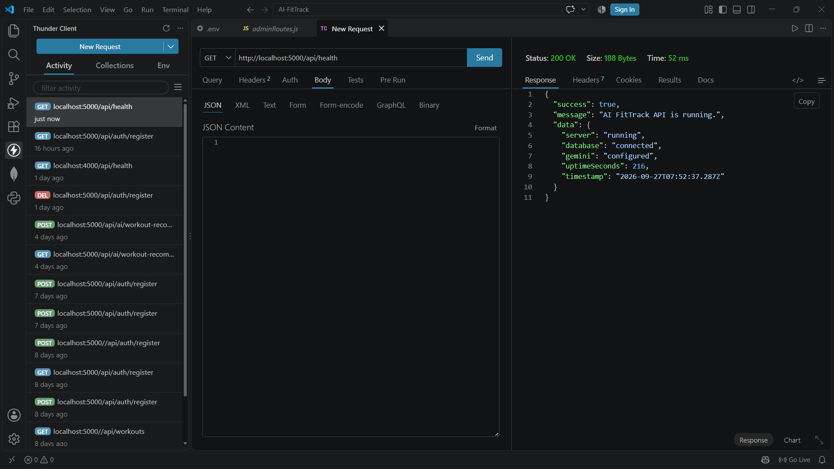
30.1 Health Check API
GET /api/health — 200 OK confirming the server is running, the database is connected, and Gemini is configured.

30.2 User Registration API
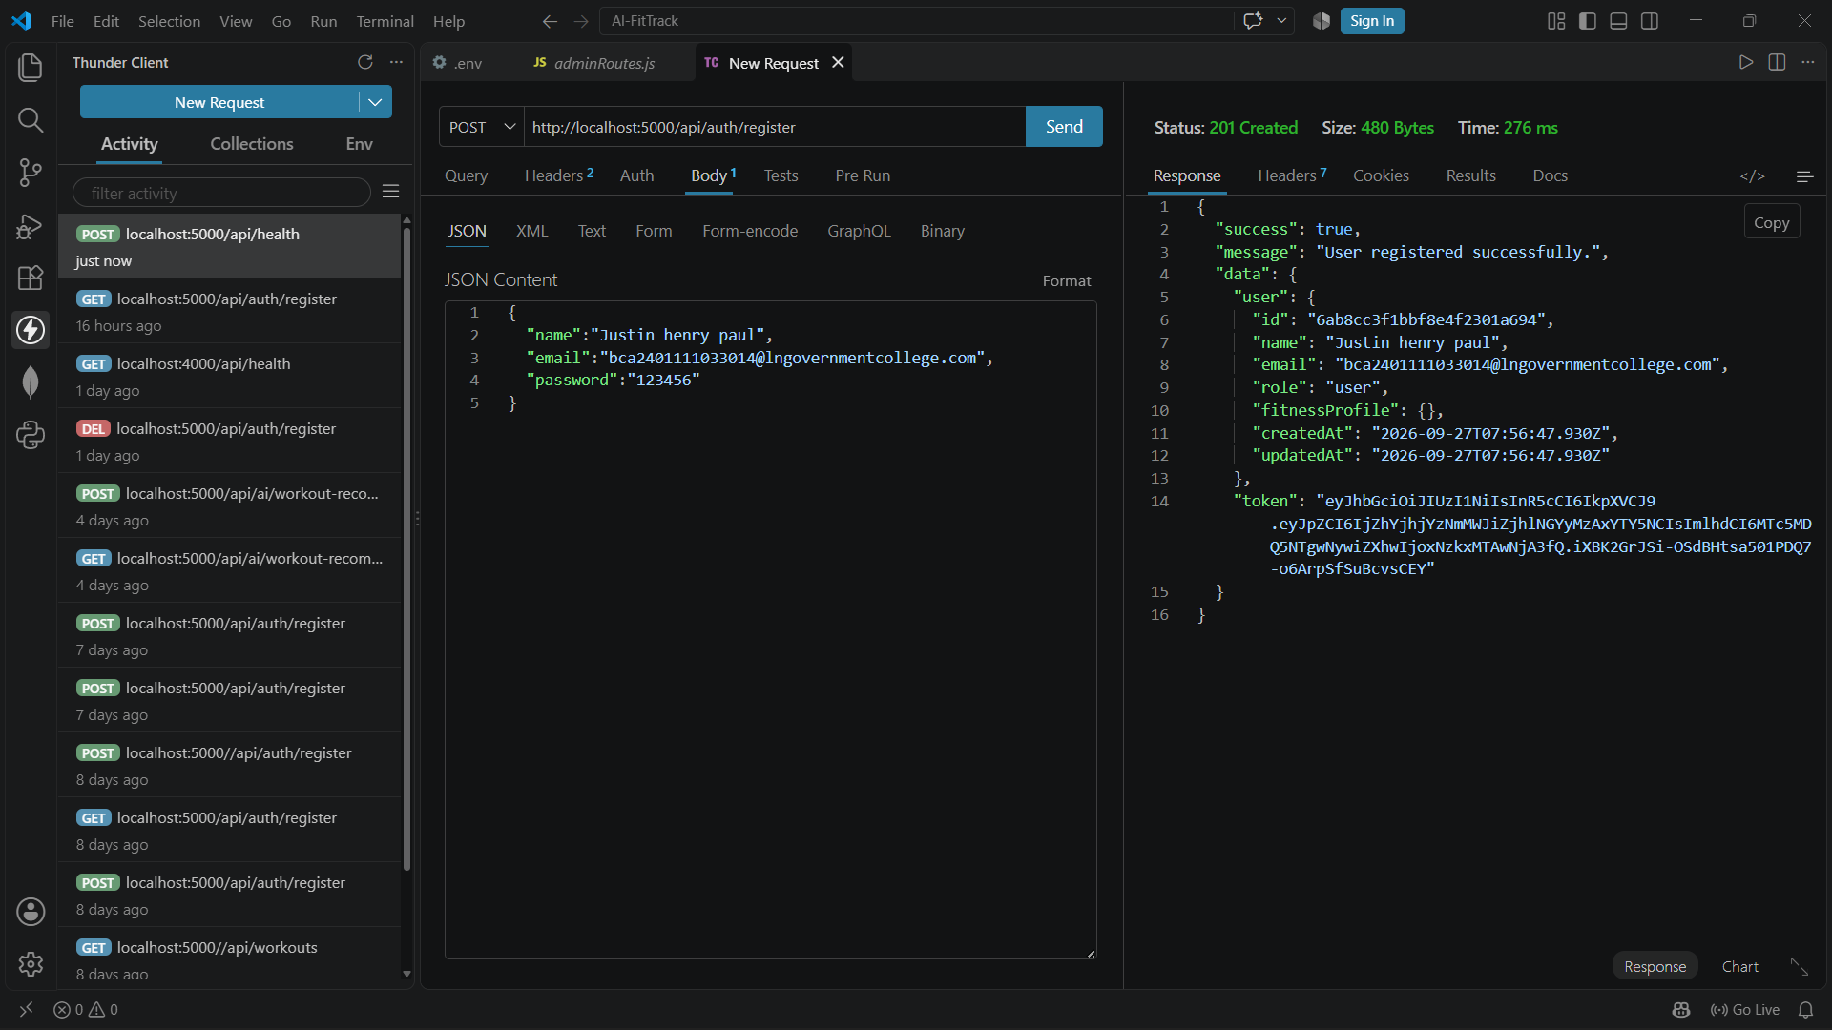
30.2 User Registration API
POST /api/auth/register — 201 Created, returning the new user object and a JWT.

30.3 Login API and JWT Response
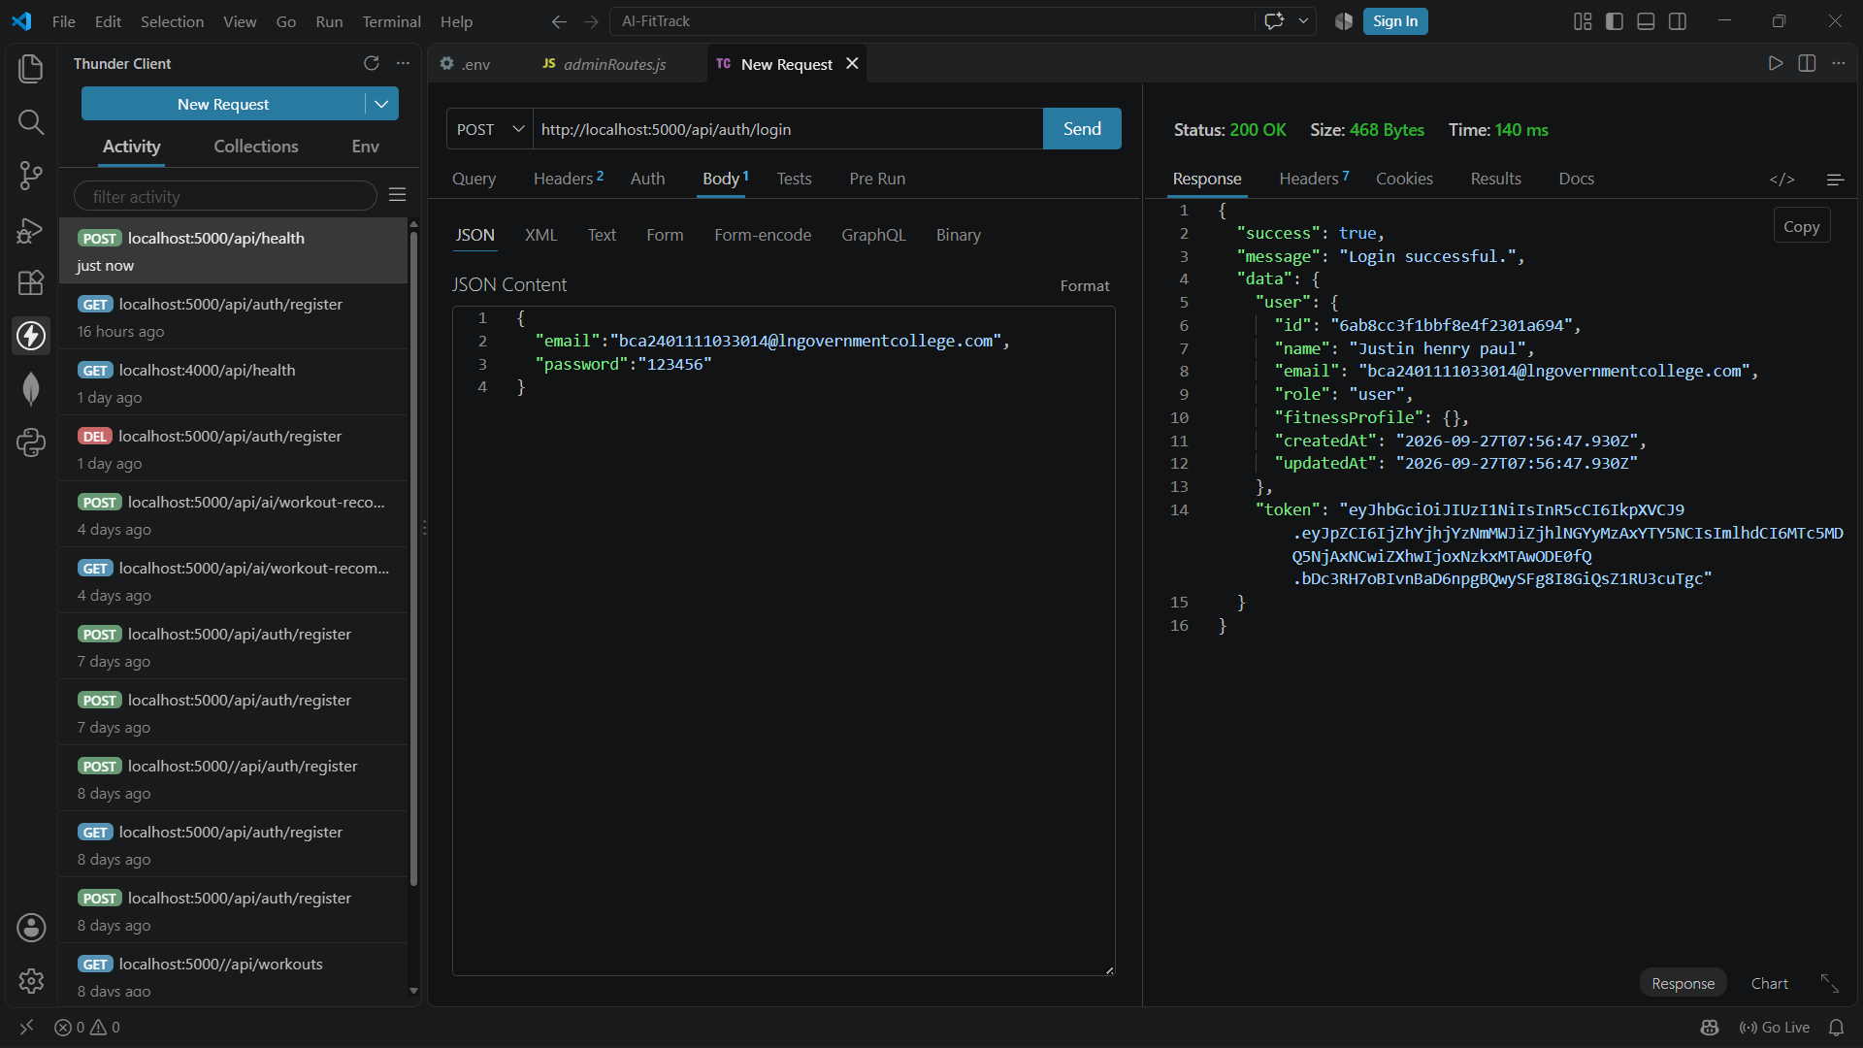
30.3 Login API and JWT Response
POST /api/auth/login — 200 OK, returning the user object and a freshly issued JWT.

30.4 Profile API (Authenticated)
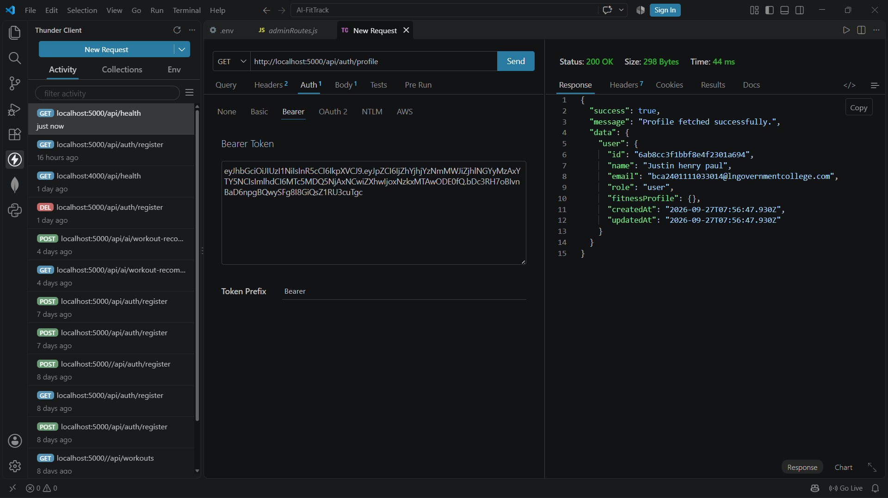
30.4 Profile API (Authenticated)
GET /api/auth/profile — 200 OK using a Bearer token, returning the member's safe profile.

30.5 Workout Creation API
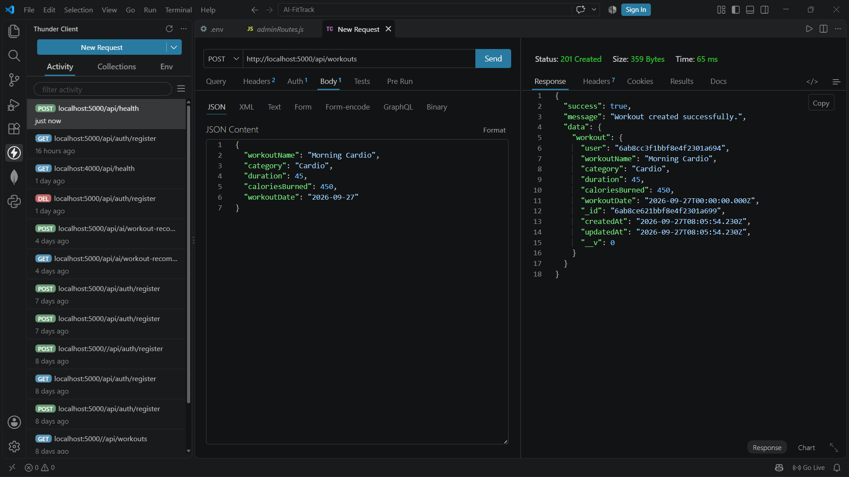
30.5 Workout Creation API
POST /api/workouts — 201 Created with the new workout document.

30.6 Workout Retrieval API
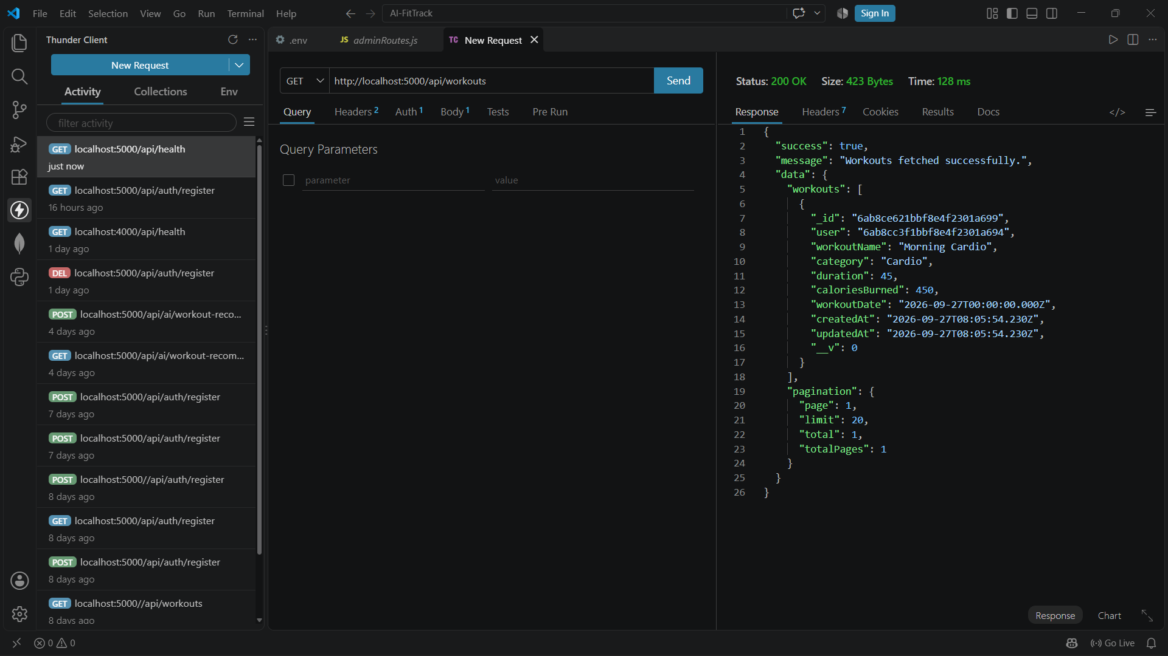
30.6 Workout Retrieval API
GET /api/workouts — 200 OK returning the paginated list of the member's workouts.

30.7 Fitness Goal Creation API
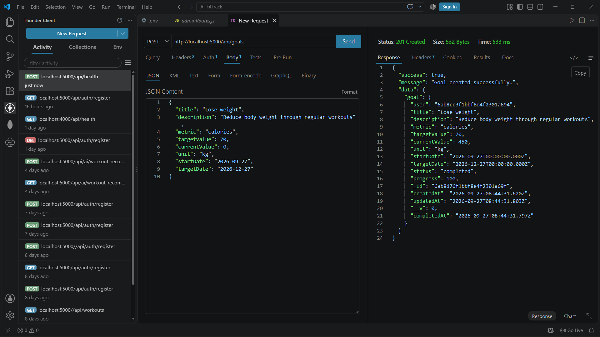
30.7 Fitness Goal Creation API
POST /api/goals — 201 Created; note status and progress are already server-calculated in the response.

30.8 Fitness Goal Retrieval API
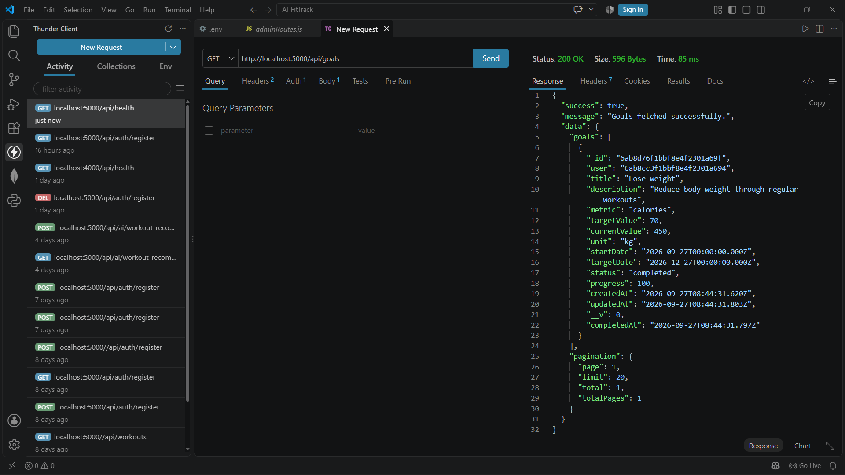
30.8 Fitness Goal Retrieval API
GET /api/goals — 200 OK, showing the goal with its recalculated currentValue, progress and status.

30.9 Attendance Check-In API
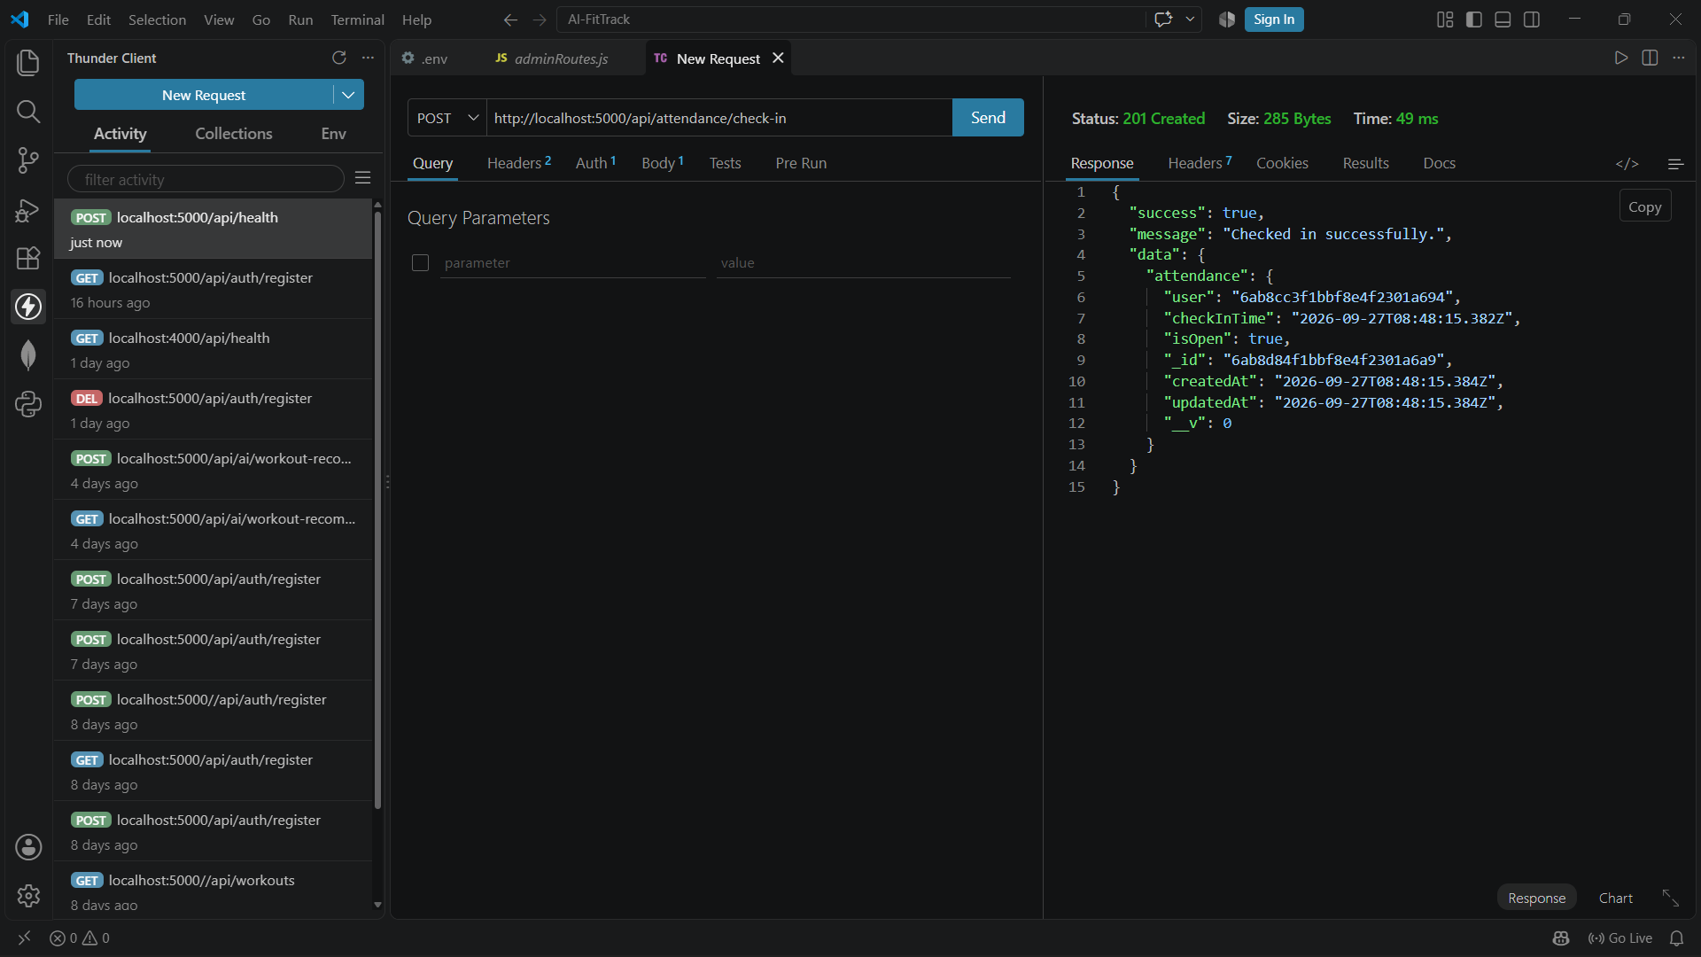
30.9 Attendance Check-In API
POST /api/attendance/check-in — 201 Created, opening a new visit with isOpen: true.

30.10 Attendance Check-Out API
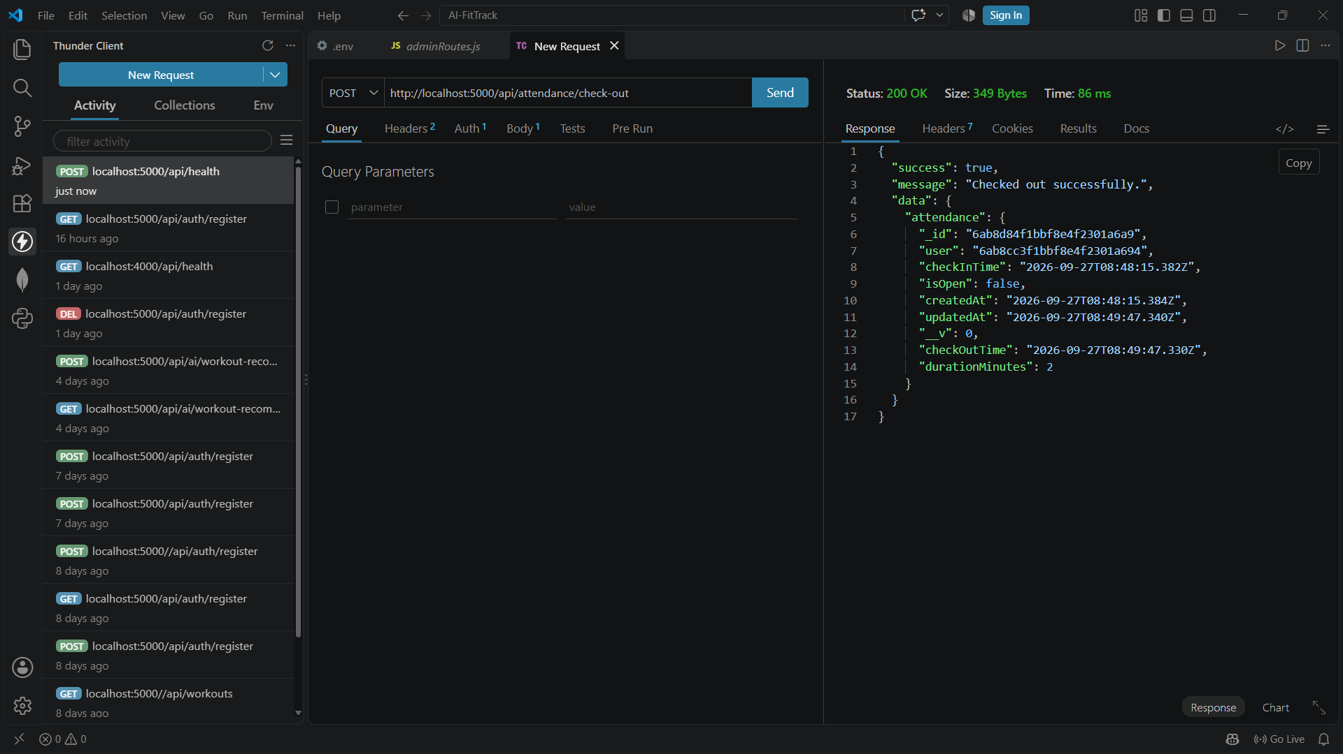
30.10 Attendance Check-Out API
POST /api/attendance/check-out — 200 OK, closing the visit and returning durationMinutes.

30.11 Progress Summary API
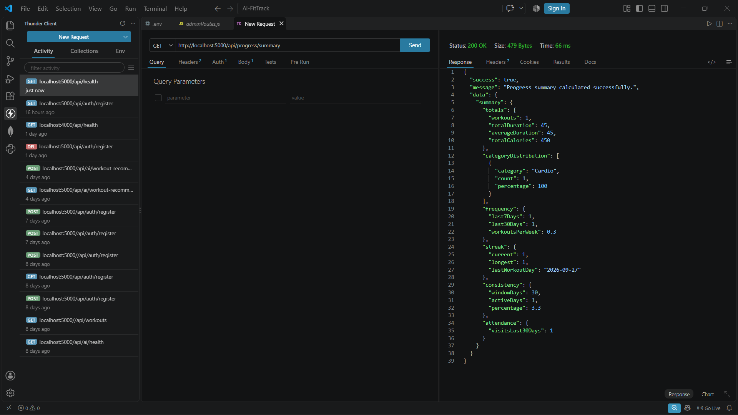
30.11 Progress Summary API
GET /api/progress/summary — 200 OK with totals, category distribution, frequency, streak, consistency and attendance.

30.12 Weekly Progress API
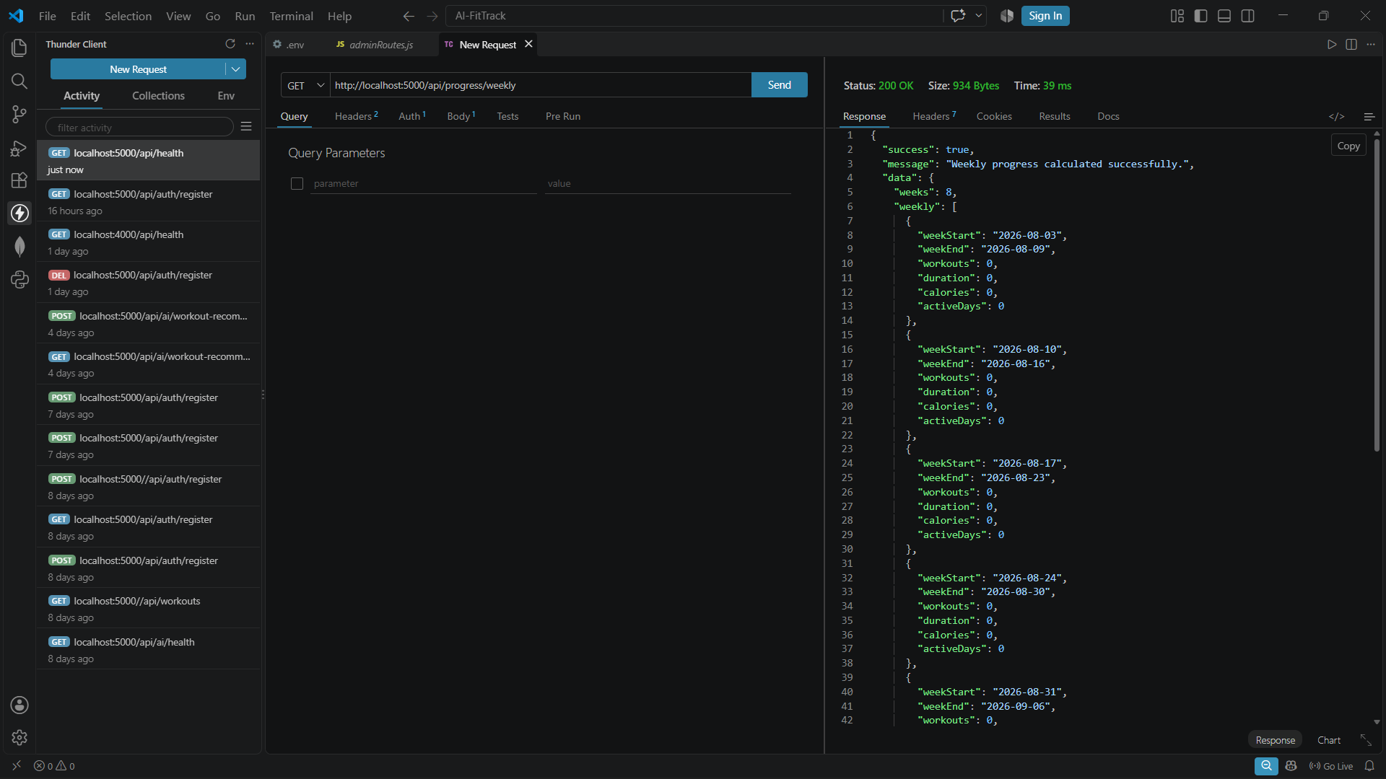
30.12 Weekly Progress API
GET /api/progress/weekly — 200 OK with an 8-week bucketed breakdown of workouts, duration, calories and active days.

30.13 AI Workout Recommendation API
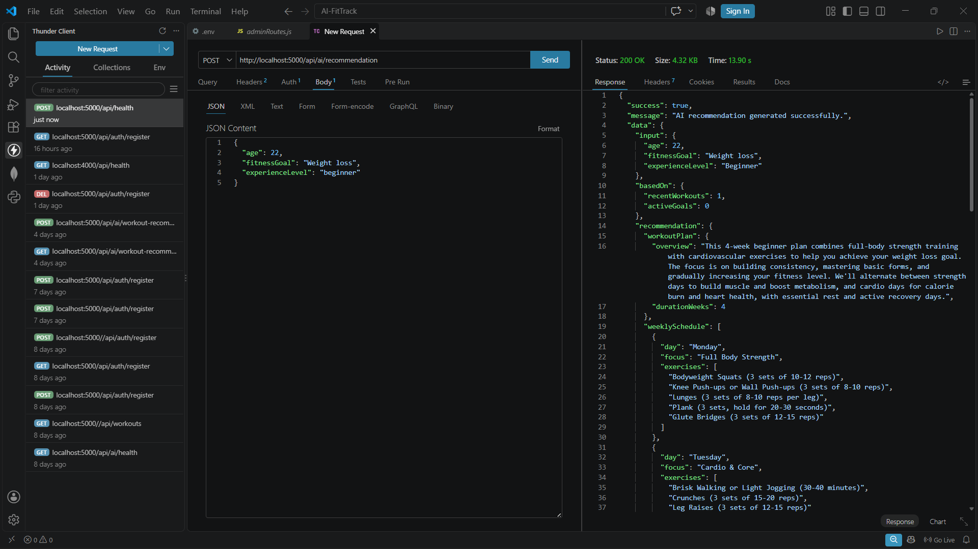
30.13 AI Workout Recommendation API
POST /api/ai/recommendation — 200 OK with a Gemini-generated weekly workout plan and schedule.

30.14 AI Fitness Insights API
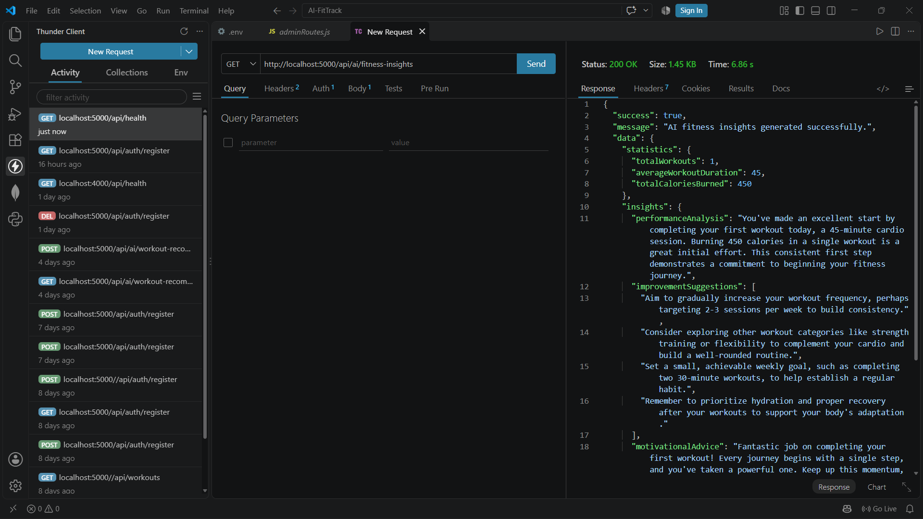
30.14 AI Fitness Insights API
GET /api/ai/fitness-insights — 200 OK with Gemini-generated performance analysis and improvement suggestions.

30.15 Admin Statistics API
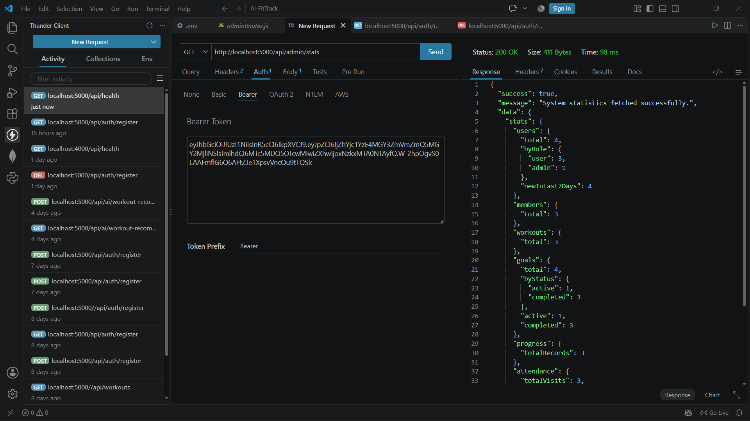
30.15 Admin Statistics API
GET /api/admin/stats — 200 OK using an admin Bearer token, returning system-wide user, workout, goal and attendance statistics.

30.16 Frontend Dashboard
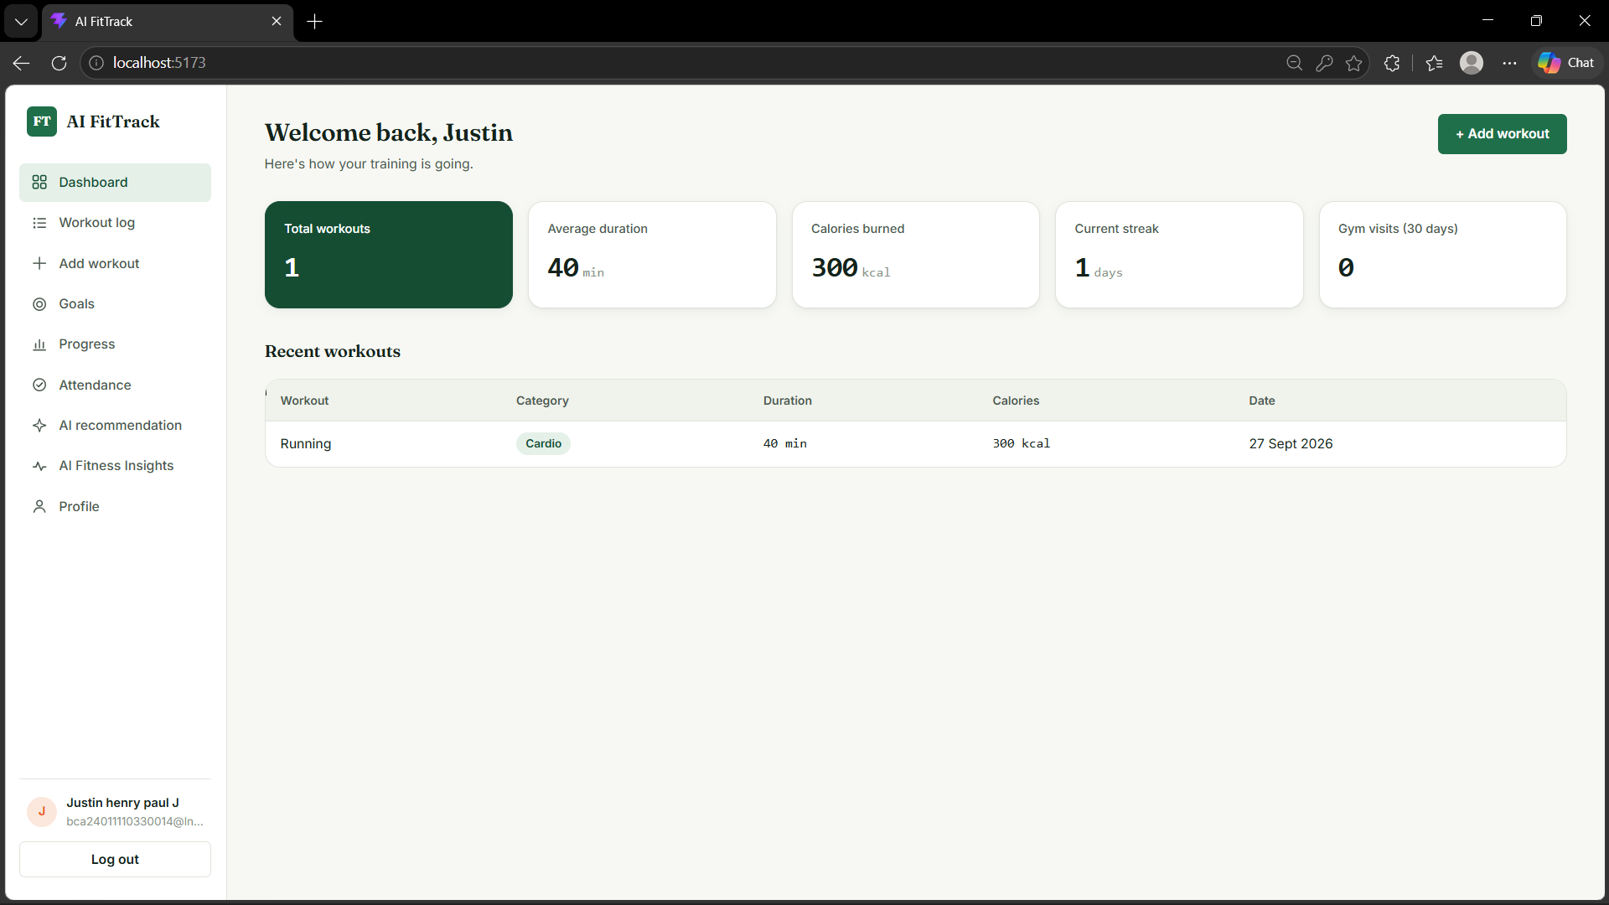

30.17 AI Recommendation Page
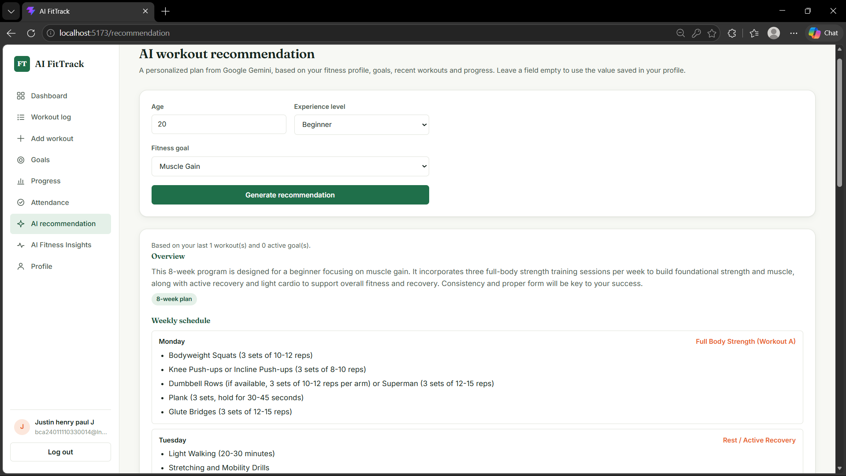

30.18 Progress/Analytics Page
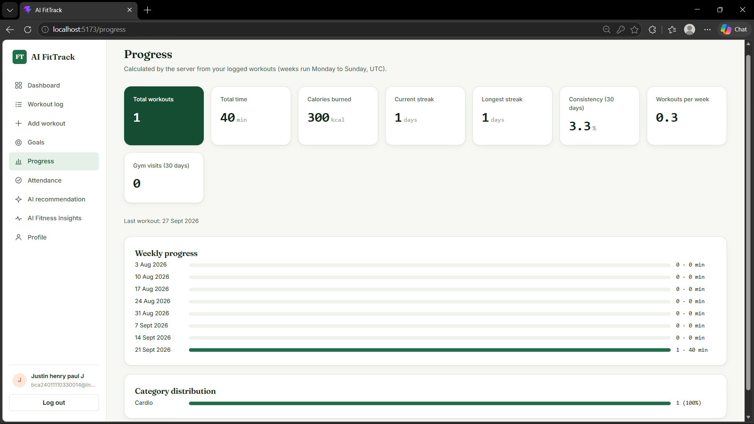

30.19 Admin Dashboard
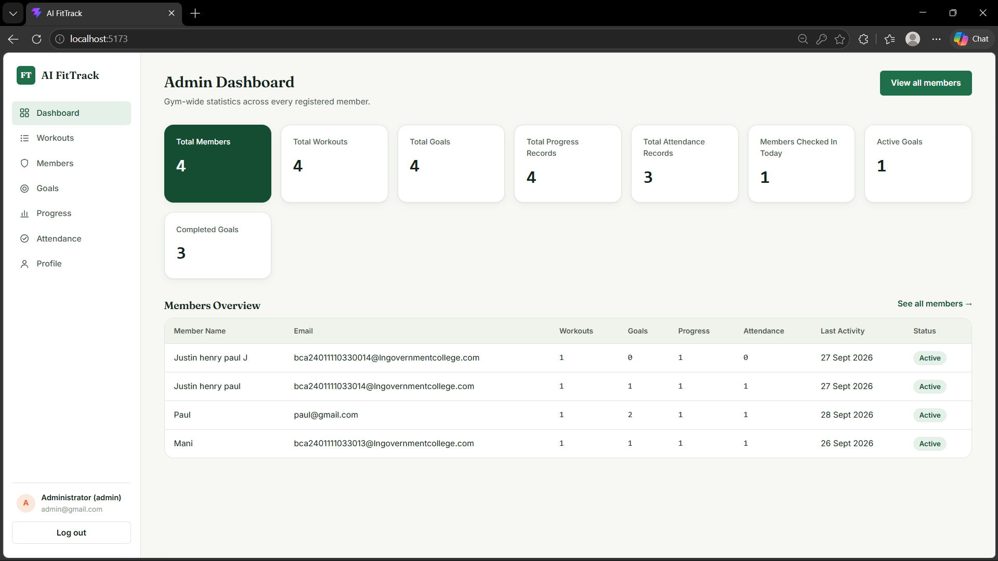

31. Demo Video Link
Demo Video Link:
Open Demo Video Folder

32. API Testing Video Link
API Testing Video Link:
Open API Testing Video Folder

33. Source Code Link
Open Source Code Folder

34. Mandatory Functionalities
Requirement | Implemented in AI FitTrack | Evidence
MVC Architecture | Yes | models/, routes/, controllers/, services/ separation (server.js, §12)
JWT Authentication | Yes | services/jwtService.js, middleware/authMiddleware.js
REST APIs | Yes | All routes in server/routes/, standardized JSON envelope
MongoDB | Yes | config/db.js, Mongoose models in server/models/
AI API Integration | Yes | services/geminiService.js (@google/genai), recommendationService.js, insightsService.js
Role-Based Access Control | Yes | middleware/authMiddleware.js authorize("admin"), adminRoutes.js
Prompt Engineering | Yes | System instructions + JSON-schema prompts in recommendationService.js and insightsService.js
API Testing | Yes | server/tests/ (automated) + Thunder Client procedure in §22
Semantic Search | Not implemented in the current version | No embedding generation, vector index, or semantic query exists in the source
Vector Search | Not implemented in the current version | No MongoDB Atlas Vector Search index or vector field exists in any model
RAG (Retrieval-Augmented Generation) | Not implemented in the current version | No document store, retrieval step, or embedding-based context injection exists

36. Conclusion
AI FitTrack, as it exists in the current codebase, is a complete, independently testable REST backend for fitness and gym-membership management. It implements secure JWT authentication, full workout and fitness-goal CRUD with server-enforced ownership and calculation rules, gym attendance tracking backed by a database-level concurrency guard, and progress analytics computed live from a member's own data. It integrates Google Gemini for two clearly scoped AI features — workout recommendations and fitness insights — both built strictly from the member's own stored information, with structured prompts, bounded retries, and error handling that fails safely without leaking upstream detail or secrets. A separate admin module gives gym staff system-wide visibility and management tools built on the same data and calculations members see for themselves.
This document deliberately does not claim template concepts such as semantic search, vector search, MongoDB Atlas Vector Search, Retrieval-Augmented Generation, document upload/analysis, or a conversational AI chatbot, because none of these exist in the current source code. Everything described above — every endpoint, field, validation rule, calculation, and error path — was verified directly against server/routes, server/controllers, server/services, server/models and server/middleware in AI-FitTrack.zip. Once the remaining placeholders (screenshots, demo video, API testing video, and source code link) are filled in with real assets, this document is ready to serve as the project's complete technical submission.

