PROJECT DOCUMENTATION
EduGenie
Google Gemini Powered Learning Assistant
An AI-powered educational assistant built with FastAPI, a plain HTML/CSS/JavaScript frontend and the Google Gemini API
Submit By:
NAME | REGISTER NUMBER
Keerthika | 2501111033017
Kaushik | 2501111033015
Karthika | 2501111033014
Kaviya | 2501111033016
EduGenie: Google Gemini Powered Learning Assistant

1. Project Description

1.1 Overview
EduGenie is a lightweight, web-based AI learning assistant that uses generative AI to make studying simpler. A student opens a single web page, chooses a learning task, enters a topic, question or passage, and receives an AI-generated result within seconds. The backend is written in Python with FastAPI, the frontend is built with plain HTML, CSS and JavaScript (no frontend framework), and all artificial intelligence is provided by the Google Gemini API through the official google-genai SDK.
Every request to Gemini passes through one central file, gemini_service.py. The Gemini model is not hard-wired into each feature: the default model is gemini-3.1-flash-lite and it can be changed by editing the GEMINI_MODEL value in the .env file. It runs locally with the uvicorn server.

1.2 Purpose of the Project
The purpose of EduGenie is to give learners a single, simple place where they can ask questions, understand difficult ideas, test themselves, revise long passages and plan what to study next. Instead of moving between search engines, notes and separate tools, the learner uses one interface backed by one AI service.

1.3 Target Users
- School and college students who need short, clear answers and simple explanations.
- Self-learners and beginners who want a structured roadmap for a new subject.
- Students preparing for revision who want to summarise long passages or check their understanding with a quiz.

1.4 Main Objectives
- To provide concise AI-generated answers to educational questions.
- To explain difficult concepts in simple, beginner-friendly language with an example.
- To generate a multiple-choice quiz from a topic or a pasted passage and let the learner check the score.
- To summarise long educational text into a short, readable form.
- To generate a Beginner, Intermediate and Advanced learning path with timelines, resources and tips.
- To keep all Gemini access in one central service so that the model and error handling can be changed in one place.
- To validate user input and return clear, friendly error messages instead of server crashes.

1.5 Main Features
Table 1: Features implemented in EduGenie
Feature | Endpoint | Source File | What it does
Question Answering | POST /qa | qna.py | Answers an academic or general question clearly and concisely.
Concept Explanation | POST /explain | explanation_module.py | Explains a topic to a beginner with a short explanation, an example and key points.
Quiz Generation | POST /quiz | quiz_module.py | Creates a 3-question multiple-choice quiz (4 options each) from a topic or text.
Text Summarization | POST /summarize | summary_module.py | Condenses an educational passage into a shorter summary.
Personalized Learning Path | POST /learn/recommendations | learning_path.py | Builds a Beginner, Intermediate and Advanced roadmap for a topic and starting level.
Health Check | GET /health | main.py | Returns {"status": "ok"}; used by the tests and shown as a status indicator in the page header.

2. Scenarios
The following scenarios describe how a student uses EduGenie. Each scenario follows the behaviour implemented in the source code.

Scenario 1: Question Answering
A student who is studying geography selects the Q&A task and types “Which is the largest ocean?” into the question box. After clicking Generate, the frontend sends the question to the /qa endpoint, Gemini is asked to answer clearly and concisely, and the answer appears in an Answer card below the form.

Scenario 2: Concept Explanation
A student finds the Pythagoras Theorem difficult. On the default Explain task she enters the topic and clicks Generate. EduGenie asks Gemini to explain the concept to a complete beginner: a short explanation of two to four sentences, a simple real-world example and, where relevant, key formulas or key points as bullets. The result is displayed in an Explanation card.

Scenario 3: Quiz Generation
To test her understanding, the student opens the Quiz task. She enters a topic (By topic) or pastes a passage (By pasting text) and receives three multiple-choice questions with four options each. After choosing answers and clicking Submit Quiz, the page marks correct and incorrect options, shows the correct answers and displays a score such as “2 / 3”.

Scenario 4: Summarization
Before an examination, a student pastes a long paragraph from a textbook into the Summary task. EduGenie asks Gemini to keep the important facts, remove repetition and present a shorter summary, shown in a Summary card.

Scenario 5: Personalized Learning Path
A learner who wants to study SQL opens the Recommend Path task, enters “SQL” as the topic and selects the current level (Beginner, Intermediate or Advanced) from a drop-down list. EduGenie returns a structured path with three stages (Beginner, Intermediate, Advanced), a timeline and a list of topics for each stage, a list of learning resources and a set of study tips.

Scenario 6: Handling Invalid Input
If a student clicks Generate with an empty field, the page shows a friendly message such as “Please enter a question.” without contacting the server. If the input is too long or the AI service is unavailable or rate-limited, the backend returns a JSON error that the page shows in a red error banner.

3. Architectural Diagram
EduGenie follows a simple layered architecture. The student interacts with a browser-based frontend. The frontend sends JSON requests to a FastAPI backend. The backend routes each request to one of five independent feature modules, and every module calls a single central Gemini service, which communicates with the Google Gemini API. The generated response travels back along the same path and is displayed by the frontend.
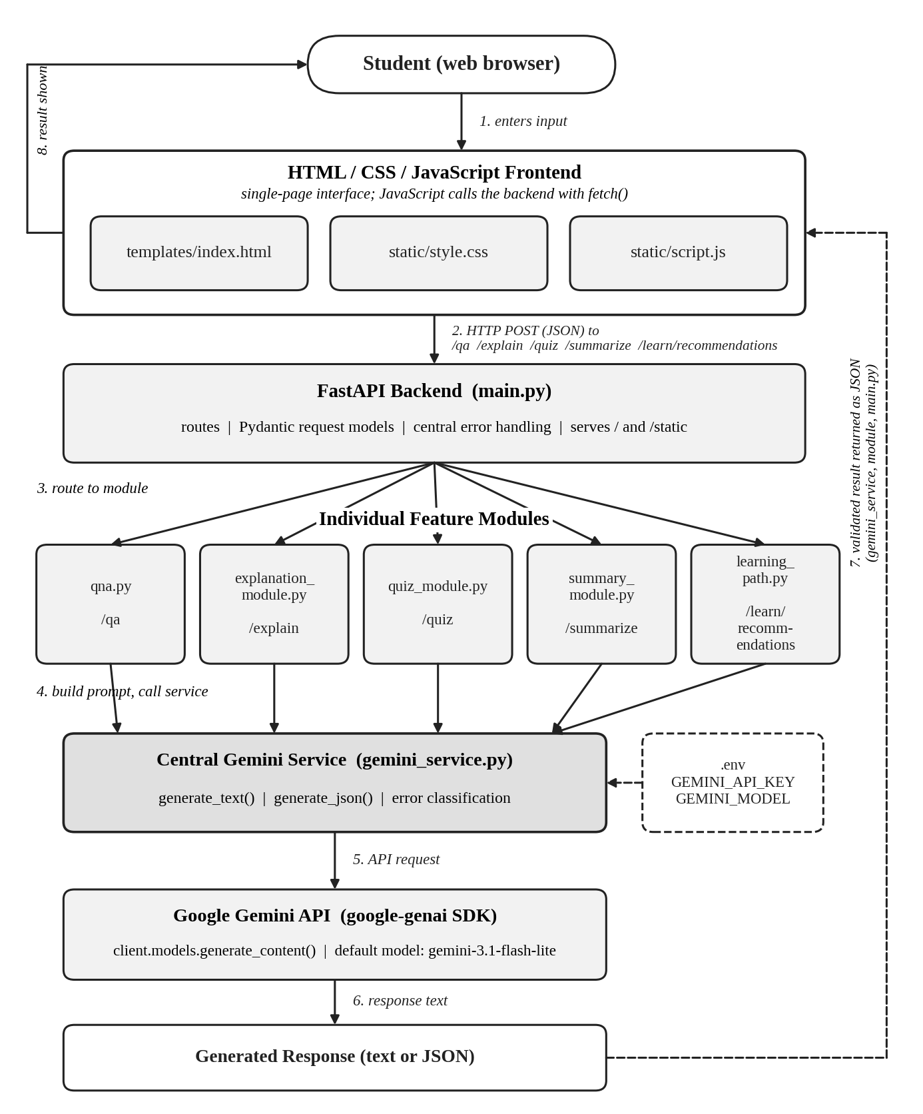
Fig. EduGenie System Architecture

Layers in the architecture
- Frontend: templates/index.html provides the page structure, static/style.css provides the styling and static/script.js builds the task forms, calls the backend with fetch() and renders the results.
- FastAPI backend: main.py defines the routes, request models, error handling and serves the page and static files.
- Feature modules: qna.py, explanation_module.py, quiz_module.py, summary_module.py and learning_path.py each validate input, build a prompt and process the result for one feature.
- Central Gemini service: gemini_service.py reads the API key and model name from the environment, creates the Gemini client once, sends prompts, parses JSON when needed and converts SDK errors into project-specific exceptions.
- Google Gemini API: the cloud model that generates the text or JSON, reached through the google-genai SDK.

4. Pre-requisites
The following software and services are required to run EduGenie. The version numbers for the Python packages are taken from requirements.txt and are minimum versions.
Table 2: Pre-requisites and their roles
Component | Requirement | Role in EduGenie
Python | 3.10 or newer (as stated in README.md) | Runtime for the backend, the modules and the tests.
FastAPI | fastapi>=0.115.0 | Web framework that defines the routes, validates requests and returns JSON responses.
Uvicorn | uvicorn[standard]>=0.32.0 | ASGI server that runs the FastAPI application (uvicorn main:app --reload).
Pydantic | pydantic>=2.9.0 | Defines request models and the quiz schema; validators check topic/text and the quiz structure.
python-dotenv | python-dotenv>=1.0.1 | Loads GEMINI_API_KEY and GEMINI_MODEL from the .env file into the environment.
Google Gemini SDK | google-genai>=1.0.0 | Official SDK used in gemini_service.py (from google import genai) to call the Gemini API.
Jinja2 | jinja2>=3.1.4 | Template engine used through Jinja2Templates to serve templates/index.html.
HTTPX | httpx>=0.27.0 | HTTP client library required by FastAPI’s TestClient used in the test suite.
pytest | pytest>=8.3.0 | Testing framework used to run tests/test_api.py.
Gemini API key | Free key from Google AI Studio | Authenticates requests to Google Gemini; stored only in the backend .env file.
Web browser and internet | Any modern browser | Displays the interface; internet access is needed to reach the Gemini API and to load the Google Fonts used by the page.

Verifying Python
After installing Python 3.10 or newer (and selecting “Add Python to PATH” during installation on Windows), verify the installation from a terminal:
python --version

Obtaining a Gemini API key
- Open Google AI Studio (https://aistudio.google.com/apikey) and sign in with a Google account.
- Create an API key.
- Keep the key private. It is pasted into the local .env file, which is excluded from version control by .gitignore.

5. Installation and Environment Setup
The commands below are taken from the project’s README. Windows commands are shown first; the macOS/Linux equivalents are given where they differ.
- Extract the project. Extract EduGenie.zip. The archive contains the EduGenie folder with main.py at its top level.
- Open a terminal in the project directory. Open Command Prompt or PowerShell (or the VS Code terminal) inside the folder that contains main.py. All later commands must be run from this folder.
- Create a virtual environment.
python -m venv venv

# macOS / Linux
python3 -m venv venv

4. Activate the virtual environment.
venv\Scripts\activate

# macOS / Linux
source venv/bin/activate

5. Install the requirements.
pip install -r requirements.txt

6. Create the .env file by copying the example file.
copy .env.example .env

# macOS / Linux
cp .env.example .env

7. Configure the Gemini API key. Open .env and replace the placeholder with the real key:
GEMINI_API_KEY=your_real_api_key_here
GEMINI_MODEL=gemini-3.1-flash-lite
HOST=127.0.0.1
PORT=8000

8. Configure the Gemini model (optional). The default model is gemini-3.1-flash-lite. To use a different Gemini model, change only the GEMINI_MODEL line; no code change is required.
9. Start the FastAPI server.
uvicorn main:app --reload

10. Open the application in a browser at http://127.0.0.1:8000.
Table 3: Environment variables in .env.example
Variable | Default | Meaning
GEMINI_API_KEY | YOUR_GEMINI_API_KEY (placeholder) | Required. Read by gemini_service.py. If it is empty, the backend reports a missing-key error when a feature is used.
GEMINI_MODEL | gemini-3.1-flash-lite | Optional. Read by gemini_service.py; selects the Gemini model for every feature.
HOST, PORT | 127.0.0.1, 8000 | Listed in .env.example, but not read by the application code. The server address is set by uvicorn (default 127.0.0.1:8000; use --host and --port to change it).

The .env file is listed in .gitignore so that the secret key is never committed. The server must be started from the project folder because main.py mounts the static and templates folders using relative paths.

6. Project Workflow

MILESTONE 1: AI Integration and Architecture

Activity 1.1: AI Model Selection
EduGenie uses one AI provider for all five features: Google Gemini, accessed through the google-genai SDK (from google import genai). No local or offline model is used; every response is generated by the Gemini API in the cloud.
- Default model: gemini-3.1-flash-lite, defined in gemini_service.py (GEMINI_MODEL = os.getenv("GEMINI_MODEL", "gemini-3.1-flash-lite")). The source comment describes it as a fast, low-cost model.
- Configurable: setting GEMINI_MODEL in .env replaces the default without any code change.
- Used for: question answering, concept explanation, summarization, quiz generation (JSON output) and learning-path generation (JSON output).

Activity 1.2: Central Gemini Service
All modules import their Gemini functions from gemini_service.py. This gives the project a single place that knows how to call Gemini; if the SDK or the model name changes, only this file needs to be updated. The service provides the following:
- Configuration: load_dotenv() loads the .env file, then GEMINI_API_KEY and GEMINI_MODEL are read from the environment.
- Safe SDK import: the SDK import is wrapped in try/except, so the application and the tests still import successfully if the package is missing; a clear error is raised only when Gemini is actually called.
- Client creation: _get_client() creates the genai.Client once and reuses it. It raises MissingAPIKeyError if the key is empty.
- generate_text(prompt): rejects an empty prompt, calls client.models.generate_content(model=GEMINI_MODEL, contents=prompt), raises an error for an empty response and returns the stripped text.
- generate_json(prompt): calls generate_text(), removes a Markdown code fence if present (_strip_markdown_fence()) and parses the result with json.loads().
- Error classification: _classify_exception() converts raw SDK or network exceptions into project exceptions by inspecting the error message (timeout, 429/quota, API key/401/403, 404/model not found, connection/network).
def generate_text(prompt: str) -> str:
if not prompt or not prompt.strip():
raise ValueError("Prompt cannot be empty.")

client = _get_client()

try:
response = client.models.generate_content(
model=GEMINI_MODEL,
contents=prompt,
)
except GeminiServiceError:
raise
except Exception as exc:
raise _classify_exception(exc) from exc

text = getattr(response, "text", None)
if not text or not text.strip():
raise GeminiInvalidResponseError("Gemini returned an empty response. Please try again.")

return text.strip()
Fig. generate_text() in gemini_service.py (docstring and comments omitted)
Table 4: Exceptions defined in gemini_service.py
Exception | Raised when | HTTP status returned by main.py
MissingAPIKeyError | The key is missing, empty or rejected by Google. | 500 (generic “key missing or invalid” message)
GeminiRateLimitError | Quota or rate limit reached (429). | 429
GeminiTimeoutError | The request to Gemini times out. | 504
GeminiInvalidResponseError | Empty response, invalid JSON or an invalid quiz/path structure. | 502
GeminiServiceError (base) | SDK not installed, model not found, connection or other errors. | 502

Activity 1.3: Environment Configuration and Backend Architecture
Secrets and settings live in the .env file, never in source code. The backend is organised in three layers: routes in main.py, feature modules that hold the prompts and input checks, and the Gemini service that performs the API call. Because modules raise ordinary exceptions and main.py maps them to HTTP responses in one function (_handle_service_error), error handling is consistent across all endpoints.

7. Folder Architecture
The project is small and flat, which keeps it easy to understand and explain. The structure of the submitted project is shown below.
EduGenie/
|-- main.py # FastAPI app and route definitions
|-- gemini_service.py # Centralized Gemini client and error handling
|-- qna.py # Question answering
|-- explanation_module.py # Concept explanation
|-- quiz_module.py # Quiz generation and validation
|-- summary_module.py # Summarization
|-- learning_path.py # Personalized learning path
|-- requirements.txt # Python dependencies
|-- .env.example # Template for environment variables
|-- .gitignore # Excludes .env, caches, virtual environments
|-- README.md # Setup and usage guide
|-- templates/
| `-- index.html # Single-page frontend
|-- static/
| |-- style.css # Styling
| `-- script.js # Frontend logic
`-- tests/
`-- test_api.py # Endpoint tests (Gemini calls mocked)
Fig. Folder structure of the EduGenie project
Table 5: Purpose of each file and folder
File / Folder | Purpose
main.py | FastAPI application: creates the app, mounts /static, configures Jinja2 templates, defines request models, the error handlers and all API routes.
gemini_service.py | Centralised Gemini integration: configuration, client creation, generate_text(), generate_json(), Markdown-fence cleanup and custom exceptions.
qna.py | Question answering module: input checks (max 1000 characters), prompt and call to generate_text().
explanation_module.py | Concept explanation module: input checks (max 300 characters), beginner-friendly prompt and call to generate_text().
quiz_module.py | Quiz module: QuizRequest, QuizQuestion and QuizResponse models, prompt construction, generate_json() call and structure validation.
summary_module.py | Summarization module: input checks (max 12,000 characters), prompt and call to generate_text().
learning_path.py | Learning path module: LearningPathRequest model, level handling, JSON prompt, generate_json() call and result checks.
templates/index.html | Single HTML page with the header, task rail, input card and result area.
static/style.css | Design tokens, layout, forms, quiz and learning-path styles and responsive rules.
static/script.js | Task definitions, dynamic form fields, validation, fetch() calls, result renderers, quiz grading and health check.
tests/test_api.py | pytest suite that tests every route with the Gemini functions mocked.
requirements.txt | List of Python packages to install.
.env.example | Template for GEMINI_API_KEY, GEMINI_MODEL, HOST and PORT.
.gitignore | Keeps .env, __pycache__, virtual environments and test caches out of version control.
README.md | Feature list, setup steps, API table, example requests, testing and troubleshooting.

8. Core Functionalities

MILESTONE 2: Core Functionalities Development

Activity 2.1: Module Implementation
Each learning feature is implemented as a separate Python module. Every module follows the same pattern: trim and validate the input, build a prompt that begins with an “EduGenie” persona, send it through gemini_service.py and return the result. All prompts, input limits and structures below are taken directly from the source files.
Table 6: Summary of feature modules
Module | Function | Input limit | Gemini helper | Output
qna.py | answer_question() | 1000 chars | generate_text | Text answer
explanation_module.py | explain_concept() | 300 chars | generate_text | Text explanation
quiz_module.py | generate_quiz() | Topic 300, text 6000 chars | generate_json | Dictionary with 3 questions
summary_module.py | summarize_text() | 12,000 chars | generate_text | Text summary
learning_path.py | generate_learning_path() | Topic 300 chars | generate_json | Dictionary: stages, resources, tips

1. Explanation Module (explanation_module.py)
The function explain_concept(topic) trims the topic, raises a ValueError if it is empty or longer than 300 characters, and builds a prompt in which EduGenie acts as a friendly tutor. Gemini is asked to explain the concept to a complete beginner, avoid unnecessary jargon and structure the reply in order: (1) a short, simple explanation of 2–4 sentences, (2) a simple real-world example and (3) key formulas or key points as bullets, only if relevant. The text returned by Gemini is passed back unchanged.

2. Q&A Module (qna.py)
The function answer_question(question) trims the question, rejects an empty question or one longer than 1000 characters, and sends a prompt in which EduGenie is a friendly study assistant. Gemini is asked to answer clearly and concisely in plain language, use short bullet points where helpful, avoid filler and avoid repeating the question. The reply is returned as text.

3. Quiz Module (quiz_module.py)
- Input: QuizRequest accepts an optional topic and an optional text. At least one is required; the topic may be up to 300 characters and the text up to 6000 characters. If both are supplied, the text is used to build the prompt.
- Prompt construction: the prompt asks for EXACTLY 3 multiple-choice questions based on the topic or the text, demands valid JSON only (no Markdown fences), gives the exact JSON structure (questions list of objects with question, options and correct_answer), requires exactly 4 options per question, requires correct_answer to be an exact copy of one option, and asks for plausible wrong options.
- Gemini generation and JSON handling: generate_json() is used. It removes a Markdown fence if Gemini added one and parses the JSON; unparseable output raises GeminiInvalidResponseError.
- Validation: the parsed data is validated with the Pydantic model QuizResponse: exactly 3 questions, each QuizQuestion has exactly 4 options and its correct_answer must match one of the options.
- Correct-answer handling: the correct answer is stored as the full text of the correct option (not a letter). The frontend compares the selected option text with it when grading.
- Error handling: a structure that fails validation is converted into GeminiInvalidResponseError and returned as HTTP 502 with a friendly message. There is no automatic retry.
class QuizQuestion(BaseModel):
question: str
options: List[str] = Field(..., min_length=4, max_length=4)
correct_answer: str

@model_validator(mode="after")
def check_correct_answer_in_options(self):
if self.correct_answer not in self.options:
raise ValueError("correct_answer must exactly match one of the options.")
return self

class QuizResponse(BaseModel):
questions: List[QuizQuestion] = Field(..., min_length=3, max_length=3)
Fig. Quiz validation models in quiz_module.py (docstrings omitted)

4. Summary Module (summary_module.py)
The function summarize_text(text) trims the text, rejects empty text or text longer than 12,000 characters, and asks Gemini to summarise the passage for a student: keep the important facts, remove repetition and filler, use short bullet points where they improve readability, and be noticeably shorter than the original while staying accurate. The length reduction is requested in the prompt; it is not enforced by code.

5. Learning Path Module (learning_path.py)
- Input: LearningPathRequest has a required topic (up to 300 characters) and a level that defaults to “Beginner”.
- Learner level: the level is matched case-insensitively against beginner, intermediate and advanced; any other value silently falls back to “Beginner”. The level is included in the prompt so that Gemini adapts pacing and depth.
- Generated stages: the prompt requires three stages in the order Beginner, Intermediate, Advanced, each with a timeline (for example “Week 1-2”) and 3 to 5 topic-specific subtopics.
- Resources: 3 to 6 learning resources, each with a type (Video, Article, Book or Documentation) and a title.
- Tips: a list of study tips.
- Checks: the module confirms that the parsed result is a dictionary with a non-empty stages list; it then fills in default values for topic, current_level, resources and tips if they are missing.

9. Q&A Module Logic
The Q&A feature is exposed through POST /qa. The steps below describe the complete life of one question.
- User enters a question. On the Q&A task the student types the question in the textarea (limited to 1000 characters by the maxlength attribute).
- Frontend sends the request. When Generate is clicked, script.js first checks that the field is not empty, then calls fetch("/qa") with the JSON body {"question": "..."}.
- FastAPI receives the request. The function qa_endpoint(payload: QARequest) in main.py receives the body.
- Request validation occurs. Pydantic checks that the question field exists and is a string. A missing or invalid field is turned into an HTTP 400 response with an error message by the custom RequestValidationError handler.
- Q&A module processes the request. qna.answer_question() trims the text, rejects an empty question (“Please enter a question.”) or one over 1000 characters, and builds the prompt.
- Gemini service is called. The module calls generate_text(prompt) in gemini_service.py.
- Gemini generates the response. The service calls client.models.generate_content() with the configured model and returns the stripped text.
- Backend returns the response. main.py returns {"answer": "..."} with status 200. If any exception occurs, _handle_service_error() returns {"error": "..."} with the appropriate status code.
- Frontend displays the response. renderProseCard("Answer", data.answer) converts the text into paragraphs, bullet lists and bold text and shows it in the result area; on error the message appears in the red error banner.
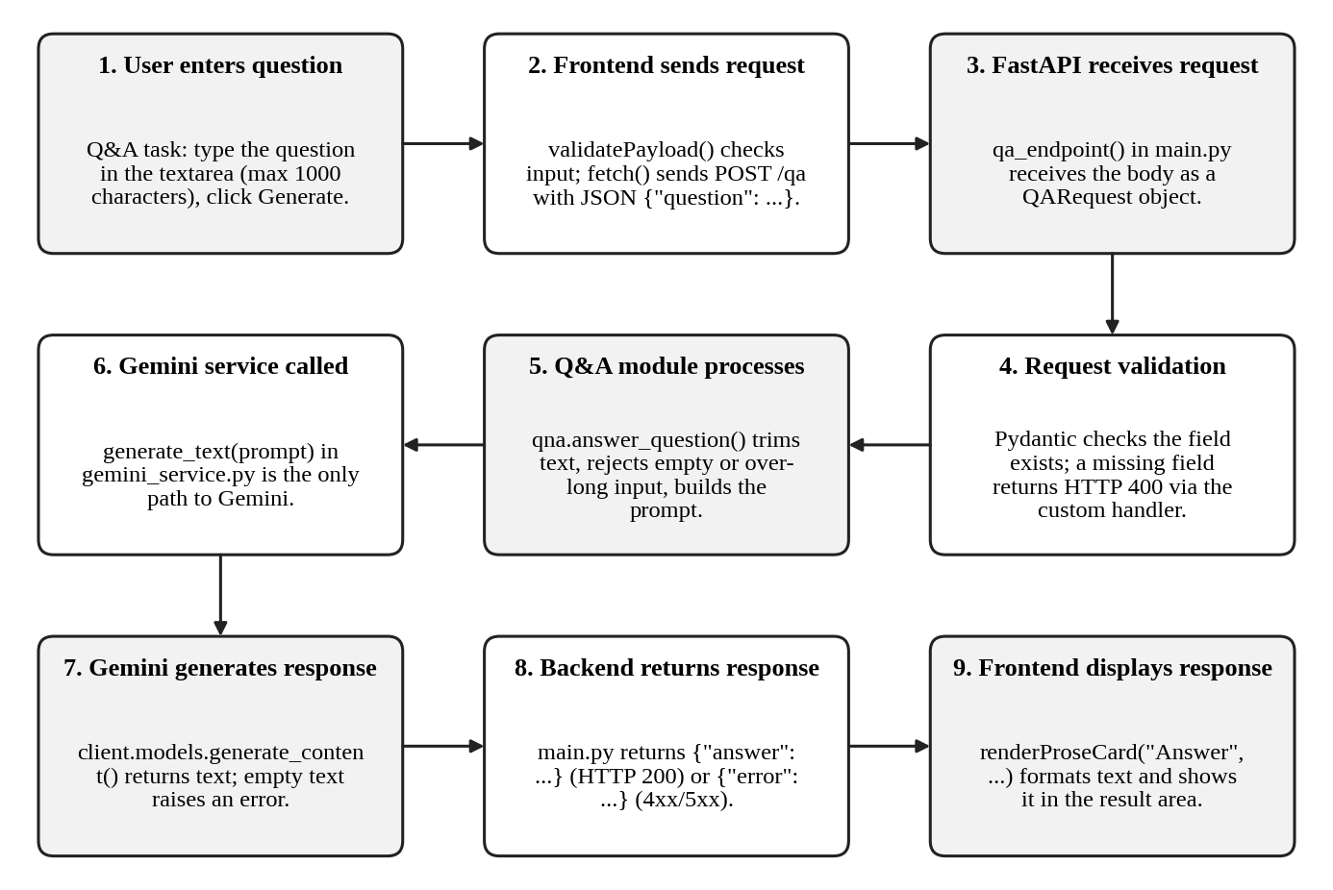
Fig. Q&A Module Logic
@app.post("/qa")
async def qa_endpoint(payload: QARequest):
try:
answer = qna.answer_question(payload.question)
return {"answer": answer}
except Exception as exc:
return _handle_service_error(exc)
Fig. The /qa route in main.py (comments omitted)
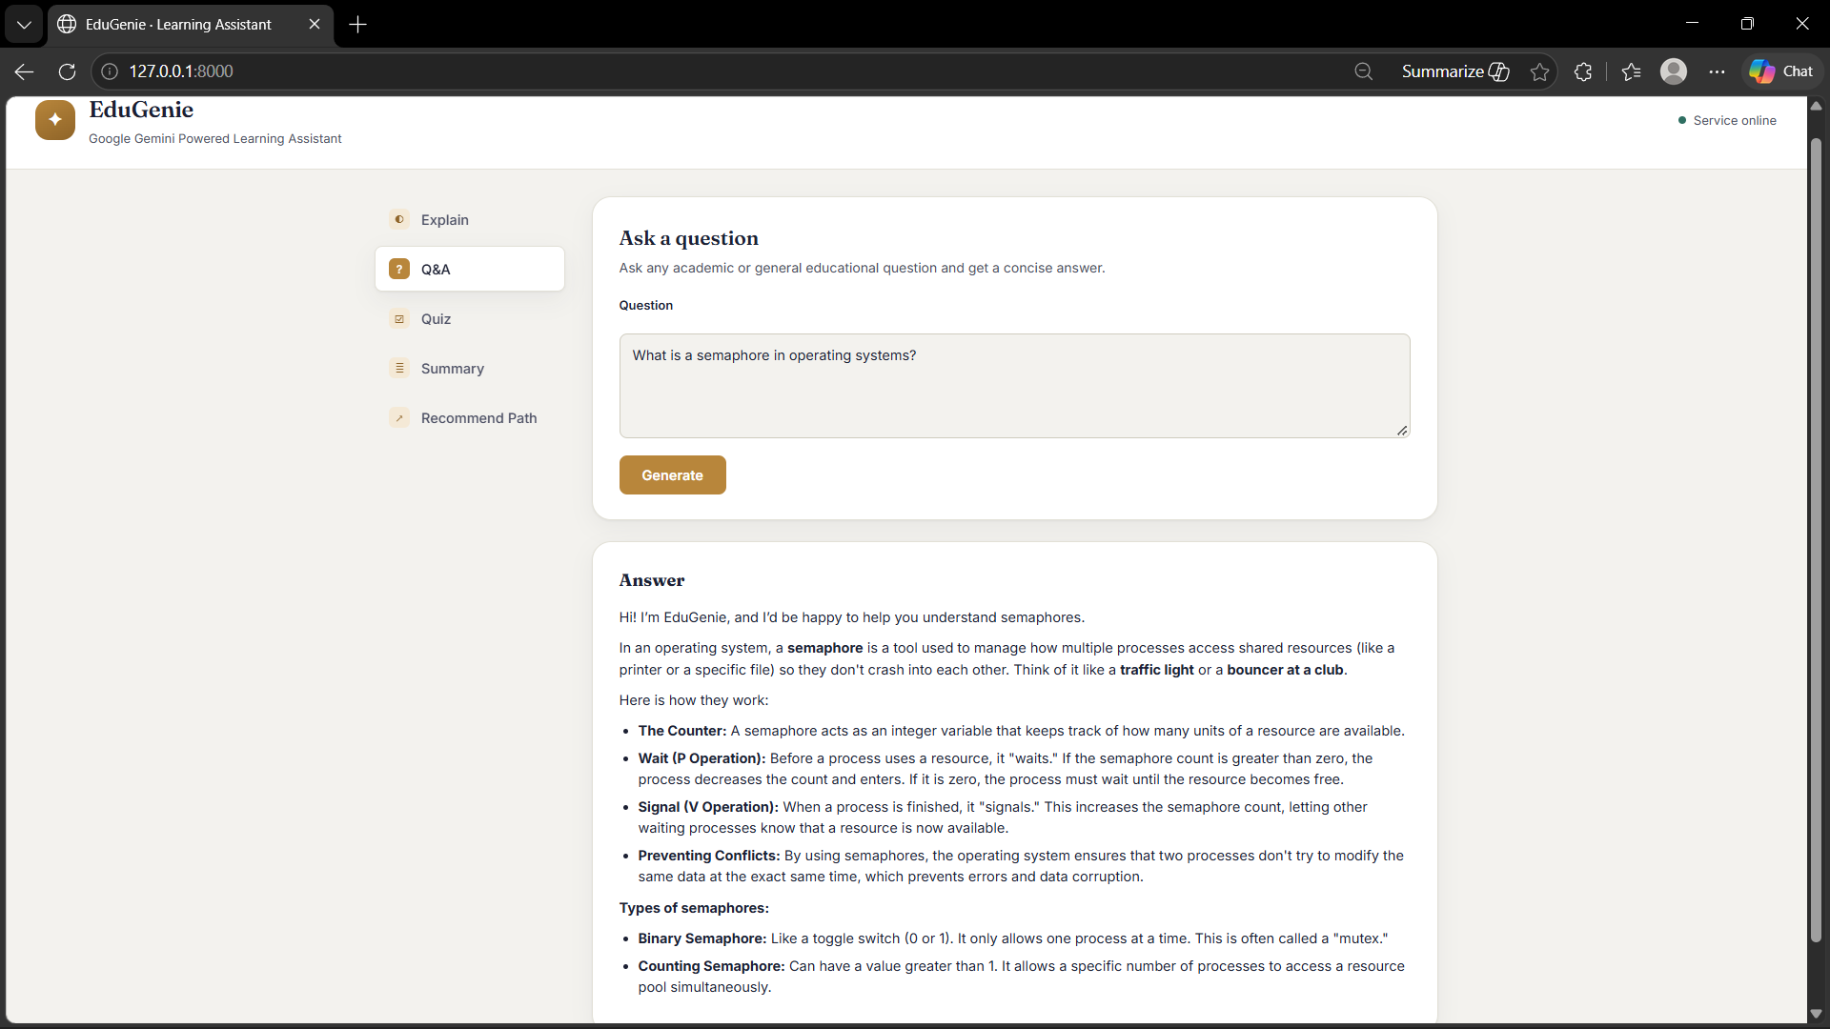
Fig. EduGenie Q&A Interface

10. Explanation Module Logic
The concept explanation feature is exposed through POST /explain and is the default task shown when the page loads.
- Input. The student enters a topic (for example “Pythagoras Theorem”) in the Topic field, which is limited to 300 characters.
- Client-side validation. validatePayload() in script.js shows “Please enter a topic to explain.” if the field is empty. Otherwise fetch("/explain") sends {"topic": "..."}.
- Server-side validation. explain_endpoint(payload: ExplainRequest) in main.py receives the request and calls explanation_module.explain_concept(payload.topic).
- Input checks. The function trims the topic. An empty topic (“Please enter a topic to explain.”) or a topic over 300 characters raises ValueError, which main.py returns as HTTP 400.
- Prompt construction. A tutor persona is used. Gemini is told to explain to a complete beginner without unnecessary jargon, in three ordered parts: a 2–4 sentence explanation, a simple real-world example and key formula or key points as bullets if relevant.
- Gemini call. generate_text(prompt) sends the prompt through the central service and returns the generated explanation.
- Response. main.py returns {"explanation": "..."} with status 200.
- Frontend display. renderProseCard("Explanation", data.explanation) shows the text in an Explanation card. Bullet lines beginning with “-” or “*”, headings beginning with “#” and bold text are converted to HTML after the text has been escaped.
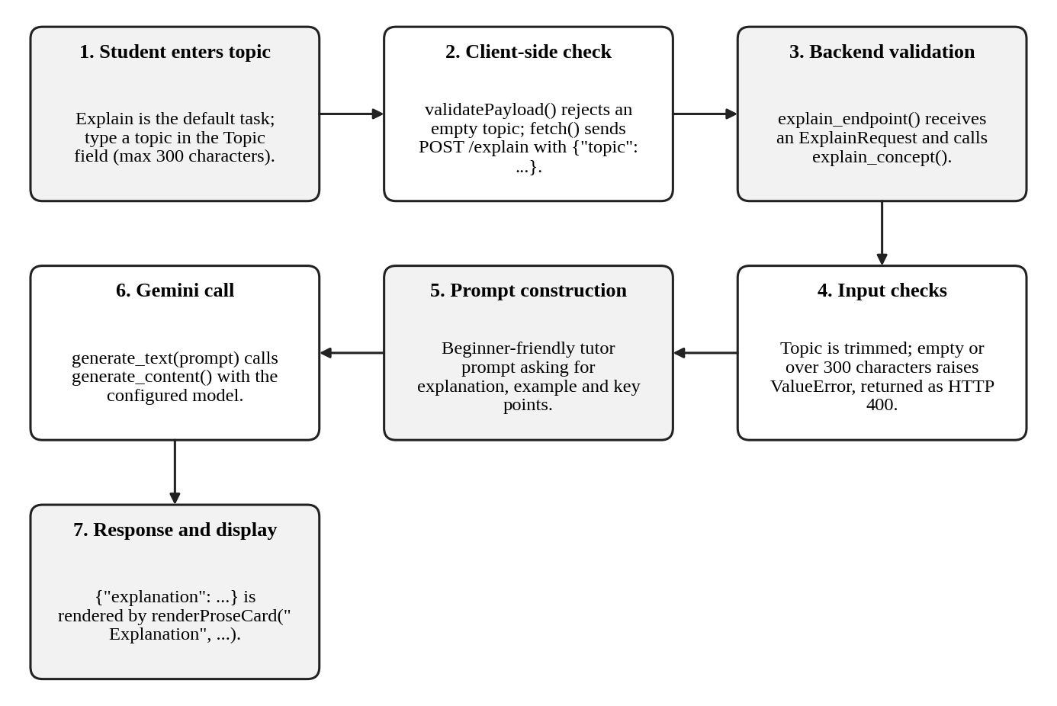
Fig. Explanation Module Logic
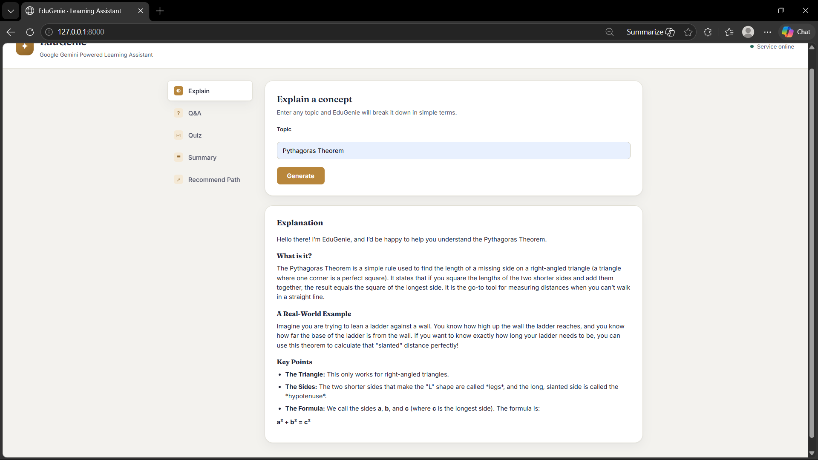
Fig. EduGenie Explain Interface

11. Quiz Module Logic
Quiz generation is the most structured feature because the AI must return machine-readable JSON that the backend validates before the frontend uses it.
- User enters a topic or text. On the Quiz task a toggle offers By topic and By pasting text. Only the visible field is sent: {"topic": "..."} or {"text": "..."}.
- Request reaches FastAPI. quiz_endpoint(payload: quiz_module.QuizRequest) receives the body. The QuizRequest validator requires a topic or text and enforces the 300/6000 character limits; a failure returns HTTP 400.
- Quiz module creates the prompt. generate_quiz(topic, text) builds a prompt for exactly 3 questions with 4 options each in a fixed JSON structure.
- Gemini generates a structured response. generate_json(prompt) calls generate_text(), which calls the Gemini API.
- Code-block cleanup. _strip_markdown_fence() removes a wrapper such as a Markdown json code fence if Gemini added one, even though the prompt forbids it.
- JSON parsing. json.loads() parses the cleaned text. If parsing fails, GeminiInvalidResponseError is raised (HTTP 502).
- Validation. QuizResponse.model_validate() checks for exactly 3 questions, 4 options per question and a correct_answer that equals one option. A mismatch raises GeminiInvalidResponseError (HTTP 502).
- Quiz returned to the frontend. main.py returns {"questions": [...]} with status 200.
- User selects answers. renderQuizCard() creates a form with one fieldset per question and radio buttons for the four options.
- Score is displayed. On Submit Quiz, gradeQuiz() compares each selected option with the correct answer, highlights correct options in green and wrong selections in red, writes “Correct!”, “Incorrect. Correct answer: ...” or “Not answered. Correct answer: ...” under each question, shows the score banner (for example “2 / 3 correct”) and disables further changes.
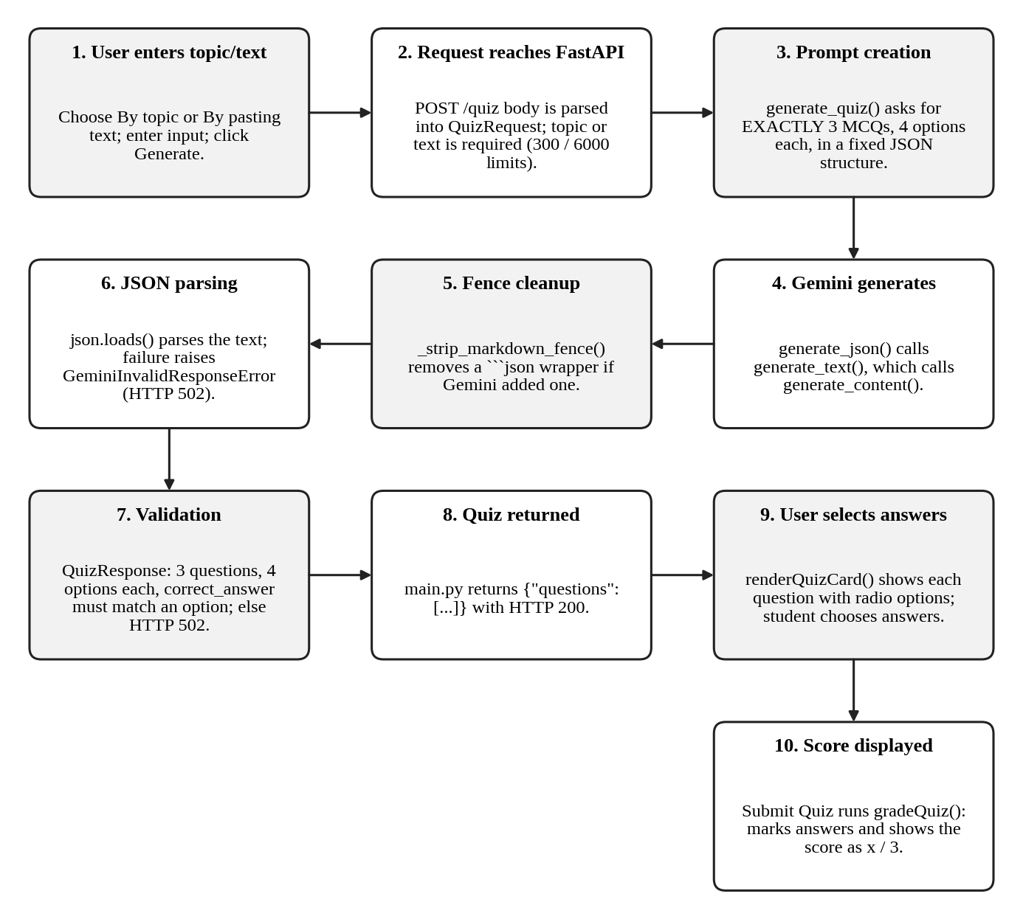
Fig. Quiz Module Logic
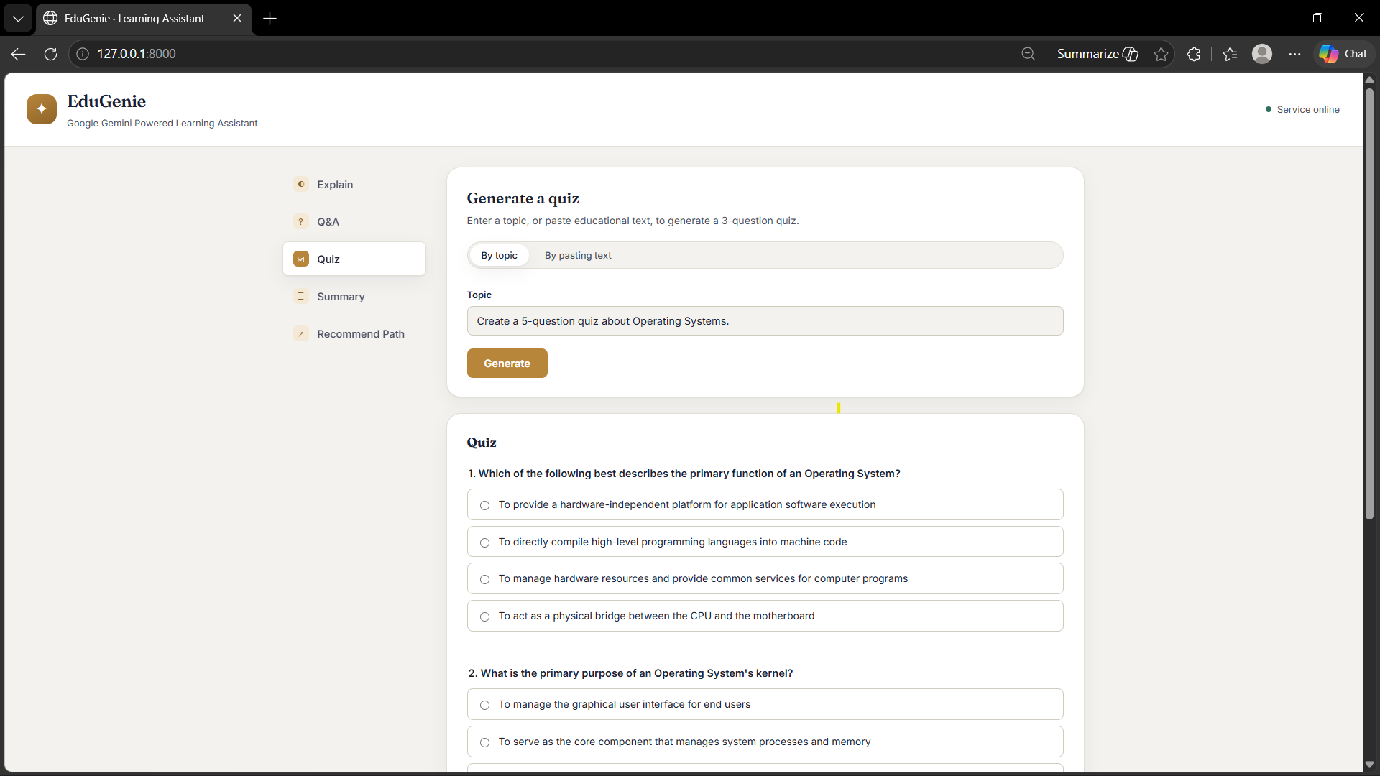
Fig. EduGenie Quiz Generation Interface
Table 7: Structure of the quiz response
Field | Description
questions | List of exactly 3 quiz questions.
questions[].question | The question text.
questions[].options | List of exactly 4 option strings.
questions[].correct_answer | Full text of the correct option; must be identical to one entry in options.

12. Summary and Learning Path

12.1 Summary Module
The summary feature (POST /summarize, summary_module.summarize_text()) accepts up to 12,000 characters of educational text. After trimming and validation, the text is embedded in a prompt that asks Gemini to keep the important facts, remove repetition and filler, use short bullet points where helpful and produce a noticeably shorter, accurate summary. The reply is returned as {"summary": "..."} and the frontend displays it in a Summary card using the same text formatter as the Q&A and Explain features. An empty text field returns HTTP 400 (“Please paste some text to summarize.”).
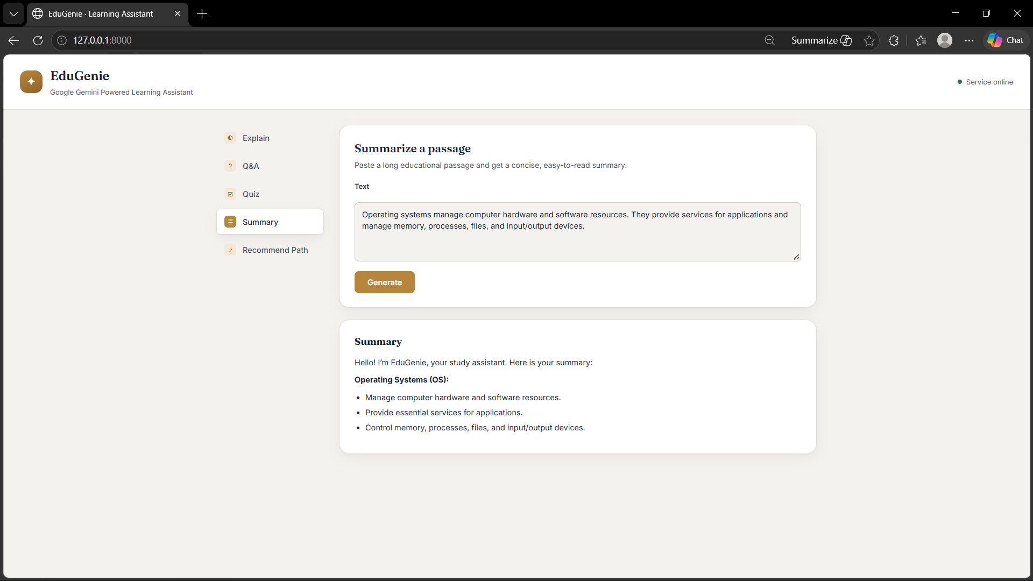
Fig. EduGenie Summary Interface

12.2 Learning Path Module
The learning path feature (POST /learn/recommendations, learning_path.generate_learning_path()) generates personalised recommendations from a topic and the learner’s current level. Gemini is asked to return only JSON in a fixed structure, and the backend returns that JSON object to the frontend.
Table 8: Structure returned by /learn/recommendations
Field | Description
topic | The subject of the learning path.
current_level | The learner level used (Beginner, Intermediate or Advanced).
stages | List of stages. The prompt requires Beginner, Intermediate and Advanced in that order.
stages[].stage | Stage name.
stages[].timeline | Suggested duration, for example “Week 1-2”.
stages[].topics | List of 3 to 5 topics for that stage (as requested in the prompt).
resources | List of learning resources; each has a type (Video, Article, Book, Documentation) and a title.
tips | List of study tips.

The frontend function renderLearningPathCard() turns this structure into a card headed “Learning path: <topic>”, shows the starting level, one row per stage (stage name, timeline and topic list), a grid of resource cards showing the type and title, and a list of tips. Resources are provided as titles only; the module does not return web links.
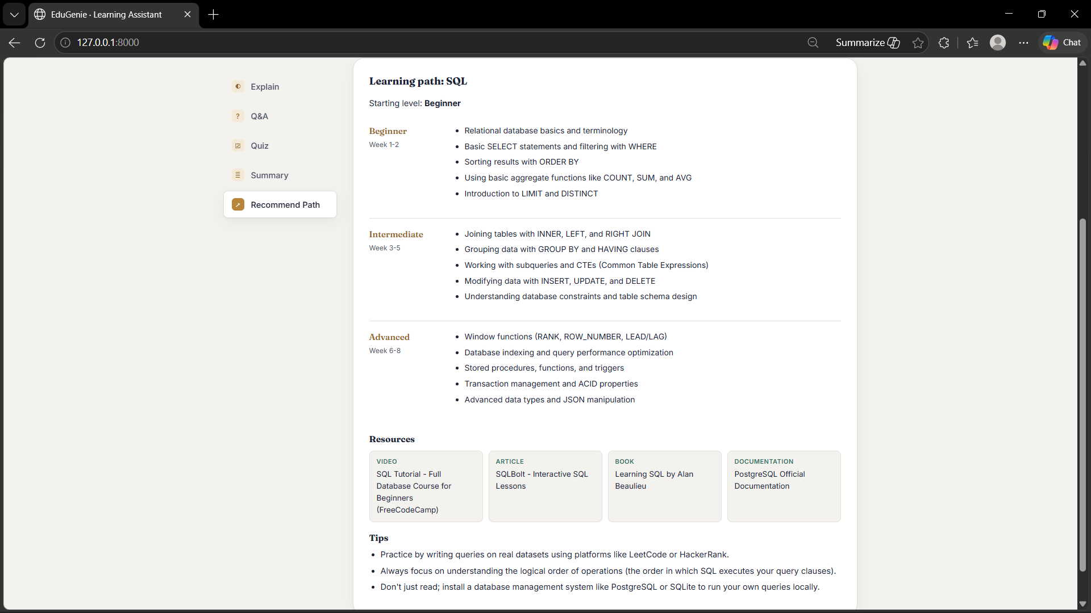
Fig. EduGenie Personalized Learning Path Interface

13. Backend API with FastAPI

Activity 2.2: Backend API with FastAPI
The FastAPI application is created in main.py with the title “EduGenie” and version 1.0.0. It mounts /static for the CSS and JavaScript files and uses Jinja2Templates to serve the page. The complete list of routes defined in main.py is shown below.
Table 9: API endpoints
Method | Endpoint | Purpose | Request body and success response
GET | / | Serves the single-page frontend (templates/index.html). | Returns the HTML page.
GET | /health | Health check. | Returns {"status": "ok"}.
POST | /qa | Answer a question. | Body {"question": str}  Returns {"answer": str}
POST | /explain | Explain a concept. | Body {"topic": str}  Returns {"explanation": str}
POST | /quiz | Generate a 3-question quiz. | Body {"topic": str} or {"text": str}  Returns {"questions": [...]}
POST | /summarize | Summarize a passage. | Body {"text": str}  Returns {"summary": str}
POST | /learn/recommendations | Build a learning path. | Body {"topic": str, "level": str (default Beginner)}  Returns {topic, current_level, stages, resources, tips}

FastAPI also generates interactive API documentation at /docs by default, because the application does not disable it; this can be used to try the endpoints in a browser.

Request validation and Pydantic models
Request bodies are validated with Pydantic. main.py defines QARequest, ExplainRequest and SummarizeRequest (one required string field each). The quiz and learning-path routes use QuizRequest and LearningPathRequest, which are defined in their own modules; QuizRequest contains a validator that requires a topic or text and checks the length limits. A custom handler for RequestValidationError converts Pydantic’s default error into a simple {"error": "..."} message with status 400. Further checks (empty text after trimming, maximum length) are performed inside each module and raise ValueError, which is also returned as HTTP 400. The modules additionally declare response schema classes (such as AnswerResponse); these are not used by the routes.

Error handling and HTTP status codes
Every route wraps its work in try/except and passes any exception to _handle_service_error(), which returns a JSON object of the form {"error": "message"}. Internal details and stack traces are logged on the server but never shown to the user.
Table 10: Error mapping in main.py
Exception | Status | Message returned to the client
ValueError (module validation) | 400 | The validation message, for example “Please enter a question.”
RequestValidationError (Pydantic) | 400 | The first validation message.
MissingAPIKeyError | 500 | “Gemini API key is missing or invalid. Please contact the administrator.”
GeminiRateLimitError | 429 | The message from the service (too many requests, wait and retry).
GeminiTimeoutError | 504 | The message from the service (request timed out).
GeminiServiceError and GeminiInvalidResponseError | 502 | “AI service is temporarily unavailable. Please try again.”
Any other exception | 500 | “Something went wrong on the server. Please try again.”

14. Frontend Development

MILESTONE 3: Frontend Development

Activity 3.1: Build the Web Interface
The frontend is a single page made of three files: templates/index.html (structure), static/style.css (design) and static/script.js (behaviour). No JavaScript framework or build tool is used.
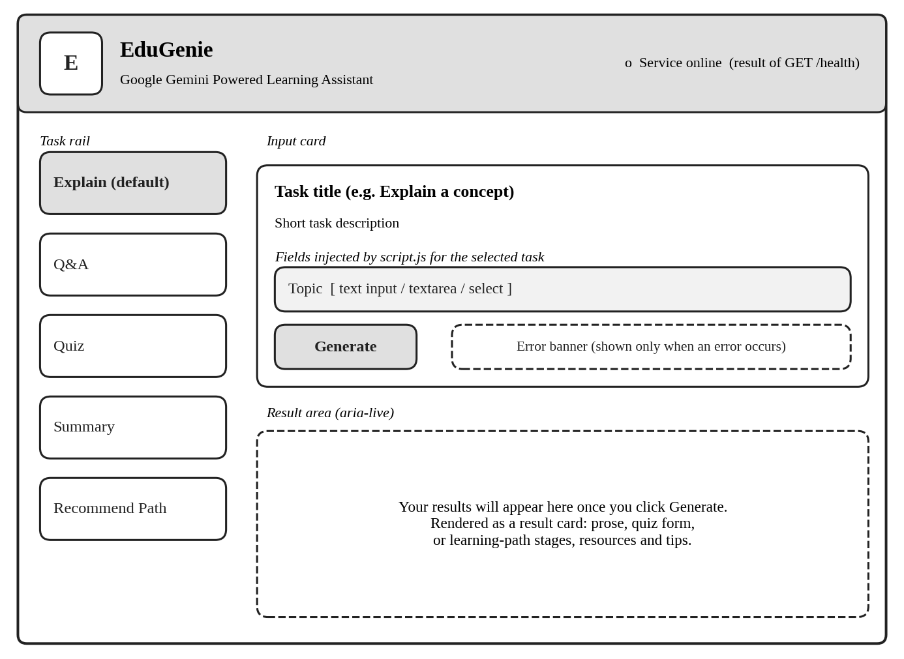
Fig. EduGenie Frontend Interface (layout schematic based on templates/index.html)
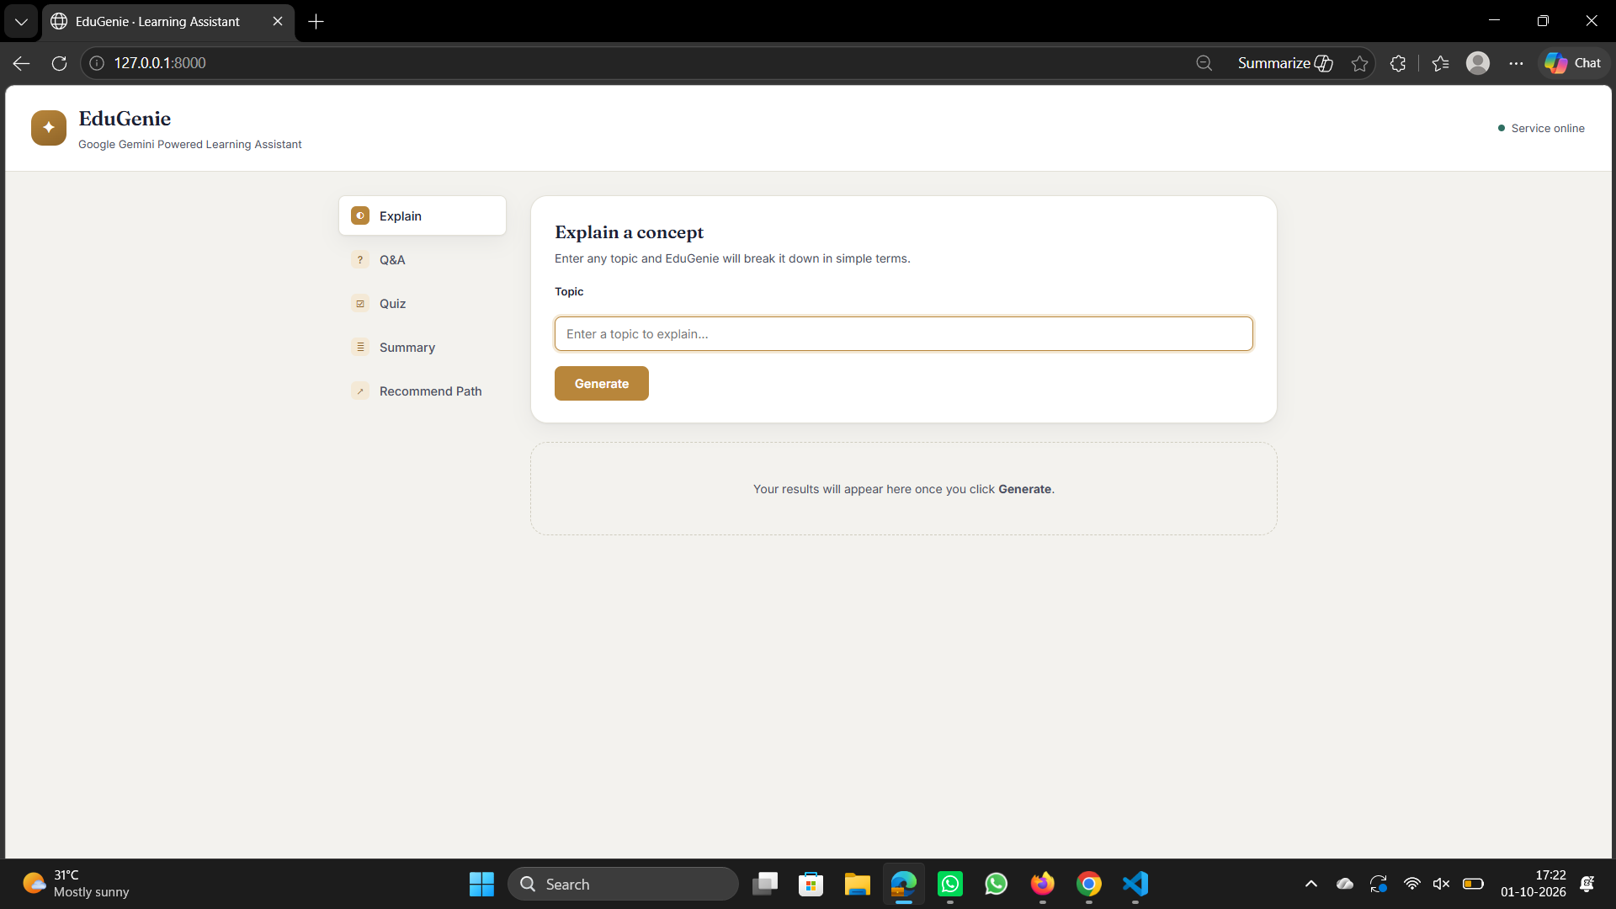
Fig. EduGenie Main User Interface

Interface components
- Header: the EduGenie name and subtitle, and a status indicator that shows “Service online” or “Service unavailable” based on a call to /health when the page loads.
- Task selection: a rail of five buttons – Explain, Q&A, Quiz, Summary and Recommend Path. Explain is selected by default. Selecting a task updates the title and description and replaces the form fields.
- Input fields: created dynamically by script.js for the selected task (see the table below).
- Generate button: a single button that shows “Generating…” with a spinner and is disabled while a request is running.
- Error banner: a red banner below the form that shows validation and server errors.
- Result area: a placeholder (“Your results will appear here once you click Generate.”) that is replaced by a result card; it is marked aria-live="polite" for accessibility.
Table 11: Input fields for each task
Task | Input fields | Result display
Explain | Topic (text input, max 300) | Explanation card
Q&A | Question (textarea, max 1000) | Answer card
Quiz | Toggle: By topic (text input, max 300) or By pasting text (textarea, max 6000) | Quiz form with radio options, Submit Quiz button and score banner
Summary | Text (textarea, max 12,000) | Summary card
Recommend Path | Topic (text input, max 300) and Current level (drop-down: Beginner, Intermediate, Advanced) | Learning path card with stages, resources and tips

Styling and responsive design
style.css defines colour and spacing values as CSS variables (a warm paper background with dark text and a brass accent colour), uses the Fraunces font for headings and Inter for body text (loaded from Google Fonts, with Georgia and system fonts as fallbacks), and styles the task rail, cards, form fields, quiz options, learning-path stages and resource cards. Two media queries make the page responsive: at 860 px and below the layout becomes a single column with the task rail turned into a horizontally scrollable row and the learning-path stages stacked; at 480 px and below the header status indicator is hidden and form rows stack vertically.

15. Frontend Integration

Activity 3.2: Live Integration
The frontend and backend are connected through JSON over HTTP. The complete path of a request is:
Frontend → JavaScript → FastAPI → feature module → Gemini service → Gemini API → FastAPI response → frontend
- The student fills the form and clicks Generate. The submit event is handled by handleSubmit() in script.js.
- task.buildPayload() reads the field values and validatePayload() checks them; a problem is shown in the error banner without a network call.
- setLoading(true) disables the button and shows the spinner, then fetch() sends a POST request to the task’s endpoint.
- FastAPI validates the body, calls the module function, which calls gemini_service and, through the google-genai SDK, the Gemini API.
- The result (or an error object) is returned as JSON. The script parses it; if response.ok is false it throws an error using the error text.
- task.render(data) builds the result card in the result area; setLoading(false) restores the button.
const response = await fetch(task.endpoint, {
method: "POST",
headers: { "Content-Type": "application/json" },
body: JSON.stringify(payload),
});
Fig. JavaScript request mechanism in script.js

How the script is organised
The TASKS object in script.js describes each of the five tasks: its title, description, endpoint, a buildFields() function that returns the form HTML, a buildPayload() function and a render() function. Adding a task means adding one entry to this object. Results are inserted into the page only after passing through escapeHtml(), so text generated by the AI cannot inject HTML.

API key security
The Gemini API key stays on the backend. It is read from the environment in gemini_service.py and is never included in index.html, style.css or script.js. The browser only communicates with the FastAPI server, using relative URLs such as /qa on the same origin, so no cross-origin configuration is needed.

16. Deployment: Running the Project

MILESTONE 4: Running EduGenie Locally

Activity 4.1: Run Locally
EduGenie is configured for local execution. After completing the setup in Section 5, start the server from the project folder with the virtual environment active:
uvicorn main:app --reload

Then open the following address in a browser:
http://127.0.0.1:8000

- .env and API key: the file must exist in the project folder and contain a valid GEMINI_API_KEY. Without it, the page loads but AI features return an API-key error message.
- Health endpoint: visiting http://127.0.0.1:8000/health returns {"status": "ok"} when the server is running. It confirms that the application is up; it does not test the Gemini connection.
- --reload: restarts the server automatically when a source file changes, which is useful during development.
- Stopping the server: press CTRL+C in the terminal where uvicorn is running.
- Changing the port: uvicorn accepts --host and --port options; the HOST and PORT lines in .env.example are not read by the application.
Table 12: Common startup requirements and problems
Problem | Likely cause | Solution
Gemini API key is missing or invalid | .env not created or key left blank | Copy .env.example to .env and add a real key; restart the server.
ModuleNotFoundError on startup | Dependencies not installed or wrong environment active | Activate the virtual environment and run pip install -r requirements.txt.
Page loads but every action fails | Server not running or wrong address | Confirm uvicorn is running and open http://127.0.0.1:8000.
Static files or page not found | Server started from another folder | Run uvicorn from the folder that contains main.py, static and templates.
Too many requests message | Gemini free-tier rate limit reached | Wait a minute and try again.
AI service temporarily unavailable | Transient Gemini error or invalid AI output | Try again; for a quiz, click Generate again.

The project contains no Dockerfile, cloud configuration or hosting scripts; deployment to a public server is therefore outside the scope of the current version.

17. Functional Testing

Activity 4.2: Functional Testing
EduGenie includes an automated test suite in tests/test_api.py, written for pytest. The tests use FastAPI’s TestClient (which relies on httpx) to call the real application routes in memory. Every call to Gemini is replaced by a mock using unittest.mock.patch (for example patch("qna.generate_text", ...) or patch("quiz_module.generate_json", ...)), so the tests run instantly and need neither an API key nor an internet connection. The suite is run from the project root with:
pytest

Table 13: Automated tests in tests/test_api.py
Test Area | Test function | Expected Behavior
Home page | test_home_page_loads | GET / returns 200 and the page contains “EduGenie”.
Health endpoint | test_health_check | GET /health returns 200 and {"status": "ok"}.
Q&A success | test_qa_success | POST /qa with a mocked answer returns 200 and the answer text.
Q&A validation | test_qa_empty_question_is_rejected | A blank question returns 400 with an error key.
Explain success | test_explain_success | POST /explain with a mocked explanation returns 200 and an explanation key.
Explain validation | test_explain_empty_topic_is_rejected | An empty topic returns 400.
Quiz success | test_quiz_success_has_three_questions_four_options_each | Returns 200 with 3 questions, 4 options each and a correct answer present in the options.
Quiz validation | test_quiz_missing_topic_and_text_is_rejected | An empty body returns 400.
Quiz invalid AI output | test_quiz_invalid_ai_json_is_handled_safely | A mocked quiz with one question and two options returns 502 with an error key; the server does not crash.
Summary success | test_summarize_success | POST /summarize with a mocked summary returns 200 and a summary key.
Summary validation | test_summarize_empty_text_is_rejected | Empty text returns 400.
Learning path success | test_learning_path_success | Returns 200 and stages named Beginner, Intermediate, Advanced in that order.
Learning path validation | test_learning_path_missing_topic_is_rejected | An empty topic returns 400.

Manual functional testing
With a valid API key configured, the application can also be tested manually through the interface by performing each of the five tasks:
- Ask a question in the Q&A task and check that an answer card appears.
- Enter a topic in the Explain task and check the explanation card.
- Generate a quiz by topic and by pasted text; answer the questions, submit and check the score and the highlighted answers.
- Paste a passage in the Summary task and check that a shorter summary is shown.
- Request a learning path for a topic at each of the three levels and check the stages, resources and tips.
- Submit an empty form and check that a friendly error message appears.
The automated suite focuses on the API layer. Functions inside gemini_service.py (fence stripping, error classification), the 429/504 status mappings, the level fallback in the learning-path module, the length limits and the frontend JavaScript are not covered by automated tests and are verified by manual use.

18. Exploring EduGenie
This section describes the experience of using each feature of the running application.

a. Asking Questions
The student selects Q&A, types a question such as “Which is the largest ocean?” and clicks Generate. The button changes to “Generating…” while the request runs. The answer then appears in an Answer card; Gemini is asked to keep it short and to use bullet points when they help, and the page renders bullets and bold text neatly. An empty question produces the message “Please enter a question.”

b. Explanation of Any Topic
On the default Explain task, the student enters a topic such as “Binary Search Algorithm” or “Quantum computing”. The Explanation card presents a short simple explanation, a real-world example and, when relevant, key points or formulas. Because the prompt asks for beginner-level language, the result is suitable for learners with no prior knowledge.

c. Summarizing Long Paragraphs
On the Summary task, the student pastes a long passage (up to 12,000 characters) and clicks Generate. The Summary card shows a shorter version that keeps the main facts, often as bullet points. Text longer than the limit is rejected with a message asking the student to shorten it.

d. Generating Quizzes
On the Quiz task, the student chooses By topic or By pasting text. Three questions appear, each with four radio-button options. After answering, Submit Quiz reveals the result: each question shows a status line, the correct option is highlighted in green, a wrong selection is highlighted in red, unanswered questions display the correct answer, and a banner shows the score out of three. The quiz is locked after submission; generating a new quiz produces a fresh set.

e. Learning Recommendations
On the Recommend Path task, the student enters a topic such as “SQL”, selects a current level and clicks Generate. The result card shows the topic and starting level, followed by the Beginner, Intermediate and Advanced stages, each with a timeline and topic list. Below the stages, a grid of resources (video, article, book or documentation titles) and a list of study tips complete the plan.

19. Conclusion
EduGenie demonstrates how a generative AI service can be turned into a practical study companion using a small and readable code base. The application delivers five learning capabilities – question answering, concept explanation, quiz generation, text summarization and personalised learning paths – through a single, easy-to-use web page, making complex material approachable for learners at different levels.
The architecture is modular. Each feature lives in its own module with its own prompt and input rules, while all Gemini communication is concentrated in gemini_service.py. This design means that the Gemini model can be changed through one environment variable, that error handling is uniform, and that new features can be added by following the same pattern. The FastAPI backend provides clear routes, Pydantic validation and a consistent JSON error format with meaningful HTTP status codes, and it keeps the Gemini API key safely on the server.
The frontend is deliberately simple: plain HTML, CSS and JavaScript with a task rail, dynamic forms, client-side validation, formatted result cards, an interactive quiz with scoring and a responsive layout. The quiz feature shows careful handling of AI output by cleaning code fences, parsing JSON and validating the structure before it reaches the user. A pytest suite with mocked Gemini calls verifies the routes, validation and failure handling without needing a network connection.

Current limitations
- The application needs an internet connection, a valid Gemini API key and available quota; it is configured for local use only.
- Each request is independent; there is no user account, database, conversation history or progress storage.
- The accuracy of the generated content depends on the AI model and is not verified by the application.
- The quiz always contains exactly three questions, and learning-path resources are titles rather than links.
- The route functions are declared async but call the synchronous Gemini SDK method, so a long AI request can delay other requests when many users are active.
Within these limits, EduGenie fulfils its objective of providing an accessible, AI-powered learning assistant and provides a solid foundation for the enhancements described in the next section.

20. Future Scope
The features described in this document are those implemented in the current version. The items below are future enhancements; none of them is part of the present application.
Table 14: Future enhancements (not implemented in the current version)
Future Enhancement | Description
Voice interaction | Allow students to speak questions and hear answers.
Multilingual support | Accept questions and produce answers, quizzes and summaries in other languages.
Mobile application | A mobile app for learning on the go.
Progress tracking | Store quiz scores and learning-path progress per user, with charts.
Gamification | Badges, streaks and challenge-based quizzes to increase motivation.
Adaptive learning | Adjust difficulty and learning paths based on the learner’s quiz results.
Teacher and parent dashboards | Views for monitoring student activity and performance.
Group study | Shared sessions where students can study and take quizzes together.
Image and PDF input | Ask questions about, or summarise, uploaded images and PDF documents.
LMS integration | Connect with learning management systems such as Moodle or Google Classroom.
Notifications | Reminders for study schedules and quiz practice.

Technical improvements
- User authentication and a database to save history and results.
- Running the blocking Gemini call in a thread pool, or using the SDK’s asynchronous client, to improve concurrency.
- Automatic retry for invalid AI output and rate-limit responses.
- Additional automated tests for gemini_service.py, rate-limit and timeout handling, and the frontend.
- Packaging with Docker and deployment to a cloud platform.

