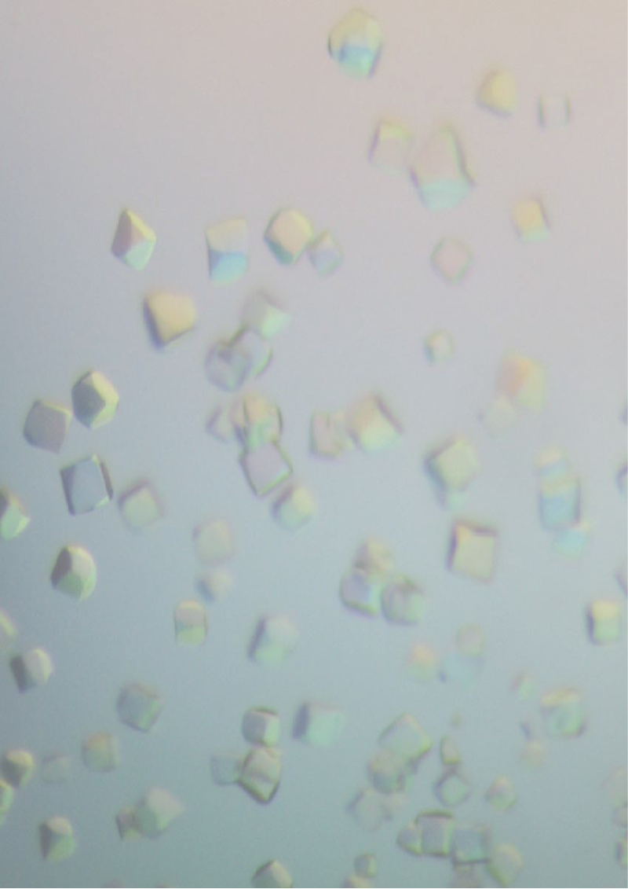


BCA BSG WINTER MEETING
19th December 2005
Chemistry Lecture Theatre 1, University of Bristol

“Structural Enzymology”
The Biological Structures Group Winter meeting this year explores and provides examples of how protein crystallography can be used to elucidate mechanism. Delegates are invited to submit abstracts for consideration for a poster session at lunchtime, and for a short oral presentation.
Organisers: Dr Jim Spencer, Department of Cellular and Molecular Medicine and Dr Andrea Hadfield, Department of Biochemistry

Abstract Deadline 2nd December 2005

For full information see: http://www.bch.bris.ac.uk/staff/hadfield/BSGwinter2005/main.htm

10:30 Arrival, Registration (Coffee and Danish Pastries)

11:00 Session 1 "Mechanisms"
Chris Schofield (Oxford) "The structural enzymology of clavam and carbapenem biosynthesis."
Vilmos Fulop (Warwick) "Beta-propellers in enzyme catalysis and regulation"
12:10 AGM of the Biological Structures Group. Chair : Richard Pauptit (Astra Zeneca)
12:30 Baguette Lunch, Exhibition and Posters
13:30 Session 2 “Techniques”
Dean Myles (Oakridge National Laboratory, Tenesse)
"Application of neutron protein crystallography to the study of enzyme structure and mechanism"
Dominique Bourgeois (EMBL Grenoble)
"In cristallo spectroscopy: a tool to study protein dynamics and function."
Dr Chris Davies "Catalytic Mechanism Of Deacylation In Penicillin-Binding Protein 5 From E. Coli"
Dr Richard Pickersgill "Elucidation of the mechanism and specificity of a novel esterase"

15:10 Tea, Exhibition and Posters
15:30 Session 3 “Intermediates”
Jim Naismith (St. Andrew’s) "Halogenation and other news from SSPF"
David Leys (Manchester) "High-resolution structures along a reaction pathway dominated by H-tunnelling"
Steve Gamblin (Mill Hill)"Mimicking the transition state of a phosphoryl transfer reaction"

17:15 Departure

Conference Fee (includes coffee, lunch and tea)
BCA Member: Standard £30:00 Student £15:00
Non-BCA Members Standard £45:00 Student £22:50
Registration form available from the website: http://www.bch.bris.ac.uk/staff/hadfield/BSGwinter2005/main.htm

