Code Review #0574

Version <1.0>

<date>

Document Control

Approval

The Guidance Team and the customer shall approve this document.

Document Change Control

|  |  |
| --- | --- |
| Initial Release: | 1.0 |
| Current Release: | TBD |
| Indicator of Last Page in Document: |  |
| Date of Last Review: | TBD |
| Date of Next Review: | TBD |
| Target Date for Next Update: | TBD |

Distribution List

This following list of people shall receive a copy of this document every time a new version of this document becomes available:

Guidance Team Members:

Dr. Roach

Customer:

Software Team Members:

Change Summary

The following table details changes made between versions of this document

|  |  |  |  |
| --- | --- | --- | --- |
| Version | Date | Modifier | Description |
| 1.0 | 02/15/2020 |  |  |
|  |  |  |  |
|  |  |  |  |

Note: The template presented in this document was taken from:

Donaldson, S., and S. Siegel, *Successful Software Development*. Upper Saddle River, NJ: Prentice Hall, 2001, pp. 321-323.

Note: The template presented in this document was taken from: Donaldson, S., and S. Siegel, *Successful Software Development*. Upper Saddle River, NJ: Prentice Hall, 2001, pp. 321-323 and modified by Humberto Mendoza and Steve Roach.

Supplementary information is from:

Pfleeger, S. *Software Engineering, Theory and Practice*. Upper Saddle River, NJ: Prentice Hall, 1998, p. 365.

Table of Contents

Document Control ii

Approval ii

Document Change Control ii

Distribution List ii

Change Summary ii

1. Review Criteria 4

1.1. Criteria 4

2. Code Review 5

2.1. Coder Comments: 5

2.2. Output 5

2.3. Error Handling 5

2.4. Code: 5

3. Appendix 6

3.1. Figure 1. 6

3.2. Figure 2. 6

# Review Criteria

This section gives information regarding the review criteria of the code to be evaluated.

## Good Criteria

Code Comments:

Output

Error Handling

Code

# Code Review

This section gives information regarding the review of the findings determined as a result of the tests conducted and observations of the source code.

## Coder Comments:

Introduction comments are clear and the purpose is straightforward. Very few grammar issues.

The code is well commented at the beginning of the class and methods.

## Output

The output consists of a title “Unsorted Initial Table” followed by the original matrix, despite its sorted or unsorted nature (Whether a table was sorted or not as an initial input, the result labeled the table as unsorted). Then a titled “Sorted Table” followed by a sorted array. Finally, the number of total operations.

The programmer did not output true or false statements to verify the return values of the methods

## Error Handling

The Code effectively handled anticipated errors like “NumberFormatException”, “NullPointerException” and others.

## Code:

The coder used t.getSize() inside the method instead of instantiating a variable that could be used across the code. This created many additional calls.

The coder is not checking whether the table is sorted initially. Instead it sorts first, then check if it is sorted which is extra computations if the table was already sorted.

The isSorted method is incorrect as shown in Figure 1. I ran a table that is not sorted and it returned true. The first value was also never checked.

As a follow up, the requirements specify that the table must be sorted by row and by columns therefore a table as shown in figure 2, should return true but instead returns false.

Sortable method works correctly.

# Appendix

## Figure 1.

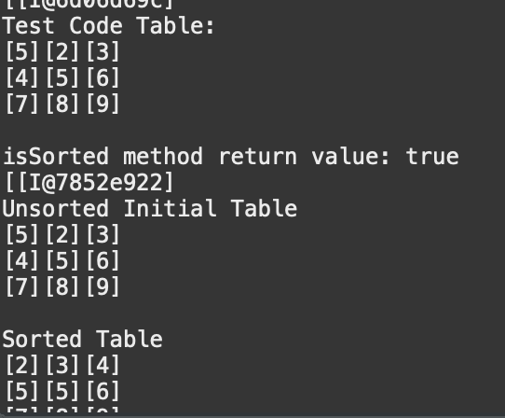

## Figure 2.

