#1989 Test Plan Review

Version <1.0>

<date>

Document Control

Approval

The Guidance Team and the customer shall approve this document.

Document Change Control

|  |  |
| --- | --- |
| Initial Release: | 1.0 |
| Current Release: |  |
| Indicator of Last Page in Document: |  |
| Date of Last Review: |  |
| Date of Next Review: |  |
| Target Date for Next Update: |  |

Distribution List

This following list of people shall receive a copy of this document every time a new version of this document becomes available:

Guidance Team Members:

Dr. Roach

Customer: #1989

Software Team Members:

Change Summary

The following table details changes made between versions of this document

|  |  |  |  |
| --- | --- | --- | --- |
| Version | Date | Modifier | Description |
| 1.0 | 02/15/2020 |  |  |
|  |  |  |  |
|  |  |  |  |

Note: The template presented in this document was taken from:

Donaldson, S., and S. Siegel, *Successful Software Development*. Upper Saddle River, NJ: Prentice Hall, 2001, pp. 321-323.

Note: The template presented in this document was taken from: Donaldson, S., and S. Siegel, *Successful Software Development*. Upper Saddle River, NJ: Prentice Hall, 2001, pp. 321-323 and modified by Humberto Mendoza and Steve Roach.

Supplementary information is from:

Pfleeger, S. *Software Engineering, Theory and Practice*. Upper Saddle River, NJ: Prentice Hall, 1998, p. 365.

Table of Contents

Document Control ii

Approval ii

Document Change Control ii

Distribution List ii

Change Summary ii

1. Review Criteria 4

1.1. Criteria 4

2. Review 5

2.1. Setup: 5

2.2. Test No: 1 5

2.3. Test No: 2 5

2.4. Test No: 3 5

2.5. Test No: 4 5

2.6. Test No: 5 5

2.7. Test No: 6 6

2.8. Test No: 7 6

2.9. Test No: 8 6

3. Concluding Remarks 7

4. Appendix 8

4.1. Figure 1. 8

4.2. Figure 2. 8

4.3. Figure 3. 9

4.4. Figure 4. 9

4.5. Figure 5. 9

4.6. Figure 6. 10

4.7. Figure 7. 10

4.8. Figure 8. 10

4.9. Figure 9. 10

5. Code 11

# Review Criteria

This section gives information regarding the review criteria of the test plan to be evaluated.

## Criteria

Spelling mistakes: Ease of understanding and reduce confusion

Grammar: Ease of interpretation for correct results

Template format: Template enables easy to add/modify test cases in future and it organizes content

Language used: Understandability

Functionality coverage: For completeness and to identify that major defects are not missed.

Duplicates: Verify there is not duplicates to save time and space.

# Review

This section gives information regarding the review criteria of the test plan to be evaluated.

## Setup:

Introduction is clear and the setup is straightforward. Setup in eclipse IDE is shown in figure 1.

## Test No: 1

Test 1 “Sorted table with valid inputs” is a vague test due to the fact that “valid inputs” is not specific.

When the test is ran, the result does not indicate that isSorted() is “true” as the test plan indicates nor did it specify that we should modify the code to mirror as shows in figure 2.

The concluding remarks specified are correct as the table remained the same. (The code prints that the first table is unsorted, though it is sorted.)

## Test No: 2

Test 2 “Unsorted table with valid inputs” is a vague test due to the fact that “valid inputs” is not specific.

When the test is ran, the result does not indicate that isSorted() is “true” as the test plan indicates nor did it specify that we should modify the code to mirror as shows in figure 3.

The concluding remarks specified are correct as the table is shown as sorted.

## Test No: 3

Test 3 “Unsorted table with valid inputs that are negative numbers”

When the test is ran, the result does not indicate that isSorted() is “true” as the test plan indicates nor did it specify that we should modify the code to mirror as shows in figure 4.

The concluding remarks specified are correct as the table is shown as sorted.

## Test No: 4

Test 4 “Unsorted table with valid inputs of numbers with more than 8 digits ex. 123456789”

When the test is ran, the result does not indicate that isSorted() is “true” as the test plan indicates nor did it specify that we should modify the code to mirror as shows in figure 5.

The concluding remarks specified are correct as the table is shown as sorted.

## Test No: 5

Test 5 “Invalid table size”

When the test is ran, the result is as indicated in expected result as shown in Figure 6.

## Test No: 6

Test 6 “Valid table size with invalid inputs” is a vague test due to the fact that “invalid inputs” is not specific.

When the test is ran, the result indicates a message that the filename file contains a non-integer value as shown in Figure 7. The document indicates “Number format exception.”

## Test No: 7

Test 7 “Valid table size with invalid special characters”

When the test is ran, the result indicates a message that the filename file contains a non-integer value as shown in Figure 8. The document indicates “Number format exception.”

## Test No: 8

Test 8 “Empty File”

When the test is ran, the result indicates a message that the filename file contains a non-integer value or is empty as shown in Figure 9. The document indicates “Number format exception.”

# Concluding Remarks

Spelling Mistakes, Grammar, Template Format, and Language:

Overall the test plan was very easy to follow due to the language used and the organized format of the template. There were no evident spelling mistakes or grammar issues which benefited the understandability of the document.

Functionality Coverage:

It lacked functionality coverage and some of the test cases were vague in terms of input values. For example, the test called “Sorted table with valid inputs” is vague as to what are “valid inputs.” The test plan also did not include instructions to print or generate any output that could validate the expected results.

Duplicates: There were no duplicate tests detected.

# Appendix

This section shows the results from the tests ran; refer to “Review” in section 2 for more details.

## Figure 1.

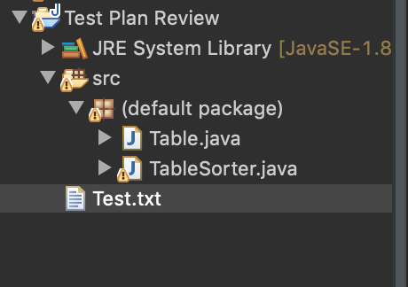

## Figure 2.

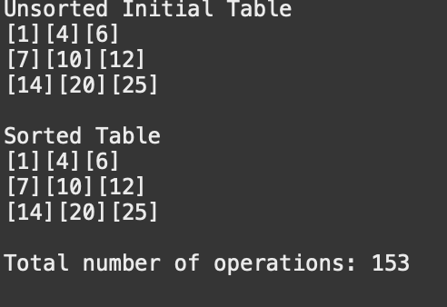

## Figure 3.

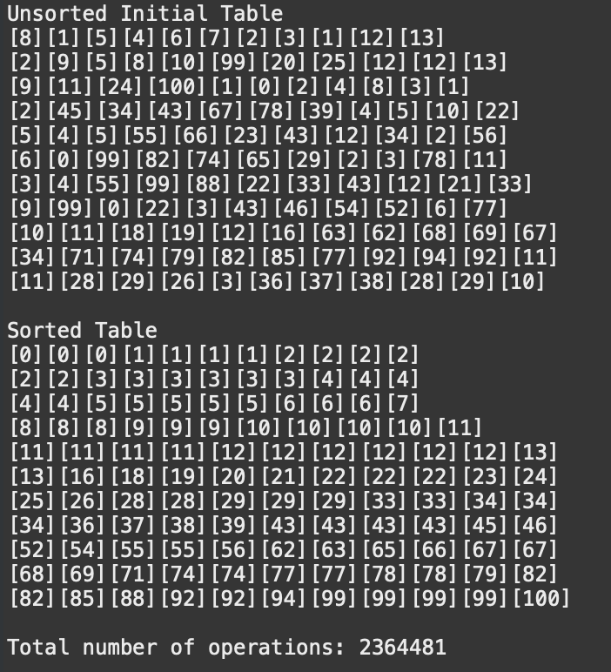

## Figure 4.

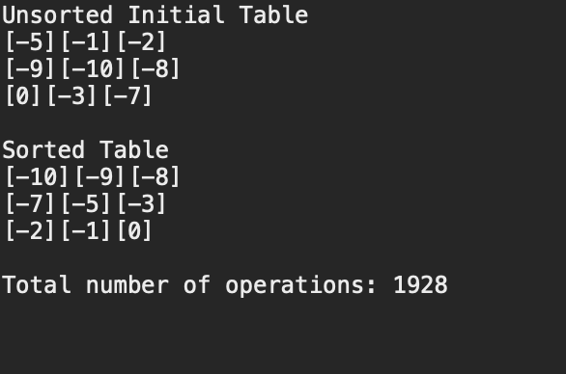

## Figure 5.

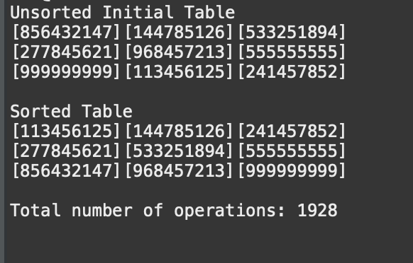

## Figure 6.



## Figure 7.



## Figure 8.



## Figure 9.

