**Bergen County Academies**

**6th Annual Joe Holbrook Memorial**

**Math Competition**

**Sponsored by BCA Math Team Booster Club**

Individual Competitions for grade 4th through 8th

Prizes for top finishers in each grade level

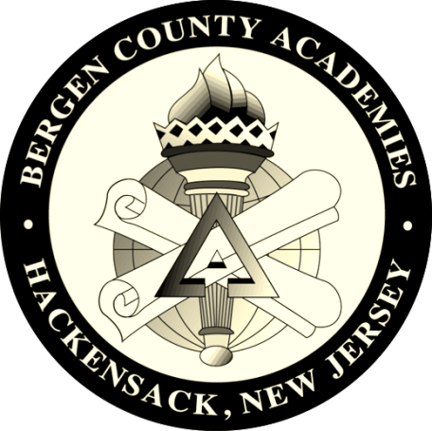

SUNDAY, OCTOBER 15, 2017

10:00AM TO 3:00 PM

Please arrive no later than 9:30 AM

Bergen County Academies

200 Hackensack Avenue

Hackensack, NJ 07601

$30 Online Registration Fee (seats are limited)

Students should bring lunch or snack

For Registration & more information visit

**Holbrook.bergen.org**