Logistic Regression

SDS 291

4/6/2020

We have data from each state (n=50) on their average income, education (% high school, % college, and % advanced degrees completed), political leaning from a 2015 Gallup poll and whether President Trump won that state (1=Win) or not (0=Did not Win) in the 2016 election.

library(Stat2Data)  
data("Election16")

# Income and Election Outcome

## Plots

Below are two plots exploring the relationship between income and President Trump winning that state. They are depicting the same pattern; the right “jitters” the data to spread the points out. (Note for the right plot, there aren’t *actually* values >1 and <0, that’s just a function of the actual data being spread out).

qplot(y=TrumpWin, x=Income, data=Election16)   
qplot(y=TrumpWin, x=Income, data=Election16) + geom_jitter(width = 0.1, height=0.05)

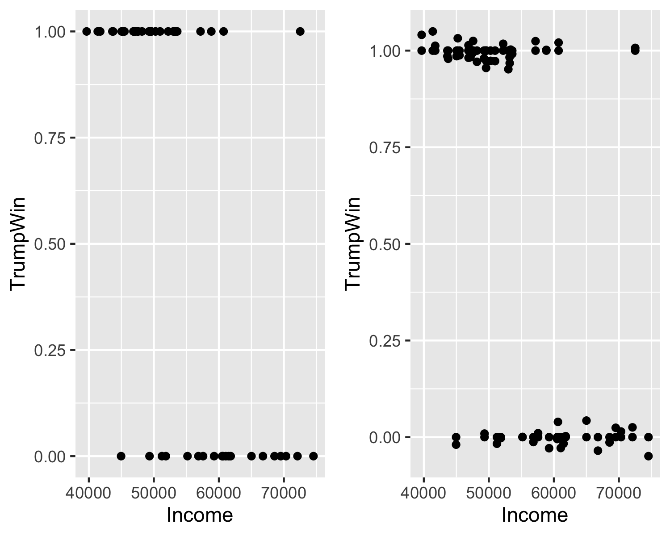

### 1. Which is the easier graph to understand? Why?

### 2. What do you conclude from the plot about the relationship between income and the 2016 election results?

## Logistic Model

Let’s fit a logistic regression model to these data: $log(\frac{π}{1−π})=β_{0}+β_{1}X_{1}$

m0<-glm(TrumpWin~Income, data=Election16, family="binomial")  
summary(m0)

##   
## Call:  
## glm(formula = TrumpWin ~ Income, family = "binomial", data = Election16)  
##   
## Deviance Residuals:   
## Min 1Q Median 3Q Max   
## -2.2049 -0.7510 0.4074 0.6566 2.5000   
##   
## Coefficients:  
## Estimate Std. Error z value Pr(>|z|)   
## (Intercept) 1.118e+01 3.076e+00 3.635 0.000277 ***  
## Income -1.967e-04 5.582e-05 -3.523 0.000426 ***  
## ---  
## Signif. codes: 0 '***' 0.001 '**' 0.01 '*' 0.05 '.' 0.1 ' ' 1  
##   
## (Dispersion parameter for binomial family taken to be 1)  
##   
## Null deviance: 67.301 on 49 degrees of freedom  
## Residual deviance: 45.923 on 48 degrees of freedom  
## AIC: 49.923  
##   
## Number of Fisher Scoring iterations: 5

We can write this fitted model as $log(odds)=11.18+−0.0001967Income$

Let’s use Income in $1,000s to make the interpretation a little easier. Then we re-fit a logistic regression model.

Election16<-Election16 %>% mutate(Income1000s = Income/1000)  
m1<-glm(TrumpWin~Income1000s, data=Election16, family="binomial")  
summary(m1)

##   
## Call:  
## glm(formula = TrumpWin ~ Income1000s, family = "binomial", data = Election16)  
##   
## Deviance Residuals:   
## Min 1Q Median 3Q Max   
## -2.2049 -0.7510 0.4074 0.6566 2.5000   
##   
## Coefficients:  
## Estimate Std. Error z value Pr(>|z|)   
## (Intercept) 11.18186 3.07576 3.635 0.000277 ***  
## Income1000s -0.19668 0.05582 -3.523 0.000426 ***  
## ---  
## Signif. codes: 0 '***' 0.001 '**' 0.01 '*' 0.05 '.' 0.1 ' ' 1  
##   
## (Dispersion parameter for binomial family taken to be 1)  
##   
## Null deviance: 67.301 on 49 degrees of freedom  
## Residual deviance: 45.923 on 48 degrees of freedom  
## AIC: 49.923  
##   
## Number of Fisher Scoring iterations: 5

### 3. Write the fitted regression model equation using the output above.

### 4. What is the direction and magnitude of the relationship between the average income and whether Pres. Trump won that state?

### 5. Calculate the log(odds) (the book calls this the Empirical Logit), the odds, and the probability of President Trump winning for each of the following income levels. As a reminder, you can calculate each from the same output.

*Log(odds):*

$$log(odds)=β_{0}+β_{1}X_{1}$$

*Odds:*

$$Odds=e^{β_{0}+β_{1}X_{1}}$$

*Probability:*

$$π=\frac{odds}{1+odds}=\frac{e^{β_{0}+β_{1}X_{1}}}{1+e^{β_{0}+β_{1}X_{1}}}$$

|  |  |  |  |  |  |  |  |
| --- | --- | --- | --- | --- | --- | --- | --- |
| Income | $40,000 | $50,000 | $51,000 | $55,000 | $60,000 | $61,000 | $70,000 |
| Log(odds) |  |  |  |  |  |  |  |
|  |  |  |  |  |  |  |  |
| Odds |  |  |  |  |  |  |  |
|  |  |  |  |  |  |  |  |
| Probability |  |  |  |  |  |  |  |
|  |  |  |  |  |  |  |  |

### 6. Plot the values on each of the three plots below.

#### 6a. Log(odds)

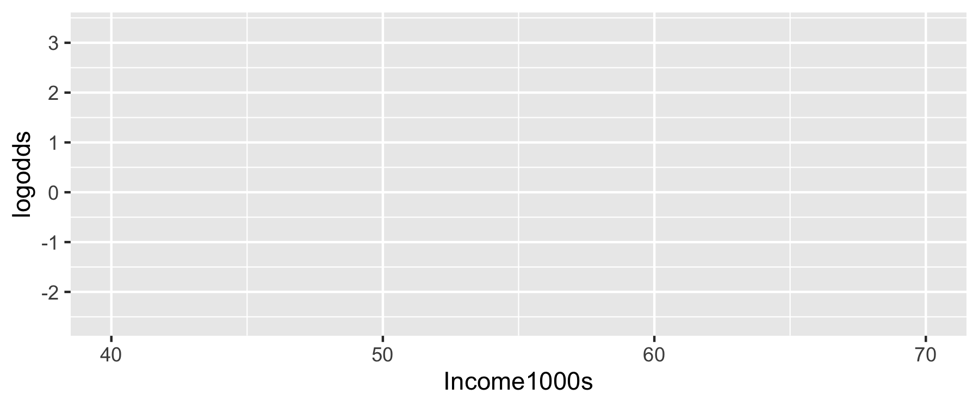

#### 6b. Odds

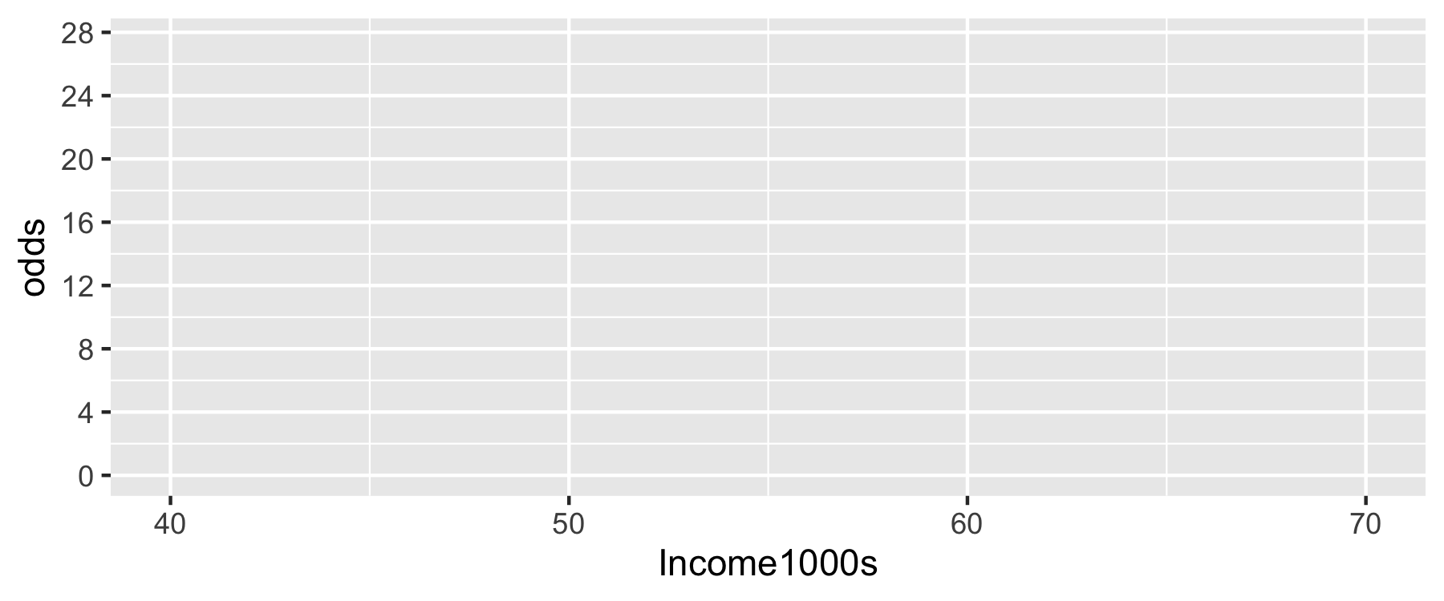

#### 6c. Probability

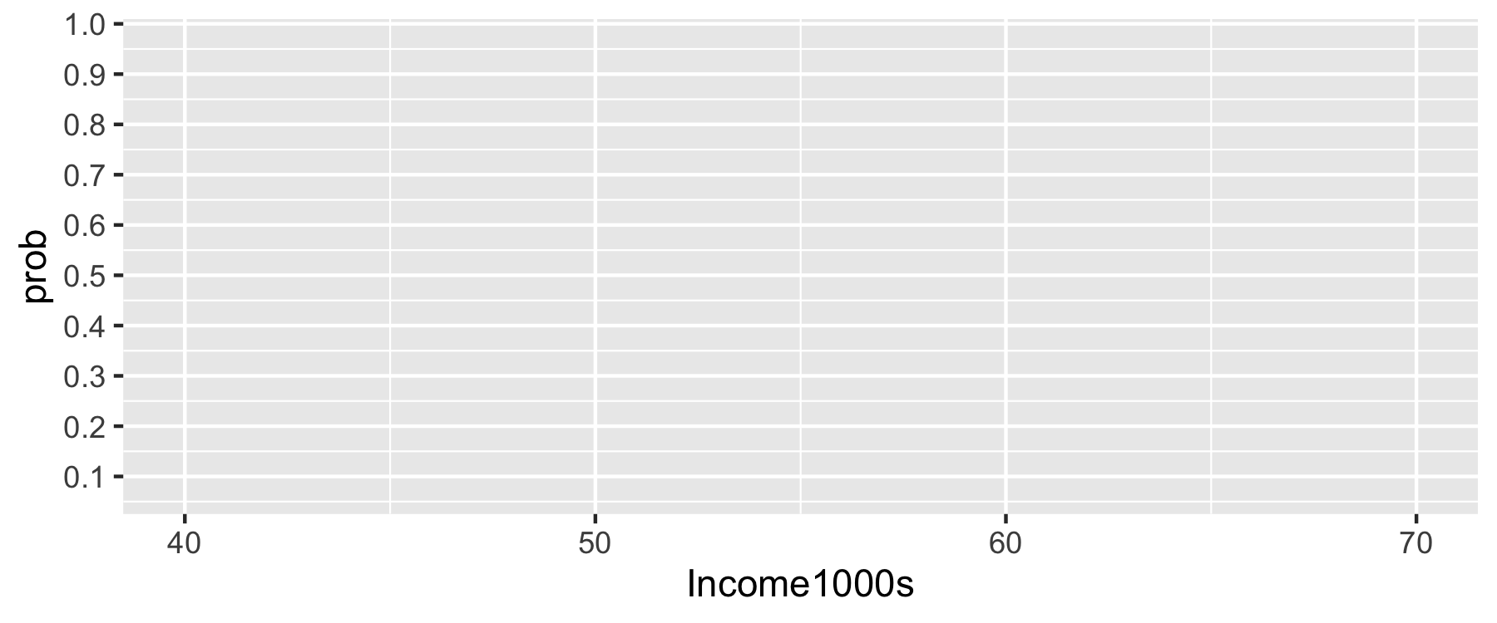

### 7. What is the ratio of odds for President Trump winning a state?

#### 7a. Calculate the ratio the odds of a (theoretical) state with $51,000 average income to a state with $50,000 average income.

#### 7b. Calculate the ratio the odds of a (theoretical) state with $61,000 average income to a state with $60,000 average income.

#### 7c. Calculate the OR from the model ($OR=e^{β_{1}}$). Interpret the odds ratio in a sentence.

#### 7d. Did you get the same values from each approach (7a-7c)? Why or why not?

### 8. Specify your hypotheses and conduct a test of whether the relationship between average income and President Trump winning a state is statistically signficant at the $α=0.05$ level.

### 9. Calculate the 95% Confidence Interval for the odds ratio of each additional $1,000 of average income and of Pres Trump winning that state. $t^{*}=1.96$

# Extra Practice

Create a binary variable of whether that state had above or below the national average rate of bachelors degree holders (35.6%) and repeat the steps above in R.

( *Hint*: Remember how to create a binary variable? See the IPUMS in-class exercise for examples of when you’ve done this before)