Logistic Regression

SDS 291

April 13, 2020

We’re going to work with the Whickham data contains observations about women, and whether they were alive 20 years after their initial observation (outcome is a 2 level factor variable - Alive/Dead). You can learn more about these data from the mosaicData help feature if you’d like.

Specifically, we’re interested in: the association of age, smoking status (smoker), and 20-year survival (outcome: alive (success), dead (reference / failure)). Bring in the relevant packages and the data (above, from the mosaic package).

# Age and Outcome

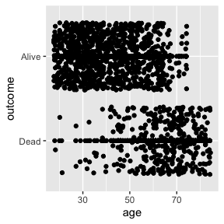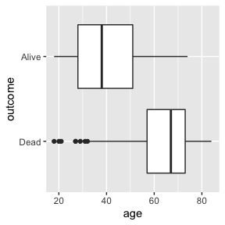

m0<-glm(outcome~age, data=Whickham, family=binomial)  
summary(m0)

##   
## Call:  
## glm(formula = outcome ~ age, family = binomial, data = Whickham)  
##   
## Deviance Residuals:   
## Min 1Q Median 3Q Max   
## -3.2296 -0.4277 0.2293 0.5538 1.8953   
##   
## Coefficients:  
## Estimate Std. Error z value Pr(>|z|)   
## (Intercept) 7.403126 0.403522 18.35 <2e-16 ***  
## age -0.121861 0.006941 -17.56 <2e-16 ***  
## ---  
## Signif. codes: 0 '***' 0.001 '**' 0.01 '*' 0.05 '.' 0.1 ' ' 1  
##   
## (Dispersion parameter for binomial family taken to be 1)  
##   
## Null deviance: 1560.32 on 1313 degrees of freedom  
## Residual deviance: 946.51 on 1312 degrees of freedom  
## AIC: 950.51  
##   
## Number of Fisher Scoring iterations: 6

1. Write the fitted equation and interpret the results (in these units) in light of the question. Be sure to comment on the magnitude and direction of the association.
2. Based on this model, what is the probability that a 60 year old was alive 20 years after the initial survey?

# Smoking Status and Outcome (Alive)

Whickham$smoker<-factor(Whickham$smoker, levels=c("Yes", "No"))  
Whickham$outcome<-factor(Whickham$outcome, levels=c("Alive", "Dead"))  
tally(~ smoker + outcome, margins=FALSE, data=Whickham)

## outcome  
## smoker Alive Dead  
## Yes 443 139  
## No 502 230

1. Calculate the Odds Ratio of non-smokers being alive in 20 years compared to smokers from the table above.

Whickham$smoker<-relevel(Whickham$smoker, ref= "No")  
Whickham$outcome<-relevel(Whickham$outcome, ref= "Dead")  
m1<-glm(outcome~smoker, data=Whickham, family=binomial)  
summary(m1)

##   
## Call:  
## glm(formula = outcome ~ smoker, family = binomial, data = Whickham)  
##   
## Deviance Residuals:   
## Min 1Q Median 3Q Max   
## -1.6923 -1.5216 0.7388 0.8685 0.8685   
##   
## Coefficients:  
## Estimate Std. Error z value Pr(>|z|)   
## (Intercept) 0.78052 0.07962 9.803 < 2e-16 ***  
## smokerYes 0.37858 0.12566 3.013 0.00259 **   
## ---  
## Signif. codes: 0 '***' 0.001 '**' 0.01 '*' 0.05 '.' 0.1 ' ' 1  
##   
## (Dispersion parameter for binomial family taken to be 1)  
##   
## Null deviance: 1560.3 on 1313 degrees of freedom  
## Residual deviance: 1551.1 on 1312 degrees of freedom  
## AIC: 1555.1  
##   
## Number of Fisher Scoring iterations: 4

1. Show that you can calculate the coefficient for smoking status from your regression model as you did in #3.
2. Based on your model, what’s the probability that a smoker was alive 20 years later?
3. Based on what you know about the risk of death for age and smoking status, do these results make sense? Explain your answer.

## Multiple Logistic Regression

m2<-glm(outcome~age+smoker, data=Whickham, family=binomial)  
summary(m2)

##   
## Call:  
## glm(formula = outcome ~ age + smoker, family = binomial, data = Whickham)  
##   
## Deviance Residuals:   
## Min 1Q Median 3Q Max   
## -3.2795 -0.4381 0.2228 0.5458 1.9581   
##   
## Coefficients:  
## Estimate Std. Error z value Pr(>|z|)   
## (Intercept) 7.599221 0.441231 17.223 <2e-16 ***  
## age -0.123683 0.007177 -17.233 <2e-16 ***  
## smokerYes -0.204699 0.168422 -1.215 0.224   
## ---  
## Signif. codes: 0 '***' 0.001 '**' 0.01 '*' 0.05 '.' 0.1 ' ' 1  
##   
## (Dispersion parameter for binomial family taken to be 1)  
##   
## Null deviance: 1560.32 on 1313 degrees of freedom  
## Residual deviance: 945.02 on 1311 degrees of freedom  
## AIC: 951.02  
##   
## Number of Fisher Scoring iterations: 6

1. What is the odds ratio for smokers compared to non-smokers in this model? Interpret in a sentence in the context of this real-world problem.
2. What is the probability of a 60 year old non-smoker being alive 20 years later?
3. What is the probability of a 40 year old smoker being alive 20 years later?
4. What does this model help us to understand about our simple logistic regression estimates above?