1. Project objective: specifically the software artifact being developed, the expected input and output of the compiler, the working status of the implementation, and any known limit of the project functionalities.

We decided to extend Proj 3 by adding Control Flow Graph. Since this is an extension of the previous projects, our proj4 uses the same grammar as the previous projs so it may take the same inputs. For example:

let val a : real ref = ref 5.5 in

let val b : real ref = ref 6.0 in

!a + !b

end

end;

The expected out put is called dotFile.dot and dotFile.dot.pdf (graphically displays Control blocks). (Figure 1)

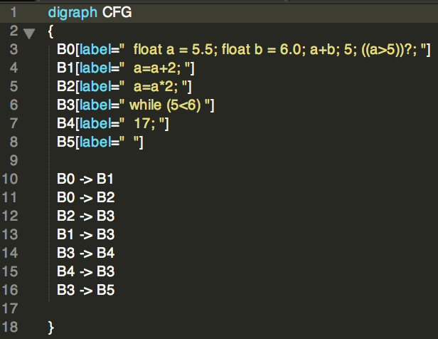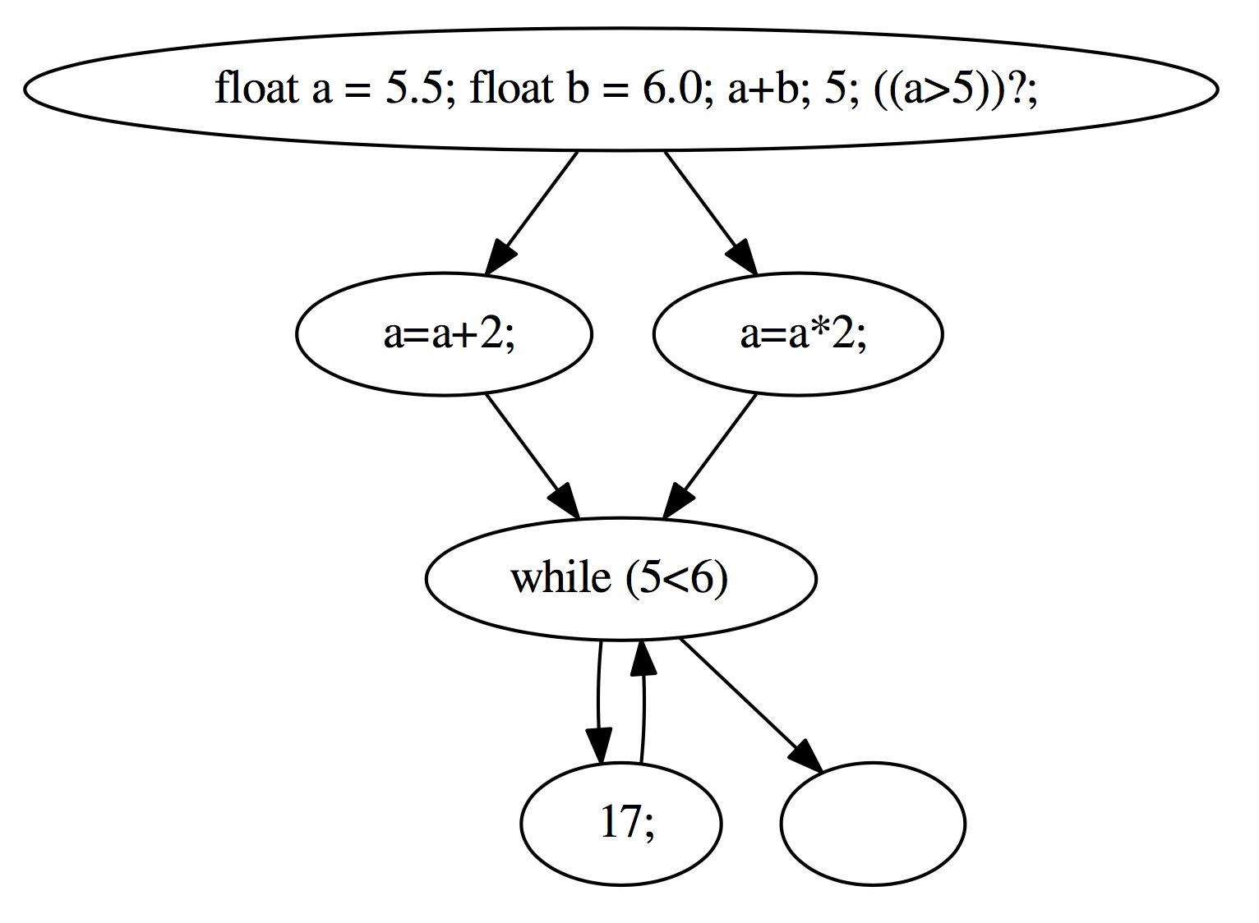

Figure 1: (a) dotFile.dot (Left); (b) Graphical representation (Right)

This control flow graph implementation is complete.

2. Participants: specifically the team members that built the project. Indicate how the work has been divided among the individuals.

Brian Caplan – Extended proj3 to include control flow graph

Oi Lee – Proj4 write up

3. Project activities: specifically make an itemized list of activities you have taken to accomplish your project goals. For each activity, indicate the timeline and the individuals involved in the activities.

1. Update proj.code

2. Update proj.pt

3. Test Input/Output

4. Write up

4. Project outcomes and accomplishments: specifically break down the overall project into smaller tasks and important milestones of project accomplishment, indicate the time line when each milestone has been accomplished, and specify which team members have contributed to each accomplishment and in what degrees.

1. Update proj.code – did not need to update

2. Update proj.pt

a) Control flow IR

b) Control flow translation schemes(for non-terminal

1) Goal block [Brian Caplan]

2) LET [Brian Caplan]

3) IF [Brian Caplan]

4) Uop [Brian Caplan]

5) PLIT [Brian Caplan]

6) WHILE [Brian Caplan]

3. Test Input/Output [Brian Caplan/Oi Lee]

a} Test Case

b) Implement Test Cases

c) Verify expectation and results

4. Write up [Oi Lee]

5. Evaluation: how have you tested the project? Present evaluation results in a meaningful fashion. For example, if you worked on a specific optimization, indicate how you measured the performance improvement and then present the evaluation results.

Manually tested different inputs and verified outputs with expectation. Compared outputs to expected outputs and manually verified it was correct.