IS 622 Week 11 Homework

Ben Arancibia

November 5, 2015

**9.3.1**

Figure 9.8 is a utility matrix, representing the ratings, on a 1–5 star scale, of eight items, a through h, by three users A, B, and C. Compute the following from the data of this matrix.

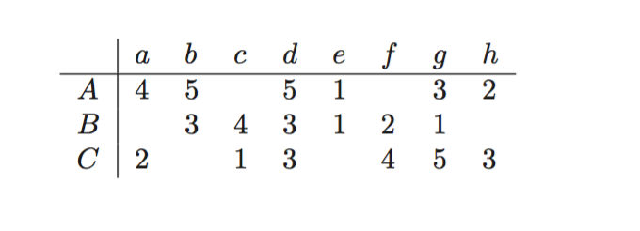

1. Treating the utility matrix as boolean, compute the Jaccard distance between each pair of users.
2. Repeat Part (a), but use the cosine distance.
3. Treat ratings of 3, 4, and 5 as 1 and 1, 2, and blank as 0. Compute the Jaccard distance between each pair of users.
4. Repeat Part (c), but use the cosine distance.
5. Normalize th ematrix by subtracting from each nonblank entry the average value for its user.
6. Using the normalized matrix from Part (e), compute the cosine distance between each pair of users.