Project Proposal

Benjamin Arancibia

11/11/2014

The Semester Project that I am hoping to tackle is an in-depth analysis of foreign aid in Honduras. All known foreign aid projects are accessible via an open data portal found at this website: <http://pgc.sre.gob.hn/>, also I have access to the server that hosts the DB for the foreign aid management system called AMP used by the Government of Honduras. Full disclosure I have access because my company (Development Gateway) built this software and I am currently the Project Manager for our project with the Government of Honduras. The reason why I want to use this data is because I am spearheading the increase in data analytics at my company and trying to convince them that we need a dedicated data analytics team.

For the technologies we used this semester I am planning on using R, Javascript (with leaflet or OSM to plot project locations). I was thinking about making a report generator with R server and plotly to be able to create on the fly reports for different data a user might want to take a look at.

In terms of what it will look like, I am imagining a combination of this:

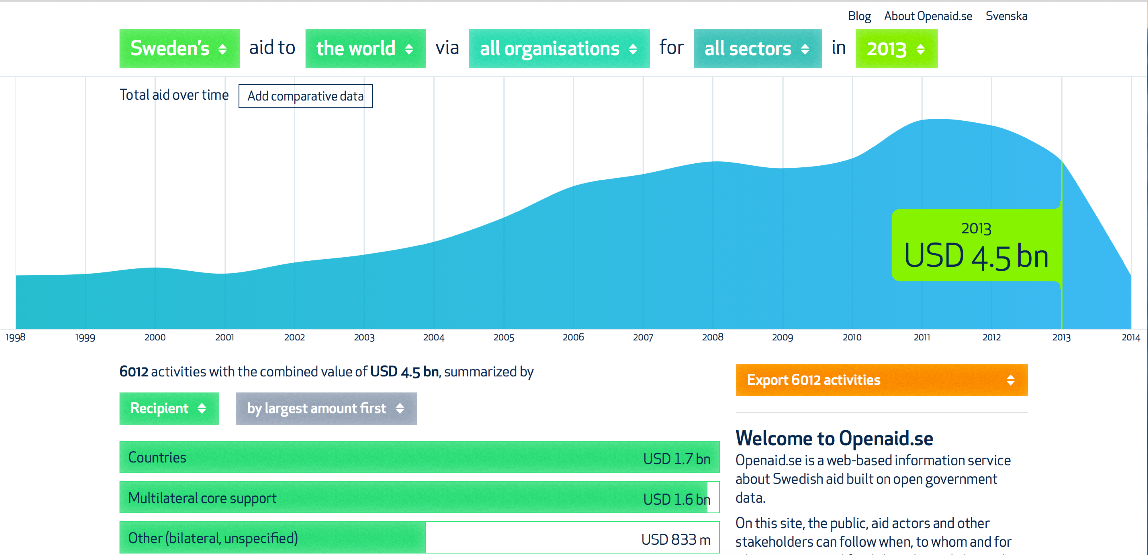

on one tab. Basically it will show aid in Honduras and be able to filter by donors or sectors.

I was also thinking a second tab with a map to show the location of projects by donor. The idea is to look for donors doing the same type of projects in the same locations. I would also theoretically like to be able to have the base layer change based on the sectors. As an example have the number of hospitals per municipality in Honduras as a chloreoplath map with health projects. Example below using Quantum GIS:

 