The Infinite Number Calculator
Programmers: Chhean Saur, Jason Hepp, Brian Cardarella

Using the calculator:
The calculator initially starts off with A = 0, B = 0, and the Answer = an Empty List.
All functions, operations, inputs, and compares are done in terms of A and B.
Example:
Press the letter A to input a number in for A. Lets input 12345
Press the letter B to input a number in for B. Lets input 54321
Next press the addition key ‘+’
Now the operation is performed in terms of A + B

Answer = 66666

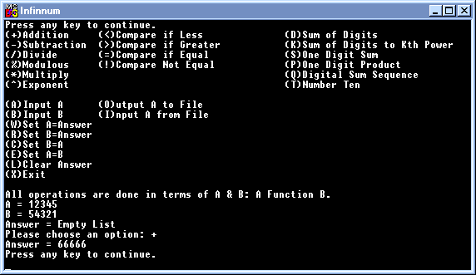
Lets try doing a compare.
Now since A = 12345, B = 54321, and the Answer = 66666.
Press the less than symbol ‘<’ to compare A and B
Now the operation is performed in terms of A < B

Answer = 66666 (This is storing the previous answer and will continue to do so unless another operation is performed)
And True is displayed since A < B
Now the operation is performed in terms of NumberTen A + B

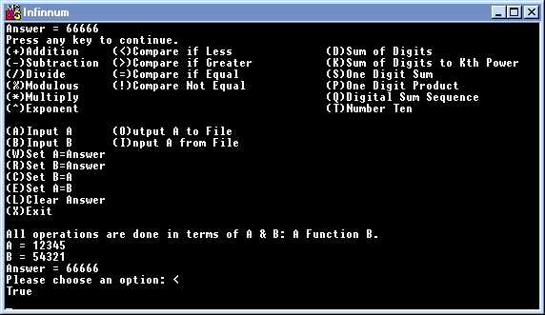

Lets try the function Number Ten.
Press the letter A to input a number in for A. Lets input 2
Press the letter B to input a number in for B. Lets input 3
Next press the letter T key or ‘T’
It will ask “Input the Nth number to stop: “, this is the A_{n} number in the sequence. Input an 11.
Now it will ask “Do you wish to print out all the numbers in the sequence? (Y/N): “. Input ‘Y’ for yes.
Notice how all eleven numbers in the sequence are displayed to the screen.
Now the 11th term in the sequence is 24, and Answer will now equal 24.
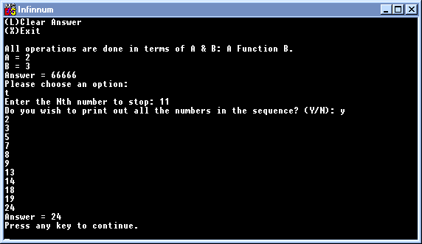
The function was done in terms of NumberTen(A,B,11).

Finally Lets try a File Function. Note that A will contain the result from a file input, and A’s result will be outputted to a file.
Press the letter A to input a number in for A. Lets input 987654321
Press the letter O to output to a file.
It will prompt you for a filename. Let’s enter “TestDat.txt”.
The number 987654321 will now be stored in the file TestDat.txt

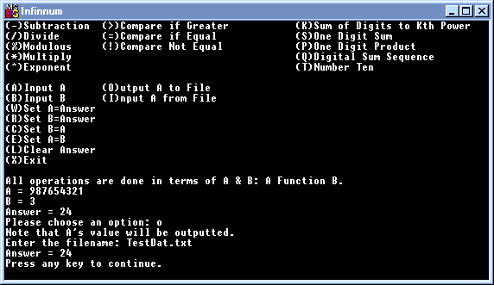
Now to check it, we can either open the file or see if it will be re-inputted into A.
Press the letter A to input a number in for A. Lets input 0
Press the letter I to input from a file.
Type in the file name “TestDat.txt”
Notice now how A resumes its previous value of 987654321.

Press ‘x’ to exit the program.

