1. I extracted the amount of friends each of Dr. Nelson’s friends had, & placed them into a .txt file. . I ran the text file through a simple Python program I made use of by utilizing the statistics library (installed through command prompt). I found about the statistics library after I began looking into the math library where I initially thought the three required functionalities belonged to. I used code from <https://pythonprogramming.net/statistics-python-3-module-mean-standard-deviation/> and <https://developers.google.com/edu/python/regular-expressions> as the basis of my program to complete the computations. The snap below is from my initial framework gathered from the first link.

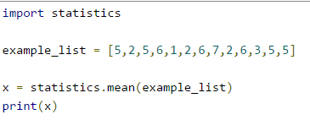

The resulting code I created is shown below-

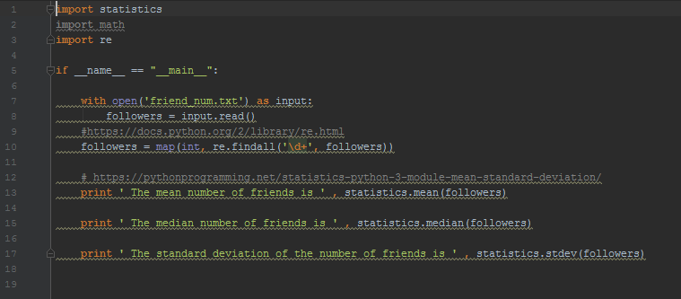

I ran my code and stored the generated output in a .txt file, friends_stat.txt.

When graphing this information, initially I tried to follow the link here <http://stackoverflow.com/questions/8774002/setting-the-color-for-an-individual-data-point> , however the point marked for Dr. Nelson did not change color. Another student sent me the following link, <http://stackoverflow.com/questions/22781685/different-colors-for-each-bar-in-stacked-bar-graph-base-graphics> and was able to fix the problem. I was told that instead of using a color on top of a color, I had to do so as a range. The revision to my code was as follows-

barplot(x,main="Facebook Friendship Paradox",xlab="Individual Friend",ylab="Friend's Friends", **col=col**)

**col <- c(rep(c("blue"),42),rep(c("white"),1),rep(c("blue"),111)).** The first 42 elements in the list are blue, followed by Dr. Nelson(white bar), and he is followed by the rest of the blue bars(111). You will have to zoom in to see the differentiation.

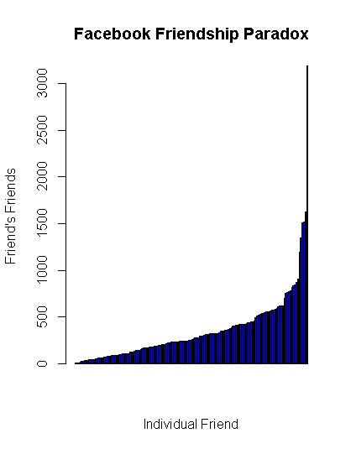

2. For question 2, I acquired exactly 50 followers on Twitter and created a .txt file listing my follower’s followers given the relatively small size of the group. I took that document, followers.txt and ran a program identical to the one above to yield my mean, median, and standard deviation values. These are stored in a file, followers_stat.txt.

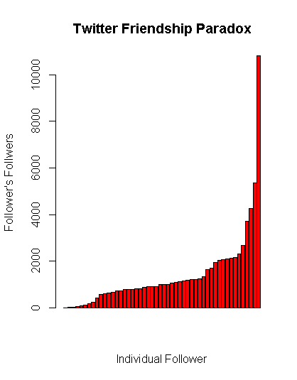

All .R files used to generate the graphs are located in my repository.