|  |
| --- |
|  |

1) We know the result of the Karate Club (Zachary, 1977) split. Prove or disprove that the result of the split could have been predicted by the weighted graph of social interactions. How well does the mathematical model represent reality?

Generously document your answer with all supporting equations, code, graphs, and arguments.

Solution: I did not know of Karate Club until Dr. Nelson brought it up and I read about it. When he asked what was the first rule of Karate Club was, I assumed it was the same as Fight Club- don’t talk about Fight Club. I read the report provided by Dr. Nelson on the prompt, <http://aris.ss.uci.edu/~lin/76.pdf> , the source detailed the split of a university karate club, that was followed by W. W. Zachary, over the course of three years due to difference in opinions on the matter of price of lessons. The group split into two unofficial factions, led by Club President John A.(wanted to stabilize prices), and the instructor Mr. Hi(wanted to raise prices). Eventually the club would become two separate clubs headed by the aforementioned parties. The paper states that “the model allows the locus of fission within the group to be accurately predicted (greater than 97% accuracy for the data reported here)”.

A graph of the club, pre-split was found on another site- <https://milesott.com/2016/08/26/karate-club-network-club/>

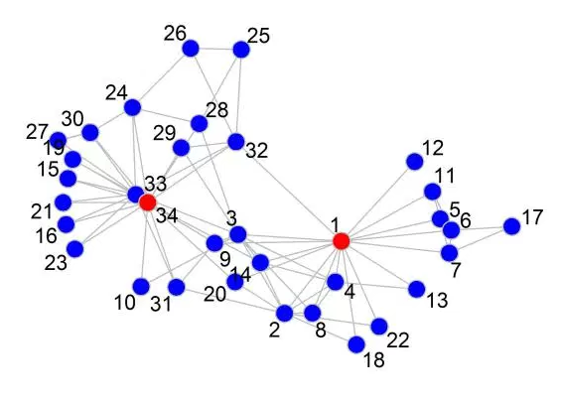

I looked to recreate this graph in myself, so I could manipulate it and recreate the split. In speaking with a classmate I was informed that R was capable of solving this problem, as it had access to the igraph library referenced in the provided readings multiple times. I read up on igraph and the tutorials provided at <http://igraph.org/r/> . <https://github.com/igraph/igraph/commit/ad7a64d69f5f964721d22ccd0eda96f30549b0f3> was also helpful in creating my graphs. I read it into RStudio using the g = portion of the following code from <http://stackoverflow.com/questions/14066700/about-community-to-membership-function> .

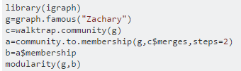

The initial graph was created using Q1_one.R

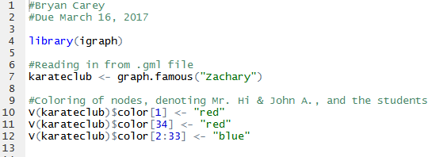

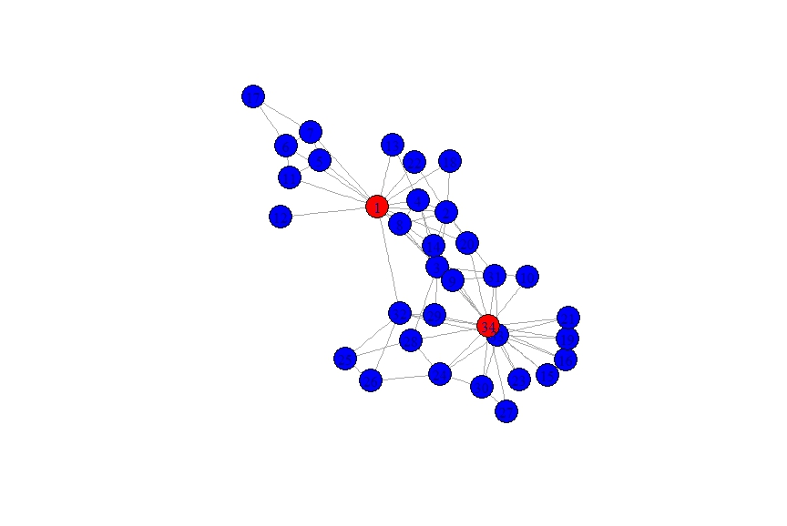

The graph, post-split was created using Q1_two.R

I referenced <http://stackoverflow.com/questions/33005510/algorithm-of-community-edge-betweenness-in-python-igraph-implementation>, <http://igraph.org/r/doc/betweenness.html>

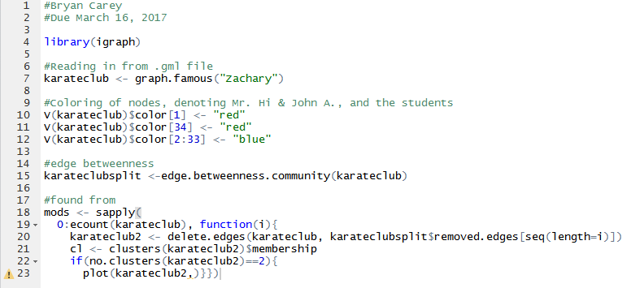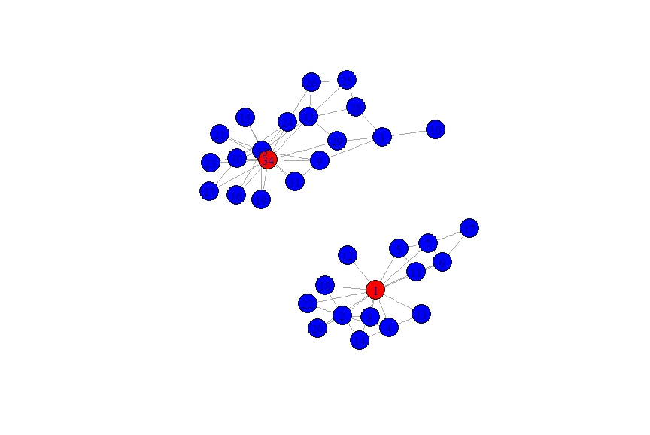

The ‘mods’ portion of the code was found at this link, <http://www.sixhat.net/finding-communities-in-networks-with-r-and-igraph.html> , which was sent to me by another student.

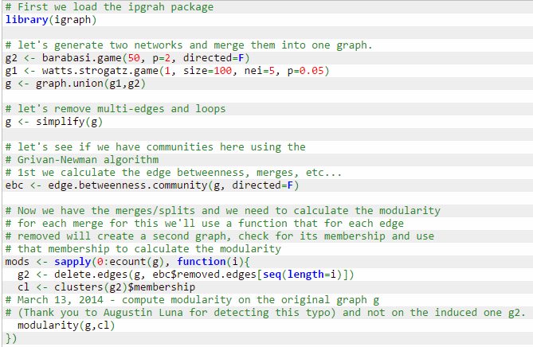

I checked my results against the graph of the actual results, found at <https://en.wikipedia.org/wiki/Zachary%27s_karate_club> .

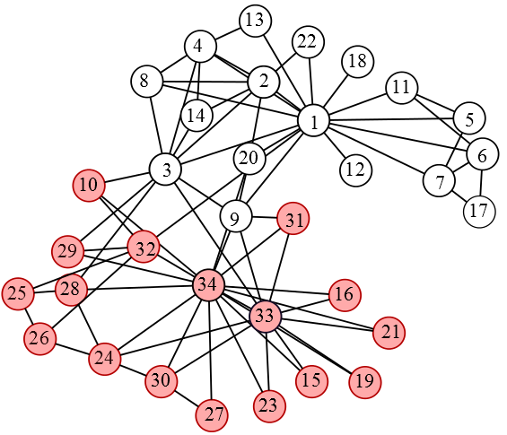

The simulation I ran was able to accurately reproduce the results of the split almost exactly with the exception of number 3, which sided with 34 as opposed to 1. This leads me to believe that yes, the split could have been predicted based upon analysis of the relationships between each of the individuals.

2) We know the group split in two different groups. Suppose the disagreements in the group were more nuanced – what would the clubs look like if they had split into groups of 3, 4, and 5?

Solution: Using my code from Q1_two.R, I was able to simulate the split into 3, 4, and 5 factions simply by changing the value in place of the two located here. Another classmate informed me of how to do so with ease.

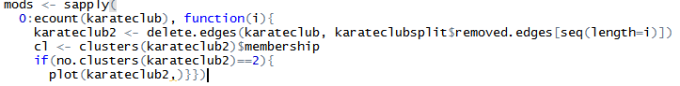

The results were as follows-

3. 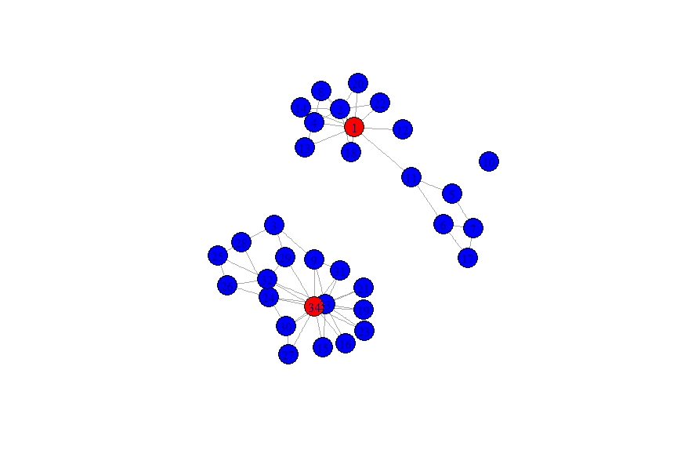

4. 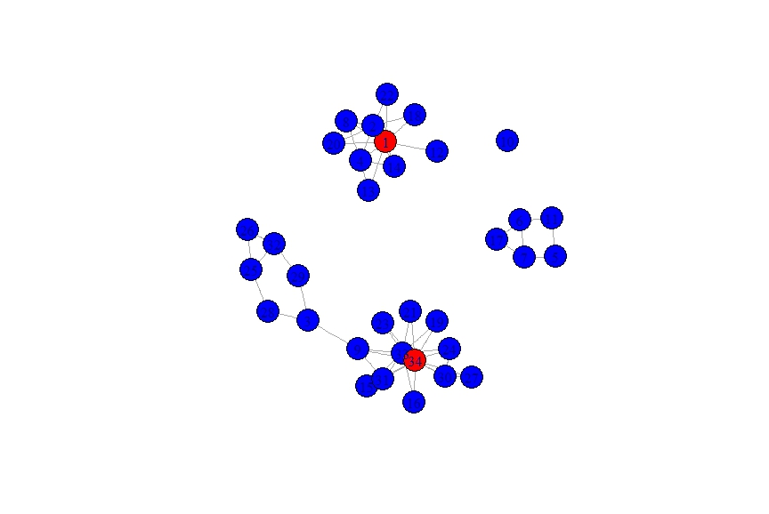

5. 