Lab 09

Adam Heald and Brandon Caudell

<https://github.com/bcaudell95/EECS448_Lab9>

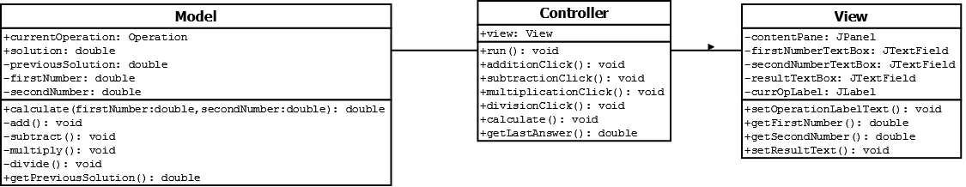

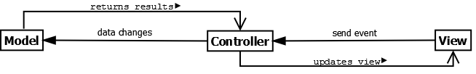

Screenshots

Add

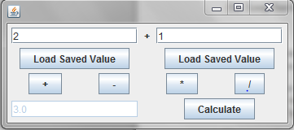

Divide

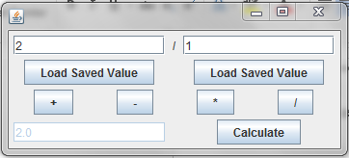

Multiply

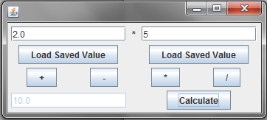

Subtract

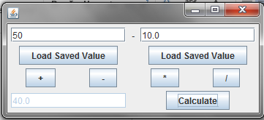

Who did what. – Adam completed the Model and Brandon completed the View and both wired it together in the Controller.