**Introduction**

We decided to take the paper “Modelling civil violence: An agent-based computational approach”

In this paper the author “Joshua M. Epstein” tried to model civil violence based on some simple concepts.

The paper is divided into two parts. In the first one he only looked into the dynamics of the behaviour between cops and one group of agents. Where the central authority seeks to suppress decentralized rebellion.

Epstein compared data like:

* Local outbursts
* Waiting time distribution between outbreaks
* Tension between active agents und non active agents
* Legitimacy reduction
* Cop reduction

The second part introduces a second ethnic group. The central authority tries to suppress communal violence between the two warring groups.

Here he tried to look into the peaceful coexistence of both groups. The parameters which he varied are:

* Cop density
* Introduction of a peace keeper

Our goal is to reproduce the same results and to apply the second model to a new problem. We would like to simulate the effects of terrorism on two warring ethnic groups.

**Represent**

Epsteins model is based on a simple set of rules in which he can vary properties like hardship, legitimacy, risk the agents are willing to take.

Like in the real world where terrorist attacks have some significant effects on the population, we would like to introduce a “bomb” to the model, which will affect the surrounding agents and cops. The bomb property will only be available for the agent “terrorists”.

He modelled the cops without the ability to join one side, be killed or to withdraw.

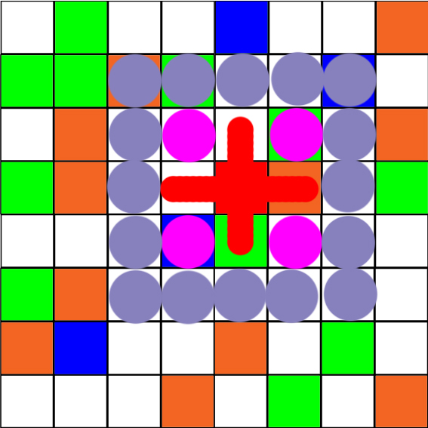Green: Agents Group 1

Brown: Agents Group 2 (terrorists)

Blue: Cops

Red: Bomb (agent 2 turns into bomb)

Bomb radius:

Red cross: highest impact; agents and cops are killed

pink circle: deterrent effect on agents

purple circle: Grievance increase of agents towards   
second ethnic group

The Bomb has the effect to kill the nearest agents (red cross).

It also has deterrent effect on an outer layer. The agents and cops will be more likely to withdraw and be scared. It is going to be harder for the agents to get active and to “rebel”.

Both cops and agents are more likely to turn sides in fear. Cops and agents in this area will switch to the side of the agent group 2 (terrorists).

The agents and cops in the purple area will be more likely to switch to the side of the agent group 1. We suppose that this effect is due the distance these agents/cops have to the bomb, so the impact increases their grievance more than their deterrence.

We are going to model this in Matlab.

**Research question**

How does terrorism affect the communal violence between two warring ethnic groups?

**Literature and previous projects you will base your model on and possible extensions**

* Paper: Modelling civil violence: An agent-based computational approach  
   –Joshua M. Epstein
* <https://www.kaggle.com/>   
  Terrorism database
* <https://www.start.umd.edu/gtd>  
  Terrorism database