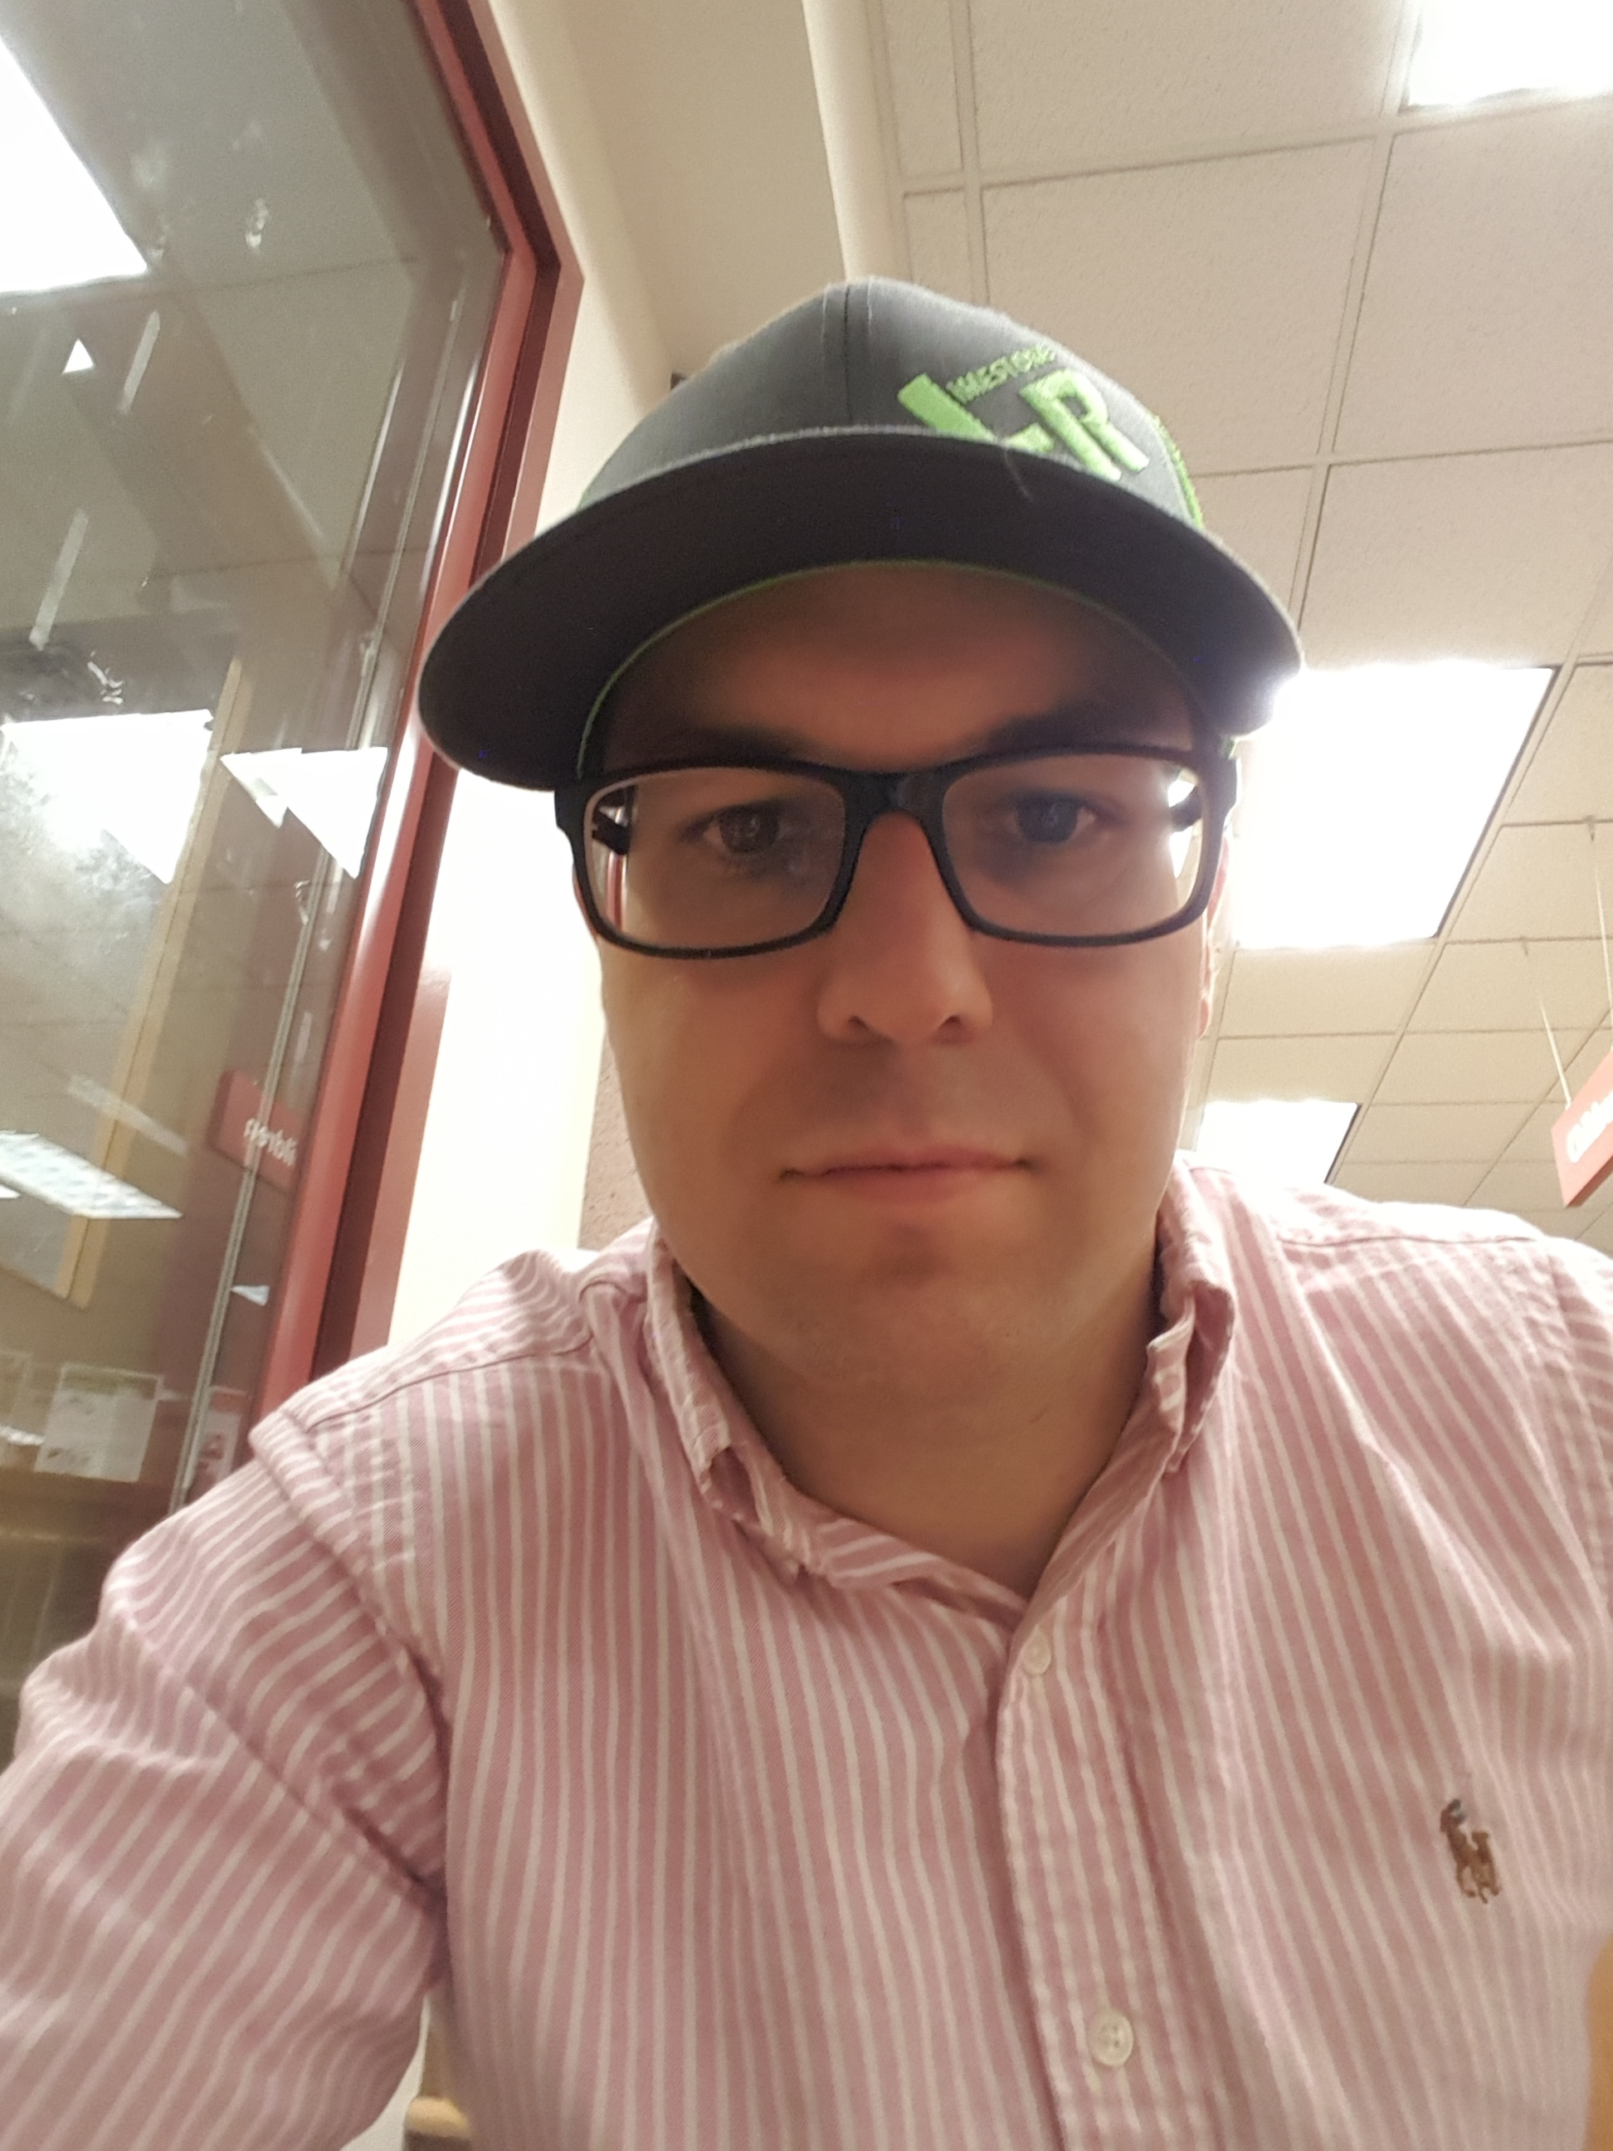

Hi I’m Derek Hobbs I was born and raised in New London, CT. I am now a Madison, WI based artist with my wife and 3 beautiful children. I am always discovering, always experimenting and never settling.

I am mainly self taught, but draw from my diverse educational background, including, study of the Graphic Design at Madison College, and my degrees in Natural Resources and Web Software Development to inform the way I work.

The ideology of my work is underpinned by my love of God, nature, the environment and the human condition. Where some of my series such as Alaskan Landscape and Endangered Animals I border on realistic representation and a more crude realistic approach caring less about the details to probe more of the essence of the subject.

Working in acrylic, oil, digital, photography and mixed media I bring my ideas and emotions alive on canvas and wood panel. My influences are derived from many sources, such as the impressionists, abstract expressionists, surrealists, pop art, realists, post modernists, design, nature, my kids, music and the list goes on its like putting everything into a coffee or tea fueled blender, to tap my subconscious where effulgent creations manifest themselves into this world.

My artwork has been featured in collaborative art shows at Madison’s Art In, various local coffee shops and at the Alicia Ashman Library located in Middleton, WI. While living in Indiana, I displayed my work at local coffee shops and a local pottery shop called the Artist Within. While there I created a street art piece along the Greenway. During my time in Fayetteville, NC I created a mural of a beach theme for a local Beach Bingo business. Growing up in CT, I worked under John DeNardis, an artist who builds custom store front displays for such clients as F.A.O. Schwarz in NYC. I also worked as a painter doing stencil work for the Garde Arts Theater renovation project in the 90’s. My work has been shown at the local Hygienic Art Gallery during their annual everyone is an artist shows.

