YIELDFORGE

YieldForge
Future-Aware Material Optimization for 2D Manufacturing
Comprehensive product proposal and perfect-information MVP validation plan
Decision requested
Approve development of a bounded perfect-information MVP to determine whether future-aware selection among high-quality Sparrow nests can produce commercially meaningful incremental net material savings over a strong commercial-style baseline.

Perfect-information MVP | >= 2.5% | >= 1.5 pp
Bounded validation scope | Preferred target-regime oracle advantage | Preferred unknown-future component

Prepared for internal R&D evaluation
Version 1.0 | August 17, 2026

Working-name notice: "YieldForge" is used throughout this proposal as a provisional product name. Active financial/DeFi products already use the name, so domain, trademark, and market-confusion screening are required before external launch. [20][21]

0. Executive Decision Summary
The proposal is to fund a falsification experiment, not to commit to a full manufacturing software build.
Recommended decision
Approve the perfect-information MVP, subject to phase-by-phase kill gates. Do not authorize the stochastic production product, CAM integrations, multi-machine scheduling, or a customer-facing platform unless the MVP identifies a target regime with at least 2.5% oracle savings, at least 1.5 percentage points attributable to unknown future demand, and acceptable supporting metrics.

The thesis
Conventional nesting systems are designed primarily to maximize the value of the current cut: fit the current parts tightly, select a currently available sheet or remnant, and generate process-feasible toolpaths. YieldForge asks a different question: among several current nests that are nearly tied on immediate utilization, which one creates the lowest total material cost over future orders?
The opportunity exists because equal-area leftovers are not economically equivalent. A compact nest may strand material in thin channels and disconnected pockets, while a nest that is only fractionally less dense may preserve one contiguous irregular remnant capable of satisfying a recurring future part family. The difference is not visible in current utilization alone. It is an inventory option-value problem expressed through exact geometry.

What the market already provides
The market is not empty. AccuFit, Lantek, Plataine, SigmaNEST, ProNest, JETCAM/CrossTrack, BySoft, RADAN, SlabWise, and related systems already cover substantial portions of nesting, remnant tracking, stock selection, current-order mixing, scheduled-order lookahead, deliberate remnant shaping, production scheduling, and defect avoidance. [3]-[11] Academic literature also treats multi-period and stochastic cutting-stock problems with usable leftovers. [12]-[16]
Accordingly, YieldForge is not defensible as "software that saves remnants" or "future-aware nesting." Its potentially differentiated kernel is narrower: exact irregular-polygon remnants, multiple near-tied process-feasible candidate nests, future demand that is not yet a firm order, marginal option value conditional on all other inventory, and a chronological counterfactual system that proves the incremental value against strong as-of-time policies.

What the MVP establishes
The MVP builds a deterministic research system around Sparrow, an open-source high-performance irregular 2D strip-packing solver, and jagua-rs, its geometry engine. [1][2] It will capture multiple Sparrow candidate layouts, extract exact residual polygons, reuse those remnants as future cutting surfaces, replay temporal order streams, and compare a strong baseline with a policy that can see every future order.
This first system contains no forecasting model. Perfect future knowledge is deliberately used to answer the prerequisite question: is there enough exploitable geometric option value to justify predicting it later? If a clairvoyant policy cannot create meaningful incremental savings, a practical stochastic system cannot rescue the business case.

Investment gates
Evidence profile | Decision | Interpretation
Target oracle <1.5% or unknown-future gap <0.5 pp | Red / no-go | Publish or archive the research and stop commercial development.
Target oracle 1.5% to <2.5% or unknown-future gap 0.5 to <1.5 pp | Yellow / validate | Acquire real manufacturer history before further product engineering.
Target oracle >=2.5% and unknown-future gap >=1.5 pp | Green / continue | Proceed to stochastic valuation only if the supporting metric gates also pass.

Bottom-line recommendation
The expected value is favorable because the MVP is bounded, technically separable, and capable of killing the idea before a multi-year build. The document therefore recommends completing the MVP while explicitly declining to underwrite the end-state product until the measured evidence profile clears the pre-registered threshold.

Contents
Document map
0 | Executive Decision Summary
1 | Proposal at a Glance
2 | Problem Statement and Optimization Thesis
3 | Current State of the Market
4 | YieldForge End-State Opportunity
5 | Validation Thesis and Falsifiable Hypotheses
6 | The Perfect-Information MVP
7 | MVP Milestones and Acceptance Gates
8 | Benchmark and Experimental Program
9 | Go / No-Go Decision Framework
10 | Risk Register and Mitigations
11 | Recommendation and Authorization Scope
Appendix A | Canonical Data Contracts
Appendix B | Acceptance-Test Matrix
Appendix C | Benchmark Parameter Grid
Appendix D | Glossary
References | Sources and prior art

1. Proposal at a Glance
YieldForge is best understood as a future material-decision layer, not as another CAM replacement.
Dimension | Proposal
Working concept | A CAM-agnostic system that chooses among process-feasible nests according to total future material economics rather than immediate packing density alone.
Initial engine | Sparrow for high-quality irregular 2D candidate generation; jagua-rs for exact geometry, irregular containers, and later material-quality zones. [1][2]
First question | How much can perfect information save over a strong commercial-style baseline when both policies share the same candidate set and compute budget?
First deliverable | A deterministic chronological simulator, exact remnant inventory, baseline suite, rollout oracle, beam-search oracle, public/synthetic benchmarks, and an investment verdict.
MVP boundary | A bounded research implementation organized into four gated phases, with explicit non-goals and a pre-registered decision framework.
Preferred success signal | Target-regime oracle advantage of at least 2.5%, ideally 3% or more; at least 1.5 percentage points attributable to unknown future demand; and no-signal controls near zero.
Immediate non-goals | No forecasting, quotes, machine scheduling, heterogeneous material fields, CAM integration, production UI, purchasing optimization, or autonomous shop execution.
End-state buyer | A high-material-spend manufacturer with recurring irregular parts, meaningful remnant inventory, and a strong incumbent CAM that YieldForge complements rather than replaces.

One-sentence product definition
YieldForge
A probabilistic material-decision layer that prices the future geometric utility of each candidate nest and selects the present action with the lowest expected cumulative material cost.

Why the validation comes first
The broad end-state system would combine irregular nesting, exact remnant inventory, order batching, material allocation, stochastic demand, machine assignment, and rolling scheduling. That is a large operations-research and industrial-integration program. The perfect-information build deliberately removes every component that is not necessary to determine whether the central economic effect exists.
This sequencing protects against the most expensive failure mode: building a sophisticated forecasting and integration platform around an oracle gap that is too small to monetize. The first program is therefore an evidence-generating research MVP with reusable technical assets, not a customer-facing production system.

The strategic distinction
System | Primary role | What it optimizes
Sparrow | Geometric optimizer | Finds extremely compact process-feasible arrangements of irregular 2D parts.
Existing CAM | Manufacturing execution authority | Applies machine rules, process parameters, toolpaths, sequencing, and NC output.
YieldForge | Economic decision layer | Determines which batch, stock object, and candidate nest produces the best long-run material state.

2. Problem Statement and Optimization Thesis
The current nest is a decision about future inventory, not merely a packing result.

2.1 The immediate-utilization blind spot
A typical nesting objective rewards the current layout for fitting more part area into less stock. This is rational but incomplete. The unused material left by a nest becomes one of three things: immediate scrap, a retained remnant that is later consumed, or a retained remnant that occupies space and is eventually scrapped. Current utilization does not distinguish between those futures.
Consider two feasible layouts for the same batch. Layout A achieves 94.0% immediate utilization but leaves several disconnected slivers. Layout B achieves 93.2% utilization and leaves one connected shape whose dimensions and contours closely match a recurring future part family. The current-period metric prefers A. The economically correct choice depends on whether B avoids enough future purchasing and handling cost to justify the 0.8 percentage-point sacrifice today.
Measure | Layout A | Layout B
Immediate utilization | 94.0% | 93.2%
Residual geometry | Disconnected channels and pockets | One contiguous recoverable irregular remnant
Current-period material use | Best | Slightly worse
Probability of future geometric fit | Low | High in recurring-family shop
Expected long-run cost | Potentially higher | Potentially lower despite current sacrifice

2.2 The true state variable is the entire inventory
A remnant does not possess a fixed standalone price. Its value depends on every other piece of compatible stock already available. If the shop already holds three remnants capable of satisfying the same likely future order, producing a fourth may add almost no option value. If the shop has no substitute and procurement lead times are long, the same geometry can be highly valuable.
Conditional value principle
MarginalValue(R | I) = FutureCost(I) - FutureCost(I union R)
where I is the complete compatible material inventory, not an empty inventory.

This non-additivity is central. Independently pricing each remnant and summing the results systematically overvalues redundant inventory. YieldForge must evaluate the inventory state produced by a candidate nest, not attach an isolated score to each leftover polygon.

2.3 The objective
The production decision should minimize cumulative material economics. In the end-state system the decision may include order batching, stock selection, machine assignment, nest selection, and timing. In the MVP, the action is deliberately narrowed to selection among current candidate nests and compatible stock objects.
Validation objective
Score(candidate) = current purchase and process cost
+ future purchased-material cost
+ storage and handling cost
- scrap proceeds
+ conservative terminal-inventory adjustment

OracleSavings = (BaselineCost - OracleCost) / BaselineCost

2.4 Geometry, not area, determines substitutability
A ten-square-foot remnant can be less useful than a seven-square-foot remnant. Area, bounding box, convexity, minimum width, connectivity, permitted rotation, kerf, grain direction, and exact polygonal fit determine whether future parts can actually use it. The validation system therefore treats remnants as exact irregular containers and uses geometric feasibility rather than area alone.
The system also distinguishes theoretical unused material from a recoverable remnant. Empty space inside a nest may be trapped in a skeleton, fragmented into narrow channels, too small to handle, or inaccessible without an additional trim cut. The first system will include both a geometric upper-bound extractor and a conservative operational extractor so that apparent savings are not created by impossible inventory.

2.5 Material properties are a spatial field
The eventual material model must retain more than material name, grade, and thickness. Some stock can contain weak zones, surface defects, heat-affected regions, certification boundaries, variable thickness, grain direction, or local inspection uncertainty. A remnant created from that stock inherits the clipped property field. A future high-strength part must not be placed over a weak region merely because the outer geometry fits.
This capability is intentionally deferred from the MVP. The initial schema will reserve fields for material and quality regions so the architecture does not need to be redesigned later, but the experiment will use one uniform material, grade, and thickness. jagua-rs already supports irregular containers, holes, inferior-quality zones, and hazard filters, making it a plausible basis for later spatial compatibility rules. [2]

2.6 The broader shop-level problem
Across a factory with multiple cutters, the decision expands from one nest to a rolling material-allocation and production-dispatch problem. The planner can decide which released orders to combine, which remnants to reserve, which cutter receives a batch, and whether a short delay improves co-nesting without missing due dates. Decisions interact because two machines can otherwise create redundant remnants for the same probable future demand.
This broader opportunity is commercially important but methodologically dangerous at the start. Adding scheduling could create savings unrelated to future remnant option value and make a negative result uninterpretable. The first program therefore prohibits deliberate waiting, future-order batching, and multi-machine assignment. It isolates the nest-selection effect.

3. Current State of the Market
Existing vendors occupy most of the broad category; the opportunity lies in a narrower intersection.

3.1 Market taxonomy
Category | Representative systems | Established capability
Geometry and CAM engines | Sparrow, ProNest, SigmaNEST, Lantek, RADAN, JETCAM | True-shape nesting, machine/process constraints, toolpaths, cut sequencing, NC generation.
Remnant and stock management | Lantek, SigmaNEST, ProNest, JETCAM, RADAN | Track stock and offcuts, select remnants, maintain traceability, create new remnants.
Material planning and orchestration | AccuFit, Plataine, BySoft, CrossTrack | Match orders to inventory, mix jobs, schedule work, integrate ERP/MES and shop-floor state.
Vertical specialist systems | SlabWise and domain-specific optimizers | Batch jobs, map defects, preserve usable remnants, optimize vertical-specific workflow.
Academic multi-period optimization | Birgin, Cherri, Nascimento, Chen and related work | Usable leftovers, future periods, stochastic demand, sequential value correction, beam search.

3.2 Closest commercial comparators
System | Publicly evidenced capabilities | Implication for YieldForge
AccuFit | 1D/2D/3D planning, ERP-linked inventory matching, plan scoring, aged-remnant priority, current-job mixing, and explicit use of scheduled future work orders in 1D to consume current remnants. [3] | Closest conceptual predecessor. Public materials do not clearly establish probabilistic uncommitted demand, arbitrary irregular future-remnant option value, or a chronological oracle.
Lantek Expert | Stored/current remnant reuse, handling and storage economics, MRP linkage, and deliberate generation of rectangular or irregular remnants through orientation and shape rules. [4] | Closest sheet-metal CAM precedent for remnant shaping. The proposed wedge must go beyond remnant rules and known-order logic.
Plataine | Dynamic cutting and kitting optimization using work orders, inventory, latest geometries, constraints, remnants, defects, and production integration. [5] | Closest architectural analogue for a material decision layer, especially in composites and advanced materials.
SigmaNEST | True-shape nesting, best sheet selection, FIFO remnant nesting, cost/heat tracking, ERP/MRP integration, due dates, and work-order mixing. [6] | Strong incumbent baseline. Vendor savings claims are useful market evidence but are not controlled evidence of incremental advantage over a modern comparator.
ProNest | True-shape nesting, plate/remnant inventory, multi-job nesting, filler parts, and Nesting System Optimization across combinations of parts, plates, remnants, and strategies. [7] | Strong immediate and known-work baseline; incumbent CAM should likely remain the execution layer.
JETCAM / CrossTrack | ERP-linked automation, stock/offcut tracking, mixed orders, material allocation, nesting, scheduling, and composite material traceability. [8] | Substantial overlap with shop orchestration; public positioning emphasizes known work and current inventory.
BySoft Shop Floor | Automatic programming, nesting, and scheduling; can delay a job to the latest safe point to achieve target material yield while protecting due dates. [9] | Direct evidence that bounded waiting and known-order batching are established capabilities.
RADAN | True-shape CAM, automatic remnants/offcuts, inventory and remnant functions across punch/profile workflows. [10] | Another strong industrial comparator for geometry and remnant execution.
SlabWise | Multi-job stone nesting, several layout alternatives, remnant usability, automatic remnant cataloging, defect mapping, and queue-based batching signals. [11] | A close workflow analogue in a vertical market, but not publicly presented as probabilistic option valuation.

3.3 Competitive landscape
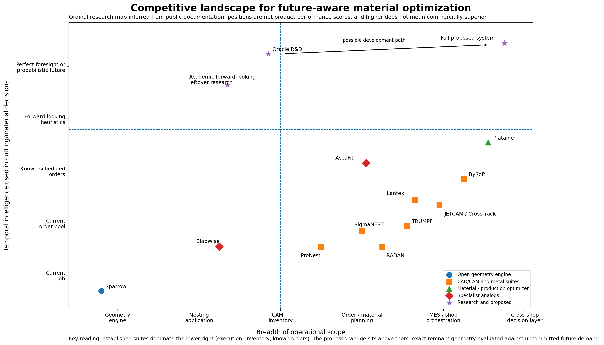
Figure 1. Ordinal research map inferred from public documentation. Positions are not performance scores; higher does not mean commercially superior. The proposed system is a target, not an existing capability. Sources: [3]-[16].
The established suites dominate the lower-right portion of the map: they are operationally broad and make decisions using current jobs, order pools, scheduled work, inventory, and machine constraints. The proposed wedge sits above those systems on the temporal axis. It seeks to value exact residual geometry against demand that has not yet become a released order.

3.4 Capability matrix
The matrix below is intentionally conservative. A filled capability means the function was clearly described in reviewed public product material; a partial mark means the functionality is adjacent, limited, or ambiguous; an open mark means it was not found publicly and does not prove internal absence. The purpose is not to rank products. It is to prevent the proposal from claiming novelty where the market already provides it.

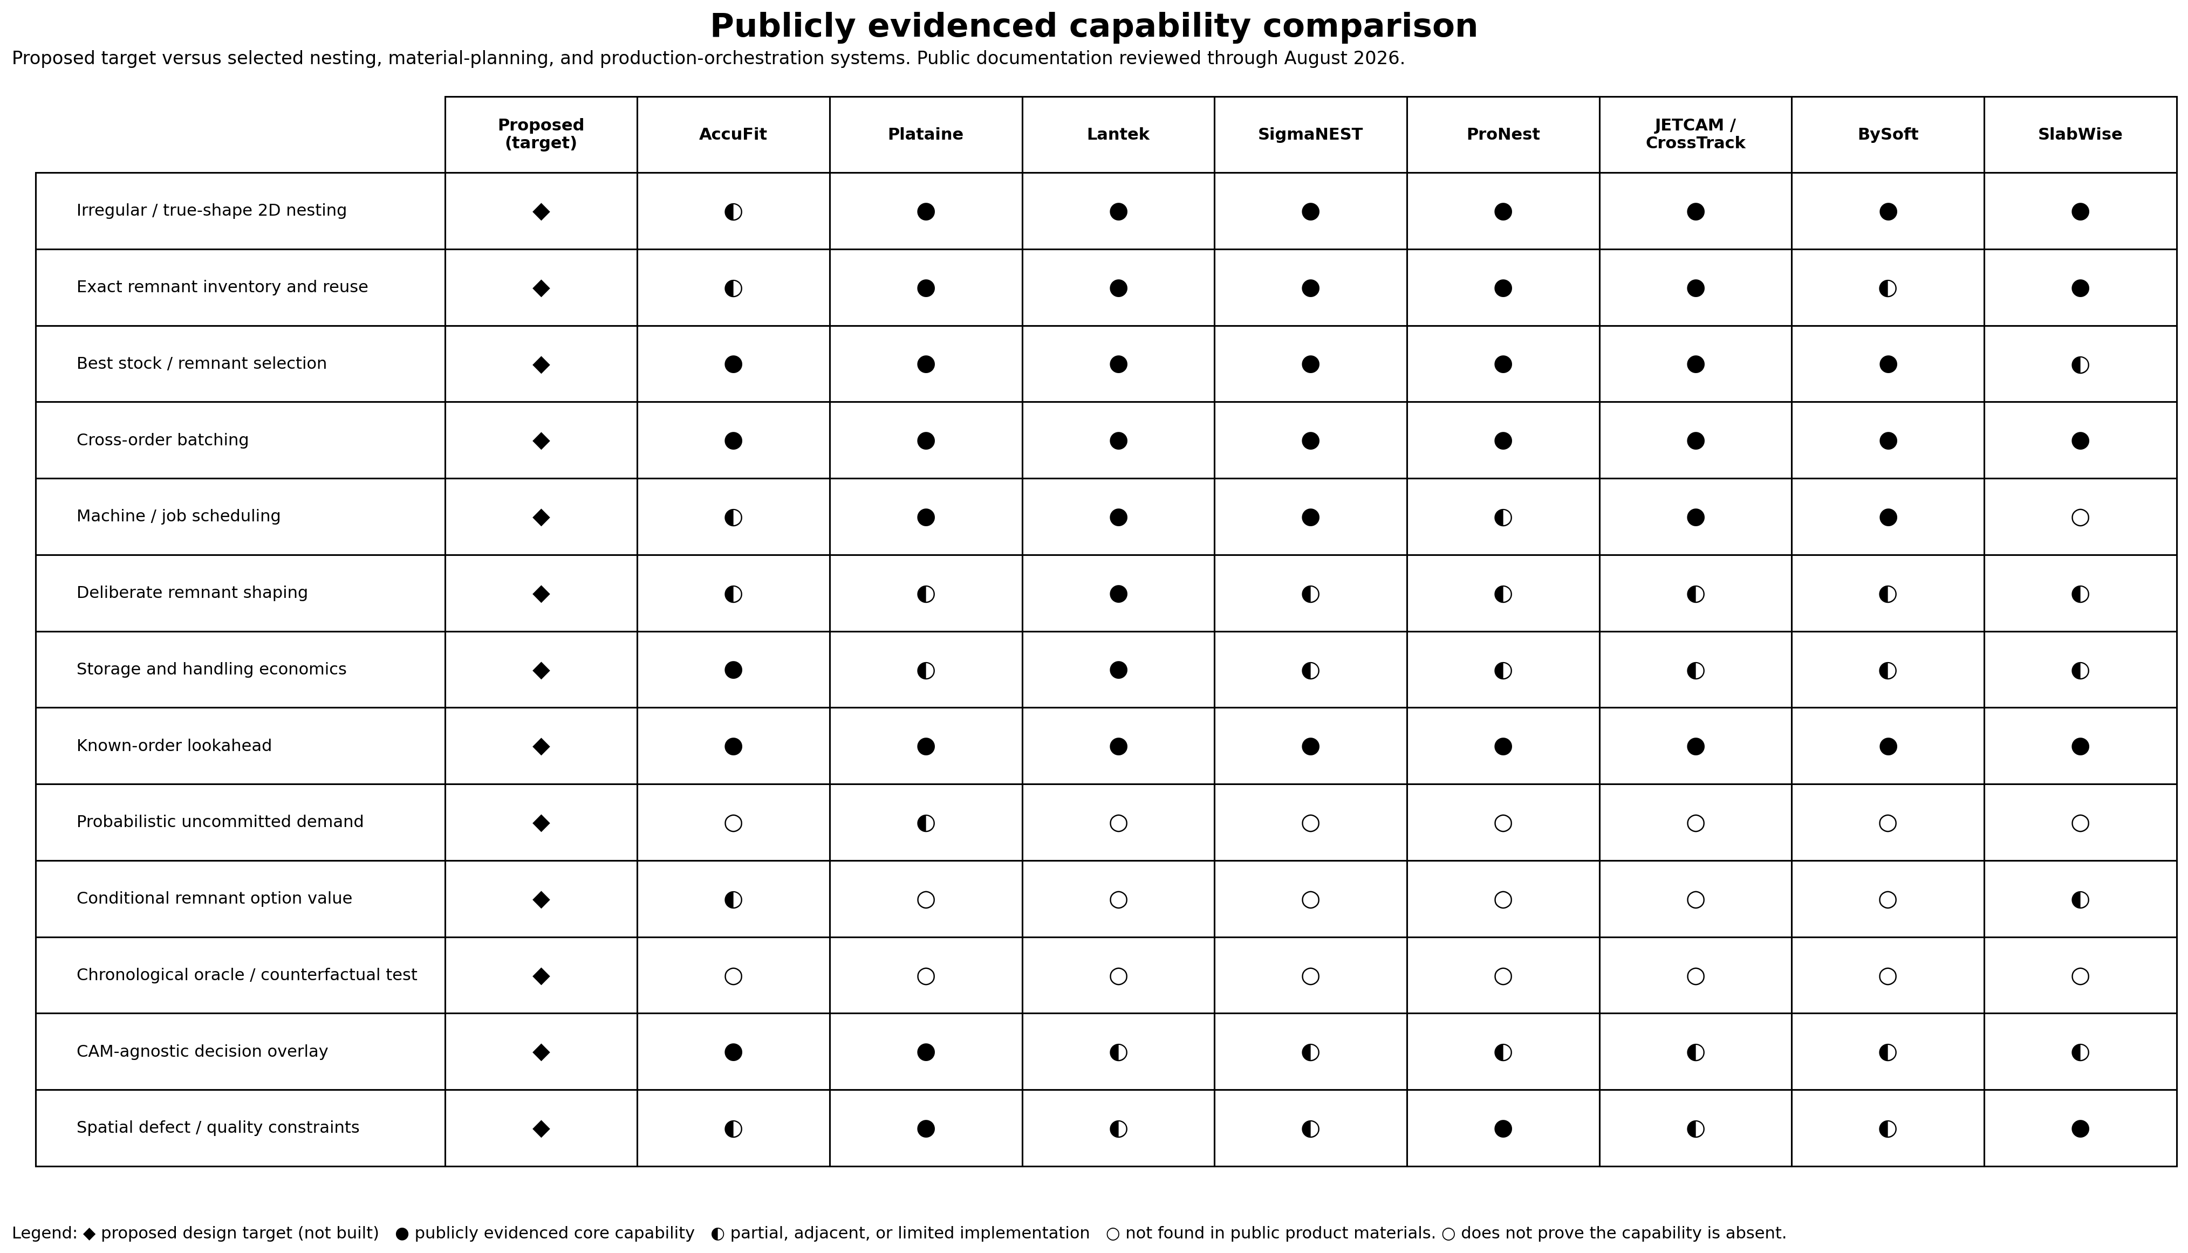
Figure 2. Publicly evidenced capability comparison. Diamond = proposed target, not built; filled circle = clearly evidenced core capability; half circle = partial or adjacent; open circle = not found in public product materials. Sources: [3]-[11].

3.5 What is already established
- Tight irregular or true-shape 2D nesting.
- Exact or approximate remnant inventory, identification, and future reuse.
- Selection of a current remnant before opening a new sheet.
- Mixing compatible currently available work orders.
- Looking ahead at scheduled or released future work.
- Delaying work within due-date constraints to improve material yield.
- Deliberately shaping remnants and considering storage or handling costs.
- Machine scheduling, defect-zone avoidance, traceability, and ERP/MES integration.
A product limited to those claims would compete as another feature-rich CAM/MES system against mature vendors with installed bases, postprocessors, machine relationships, and shop-floor workflows. That is not an attractive initial entry strategy.

3.6 The narrower white space
Potentially differentiated element | Meaning
Exact irregular residual state | Value the actual connected polygonal remnants produced by each candidate, including holes and later quality zones.
Near-tied candidate comparison | Search for economic dispersion among layouts that are essentially equivalent on current material use.
Uncommitted demand | Use historical recurrence, quotes, customer signals, and uncertainty rather than only released work orders.
Conditional option value | Measure avoided future purchases given the complete inventory state, preventing double-counting of substitute remnants.
Chronological proof | Replay decisions with strict as-of-time information and compare with a perfect-information policy under the same action space.
CAM-agnostic overlay | Integrate above existing CAM rather than recreating toolpaths, machine logic, and NC postprocessors.

3.7 Academic prior art
The research thesis is adjacent to a substantial usable-leftovers literature. Birgin, Romao, and Ronconi formulate multi-period two-dimensional non-guillotine cutting with usable leftovers and later introduce a forward-looking matheuristic that estimates the future utilization of leftovers. [12][15] Cherri and coauthors formulate usable leftovers under unknown future demand as a two-stage stochastic program with recourse. [13] Nascimento and coauthors study two-dimensional usable leftovers under demand uncertainty and report meaningful value of stochastic information in their tested setting. [14] Chen and Chen combine sequential value correction and beam search over multiple periods. [16]
These papers make two things clear. First, the basic principle is legitimate: future use can change which current cutting pattern is best. Second, YieldForge cannot claim to have invented stochastic future-aware cutting. The research contribution must be framed around exact irregular industrial geometry, modern high-performance candidate generation, conditional inventory-wide value, strong commercial baselines, and chronological validation.

3.8 Legal, licensing, and naming caveats
Sparrow is distributed under the MIT license. jagua-rs is distributed under MPL-2.0. [1][2] The proprietary simulation, valuation, and decision layers should remain modular, and a targeted licensing review should precede distribution of modified geometry components.
US8862261B1 addresses cutting-stock optimization across schedules and batches with lookahead and operational factors. [19] This proposal makes no infringement or freedom-to-operate conclusion; claim-level review is required before implementing the later scheduling layer. The perfect-information MVP is narrower, but the patent remains in the risk register.
The working name requires clearance. YieldForge.ai and YieldForge Agent are active DeFi-related uses; trademark, domain, search-visibility, and class conflicts remain unassessed. [20][21]

4. YieldForge End-State Opportunity
The end-state is a material-intelligence layer coordinating geometry, inventory, demand, and execution.

4.1 Product definition
YieldForge would sit above the factory's ERP/MRP, inventory records, CAM systems, quote pipeline, and machine state. It would request or generate multiple feasible actions, calculate the exact material state created by each action, estimate the downstream value of that state, and recommend the action minimizing expected cumulative cost.
The product should initially complement, not replace, systems such as SigmaNEST, ProNest, Lantek, RADAN, or JETCAM. The incumbent CAM remains responsible for machine-specific process validation, lead-ins and lead-outs, common-line rules, thermal constraints, cut sequencing, and NC generation. YieldForge supplies the economic objective and chooses among process-feasible alternatives.
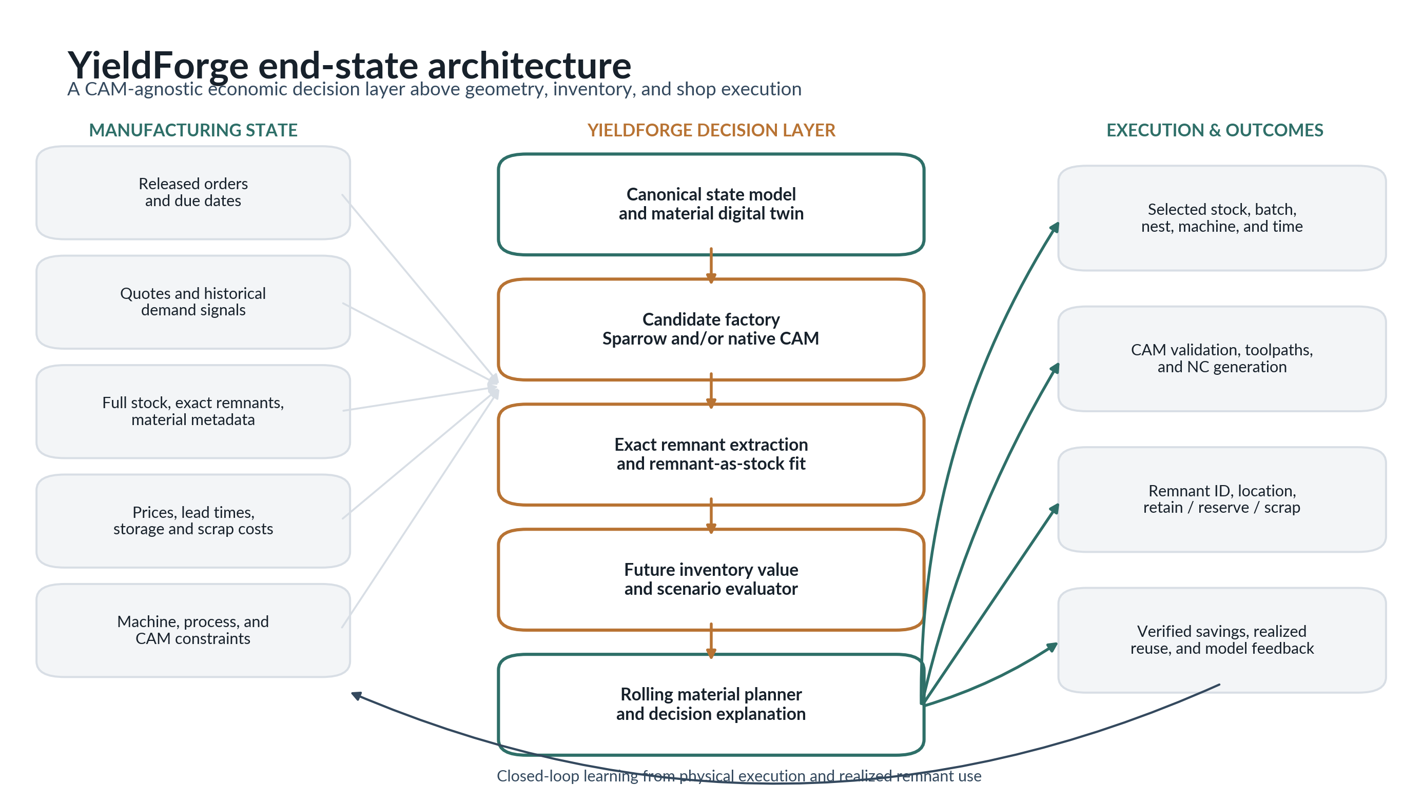
Figure 3. YieldForge end-state architecture. The center layer is the proposed system; the left and right columns represent existing manufacturing data and execution infrastructure.

4.2 End-to-end workflow
- Observe released orders, due dates, quotes, historical demand, full stock, exact remnants, material metadata, prices, lead times, machine constraints, and current shop state.
- Form candidate batches and stock assignments within due-date and process constraints.
- Ask Sparrow, a proprietary geometry engine, or the native CAM to generate multiple process-feasible nests rather than one immediate optimum.
- Extract the exact physically recoverable remnant polygons and carry forward their material, quality, direction, age, cost, and provenance.
- Evaluate each resulting inventory state across scenarios of future demand, purchases, remnant allocation, storage, handling, and scrap.
- Select the risk-adjusted action with the lowest expected cumulative cost and produce a human-readable decision explanation.
- Send the selected nest to the incumbent CAM for final validation and NC generation.
- Record physical execution, actual remnant creation, later reuse, and realized savings to update the model and prove value.

4.3 Product modules
Module | Function
Material state service | Canonical full-sheet/remnant inventory with exact geometry, metadata, location, provenance, and quality fields.
Candidate gateway | Adapters for Sparrow and commercial CAM systems; normalizes candidate nests and compute budgets.
Remnant geometry service | Computes recoverable polygons, remnant topology, fit signatures, and subsequent remnant-as-stock nesting.
Future value engine | Scenario rollout or learned approximation of marginal future cost reduction conditional on complete inventory.
Rolling material planner | Selects batch, stock, nest, machine, and timing under due-date, setup, and capacity constraints.
Lifecycle manager | Revalues, reserves, locates, and disposes remnants according to storage cost, scrap value, and changing demand.
Evidence layer | Chronological counterfactuals, A/B shadow mode, realized savings attribution, and executive reporting.

4.4 Ideal initial customer profile
- At least USD 10 million, and preferably USD 25 million or more, in annual eligible sheet, plate, slab, fabric, foam, honeycomb, or composite material spend.
- Recurring or related part families rather than purely one-off geometry.
- Meaningful volumes of remnants, offcuts, or short rolls that are retained but imperfectly reused.
- Expensive or lead-time-sensitive material where a one-percentage-point improvement is financially material.
- A mature CAM/MES environment capable of exporting stock, orders, candidate nests, and execution results.
- Enough operational flexibility to mix compatible orders or reserve remnants without compromising due dates.
- An executive sponsor willing to measure savings against a counterfactual baseline rather than accept utilization screenshots.

4.5 Economic significance of small percentages
Annual eligible material spend | 0.5% saving | 1.0% saving | 2.0% saving
USD 5M | USD 25k | USD 50k | USD 100k
USD 10M | USD 50k | USD 100k | USD 200k
USD 25M | USD 125k | USD 250k | USD 500k
USD 50M | USD 250k | USD 500k | USD 1.0M
USD 100M | USD 500k | USD 1.0M | USD 2.0M

At 1%, the value proposition becomes straightforward for large shops: a manufacturer spending USD 25 million annually on eligible material has a gross opportunity of roughly USD 250,000 per year before software fees and implementation cost. At 0.25%, the product requires much larger spend and becomes difficult to distinguish from normal operating variance. This is why the validation threshold is set aggressively.

4.6 Commercial packaging
Mode | Description | Commercial implication
Shadow audit | Ingest historical or live read-only data; quantify missed remnant opportunities and customer-specific oracle gap. | Lowest integration risk; strongest initial sales proof.
Advisory overlay | Score candidate nests from incumbent CAM and return a recommendation with expected value and confidence. | Avoids replacing CAM; depends on candidate diversity and APIs.
Orchestration layer | Vary order pools, stock choices, objectives, and CAM calls; select the globally preferred plan. | More value and control; greater integration burden.
Geometry mode | Generate complete nests through a Sparrow-derived engine and pass them into CAM for validation and execution. | Maximum algorithmic control; highest certification and process risk.
Full shop planner | Coordinate batching, machine assignment, remnant reservation, purchasing, and rolling schedules. | Largest opportunity; not justified until the narrow value signal is proven.

4.7 Potential defensibility
- A longitudinal corpus linking exact part geometry, order arrival, candidate nests, remnant creation, later reuse, purchase avoidance, and realized operational cost.
- A conditional remnant value function that understands substitutes and complements across the complete material inventory.
- A candidate-diversification method that searches residual topology rather than merely rerunning compactness optimization.
- CAM-normalization adapters and a process-feasibility feedback loop across heterogeneous industrial systems.
- Customer-specific chronological simulators that qualify opportunity before deployment and measure realized savings afterward.
- Operational knowledge about which theoretically usable remnants are actually recovered, found, moved, and consumed.
The moat would not be Sparrow itself. Sparrow is open source. The defensible asset would be the economic state model, empirical data, integration layer, search guidance, and demonstrated ability to capture future option value in real operations.

5. Validation Thesis and Falsifiable Hypotheses
The first program is successful only if it produces a decision, including a credible decision to stop.

5.1 Primary validation question
Core question
If every future order were known perfectly, how much net purchased-material cost could be avoided by selecting future-aware nests and remnants rather than applying the strongest policy available with only information known at the time?

5.2 Why perfect information is the correct first test
Forecasting error can only reduce achievable value. Perfect information therefore measures the size of the opportunity before the project invests in predicting it. If the oracle gap is 0.3%, a practical model capturing half the available signal produces only 0.15% before integration and operational losses. If the oracle gap is 2.5%, a practical system can lose substantial value to forecast error and still remain commercially relevant.
The benchmark will not be called a mathematical upper bound unless exact optimization is achieved. The scalable oracle uses rollout and beam search over a constrained action space. It is a perfect-information policy benchmark: it knows the realized future but may still miss the globally optimal sequence. Small tractable instances will be solved exhaustively to measure that approximation gap.

5.3 Pre-registered hypotheses
Hypothesis | Falsifiable statement
H1 - Candidate dispersion | Near-optimal Sparrow layouts with <=1% immediate material-cost difference will create materially different future inventory value.
H2 - Recurrence dependence | Oracle savings will increase monotonically with geometric family recurrence and will approach zero in the no-signal control.
H3 - Asymmetric trade | In target regimes, cumulative material savings will exceed the immediate utilization sacrifice by at least three to one.
H4 - Strong-baseline survival | The oracle advantage will remain after remnant-first stock selection, regularity heuristics, current-order co-nesting, storage cost, and conservative terminal treatment.
H5 - Search sufficiency | Ordinary multi-seed Sparrow candidates will expose at least part of the opportunity; expanded candidate diversity will reveal whether search, rather than information, is the binding constraint.
H6 - Operational robustness | A nontrivial portion of the advantage will survive conservative remnant eligibility rules rather than depending on idealized internal voids or unusable slivers.

5.4 Scope frozen for the experiment
- One cutter and no machine scheduling.
- One uniform material, grade, thickness, and surface-quality class per benchmark stream.
- One standard rectangular new-stock size, with unlimited availability at a fixed purchase cost.
- Every decision epoch contains a current released batch that must be fulfilled immediately. Multi-sheet jobs are deterministically decomposed into sheet-sized sub-batches before policy comparison.
- All currently released compatible parts may be co-nested; unreleased future orders may not be advanced, delayed, or batched by the baseline.
- Fixed kerf, clearance, allowed rotations, and minimum remnant rules.
- Existing exact remnants can be selected and recursively cut into new remnants.
- No purchasing lead times, quotes, stochastic predictions, heterogeneous quality fields, operator schedules, or CAM postprocessing.

5.5 Information sets
Policy | Information available | Purpose
Myopic geometry policy | Current released batch, current inventory, current candidate nests. | Chooses best immediate material utilization.
Commercial-style baseline | Current released compatible work, current inventory, remnant age/regularity, storage and scrap parameters. | Uses strong current-state heuristics and the best-performing baseline variant.
Known-order lookahead baseline | All firm orders that are already released or scheduled as of the decision timestamp. | Uses deterministic known work but no later realized orders.
Perfect-information rollout | The entire realized future stream, but only for evaluating the current candidate; later decisions follow a strong deterministic policy. | Computationally tractable first oracle.
Perfect-information beam search | The entire realized future stream at every decision, within a pruned beam of inventory states. | Stronger sequential oracle; validated against exact small cases.

6. The Perfect-Information MVP
A deterministic research executable that turns Sparrow nests into chronological material decisions.
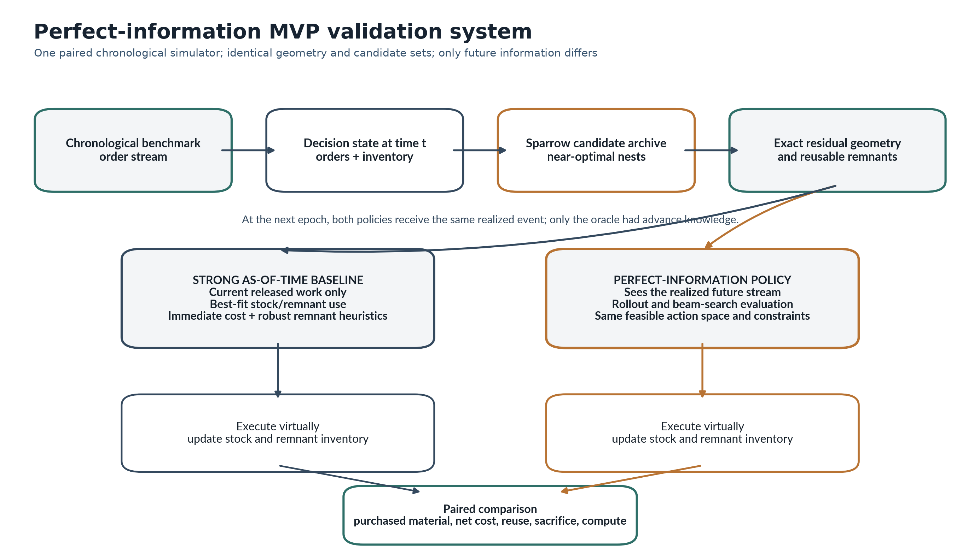
Figure 4. Validation architecture. The baseline and oracle share geometry, candidate sets, remnant accounting, and benchmark streams; only the future-information policy differs.

6.1 System boundary
The system begins with a chronological order stream and an initial inventory. At each event it generates candidate nests for compatible stock, extracts resulting remnants, invokes a policy, executes the selected action virtually, updates inventory, and advances time. The same stream is replayed under every baseline and oracle policy. All randomness is seeded and all candidate sets are persisted so comparisons are paired and reproducible.

6.2 Canonical domain model
Entity | Minimum fields for validation
Part | ID, exact polygon, quantity expansion, allowed rotations, clearance, order link.
Order event | ID, timestamp, due status, released batch, part instances, hidden/revealed status for each policy.
Stock piece | ID, exact outer polygon, full-sheet/remnant flag, parent stock, acquisition cost, creation time, metadata placeholders.
Placement | Part ID, stock ID, rotation, translation, solver provenance.
Candidate nest | Stock choice, placements, current cost, solver seed/configuration, raw residual geometry, retained remnants.
Inventory state | All current full sheets/remnants, cumulative purchases, scrap, storage state, and provenance chain.
Decision event | Policy, information set, candidate archive, chosen action, rejected alternatives, cost accounting.

6.3 Sparrow candidate factory
Sparrow is selected because it is open source, reproducible through seeds, and designed for high-quality irregular 2D strip packing. [1] Its strength makes the test rigorous: YieldForge must find future value among layouts generated by a solver already optimized aggressively for current compaction.
The adapter will not request one answer. It will capture multiple feasible incumbents from progressive runs, execute multiple deterministic seeds, and retain solutions inside an immediate-cost envelope relative to the best myopic layout. The initial envelope grid will include 0%, 0.1%, 0.25%, 0.5%, 1.0%, and 2.0%. The system will report how much candidate topology diversity emerges at each sacrifice level.
Sparrow solves strip packing rather than a generic fixed-bin objective. The adapter will set the strip width to the standard sheet width, determine the best occupied length, retain layouts within epsilon, and reject layouts that exceed the fixed sheet length. For irregular remnants, the system will call jagua-rs or a thin custom optimizer because jagua-rs supports irregular containers and separates geometric feasibility from the optimization strategy. [2]

CANDIDATE DEDUPLICATION
Candidate count is not a useful diversity measure if the residual states are equivalent. The archive will deduplicate candidates using connected-component count, largest component area, minimum width, aspect ratios, edge accessibility, convexity, raster or distance-transform signatures, and fit against a representative set of future shapes. The full exact polygons remain the source of truth.

6.4 Exact remnant extraction
For each candidate, the geometry engine subtracts buffered placed parts and process loss from the stock polygon. The connected components of the residual form theoretical leftover regions. Each region is then classified as retained remnant or scrap according to minimum area, minimum width, bounding dimensions, connectivity, and an optional edge-access rule.
Geometric accounting
Unused = Stock minus union(buffered placed parts) minus forbidden zones
RetainedRemnants = eligible connected components(Unused)
Scrap = Unused minus RetainedRemnants

Every nest must satisfy the accounting invariant: stock area approximately equals placed-part area plus retained-remnant area plus scrap plus modeled process loss. Tolerances will be explicit. Any violation fails the run because a small geometric accounting bug can manufacture a false economic advantage over thousands of orders.

6.5 Remnant-as-stock feasibility
A retained remnant becomes an irregular container available to later orders. The fit engine first applies cheap compatibility and size filters, then performs an exact placement search. Successful use produces a placement set and a new residual polygon, preserving the full parent-child provenance chain. This recursive capability is the physical core of the experiment: a remnant is valuable only if future demand can actually consume it.
The exact fit oracle will be exposed independently from the policy layer. This prevents policies from using area or bounding-box approximations as ground truth and allows geometry tests to be verified separately from economic tests.

6.6 Deterministic chronological simulator
- Initialize the standard-sheet supply, any starting remnants, fixed cost parameters, and a timestamped order stream.
- Reveal only information permitted to the active policy at time t.
- Enumerate compatible current stock pieces and generate or retrieve cached candidate nests.
- Extract retained remnants and the full resulting inventory state for every candidate.
- Ask the policy to select an action and persist its rationale and candidate scores.
- Virtually execute the cut, update purchased material, scrap, retained inventory, storage age, and provenance.
- Advance the clock, reveal the next event, and repeat until the closed evaluation horizon ends.
- Liquidate or conservatively value ending inventory according to the pre-registered terminal rule.
Identical input events, geometry versions, policies, and seeds must produce byte-equivalent decision logs or a formally defined canonical equivalent. Event sourcing will make every policy difference auditable.

6.7 Strong baseline suite
The final comparison will use the strongest baseline, not the easiest baseline to beat. Candidate policies include:
- Best immediate Sparrow utilization on a new sheet.
- Remnant-first, smallest-sufficient-stock selection.
- Largest/oldest remnant first to reduce inventory congestion.
- Best-fit policy minimizing immediate residual area.
- Regular-remnant heuristic favoring one large edge-accessible component.
- Current released-order co-nesting and known-order lookahead.
- Composite policy selected on a separate calibration set, then frozen before final evaluation.
The baseline and oracle will share the same candidate sets and stock eligibility rules in the primary analysis. A secondary expanded-search analysis will separately measure whether candidate generation is the bottleneck.

6.8 Oracle A: perfect-future rollout
For every current candidate, Oracle A executes the candidate and then replays the complete realized future using the strongest deterministic baseline. It chooses the current candidate with the lowest total downstream cost. This is a one-step policy-improvement method: future demand is known, but future decisions are not globally reoptimized.
Oracle A
Q_rollout(candidate_t) = CostNow(candidate_t)
+ CostOfActualFuture under frozen strong policy
Choose candidate_t with minimum Q_rollout

Oracle A is computationally manageable, interpretable, and likely sufficient to reveal whether residual geometry has option value. It is not the strongest possible clairvoyant policy.

6.9 Oracle B: beam-search perfect-information policy
Oracle B expands multiple candidate decisions at every event and retains a beam of materially distinct inventory states. State hashing, cost bounds, inventory dominance, and candidate caching control the combinatorial growth. Beam width and compute budget will be reported with every result.
Dominance is conservative. One state can eliminate another only when it has no higher incurred cost, fulfills the same demand, and its remaining inventory is demonstrably at least as useful under an exact or safely relaxed comparison. Approximate geometry similarity may be used for beam diversity but not to assert strict dominance.

EXACT VALIDATION ON SMALL INSTANCES
Small order streams with limited candidates will be enumerated exhaustively. The gap between exact search and beam search establishes whether the scalable oracle is strong enough to support a go/no-go decision. If the approximation gap is large or unstable, the project cannot responsibly interpret the measured oracle savings as the opportunity ceiling.

6.10 Cost accounting
Cost component | Validation treatment
New stock purchase | Full acquisition cost when a standard sheet is opened; no area-prorated fiction unless the benchmark explicitly models it.
Scrap proceeds | Credited only when material is actually scrapped, at a conservative fixed value.
Storage | Per-remnant or area/time cost charged while material remains in inventory.
Handling | Fixed touch cost when a remnant is returned to stock or retrieved for cutting.
Process loss | Fixed kerf/clearance model applied identically to all policies.
Terminal inventory | Primary result uses conservative liquidation at scrap value or zero incremental option credit; sensitivity includes alternate treatments.

6.11 Technical stack
Component | Role | Initial technology
Sparrow fork / pinned commit | Irregular strip-packing candidate generation and incumbent capture. | Rust
jagua-rs | Collision detection, irregular containers, exact remnant-as-stock feasibility, later zones. | Rust
Geometry and accounting layer | Polygon Boolean operations, canonicalization, invariants, descriptors. | Rust first; Shapely/GEOS for prototyping where safe
Simulator and policies | Event replay, baselines, rollout, beam search, experiment orchestration. | Python
Data | Immutable events, candidate archives, metrics, benchmark manifests. | Parquet + DuckDB + JSON manifests
Testing | Unit, property, differential, geometry regression, deterministic replay. | pytest/Hypothesis + Rust proptest
Analysis | Paired statistics, confidence intervals, sensitivity plots, decision report. | Python / pandas / matplotlib

6.12 Repository and reproducibility artifacts
Indicative repository structure
yieldforge-oracle/
crates/domain-model/
crates/remnant-geometry/
crates/fit-oracle/
adapters/sparrow/
python/simulator/
python/policies/
benchmarks/static/
benchmarks/sequential/
experiments/oracle-gap/
schemas/ and manifests/

Every published result will include the Sparrow commit, jagua-rs version, benchmark generator version, stream seed, solver seeds, epsilon, candidate budget, remnant rules, policy configuration, beam width, terminal treatment, and source hashes. Candidate archives should be cached so policy comparisons never silently receive different action sets.

6.13 Explicit non-goals
- No web application, production database service, Kubernetes deployment, authentication, or customer dashboard.
- No neural network, reinforcement learning, demand forecast, quote-conversion model, or learned value function.
- No machine postprocessor, NC code, cut-sequence optimization, thermal model, or certification workflow.
- No heterogeneous strength or quality fields beyond reserved schema placeholders.
- No multi-machine dispatch, order waiting, purchasing optimization, or shop-floor control.
- No claim that the scalable oracle is a mathematical upper bound without exact proof.

7. MVP Milestones and Acceptance Gates
The MVP is divided into four independently reviewable phases. Each phase produces a usable research artifact and has an explicit acceptance gate; later phases are not assumed to proceed automatically.
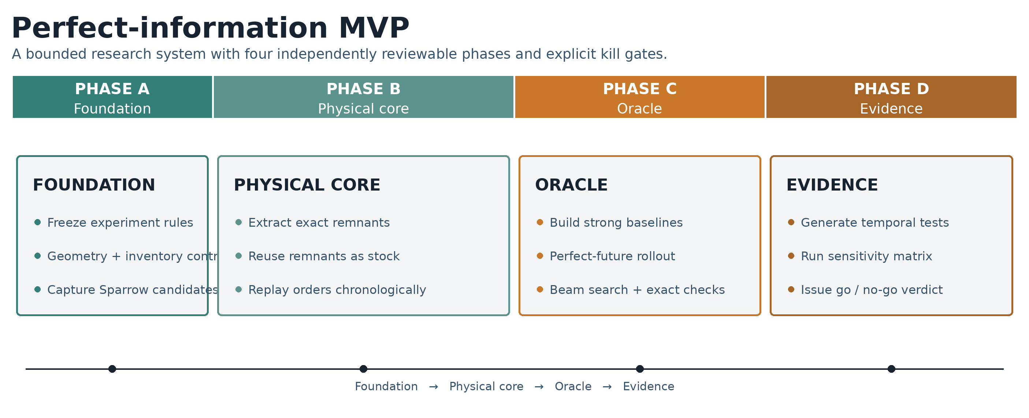
Figure 5. Four-phase perfect-information MVP. Detailed acceptance criteria and kill gates appear in the milestone table below.
ID | Milestone | Primary deliverable | Acceptance gate
M0 | Experiment specification and invariants | Frozen scope, metrics, information sets, cost rules, terminal treatment, and benchmark manifest format. | No ambiguous policy information or cost accounting remains.
M1 | Canonical schemas and geometry round-trip | Part/order/stock/remnant/placement/state schemas; exact import/export tests. | Geometry survives transformations within declared tolerance.
M2 | Sparrow candidate harness and archive | Pinned adapter, multi-seed runs, progressive incumbent capture, epsilon filters, reproducible candidate store. | At least one benchmark yields a stable population of materially distinct near-optimal residual states.
M3 | Remnant extraction and accounting | Exact connected residuals, eligibility filters, scrap classification, area reconciliation, visual fixtures. | All accounting invariants pass across adversarial geometry tests.
M4 | Irregular remnant reuse and fit oracle | Future parts nested into irregular remnants; recursive residual creation; provenance tracking. | Favorable toy sequence demonstrably avoids a new sheet through exact remnant reuse.
M5 | Deterministic chronological simulator | Event sourcing, inventory mutation, storage/scrap accounting, replay logs, cached actions. | Identical manifests produce identical decision histories and totals.
M6 | Strong baseline policies | Myopic, remnant-first, best-fit, aged-remnant, regularity, current-pool, and known-order policies. | Baseline selection is frozen on calibration data before final evaluation.
M7 | Perfect-information rollout oracle | Current-action rollouts through the realized future with paired candidate sets. | Hand-verified toy cases and monotonic sanity tests pass.
M8 | Beam-search oracle and exact checks | State hashing, pruning, beam diversity, exhaustive small-instance reference. | Approximation gap is quantified and acceptable for decision use.
M9 | Benchmark generator and sensitivity plan | Static geometry ingestion, temporal regimes, controls, seeds, and parameter grid. | No-signal and high-recurrence controls behave in the expected direction.
M10 | Experiment execution and verdict | Paired results, confidence intervals, ablations, failure analysis, go/no-go report. | Decision issued under the pre-registered threshold without post-hoc threshold changes.

7.1 Phase A - Foundation
Phase A freezes the experiment, establishes canonical geometry, and turns Sparrow into a reproducible candidate source. It ends before the more difficult remnant inventory and simulator work. The review artifact is a set of candidate nests and residual-state visualizations generated from immutable manifests.
Kill gate A
Stop if geometry cannot round-trip reliably, Sparrow cannot be instrumented within the allotted time, or deliberately favorable layouts fail to produce meaningfully different residual states.

7.2 Phase B - Physical core
Phase B creates exact remnants, reuses them as irregular stock, and replays a chronological inventory. This phase must prove the physical mechanism before any oracle algorithm is trusted.
Kill gate B
Stop if material accounting does not reconcile, remnant-as-stock placement is unstable, or identical replay manifests do not produce identical histories.

7.3 Phase C - Oracle
Phase C establishes strong baselines and two perfect-information policies. The rollout oracle provides a tractable signal; beam search tests whether long-horizon interactions materially increase value. Exhaustive small instances validate search quality.
Kill gate C
Stop or redesign if the scalable oracle is materially weaker than exact search on tractable cases, if the result depends on a strawman baseline, or if runtime prevents a meaningful benchmark sweep.

7.4 Phase D - Evidence
Phase D generates the controlled temporal dataset, runs the sensitivity and ablation matrix, and issues the investment decision. The final report must include negative controls and failure modes, not only favorable regimes.
Final gate
Proceed beyond the oracle only if net incremental savings clear the threshold against the strongest baseline and survive conservative remnant, storage, terminal-value, and search-quality assumptions.

7.5 Program outputs
- A versioned open-source dependency manifest and reproducible research repository.
- Canonical schemas for exact parts, stock pieces, remnants, candidate nests, and inventory events.
- A Sparrow candidate archive with topology-aware diversity measures.
- An exact remnant extraction and irregular reuse engine.
- A deterministic chronological simulator and baseline policy suite.
- Perfect-information rollout and beam-search policies with exact small-case validation.
- A public-geometry-based synthetic temporal benchmark suite.
- A final decision report explaining whether value exists, where it exists, and what limits it.

8. Benchmark and Experimental Program
The evidence must separate geometry opportunity, future-information value, search limitations, and operational assumptions.

8.1 Benchmark sources
Source | Content | Use in YieldForge
Sparrow benchmark instances | Irregular shapes and known solver behavior included or referenced by the Sparrow project. [1] | Candidate generation regression and geometry stress tests.
ESICUP irregular datasets | Classic instances including Albano, Dagli, Fu, Jakobs, Marques, Shapes, Shirts, Swim, Trousers, and related corpora. [17] | Diverse static polygon families and solver comparability.
Forward-looking usable-leftover code/instances | bromro2 and companion work for multi-period two-dimensional non-guillotine cutting. [12][15] | Simulator semantics and forward-looking policy comparison, though the formulations differ from irregular nesting.
Stochastic usable-leftover instances | Published multi-stage 2D cutting-stock instances with scenario trees and uncertain demand. [18] | Cost and scenario-accounting validation; rectangular structure is not a substitute for irregular benchmarks.
Synthetic sequential irregular suite | New timestamped streams built from real polygons with controlled recurrence, family variation, bundles, and regime shifts. | Primary evidence for the oracle opportunity under known ground-truth conditions.

8.2 Why a new temporal benchmark is necessary
Public nesting datasets are primarily static: they provide polygons and stock dimensions but not chronological order arrivals, quotes, inventory history, remnant creation, storage, or later reuse. Published usable-leftover datasets provide valuable multi-period structure but often use rectangles or guillotine constraints. The central experiment therefore requires a synthetic temporal layer built from real irregular geometries.
Synthetic data is acceptable for the first falsification test only if the generator is transparent, controls include no-signal regimes, parameters are varied widely, and the final claim is limited to opportunity under modeled conditions. A positive synthetic result does not authorize product development; it authorizes acquisition of real manufacturer history.

8.3 Temporal demand regimes
Regime | Construction | Expected diagnostic
No-signal control | Future shapes are independent or nearly unique. | Oracle advantage should approach zero after storage and terminal accounting.
Exact recurrence | A small set of identical part families returns repeatedly. | Upper-bound favorable regime and geometry plumbing check.
Variant recurrence | Related shapes vary in scale, contour, quantity, or allowed rotation. | More realistic family-level reuse test.
Correlated bundles | Orders arrive as recurring assemblies or kits of related parts. | Tests complementary demand rather than independent part arrivals.
High-mix custom | Many unique shapes with weak family structure. | Likely low-value customer archetype; tests stop conditions.
Highly repetitive | Strong recurrence, high volume, expensive stock, and frequent compatible remnants. | Likely target-customer archetype.
Regime shift | Previously common families decline and new families emerge. | Tests inventory overproduction and horizon sensitivity.

8.4 Core parameter grid
The full factorial space is too large to run naively. Candidate generation will be cached, and the program will use a two-stage design: a screening matrix to identify sensitive variables, followed by a concentrated paired evaluation around plausible customer regimes.
Variable | Levels | Purpose
Immediate sacrifice epsilon | 0%, 0.1%, 0.25%, 0.5%, 1%, 2% | Measures the price paid today to create future options.
Candidate budget | Multiple seeds / progressive incumbents; low, medium, high compute | Determines whether search diversity limits the opportunity.
Remnant threshold | Minimum area and minimum-width combinations | Separates idealized leftovers from operationally plausible inventory.
Family recurrence | 0% through strong recurrence | Primary explanatory variable for future value.
Family variation | Exact, affine variants, contour variants, bundle variants | Tests geometric generalization.
Order volume and horizon | Short, medium, long streams | Measures accumulation, reuse, and terminal effects.
Storage and handling | Zero, nominal, conservative | Tests whether savings survive inventory friction.
Scrap and stock prices | Low, nominal, high material value | Identifies economic segments.
Rotation rules | Restricted versus flexible | Changes substitutability and fit opportunity.

8.5 Primary metric
Primary outcome
Net purchased-material cost relative to the strongest as-of-time baseline, including storage and handling, subtracting realized scrap proceeds, and applying a conservative terminal-inventory rule.

Average current nest utilization is a diagnostic, not the decision metric. A future-aware policy is permitted to show slightly worse utilization on the current sheet if it reduces cumulative purchased material across the horizon.

8.6 Supporting metrics
Metric family | Reported measures
Purchased stock | Sheets opened, area purchased, and purchase cost.
Waste | Scrap area, scrap value, and process loss.
Remnant behavior | Count created, count reused, reuse rate, average lifetime, ending inventory.
Tradeoff | Immediate utilization sacrificed, long-run savings, and savings-to-sacrifice ratio.
Search | Candidate diversity, oracle A vs B gap, beam vs exact gap, compute time.
Distribution | Mean, median, lower-tail outcome, fraction of streams with positive savings, and outlier contribution.
Segmentation | Savings by geometry corpus, recurrence, material price, volume, and remnant policy.

8.7 Experimental controls
- Paired streams: every policy sees the same order events, initial inventory, geometry, costs, and candidate archives.
- Common seeds: any random candidate generation is persisted before policy evaluation.
- No-signal control: the oracle must not generate systematic apparent value where future geometric information is absent.
- Closed-horizon accounting: ending remnants receive scrap value or no option credit in the primary analysis; alternate terminal values are sensitivity tests.
- Calibration/test separation: baseline tuning and thresholds are frozen before final benchmark evaluation.
- Exact small cases: beam-search quality is measured rather than assumed.
- Ablations: remove remnant regularity, storage cost, current-order pooling, and expanded search one at a time to explain the source of gains.
- No cherry-picking: all pre-registered regimes and seeds are reported, including negative results.

8.8 Statistical interpretation
Results will be paired at the stream level. The report will provide means, medians, bootstrap confidence intervals, and the distribution of savings across streams. A positive average driven by a few extreme cases is not sufficient. The lower confidence bound and the proportion of positive streams matter because a commercial customer needs repeatable savings, not a lottery ticket.
The benchmark is a controlled simulation rather than an estimate of the universal market. Results will be stated conditionally: for example, "under recurring-family regimes with these costs and remnant constraints, the perfect-information policy reduced purchased material by X%." Generalization to real shops requires subsequent historical data.

8.9 Diagnostics the experiment must produce
- Information gap: strong baseline cost minus perfect-information cost using the same candidate set.
- Search gap: perfect-information cost using ordinary candidates minus perfect-information cost using expanded search.
- Recoverability gap: geometric upper-bound savings minus conservative operational-remnant savings.
- Long-horizon gap: rollout oracle minus beam-search oracle.
- Baseline gap: simple myopic policy minus strongest commercial-style baseline.
- Terminal-value sensitivity: result under zero, scrap-only, and bounded continuation value for ending remnants.

8.10 Expected signal profile by benchmark regime
A credible result should not show the same uplift everywhere. The oracle advantage should increase as geometric recurrence, remnant substitutability, material value, and operational flexibility increase, while the random/no-recurrence control remains near zero. The following ranges are pre-registered evidence targets, not predicted results.
Benchmark regime | Compelling oracle range | Interpretation
Random / no recurrence | 0.0%-0.3% | Correct negative control; the system should have almost no exploitable future information.
High-mix custom / weak recurrence | 0.3%-0.8% | Limited opportunity is expected; unlikely to support a broad product.
Moderate recurrence | 1.0%-1.5% | The mechanism is emerging but still requires a high-spend customer segment.
Strong recurrence | 1.5%-2.5% | Commercially interesting; warrants real historical data.
High recurrence + known-order pooling | 2.5%-3.5% | Strong result within the MVP scope; enough headroom for a later stochastic policy.
High-value material + high recurrence | 3.0%-5.0%+ | Compelling vertical opportunity.
Best identifiable customer phenotype | >=4.0% | Major opportunity if the phenotype can be recognized before integration.

8.11 Supporting metric gates
The percentage saving is necessary but insufficient. The benchmark must also demonstrate that the effect is inexpensive to obtain, distributed across many decisions, operationally realizable, and available in ordinary Sparrow candidate populations.
Metric | Green target | Yellow / investigate | Red concern
Target-segment oracle advantage | >=2.5%; ideal >=3.0% | 1.5%-<2.5% | <1.5%
Unknown-future component | >=1.5 pp; ideal >=2.0 pp | 0.5-<1.5 pp | <0.5 pp
Immediate utilization sacrifice | <=0.25% ideal; <=0.5% acceptable | >0.5%-1.0% | >1.0%
Opportunity frequency | 20%-40% of eligible nests changed | 10%-20% | <10% or isolated events
Preserved-remnant realization | >=70% ideal; >=60% minimum | 40%-<60% | <40%
Savings concentration | Top 10 decisions <20% of savings | 20%-35% | >50%
Ordinary Sparrow candidate availability | >=70% ideal; >=60% minimum | 40%-<60% | <40%
No-signal control | 0.0%-0.3% | >0.3%-0.5% | >0.5%

8.12 Illustrative profile that would constitute a strong result
The following profile is a pre-registered example of what would justify the conclusion that YieldForge has found a substantial, explainable optimization opportunity. It is not a forecast and must not be presented as an achieved result.
Benchmark or diagnostic | Illustrative strong result
No-recurrence control | +0.1%
Weak recurrence | +0.6%
Moderate recurrence | +1.5%
Strong recurrence | +2.7%
Target high-value regime | +4.1%
Target-regime median | +3.0%
Immediate utilization sacrificed | 0.28%
Eligible nests changed | 31%
Preserved remnants eventually reused | 72%
Opportunity present in ordinary Sparrow candidates | 78%
Savings attributable to unknown future demand | 2.1 percentage points
Top 10 decisions share of total savings | 14%

9. Go / No-Go Decision Framework
The threshold is based on incremental net savings over a strong baseline, not on utilization or savings against discarding all scraps.
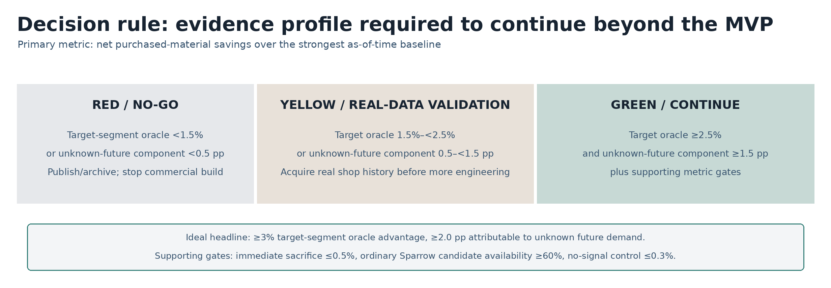
Figure 6. Pre-registered evidence profile for deciding whether to continue beyond the perfect-information MVP.

9.1 Quantitative thresholds
Evidence profile | Signal | Required action
Target oracle <1.5% or unknown-future component <0.5 pp | Red / no-go | Publish or archive the MVP and stop commercial development.
Target oracle 1.5% to <2.5% or unknown-future component 0.5 to <1.5 pp | Yellow / validate | Obtain real manufacturer history; do not build the stochastic product yet.
Target oracle >=2.5% and unknown-future component >=1.5 pp | Green / continue | Proceed to stochastic valuation only if the supporting pass conditions also hold.

9.2 Preferred pass condition
Preferred result
At least 2.5% mean net oracle savings in a plausible target-customer regime, ideally 3% or more; at least 1.5 percentage points attributable to unknown future demand; immediate utilization sacrifice no greater than 0.5%; ordinary Sparrow candidate availability of at least 60%; and no dependence on optimistic terminal inventory credit.

A target-regime oracle gap of at least 2.5% is preferred because an eventual stochastic model will capture only part of the information advantage. The strongest result would be 3% or more, with at least 1.5 percentage points - ideally 2.0 points - attributable specifically to demand that was not yet a firm order. An oracle gap below 1.5% leaves too little tolerance for prediction error, physical recoverability, operator behavior, and integration friction.

9.3 Additional pass conditions
Condition | Minimum evidence
Strong comparator | Result is measured against the best frozen baseline with current-order pooling, remnant selection, regularity, age/FIFO, storage cost, and known-order lookahead.
Unknown-future differentiation | At least 1.5 percentage points of target-regime savings remain after the known-order lookahead baseline.
Economic asymmetry | Immediate utilization sacrifice is no more than 0.5%, and long-run savings materially exceed that sacrifice.
Candidate availability | At least 60% of valuable actions are present in ordinary near-optimal Sparrow candidate archives.
Opportunity frequency | The policy changes a meaningful share of eligible nests, ideally 20%-40%, rather than depending on rare outliers.
Remnant realization | At least 60% of deliberately preserved remnants are consumed within the modeled horizon under the oracle.
Distributed savings | The top 10 decisions contribute less than roughly 20%-25% of total savings.
Conservative inventory | Savings survive scrap-only or zero option value for terminal remnants and nominal storage/handling costs.
Operational remnants | A material portion survives minimum width, area, accessibility, and handling rules.
Broad enough evidence | Positive results appear across more than one geometry corpus and not only an exact-repeat toy regime.
Search credibility | Beam search is acceptably close to exhaustive small cases, or the reported opportunity is discounted by the approximation gap.
No-signal sanity | Random/no-recurrence controls remain within approximately 0.0%-0.3% systematic savings.

9.4 Automatic stop conditions
- Target-segment perfect-information savings remain below 1.5% in plausible high-recurrence regimes.
- The incremental component attributable to unknown future demand remains below 0.5 percentage points after known-order lookahead.
- Savings disappear when the strongest commercial-style baseline is used.
- Savings require more than 1% immediate utilization sacrifice or depend on remnants that fail conservative recoverability rules.
- The no-signal control exceeds 0.5%, indicating a simulator, terminal-value, or accounting defect.
- Ordinary Sparrow candidate archives contain less than 40% of valuable actions and expanded search is impractical.
- Beam search cannot be validated and the result is too sensitive to beam width or arbitrary pruning.
- A small number of outlier streams or decisions accounts for most aggregate savings.

9.5 Interpretation examples
Observed result | Decision meaning
Oracle 0.9%; unknown-future component 0.2 pp | Red. The differentiated economic ceiling is too small; publish/archive and stop.
Oracle 2.0%; unknown-future component 0.9 pp | Yellow. Obtain real shop history, but do not build the stochastic product yet.
Oracle 2.8%; unknown-future component 1.7 pp; sacrifice 0.4%; candidate availability 68% | Green. Proceed to stochastic valuation and seek a real-data partner.
Oracle 4.1% in a narrow high-value vertical; 1.2% elsewhere | Pursue the qualified vertical rather than a universal product.
Oracle 3.1%, but no-signal control 1.0% | Invalid. Diagnose leakage or accounting bias before interpreting the result.

9.6 Final report format
The final artifact is a decision memo, not a demonstration video. It must state the strongest result, the most conservative result, the dependence on recurrence and cost assumptions, the baseline used, the search-quality gap, the operational recoverability gap, and the reason to continue or stop. The threshold will not be lowered after seeing the data.

10. Risk Register and Mitigations
The validation is designed to expose failure early, but several technical and commercial risks remain.
Risk | Severity | Mitigation
No meaningful oracle gap | High / existential | Run perfect information before forecasting or integration; stop below threshold.
Synthetic-to-real gap | High | Limit claims; require a subsequent historical manufacturer replay before product development.
Strawman baseline | High | Implement multiple strong policies, freeze the best on calibration data, and use identical candidate sets.
Candidate-set bias | High | Run multi-seed/progressive Sparrow archives, epsilon sweeps, and an expanded-search ablation.
False remnant value from geometry bugs | High | Exact accounting invariants, adversarial fixtures, differential tests, and visual regression.
Unrecoverable residual regions | High | Report geometric upper bound and conservative operational extractor separately.
Horizon/terminal artifact | High | Primary result uses scrap-only or zero terminal option credit; run horizon sensitivity.
Oracle search weakness | Medium-high | Compare rollout, beam, and exhaustive small cases; disclose approximation gap.
Compute explosion | Medium-high | Cache candidates, prune stock choices, hash states, use beam diversity, and stage experiments.
Existing products already solve enough | Medium-high | Measure incremental advantage over a composite commercial baseline; do not rely on novelty claims.
Low demand recurrence | Medium-high | Use recurrence as a customer-qualification variable; accept that the product may be vertical-specific.
Operator nonuse of remnants | Later high risk | Not in first scope; future pilot must use conservative recovery rules and shadow-mode feedback.
CAM/API limitations | Later high risk | Prefer advisory mode and customer systems with candidate/export APIs.
Material quality complexity | Later medium-high risk | Reserve schema fields; add categorical zones before continuous structural properties.
Licensing and patent exposure | Medium | Keep layers modular; obtain MPL and patent claim review before distribution/scheduling.
Working-name collision | Low for research / medium for launch | Use YieldForge internally; conduct trademark/domain/category clearance before external branding.

10.1 The most important methodological risk
The largest risk is not that the code fails. It is that the experiment returns an attractive percentage by comparing a clairvoyant policy with a weak current-state policy. The baseline must therefore include the strongest practical advantages already available to a competent shop: existing remnant selection, current order pooling, regularity preferences, age/FIFO logic, storage cost, and scheduled known orders. The oracle should differ primarily in its knowledge of later realized demand.

10.2 The most important commercial risk
The broad system overlaps mature CAM, MES, material planning, and specialist optimization vendors. Even a technically positive result does not imply a standalone company. Commercial value depends on whether the differentiated oracle gap can be captured through an overlay that integrates with installed systems without requiring a wholesale replacement. The validation program proves an economic kernel, not distribution, integration, or sales.

11. Recommendation and Authorization Scope
Approve the evidence program; do not pre-approve the product build.

11.1 Recommendation
Authorize the YieldForge perfect-information MVP as a gated research build. Each phase produces an independently reviewable artifact and can terminate the effort without implying authorization for the stochastic product, commercial integrations, or shop-floor deployment.
This is a rational bet because the technical work is bounded, the core artifacts are reusable, and the result can falsify the opportunity before the project incurs the much larger costs of forecasting, CAM integration, shop scheduling, customer data onboarding, and production hardening.

11.2 What authorization includes
- The precise scope, milestones, and tools described in Sections 5 through 8.
- Use of Sparrow and jagua-rs under pinned versions for research and benchmarking.
- Creation of exact remnant geometry, chronological simulation, strong baselines, and perfect-information policies.
- Generation and publication-ready documentation of synthetic benchmark streams derived from public irregular geometry.
- A final go/no-go report under the thresholds in Section 9.

11.3 What authorization explicitly excludes
- A customer-facing SaaS product or production deployment.
- A stochastic demand or quote-conversion model.
- Commercial CAM, ERP, MES, or machine integrations.
- Multi-machine scheduling, purchasing automation, or autonomous production dispatch.
- Material defect/strength fields beyond schema placeholders.
- Sales, branding, trademark filing, or external marketing under the YieldForge name.
- Any implementation beyond the MVP's defined scope without a separate decision.

11.4 Decision statement
Proposed authorization
Proceed with Phase A of the perfect-information MVP. Continue into later phases only when the preceding acceptance gate is passed. Continue beyond the MVP only if the pre-registered quantitative and qualitative evidence profile is met. A negative result is a successful outcome if it prevents a much larger speculative build.

Appendix A. Canonical Data Contracts
Indicative schemas for the validation system; implementation types may change without changing semantics.

A.1 Part
Part {
id: string
polygon: exact Polygon2D
allowed_rotations_deg: list[float]
clearance: float
order_id: string
material_key: optional string # fixed in v1
quality_requirements: optional # reserved, unused in v1
}

A.2 Order event
OrderEvent {
id: string
timestamp: datetime
release_timestamp: datetime
due_timestamp: optional datetime
part_instances: list[PartID]
benchmark_family: hidden metadata
}

A.3 Stock piece and remnant
StockPiece {
id: string
outer_polygon: exact Polygon2D
source_type: FULL_SHEET | REMNANT
parent_stock_id: optional string
created_at: datetime
acquisition_cost: float
scrap_value_per_area: float
storage_location: optional string
material_key: string
quality_regions: optional list[Region] # reserved
}

A.4 Candidate nest
CandidateNest {
id: string
stock_piece_id: string
placements: list[Placement]
sparrow_commit: string
solver_seed: int
solver_config_hash: string
immediate_cost: float
residual_components: list[Polygon2D]
retained_remnants: list[StockPiece]
scrap_components: list[Polygon2D]
descriptors: map[string, float]
}

A.5 Inventory and decision state
InventoryState {
event_index: int
available_stock: canonical list[StockPiece]
cumulative_purchase_cost: float
cumulative_storage_cost: float
cumulative_handling_cost: float
cumulative_scrap_proceeds: float
history_hash: string
}

DecisionRecord {
policy_id: string
information_cutoff: datetime
candidate_archive_hash: string
chosen_candidate_id: string
policy_score: float
rejected_candidate_scores: list
}

Appendix B. Acceptance-Test Matrix
Tests required before a milestone is considered complete.
Test | Acceptance criterion | Milestone
Geometry import | Known polygons preserve area, orientation, holes, and coordinates across JSON -> Sparrow -> internal form. | M1
Transform round-trip | Placement rotation/translation reconstructed from solver output matches rendered geometry. | M1
Candidate determinism | Pinned commit, seed, and config reproduce the same canonical candidate archive. | M2
Diversity deduplication | Near-identical residual states collapse; materially different topology remains. | M2
Boolean accounting | Stock = parts + process loss + retained remnants + scrap within tolerance. | M3
Adversarial geometry | Holes, touching boundaries, narrow channels, concavity, and precision fixtures do not corrupt output. | M3
Irregular fit positive | Known future part fits an irregular remnant and returns a valid placement. | M4
Irregular fit negative | Area/bounding-box-compatible but geometrically impossible part is rejected. | M4
Recursive provenance | Remnant cut from remnant retains parent chain and correct accounting. | M4
Replay determinism | Same manifest produces identical events, decisions, inventory, and totals. | M5
Information isolation | Baseline cannot access unreleased future events; oracle can access only through explicit interface. | M5
Baseline sanity | Remnant-first/best-fit policies dominate obviously weak policies on constructed cases. | M6
Rollout sanity | Oracle A selects a known future-beneficial candidate in constructed examples. | M7
No-signal sanity | Oracle advantage approaches zero across sufficiently large independent-demand controls. | M7/M9
Beam exactness | Beam search matches exhaustive optimum on small instances at specified beam width. | M8
Beam degradation | Approximation gap is measured as beam width is reduced. | M8
Terminal invariance | Primary conclusion does not reverse under scrap-only versus zero terminal option credit. | M9/M10
Decision reproducibility | Final tables and figures regenerate from immutable manifests and source hashes. | M10

Appendix C. Benchmark Parameter Grid
Proposed screening and confirmation design.

C.1 Screening phase
Dimension | Screening setting
Geometry corpora | At least 5 distinct irregular benchmark families.
Temporal regimes | No-signal, exact recurrence, variant recurrence, bundles, high-mix, repetitive.
Streams per cell | Initial 20-30 paired streams; expand promising cells.
Epsilon | 0%, 0.25%, 0.5%, 1%, 2%.
Remnant rules | Permissive geometric, nominal operational, conservative operational.
Candidate budgets | Low and medium; high on a diagnostic subset.
Terminal rule | Primary scrap-only; sensitivity zero credit and bounded continuation value.

C.2 Confirmation phase
The confirmation phase freezes the most plausible customer regimes and runs at least 100 paired streams per selected condition, subject to compute. It reports confidence intervals, median savings, positive-stream rate, and outlier concentration. The final verdict is based on confirmation, not the screening maximum.

C.3 Required ablations
Ablation | Comparison | Diagnostic
Remove future information | Oracle -> strong baseline | Confirms measured value is attributable to information.
Remove remnant storage cost | Nominal -> zero | Measures how much friction suppresses theoretical opportunity.
Permissive -> conservative remnants | Geometry upper bound -> operational policy | Quantifies recoverability gap.
Ordinary -> expanded candidates | Same policy, larger/topology-guided action set | Quantifies search gap.
Rollout -> beam | One-step future evaluation -> sequential future optimization | Quantifies long-horizon interaction.
Strong -> simple baseline | Composite baseline -> myopic Sparrow | Shows how much easy value incumbents already capture.

Appendix D. Glossary
Key terms used consistently throughout the proposal.
Term | Definition
Candidate nest | A complete feasible placement of the current part batch on a particular stock object.
Current-state baseline | A policy limited to information genuinely known at the decision timestamp.
Exact remnant | A connected residual polygon retained as inventory after subtracting parts and process loss.
Geometric upper bound | A permissive extraction treating every eligible empty connected component as recoverable.
Known-order lookahead | Optimization using orders already released or scheduled, excluding later uncommitted demand.
Marginal option value | The reduction in expected future cost caused by adding a remnant to the existing inventory state.
Oracle advantage | Net cost difference between the strongest current-state baseline and the perfect-information policy.
Perfect-information policy benchmark | A policy that sees the realized future but may still use approximate search; not automatically a mathematical upper bound.
Recoverability gap | Difference between savings under ideal geometric remnants and conservative operational remnants.
Residual topology | Connectivity, shape, width, edge access, holes, and other structural properties of unused material.
Search gap | Difference between perfect-information performance under ordinary versus expanded candidate generation.
Terminal inventory rule | How remnants remaining at the end of a finite benchmark horizon are valued or liquidated.

References
Official product documentation, open-source projects, academic literature, datasets, and legal/name caveats.
[1] Jeroen Gar. Sparrow: a high-performance solver for the 2D irregular strip packing problem. GitHub repository, MIT license. https://github.com/JeroenGar/sparrow Accessed August 17, 2026.
[2] Jeroen Gar. jagua-rs: collision-detection and geometry engine for 2D nesting, including irregular containers and zones. GitHub repository, MPL-2.0. https://github.com/JeroenGar/jagua-rs Accessed August 17, 2026.
[3] AccuFit Solutions. Product and Benefits pages: 1D/2D/3D material planning, scoring, inventory matching, aged remnants, and scheduled future work-order logic. https://accufitsolutions.com/Product Accessed August 17, 2026.
[4] Lantek. Intelligent remnant handling with Lantek Expert. https://www.lantek.com/us/news/intelligent-remnant-handling-with-lantek-expert Accessed August 17, 2026.
[5] Plataine. Cut & Kit Optimizer / FabricOptimizer product information. https://www.plataine.com/application/fabricoptimizer-cutting-kitting-optimization/ Accessed August 17, 2026.
[6] SigmaTEK. SigmaNEST product information: nesting, inventory, remnants, work orders, and ERP/MRP integration. https://www.sigmanest.com/en/sigmanest Accessed August 17, 2026.
[7] Hypertherm Associates. Nesting software and ProNest capabilities, including inventory, multiple jobs, and system optimization. https://www.hypertherm.com/solutions/technology/cam-software/nesting-software/ Accessed August 17, 2026.
[8] JETCAM. JETCAM Expert, CrossTrack, and nesting automation product information. https://pages.jetcam.net/ Accessed August 17, 2026.
[9] Bystronic. Managing the Big Picture with MES: automatic programming, nesting, scheduling, due-date-aware delay, and yield release rules. https://www.bystronic.com/usa/en-us/blog/managing-big-picture-mes Accessed August 17, 2026.
[10] Hexagon. RADAN Radcombi / RADAN nesting and remnant capabilities. https://hexagon.com/products/radan-radcombi Accessed August 17, 2026.
[11] SlabWise. Nesting product information for stone fabrication, job batching, remnants, and defect zones. https://slabwise.com/product/nesting Accessed August 17, 2026.
[12] Birgin, E. G., Romao, O. C., and Ronconi, D. P. A forward-looking matheuristic approach for the multi-period two-dimensional non-guillotine cutting stock problem with usable leftovers. Expert Systems with Applications, 2023. https://arxiv.org/abs/2107.11901 Accessed August 17, 2026.
[13] Cherri, A. C., Cherri, L. H., Oliveira, B. B., Oliveira, J. F., and Carravilla, M. A. A stochastic programming approach to the cutting stock problem with usable leftovers. European Journal of Operational Research 308(1), 2023. https://doi.org/10.1016/j.ejor.2022.11.013 Accessed August 17, 2026.
[14] Nascimento, D. N., Cherri, A. C., Oliveira, J. F., and Oliveira, B. B. The two-dimensional cutting stock problem with usable leftovers and uncertainty in demand. Computers & Industrial Engineering 186, 2023. https://doi.org/10.1016/j.cie.2023.109705 Accessed August 17, 2026.
[15] Birgin, E. G., Romao, O. C., and Ronconi, D. P. The multiperiod two-dimensional non-guillotine cutting stock problem with usable leftovers. International Transactions in Operational Research 27(3), 2020. https://doi.org/10.1111/itor.12648 Accessed August 17, 2026.
[16] Chen, Q., and Chen, Y. Heuristics for the two-dimensional cutting stock problem with usable leftover. Intelligent Data Analysis 28(2), 2024. https://doi.org/10.3233/IDA-227447 Accessed August 17, 2026.
[17] ESICUP. Public cutting and packing benchmark datasets, including classic irregular nesting instances. https://github.com/ESICUP/datasets Accessed August 17, 2026.
[18] Nascimento, D., Cherri, A., Oliveira, B. B., and Oliveira, J. F. Instances for the Multi-Stage Two-Dimensional Cutting Stock Problem with Usable Leftovers and Uncertainty in Demand. Mendeley Data, 2025. https://data.mendeley.com/datasets/6jpyk7pzpv/1 Accessed August 17, 2026.
[19] US8862261B1. Method and system for cutting-stock optimization across schedules and batches. Google Patents. https://patents.google.com/patent/US8862261B1/en Accessed August 17, 2026.
[20] YieldForge.ai. AI-powered DeFi yield optimization product site; cited solely for working-name collision review. https://www.yieldforge.ai/ Accessed August 17, 2026.
[21] YieldForge Agent. Base DeFi yield automation product site; cited solely for working-name collision review. https://yieldforge.one/ Accessed August 17, 2026.

Research and market-analysis disclaimer: vendor capabilities and savings figures are based on public product materials and vendor case studies, not independent comparative testing. "Not found publicly" does not establish that a private or undocumented capability is absent. Patent and naming comments are issue-spotting only and are not legal advice.

