Whaling, Hunting, and Trapping in Hornsund, Svalbard: Zooarchaeological analysis of Gåshamna-West
Introduction
Svalbard has no indigenous population and no continuous pre-modern settlement history; instead, its cultural record is dominated by short, repeated episodes of seasonal or overwintering exploitation by externally based groups. From the early seventeenth century, the archipelago became a focal arena for European commercial whaling and associated hunting, followed later by Russian Pomor overwintering hunts and, from the nineteenth century onward, Norwegian trapping and scientific activity. Together these phases produced a distinctive archaeological record in which industrial processing features, ephemeral dwellings, graves, and large faunal assemblages occur in direct association with a historically documented, international extractive economy (Conway, 1906; Hacquebord, 2001).
Within this broader setting, Hornsund—the southernmost major fjord system on Spitsbergen—was repeatedly used as a bay-whaling landscape during the early modern period. Bay-whaling targeted bowhead whales (Balaena mysticetus) entering fjords and nearshore waters, with carcasses flensed and rendered at shore stations where blubber was converted into oil in brick-built tryworks (“blubber ovens”). Such stations leave a characteristic archaeological signature: oven/furnace remains, working platforms, dwellings or tent foundations, graves, and extensive whale bone scatters and concentrations. In Svalbard overall, the density of whaling stations and bone deposits documents intensive exploitation of bowheads and other marine mammals, with long-term ecological consequences (Hacquebord, 2001).
Gåshamna is one of the key cultural-heritage localities in Hornsund for investigating the relationship between historically described bay-whaling and the archaeological record. The site is located on the southern side of Hornsund, in Sørkapp Land, as an open bay between Schønningholmane and Hornstullodden. Its archaeological deposits occur on an active gravel-plain/deltaic landform (Gåshamnøyra) shaped by meltwater and shifting channels, creating an unusually dynamic taphonomic setting in which erosion and redeposition continuously expose and remove cultural material. This combination—dense early modern industrial remains, large faunal assemblages, and rapid geomorphic change—makes Gåshamna both exceptionally informative and unusually vulnerable.
Despite several surveys and emergency excavations, the zooarchaeological component of Gåshamna has remained under-analysed relative to the scale of the surface assemblage and its potential to address core questions in early Arctic industry: which cetacean (and other non-cetacean) taxa are represented at processing sites; how many individuals were brought to shore; what age classes were exploited; whether carcass transport and butchery followed standardized operational routines; and how whalers provisioned themselves (local meat versus imported foods) during seasonal occupation. This paper addresses these issues through systematic recording and analysis of exposed faunal material and associated site structure at Gåshamna (West), integrating these observations with the documentary and archaeological research history of Hornsund whaling.

Location, landscape setting, and site structure
Gåshamna is a bay on the southern shore of Hornsund in Sørkapp Land (southern Spitsbergen). The shoreline and adjacent plain are dominated by unconsolidated gravels associated with the Gåshamnøyra gravel plain between Gåshamna and the glacier Gåsbreen. In practical archaeological terms, this setting produces two crucial conditions: (1) exceptional exposure and visibility of bone and structural remains on the surface, and (2) high rates of loss and displacement as meltwater reworks sediments and channels migrate.
Archaeological remains in Gåshamna are typically described as forming two main loci—Gåshamna East and Gåshamna West—separated by the glacial river draining Gåsbreen. Both loci contain features consistent with early modern shore-based whaling infrastructure (tryworks/blubber ovens, working areas, dwellings/tent foundations) and associated bone concentrations, alongside evidence for later reuse of the landscape by other groups.
Written sources place Hornsund within the competitive sphere of early seventeenth-century European whaling, including episodes of conflict and negotiated access among English and Dutch actors, followed by changing patterns of use as whaling shifted to pelagic whaling abandoning shore-based whaling. (Purchas, 1906; Conway, 1906; Hacquebord, 1984). Gåshamna is plausibly identifiable with “Bowles Bay” in this historical literature; the Norwegian Polar Data Centre’s place-name registry notes the long-standing debate and records Conway’s (1906) interpretation of Bowles Bay as Gåshamna. Archaeologically, the extensive whale bone deposits and multiple tryworks features fit the expectations of an intensively used bay-whaling station, comparable in functional terms (though not in scale) to better-known sites elsewhere in Svalbard, such as Smeerenburg.
After the decline of intensive shore-based whaling, Pomor activity became an important component of Svalbard’s cultural landscape, including in the Hornsund region, dating to the 18th–mid-19th century. The nearby Schønningholmane site has been treated as a Pomor settlement complex (Chochorowski & Jasiński, 1988), providing a plausible regional context for Pomor land use and resource harvesting in the vicinity of Gåshamna.
Norwegian trappers in Hornsund reused earlier whaling infrastructure and materials, including whale bone, in hut construction and as structural supports during the 19th and 20th centuries. Such reuse is archaeologically important because it can mix material signatures across periods while also documenting how later occupants engaged with—and physically altered—earlier industrial landscapes.
Gåshamna also contains remains from the Russian scientific station Konstantinovka (1899–1901), established as part of the Swedish–Russian Arc-of-Meridian expedition. A recent cultural-heritage documentation report places Konstantinovka in Gåshamna on the southern shore of Hornsund and summarizes the station’s construction, staffing, and present condition as a ruin with later reuse of materials in a trapper’s hut.

Previous fieldwork
Gåshamna comprises two loci—Gåshamna East and Gåshamna West—separated by the glacial river from Gåsbreen. The area was first recorded by Tromsø Museum in 1976 by the head of cultural preservation, Per Kyrre Reymert. Only Gåshamna West was revisited in the present study. The cultural remains lie on an eroding gravel plain that has been subject to sustained weathering for centuries.
Concerns over ongoing erosion prompted emergency excavations between 1991 and 1994 under the supervision of Jørgensen (1991), following mapping in 1990. Gåshamna West consists of six blubber ovens used to render whale oil, concentrations of whale bone, the remains of a house, a partially collapsed hut (constructed in part using whale crania), and a grave. Jørgensen (1991) reported 41 crania in central Gåshamna and a further 13 near kiln 4 just south of the central area (54 crania in total), along with mandibles (partly broken or sawn).
Jørgensen (1991) also partially excavated oven 3 on the small “island,” but erosion and gravel sedimentation had already largely destroyed the feature. Only 34 finds were recovered, including red bricks, iron nails, mammal bone (likely whale), baleen, pottery, textile remains, rope fragments, a clay pipe, and a stoneware drinking cup (a Bartmann jar/“Rhine ware”). While the clay pipe and Rhine ceramics could suggest Dutch activity, Jørgensen (1991) noted that both were widely traded commodities and are not diagnostic of Dutch presence. Small test excavations at ovens 5 and 6 yielded charcoal and degraded wood fragments but no additional diagnostic material. Jørgensen (1991) further compared the 1991 observations to the 1976 registration and concluded that several features had been severely damaged or destroyed, underscoring the vulnerability of the site.
In 1992, Hultgreen (1992) excavated the house foundations—the only house interpreted as directly associated with whaling activities. Thirteen wooden posts were documented, suggesting repeated rebuilding or repair. Finds from the house included animal bone (especially bird), clay pipes, iron nails, red bricks, charcoal, worked wood (including planks exposed to heat), textile fragments (clothing), barrel lids, and a large whale bone likely used as fuel. No pottery was recovered. Hultgreen (1992) also excavated an oven approximately 6 m NNW of the mound. Although heavily degraded by erosion, it produced clay pipes, iron nails, pottery, bones, and flint pieces; however, these did not provide secure dating evidence.
The Arctic Centre (University of Groningen) subsequently surveyed Gåshamna West and divided the area into nine structures, recording 42 whale crania distributed across them. In structure 9, two 1 m² test pits yielded wood chips, iron nails and other iron objects, textiles, leather, baleen, barrel bands and staves, clay pipes, and potsherds. Their faunal identifications included 91 cattle (Bos taurus), 5 sheep/goat (Ovis aries/Capra hircus), 2 pig (Sus domesticus), 9 reindeer (Rangifer tarandus), 1 polar bear (Ursus maritimus), 13 Arctic fox (Vulpes lagopus), 18 cetacean fragments (including a rib fragment, a vertebral epiphysis, and an unspecified ear bone), and 186 indeterminate fragments. They also identified 2,224 bird remains, of which 1,146 were assigned to genus or species; these included, among others, 878 northern fulmar (Fulmarus glacialis), 170 black-legged kittiwake (Rissa tridactyla), 41 common eider (Somateria mollissima), and 38 glaucous gull (Larus hyperboreus)/great black-backed gull (Larus marinus).
Evidence from Gåshamna East also points to whaling activity, including a blubber oven, ten graves, and a house foundation (Jørgensen, 1991). Excavations in 1992 and 1994 targeted a house foundation, a blubber oven, and two graves. The house may represent three occupation phases, and the blubber oven three phases of use (Hultgreen, 1992). Based on associated finds, it has been suggested that the blubber oven and house foundation at Gåshamna East are of English origin and date to the first half of the seventeenth century.
In 2004, the Arctic Centre (University of Groningen) conducted fieldwork at Gåshamna East and documented the remains of a tent measuring 7.5 × 6 m and half of a double furnace. The tent appeared to have been constructed over the remains of an earlier oven. Bricks were widely dispersed across the area, and large quantities of whale bone were present.
Despite the abundance of zooarchaeological material at Gåshamna, it has received limited analytical attention. Two mandible specimens identified as fin whale (Balaenoptera physalus) were radiocarbon dated by Birkenmajer and Olsson (1998), yielding 620 ± 65 BP and 670 ± 75 / 675 ± 80 BP (duplicate measurements). They proposed a marine reservoir correction of −350 years, placing the material within the ca. 1610–1640 period associated with whaling at Gåshamna. However, the fin whale attribution is questionable: fin whales were not targeted in early seventeenth-century whaling around Svalbard, and no fin whale remains were identified in the present study.

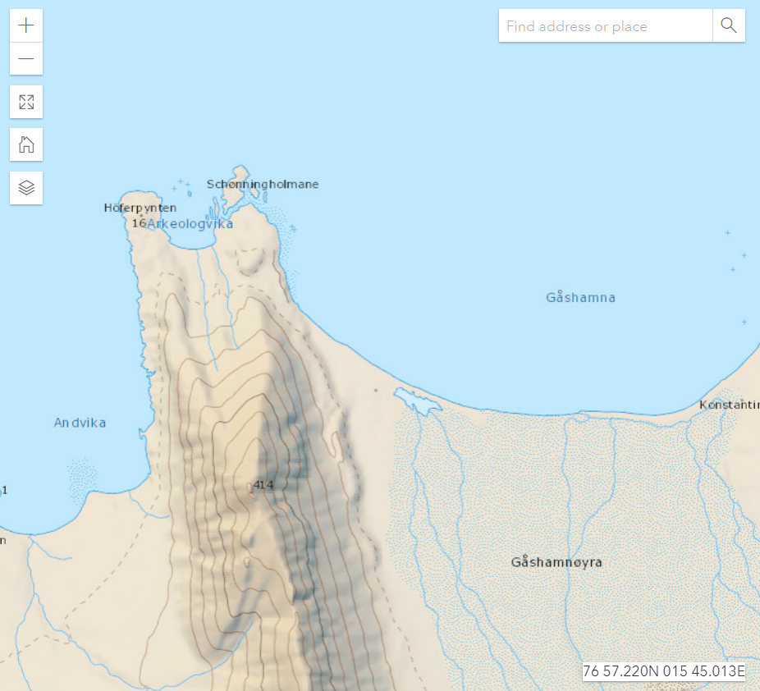

Material and Methods
- Zooarchaeological survey
A zooarchaeological survey was conducted at Gåshamna. During the survey, all visually identified bone specimens were recorded; where possible, we identified skeletal elements and assigned taxa using established morpho-osteological criteria. Whale remains were identified using van Beneden and Gervais (1880) and van den Hurk (2020). Given the regional fauna, we focused primarily on bowhead whale (Balaena mysticetus), and secondarily on blue whale (Balaenoptera musculus), fin whale (B. physalus), common minke whale (B. acutorostrata), humpback whale (Megaptera novaeangliae), sperm whale (Physeter macrocephalus), beluga (Delphinapterus leucas), and narwhal (Monodon monoceros). For walrus, polar bear, seals, Arctic fox, and other terrestrial/marine mammals, we consulted the Idaho Virtual Museum (2024).
In addition to element and species identifications, we recorded epiphyseal fusion status (fused/unfused) to assess age class and documented taphonomic modifications (e.g., working traces, cut marks, chop marks, burning). These observations support reconstruction of site activities and the species and age categories targeted or processed (e.g., fully grown adults vs. juveniles).
Finally, we measured the maximum dimension of each specimen to assess spatial clustering within the bone scatter, which may indicate activity foci as well as patterns of fragmentation and erosion. Whale bone specimens were particularly heavily fragmented.

- Osteometric analysis
We also carried out standardized caliper-based measurements of the bowhead whale crania from Gåshamna. Because the crania were highly fragmented, we focused on the better-preserved posterior portions. Several specimens were partly buried and therefore inaccessible for osteometric analysis, which reduced the sample size. Although comparable reference measurements from modern bowhead whales are unavailable, the metrics still allow differentiation between juvenile and adult individuals, enabling reconstruction of whalers’ size preferences.

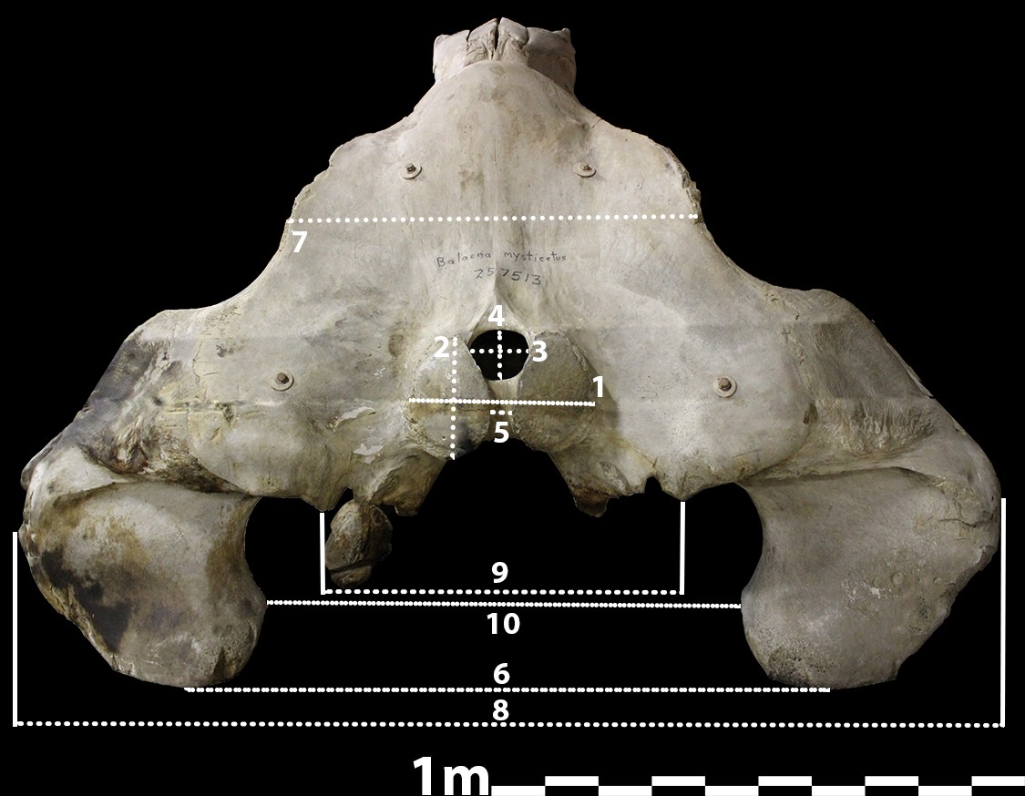
1. Width of occipital condyles
2. Height of occipital condyles
3. Width of Foramen Magnum
4. Height of Foramen Magnum
5. Width between the two occipital condyles
6. With from most ventral points of retroglenoid processes
7. Width of occipital at the least curved position
8. Maximum width of cranium
9. Width of the most ventral points of palatines
10. Smallest width between retroglenoid processes
11. width of temporal in the centre
12. Width of temporal at most anterior point
13. Smallest width of temporal

- AMS Dating
Moreover, we conducted minimally destructive sampling of selected walrus and whale remains to obtain AMS 14C dates and place the assemblage in a secure temporal framework. We targeted ten whale crania and two tympanic bullae. Using a Dremel rotary tool, we removed small bone fragments (typically ~500 mg). Collagen was extracted using a modified Longin (1971) protocol as described in Seiler et al. (2019), with an additional lipid-extraction step performed at the NLD (NTNU, Norway). Full methodological details are provided in van den Hurk et al. (2023).
For each specimen, 2.0–3.0 mg of collagen was weighed into tin capsules and AMS dated following Seiler et al. (2019). Samples were converted to homogeneous graphite using the automated TOR (Trondheim Oxidation and Reduction) system, which applies iron-catalyzed hydrogen reduction of CO₂ (Vogel et al., 1984) and removes residual water via Peltier cooling (Wacker et al., 2010). 14C measurements were carried out on the NLD 1 MV AMS system (High Voltage Engineering Europa B.V.). All new dates, together with previously published results, were calibrated using the Marine20 curve (Heaton et al., 2020) and a local ΔR correction (ΔR20) calculated following the methods described below.

- Marine Reservoir Correction
Radiocarbon dating of marine taxa is affected by the marine reservoir effect (MRE): surface ocean dissolved inorganic carbon (DIC) is, on average, depleted in ¹⁴C relative to the contemporaneous atmosphere because ocean mixing and ventilation operate on slower timescales than atmospheric exchange. Consequently, marine organisms typically yield radiocarbon ages that are older than coeval terrestrial materials. Marine radiocarbon measurements therefore require calibration against a global marine calibration curve, which incorporates the average global marine–atmosphere offset (Stuiver and Braziunas, 1985). Temporal changes in global marine ¹⁴C have been modelled by Heaton et al. and implemented in the Marine20 curve (Heaton et al., 2020; 2023).
Calibration of marine dates generally requires a further, regional/local correction because the reservoir age of a given water mass can deviate substantially from the global mean due to processes such as sea-ice cover, freshwater input, upwelling, and variable ocean circulation. This deviation is expressed as ΔR, defined as the difference between the measured local marine reservoir age and the age predicted for the global surface mixed layer by the chosen marine calibration curve (Stuiver et al., 1986). ΔR can vary at small spatial scales and among individuals (sometimes discussed as ΔR_{L}), but can also be treated statistically as a regional offset (ΔR_{R}) within an oceanographically coherent area (Pieńkowski et al., 2022). Estimation of ΔR_{R} typically relies on dating known-age pre-bomb marine material and/or paired terrestrial–marine samples that are demonstrably contemporaneous (Reimer and Reimer, 2001; Dyke et al., 2019). The resulting ΔR_{R} estimate is then applied to marine samples from nearby localities with comparable oceanographic conditions.
Several studies have produced ΔR_{R} estimates relevant to Arctic cetaceans. Furze et al. (2014) and Pieńkowski et al. (2023) calculated ΔR_{R} values for bowhead whale and beluga in the North American Arctic using paired ages from bone and driftwood derived from the same glacio-isostatically uplifted shorelines. Mangerud et al. (2006) and Pieńkowski et al. (2022) similarly estimated reservoir offsets from known-age pre-1950 whale specimens, primarily from the Barents Sea region. Westbury et al. (2024) calibrated a large set of bowhead specimens from Svalbard and the Norwegian coast using the Barents Sea baleen-whale ΔR_{R} = 7±39 reported by Mangerud et al. (2006), although that value was originally derived in relation to earlier generations of marine calibration curves and its transferability across curves and regions warrants caution. More importantly, a Barents Sea–based ΔR_{R} may not be fully appropriate for bowhead whales associated with Svalbard, because bowheads typically occupy colder, more northerly waters and may integrate carbon from water masses with different ventilation histories than those represented by Barents Sea reference material.
Bay-whaling in Hornsund is historically constrained to a relatively narrow window (ca. 1614–1657). If the Gåshamna cetacean remains can be securely attributed to that whaling phase, they provide an unusually tight calendar-age bracket (≈45 years) for marine specimens. This makes the assemblage particularly valuable for evaluating whether an existing regional ΔR_{R} is appropriate for Svalbard bowheads, and—if paired terrestrial material or other independent chronological anchors are available—for estimating a Svalbard-specific ΔR_{R} for Marine20 in a historically well-defined context.

Results
- Zooarchaeological survey
At Gåshamna West, survey and recording focused on the area surrounding the main concentration of bowhead whale crania. The Gåsbreen river system formed the eastern boundary of the survey, while a deep gully marked the northwestern boundary. A rapid reconnaissance northwest of the focus area indicated additional bone was present, but at lower densities. To the north, the shoreline provided a natural limit; few specimens occurred close to the shore, likely reflecting removal and redeposition by rainfall and glacial runoff. The southern boundary was defined operationally: after the southernmost finds, survey continued a further 10 m without additional material and the area was delimited at that point.
A total of 628 whale bone fragments were recorded. These included numerous small, highly fragmented and unidentifiable pieces, as well as larger cranial fragments. Several specimens were partially buried, indicating ongoing cycles of exposure and burial consistent with an actively reworked gravel-plain surface assemblage. In addition, 49 cranial specimens were identified, all attributable to bowhead whale (Balaena mysticetus). Based on these crania, the minimum number of individuals (MNI) is 49, although the true number may be higher given fragmentation and partial burial of elements.
All 49 crania exhibited similar modification patterns: the maxillae were fully or largely broken off. A further 40 mandibles were recorded, comprising 10 left mandibles and 7 right mandibles; for the remaining 23, laterality could not be determined due to fragmentation and/or partial burial. Several mandibles had been sawn through, consistent with deliberate processing and potential oil extraction from mandibular tissues. In addition to sawing, numerous whale vertebral and vertebral transverse and spinous processes were recorded as chopped, and one whale vertebra was noted as having been used as a chopping block.
Postcranial elements included three ulnae and two radii. One ulna had both proximal and distal epiphyses fused, whereas the remaining two ulnae were unfused. Of the two radii, one was highly fragmented and the other was complete with both epiphyses unfused. Multiple whale vertebral epiphyses were also recorded as unfused, while several vertebrae were fully fused. Overall, the presence of unfused ulnae, a radius, and unfused vertebral epiphyses indicates that juvenile bowheads were represented alongside fully mature individuals.
Beluga (Delphinapterus leucas) was represented by 22 identified specimens distributed across the site. These remains were generally less fragmented than the large-whale fragments and included partially articulated material, suggesting shorter exposure and potentially a more recent depositional history than the bowhead assemblage. Two radii—one with fused epiphyses and one unfused—indicate an MNI of 2. An axis exhibited clear cut marks on the right transverse process, demonstrating on-site butchery. One beluga/dolphin vertebra and multiple ribs and cranial fragments were also recorded, supporting repeated presence of smaller cetaceans at the locality.
Polar bear (Ursus maritimus) was represented by 34 specimens. Most derive from juvenile individuals, as indicated by predominantly unfused epiphyses across multiple elements. Three partial front limbs were also recorded and appear relatively recent. Seven radii were identified; because laterality was not recorded, the polar bear MNI is 4 based on radii. No cut or chop marks were observed, and several specimens were explicitly noted as recent, suggesting that at least part of the polar bear material represents modern or near-modern additions to the surface assemblage rather than whaling-phase refuse.
Cattle (Bos taurus) was represented by 29 specimens. As cattle do not occur naturally on Svalbard, these remains indicate importation of livestock products (either live animals transported to the site or, more likely, bone-in meat). Identified elements consisted largely of meat-rich parts (pelvis, humerus, ribs, vertebrae), and chop marks were observed on several specimens, consistent with butchery. The cattle remains were clustered around Grøhdal House, suggesting that they may relate to refuse associated with the Norwegian trapper occupation rather than seventeenth-century whaling.
Reindeer (Rangifer tarandus) was represented by 14 specimens, with an MNI of 1. No cut or chop marks were observed; several elements were recorded as recent, and the reindeer remains may therefore largely reflect recent carcasses or scavenged material rather than cultural deposition.
Arctic fox (Vulpes lagopus) was represented by seven specimens. A partial skeleton and a cranium were assessed as modern. A fox den was present beneath one archaeological feature and most fox remains were found in its immediate vicinity. This raises the possibility that some bones—potentially including some polar bear limb elements and reindeer remains—represent scavenged material accumulated by fox activity near the den. Consistent with this, higher concentrations of reindeer and polar bear bone were observed close to the den.
A single walrus cranium was identified; it was partially broken and the tusks had been removed. In addition, one seal vertebra was recorded. One scapula was identified only as cattle/reindeer, and six further specimens were non-cetacean but could not be identified to taxon. Overall, the assemblage combines an extensive, heavily modified bowhead component (with sawing and chopping consistent with processing) with a smaller set of other taxa, some of which show “recent” preservation states and juvenile-dominated profiles (notably polar bear), indicating at least some degree of post-depositional mixing in the surface record.

Species | Number of Identified Specimens | Minimal number of Individuals
Whale | 631 | 49
Polar bear | 34 | 2
Cattle | 30 | 3
Beluga | 23 | 2
Reindeer | 14 | 1
Arctic fox | 7 | 2
Unidentified animal | 6 | -
Walrus | 1 | 1
Seal | 1 | 1

- Spatial spread of bone specimens and erosion
To understand the spatial organization of early modern whaling activities at Gåshamna West, we conducted a DBSCAN (Density-Based Spatial Clustering of Applications with Noise) analysis of the whale bone finds. Using a search radius (eps) of 7 meters and a minimum sample threshold (min_samples) of 15 points, we identified five distinct spatial clusters of whale bone elements across the gravel plain. To visualize the extent of these clusters, we generated organic boundary polygons by buffering the clustered points by 3.5 meters and applying a Douglas-Peucker simplification algorithm. The spatial distribution shows clear concentrations of bone material surrounding the blubber ovens (tryworks) and the dwelling foundations, indicating localized processing and discard zones rather than a uniform scatter across the site. The silhouette score of the clustered points is 0.315 (excluding noise), representing a moderately defined spatial structure where clusters are located in close proximity but remain statistically distinguishable. The noise level was calculated at 34.6%, representing isolated bone fragments scattered by geomorphic processes or secondary taphonomic agents across the dynamic plain.
To evaluate whether these spatial clusters represent functionally distinct activity areas, we conducted a Chi-Square test of independence on the distribution of whale skeletal elements across the five identified clusters. The result reveals a highly significant statistical difference in the anatomical profiles of the clusters (Chi-Square = 136.64, df = 60, p = 6.56e-8). This strongly suggests that different parts of the site were used for distinct carcass disarticulation or discard practices. To identify the specific anatomical anomalies driving this significance, we calculated Haberman’s adjusted standardized residuals, which follow a standard normal distribution. Values exceeding +/- 1.96 indicate significant over- or underrepresentation of specific bones. For instance, Cluster 4 exhibits a massive overrepresentation of vertebral epiphyses (adjusted residual = +5.8) and vertebrae (+1.7), suggesting a specialized spine processing or dumping zone. In contrast, other clusters (e.g. Cluster 1 and 2) are significantly enriched in cranial fragments (adjusted residuals of +1.8 and +2.0 respectively), pointing to primary butchery areas near the blubber ovens.
We also constructed a uniform hexagonal density grid (cell resolution of 50 meters) across the global extent of the site to compare the spatial densities of different species finds. The results reveal clear, non-overlapping spatial hotspots that reflect the multi-period nature of the landscape. Whale bone density is heavily concentrated around the early modern whaling infrastructure (Gåshamna West locus). Cattle remains, on the other hand, are clustered tightly around the Grøhndal House (trapper hut), indicating they belong to the historic Norwegian trapping phase. Polar bear and reindeer bone densities exhibit a distinct hotspot around the active Arctic fox den, reinforcing the taphonomic observation that scavengers have contributed to the post-depositional accumulation of terrestrial mammal bones.
We extracted elevation values for all clustered whale bones using a 2022 high-resolution Digital Elevation Model (DEM) of Gåshamna to examine the topographic positioning of the activity zones. The elevation analysis shows that the whaling areas are positioned between 1.5 and 5.5 meters above sea level. Standardized boxplots show distinct altitudinal zonation among the clusters: Cluster 0 and 1 are located at lower elevations (mean ~2.1m and ~2.5m), representing processing areas closer to the historical shoreline for easier landing of whale carcasses. Cluster 4 is located at a higher elevation (mean ~4.2m), potentially representing a discard zone positioned on higher ground.
To examine whether logistical constraints influenced carcass transport, we calculated a Pearson correlation between bone size (length in cm) and landscape elevation. The analysis shows a weak negative correlation (r = -0.124), indicating that larger, heavier bones (like mandibles and large cranial fragments) tend to be located closer to the shoreline at lower elevations, while smaller, more transportable bones were carried further inland to higher ground. Furthermore, we calculated a slope gradient raster from the DEM (masking NoData values to prevent boundary errors) to assess surface stability. A stability threshold of 5 degrees was set to distinguish flat, stable working surfaces from steeper, unstable slopes. The slope angle per cluster shows that almost all clustered points are located on flat ground with a mean slope of 2.1 to 3.8 degrees. This confirms that whalers selected flat, stable surfaces for processing activities, and that post-depositional slope wash has not significantly displaced the core bone concentrations.

- Bowhead whale osteometrics
Cranial measurements indicate appreciable inter-individual size variation, but extensive fragmentation means many individuals are represented by only a subset of measurements. We therefore treat cranial metrics as a relative size indicator rather than a basis for definitive age-classing or demographic reconstruction. Cranial measurements were converted to a relative size index by log-transforming each measurement and scaling to the measurement-specific mean. Measurement 5 was immediately excluded as it exerted disproportionate influence on index variance. To evaluate whether the other cranial measurements provide coherent size information despite substantial fragmentation and missing data, we applied a set of internal-consistency diagnostics that do not require replicate measurements.
First, we computed pairwise Spearman rank correlations among measurements using pairwise complete observations (Table X), with the corresponding pairwise sample sizes reported separately (Table Y). Spearman’s ρ was chosen because it is robust to non-normality and because the dataset contains substantial missingness and uneven variance across measurements. In this context, a measurement that tracks overall skull size is expected to show broadly positive covariation with other size-linked dimensions, whereas a measurement dominated by landmark ambiguity, taphonomic distortion, or inconsistent scaling should show weak or inconsistent associations.
The Spearman results show a coherent block of positively covarying measurements (Table X; Fig. X), most notably involving measurements 6, 8, and 10 (e.g., ρ6–10 is strong and positive, and 8 covaries positively with both 6 and 10). Measurements 1 and 2 also correlate strongly with each other, indicating that they capture a shared scale component. Interpretation of weaker cells is guided by Table Y, since several correlations are based on limited overlap and should not be over-weighted when n is small. Overall, the correlation structure (Table X; Fig. X) supports the interpretation that a subset of the measurement set behaves consistently as a size proxy.
Second, we calculated item–total correlations (Table Z) to assess whether each measurement behaves as a coherent contributor to a composite index. For each measurement $j$, we computed a composite per specimen as the mean of all other available measurements (excluding $j$), requiring at least three other measurements to reduce instability from very sparse cases. We then correlated the focal measurement with this composite using Spearman’s ρ. Measurements with high item–total correlations are those that align well with the latent size signal expressed by the remainder of the dataset; conversely, measurements with near-zero item–total correlations contribute little consistent information and may introduce noise into composite size estimates.
Item–total results (Table Z) reinforce the correlation-based interpretation: measurement 6 and measurement 10 show strong coherence with the remainder of the dataset, while measurement 8 is moderately supportive. By contrast, measurements 3 and 4 show very low item–total correlations, indicating that—within this assemblage and preservation context—these variables do not behave consistently as size proxies and may reflect landmark sensitivity, taphonomic effects, or a shape component that does not scale with overall size.
Finally, we assessed internal consistency using Cronbach’s alpha and alpha-if-deleted (Table W), calculated on complete-case subsets (no imputation) to avoid imposing a covariance structure on sparse data. With small complete-case sample sizes, alpha is treated as a diagnostic rather than a definitive reliability estimate: the key inference is whether including specific variables causes the scale to behave incoherently, and whether removing them improves internal consistency. In this dataset, adding the problematic variables substantially degrades scale coherence (Table W), consistent with the weak item–total and inconsistent pairwise correlation patterns.
Taken together (Tables X–W; Fig. X), these diagnostics support retaining measurements 1, 2, 6, 8, and 10 as a core set for composite size analyses. Variables with limited overlap (7, 11, 12, 13) can be treated as supplementary when present, but are not required for an assemblage-wide index due to missingness. Measurements 3 and 4 were therefore omitted from further composite size analysis (and measurement 5 had already been excluded earlier due to disproportionate leverage).
Using measurements 1, 2, 6, 7, 8, 10, 11, 12, and 13, we calculated a composite logarithmic size index for each cranium by averaging the available standardized log-transformed values across these measurements. This produced a single relative size estimate per individual for the 30 crania for which sufficient measurements were available. The resulting index provides a straightforward way to visualize relative body size variation among the bowhead whales represented in the cranial scatter at Gåshamna West (Fig. X), while minimizing the influence of any single dimension and accommodating minor incompleteness through averaging.
Overall, the distribution is tightly clustered around ~1.0, indicating that most measured individuals fall close to the assemblage mean and suggesting limited detectable size variation among the majority of crania. One cranium stands out as markedly smaller than the rest (index ≈ 0.944), forming a clear low-end outlier relative to the main cluster. At the upper end, only a small number of crania exceed ~1.01–1.02, indicating the presence of a few larger-than-average individuals but no strong evidence for a distinct second mode. Taken together, the histogram suggests that the measurable portion of the assemblage is dominated by individuals of broadly similar adult size, with occasional smaller and larger individuals also present—consistent with the independent osteological evidence that both mature and juvenile animals occur in the wider assemblage (e.g., unfused epiphyses in postcranial elements), even if the cranial index alone cannot securely assign age classes. However, there appears to have been clear focus on adult individuals, with only one out of thirty specimens being clearly identified as a smaller, juvenile specimen.

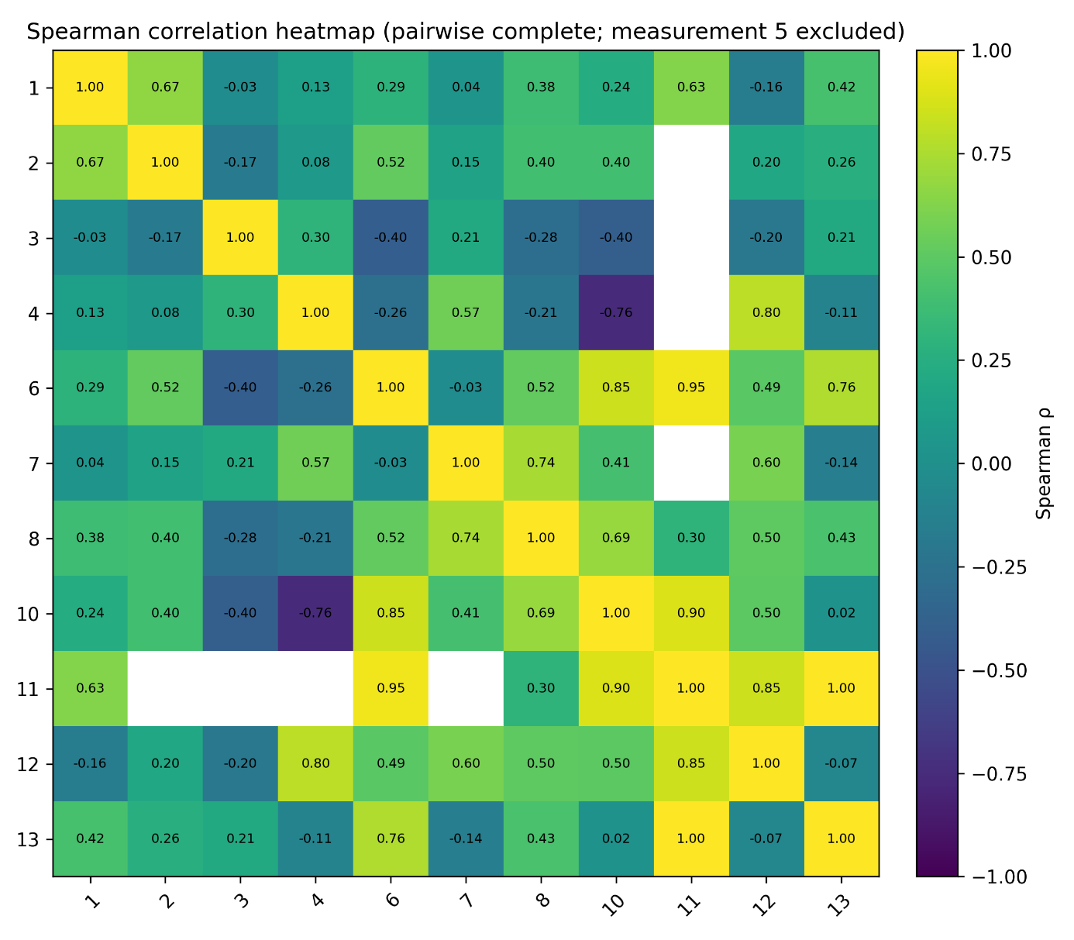
11 missing for several as it was not taken together with those

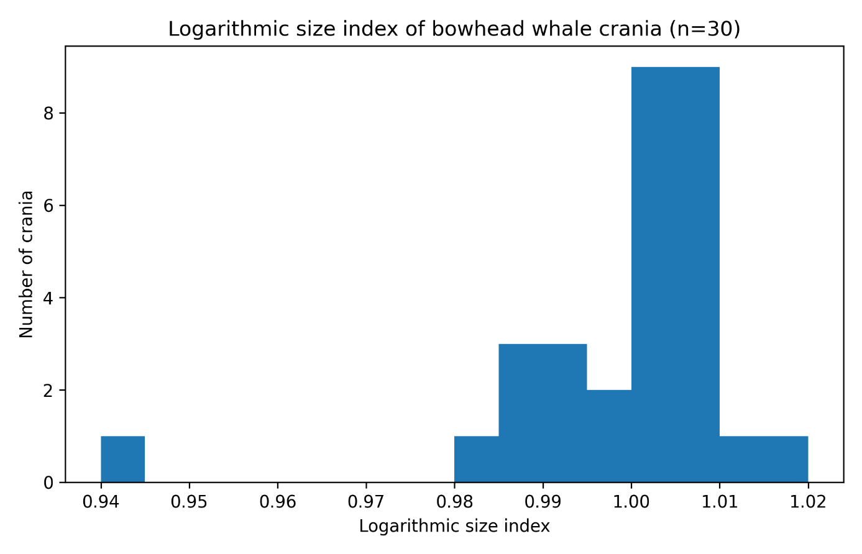

- Radiocarbon Dating
Radiocarbon dating was undertaken on twelve bowhead whale specimens from Gåshamna West to assess the chronology of the cranial scatter and to evaluate whether the assemblage is consistent with the historically documented bay-whaling phase in Hornsund. One specimen, Skull-159, yielded a conventional radiocarbon age of 1585 ± 25 BP, substantially older than all other dated samples. Skull-159 was therefore evaluated against collagen quality criteria. In addition to its anomalous age, it displayed atypical geochemical characteristics relative to the rest of the dataset, including a markedly depleted δ¹³C value (−19.0‰) and an elevated inferred atomic C:N ratio (4.0) based on measured %C and %N, which falls outside commonly accepted ranges for well-preserved, uncontaminated collagen. These indicators suggest compromised collagen integrity and/or the presence of exogenous carbon, either of which can bias radiocarbon measurements toward artificially old ages. This specimens was excluded from chronological interpretation and from any subsequent analyses.
A second specimen, Skull-145, produced an older result than the main cluster (980 ± 20 BP) as well, and had a relatively depleted δ¹³C value (−19.4‰). However, in contrast to Skull-159, Skull-145 did pass collagen quality criteria (with %C and %N consistent with acceptable collagen and an inferred atomic C:N within expected limits). Skull-145 was therefore retained as a valid data point and interpreted as potentially reflecting either (i) incorporation of carbon from a somewhat different foraging baseline/water-mass history (i.e., variable effective reservoir age among individuals), or (ii) an earlier mortality event subsequently incorporated into the scatter through redeposition or reuse. Regardless of the mechanism, its radiocarbon measurement is considered analytically reliable.
After excluding Skull-159, the remaining 11 dates form a broadly coherent dataset consistent with deposition during, or close to, the early modern whaling horizon. Conventional radiocarbon ages range from 645 ± 20 BP to 980 ± 20 BP (including Skull-145), with most specimens clustering tightly between 645–765 BP, while the two bullae (Whale-349 and Whale-800) yielding slightly older values (~825–830 BP) and Skull-145 being older still. Stable carbon isotope values for the main cluster are relatively consistent (δ¹³C ≈ −15.0 to −16.8‰), supporting broadly similar marine carbon baselines across most individuals, whereas the more depleted δ¹³C in Skull-145 suggests a different baseline or life history. These conventional radiocarbon ages also agree with the two dates provided by Birkenmajer and Olsson (1998): 620 ± 65 BP and 670 ± 75 / 675 ± 80 BP. The δ¹³C values of these two specimens also align with the data provided here, yet they did not provide the measured %C and %N, not allowing for further quality control of these two dates.

- Marine Reservoir Correction and Calibration
With the earliest documented bay-whaling in Hornsund beginning in 1613 and the English abandoning bay-whaling in Hornsund by 1657, the principal whaling-phase accumulation at Gåshamna is expected to fall within a historically constrained ~45-year interval. To improve calibration of the Gåshamna bowhead dates under these constraints, we estimated a Svalbard bowhead-specific ΔR₂₀ using the 11 bowhead whale specimens that passed collagen quality control (excluding Skull-159). The two radiocarbon determinations reported by Birkenmajer and Olsson (1998) on mandibles were not included because the original reporting does not allow assessment of collagen preservation/pretreatment quality.
ΔR₂₀ estimation was performed using Bayesian modelling in OxCal (Bronk Ramsey, 2009; Bronk Ramsey et al., 2012; Macario et al., 2023). Following the approach of van den Hurk et al. (2025), we used a normally distributed prior with mean 0 and standard deviation 500 years to allow broad accommodation of plausible eastern North Atlantic reservoir offsets as summarized in regional compilations (Reimer and Reimer, 2001). The model returned a local offset of ΔR₂₀ = -112 ± 21.5 ¹⁴C years (posterior mean and SD), with agreement indices (A_{model} = 158.2 and A_{overall} = 158.1, exceeding the recommended threshold of 60; Bronk Ramsey, 2009). Pending additional independently constrained material (e.g., known-age or paired terrestrial–marine samples) providing improved spatiotemporal coverage for Svalbard waters, ΔR₂₀ = -112 ± 21.5) represents an empirically based best estimate for calibrating radiocarbon dates of Svalbard bowhead whales in this study. This estimate was then applied to calibrate the bowhead radiocarbon dates using Marine20.
Applying ΔR₂₀ = -112 ± 21.5 produces modelled calibrated age ranges that remain broadly consistent with early modern activity at Gåshamna West. The 95.4% modelled ranges span 1310–1906 CE across the dated specimens. Most of the assemblage falls within overlapping seventeenth–eighteenth century ranges, consistent with a predominantly post-medieval/early modern accumulation associated with bay-whaling and subsequent site use. One specimen (Cranium-145) remains earlier than the main cluster after correction (modelled mean 1429 CE, 95.4% range 1310–1538 CE), indicating that some individual variability persists even after applying a local offset, and that limited incorporation of earlier material and/or differences in individual carbon baselines cannot be excluded. Moreover, the two tympanic bullae (Whale-349 and Whale-800) yielding slightly older, and tightly clustered, calibrated dates (95.4% range 1446-1677 CE and 1449-1680 CE respectively).
Overall, the dated assemblage supports the interpretation that the cranial scatter at Gåshamna West largely relates to post-medieval/early modern activity, consistent with the historically constrained bay-whaling phase, while also indicating that individual variability and/or limited incorporation of older material cannot be ruled out.
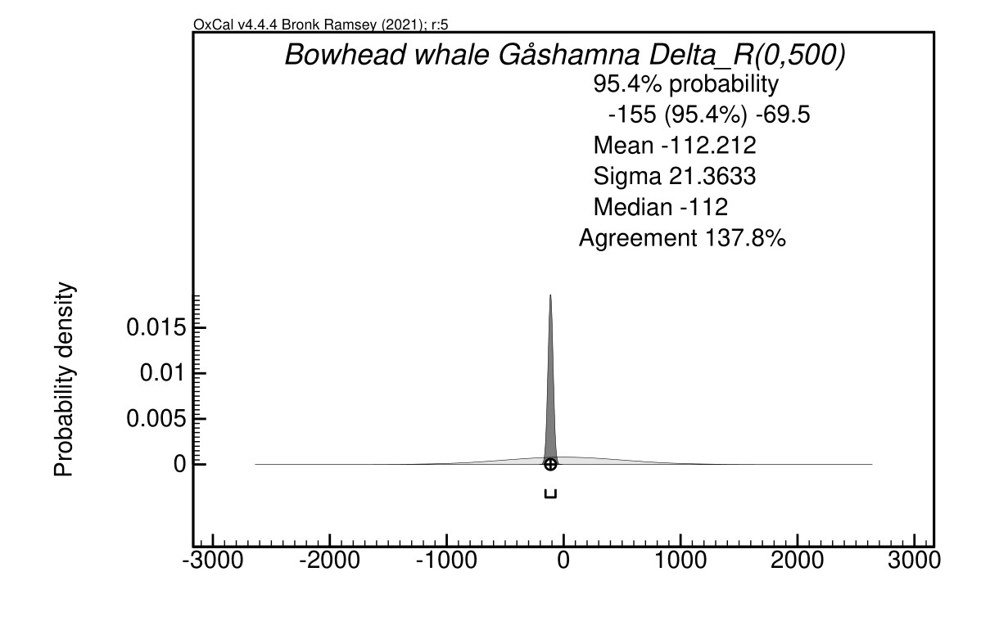

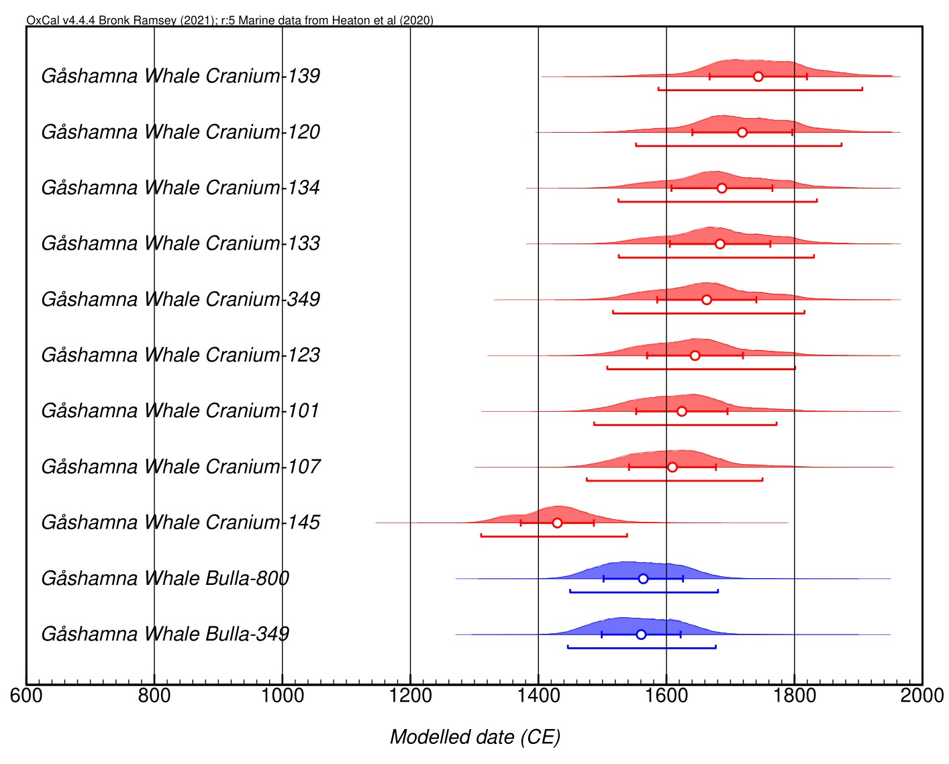
Discussion

Discussion on spread of specimens

While Jørgensen (1991) reported 54 whale crania at Gåshamna West and van Kruiningen et al. (2004) reported 42 crania, our survey recorded 49 bowhead whale crania. The discrepancy may partly reflect differences in survey coverage and counting strategy (e.g., whether crania north of our focus area were included in earlier tallies), but it may also reflect partial burial and re-exposure of crania under sand and gravel, which we observed during fieldwork (several cranial and mandibular elements were partially embedded). In this setting, “missing” crania may be concealed rather than removed, and the observed count should be treated as a minimum snapshot of a dynamic surface assemblage rather than a fixed inventory. However, Birkenmajer and Olsson (1998) also noted that in between 1959 and 1974, numerous whale bones disappeared from the site, likely taken as souvenirs by tourists or for museum exhibitions.
The faunal assemblage at Gåshamna West also illustrates the interpretive challenges posed by a multi-period, repeatedly reused locality. The site was occupied sequentially by early modern whalers and later by Pomor hunters and Norwegian trappers, and the spatial overlap of these occupations complicates direct attribution of most taxa to a single cultural group. In contrast, the concentration of large bowhead cranial remains is most parsimoniously interpreted as a legacy of seventeenth-century whaling activity: bowhead crania dominate the assemblage, cranial elements show consistent modification patterns (maxillae largely broken off), and several mandibles were sawn through, indicating deliberate processing. In addition, the assemblage contains abundant chopped whale vertebral fragments and processes (with at least one vertebra used as a chopping surface), consistent with intensive carcass disarticulation and reduction on site. Based on the osteometric analyses on the various crania, as well as the fusion state of the various bowhead whale radii and ulnae, the majority of the specimens were identified as adult individuals, yet juvenile individuals were occasionally taken as well.
By contrast, many of the non-cetacean remains—particularly polar bear, cattle, reindeer, and Arctic fox—are more difficult to assign culturally. Several lines of evidence suggest that at least some of these remains represent recent additions and/or scavenger-mediated accumulations rather than whaling-phase refuse. Polar bear remains are dominated by juvenile individuals (predominantly unfused epiphyses), and some limb elements appeared relatively fresh. Arctic fox activity is also archaeologically visible: a den was present within the site area, and fox remains clustered around it. This raises a strong possibility that foxes contributed to the local bone scatter by transporting parts of carcasses into and around the den area. In such cases, the excellent macroscopic preservation of many bones can be misleading—fresh, scavenger-transported material can occur immediately adjacent to centuries-old cultural remains, and surface preservation alone is not a reliable discriminator of age in this environment.
Radiocarbon results further support a predominantly post-medieval/early modern assemblage while also highlighting the uncertainties inherent to dating highly mobile marine mammals. After applying the locally estimated ΔR₂₀ = -112 ± 21.5, the 11 quality-controlled bowhead dates yield modelled 95.4% modelled ranges span 1310-1906 CE which broadly overlap the historically constrained period of bay-whaling and later early modern site use. The dataset is not perfectly tight, but the spread is modest and is consistent with a combination of (i) calibration-curve uncertainty and (ii) small-scale variation in effective reservoir age among individuals. One cranium (Cranium-145) remains older than the main cluster after correction (modelled mean 1429 CE, 95.4% 1310–1538 CE), indicating that individual variability persists even after applying a Svalbard-specific offset and that not all bowhead remains need be strictly contemporaneous.
A parsimonious explanation for the remaining inter-individual variation is differential uptake of radiocarbon across feeding areas and migration routes. Modern satellite telemetry demonstrates that bowhead whales occupying the Fram Strait region can show divergent migratory trajectories within the same season, including movements toward eastern Greenland and toward the Barents/Franz Josef Land region (Kovacs et al., 2020). Although sea-ice and oceanographic conditions have changed since the seventeenth century, the principle remains relevant: whales exploiting different water masses can incorporate carbon from marine reservoirs with differing ventilation histories, producing measurable differences in apparent radiocarbon age. Taken together, the zooarchaeological patterning (intensive processing signatures and juvenile representation) and the radiocarbon results support a whaling-associated origin for the main cranial scatter, while emphasizing that surface deposits at Gåshamna West represent a palimpsest in which cultural reuse, scavenger activity, and marine reservoir variability all influence the observed record.
Two of the dated specimens (Whale-349 and Whale-800), both tympanic bullae, returned among the older radiocarbon ages in the dataset (95.4% range 1446-1677 CE and 1449-1680 CE). Because all dated specimens (crania and bullae) are isolated surface finds, we cannot determine whether any bulla is associated with any dated skull. This prevents within-individual tests (i.e., paired-element dating) and means that the apparent offset between bullae and most crania must be interpreted as a pattern across unassociated elements rather than as a demonstrated element-to-element difference within the same whale.
A plausible biological explanation is element-specific tissue turnover in ear-region bones. In mammals, the otic capsule is widely recognized as unusual in showing strongly reduced remodelling after development compared with most skeletal elements (Frisch et al., 2000; Zehnder et al., 2006). In cetaceans, the periotic–tympanic (petro-tympanic) complex is exceptionally compact and rapidly attains adult-like structure early in life; histological work on known-aged common dolphins shows that the periotic and tympanic bones reach near-maximum size at or near birth, become highly mineralized within the first months, and then stabilize in mass/compactness/density after the first year, consistent with limited subsequent turnover under normal conditions (de Buffrénil et al., 2004). If collagen in the tympanic bulla is formed disproportionately early and remodels less (or more slowly) than collagen in other cranial elements, radiocarbon ages obtained from bullae could incorporate a larger “inbuilt age” component, yielding dates that are systematically older than the animal’s time of death and—by extension—older than dates derived from elements with greater lifetime turnover.
At the same time, it is important to note that cetacean tympanic bullae can remodel under certain circumstances. Documented cases of fractured and subsequently healed bullae demonstrate substantial remodelling and repair, indicating that the tissue is not biologically inert (Yamato et al., 2016). Such remodelling, however, appears episodic (e.g., trauma-related) and does not necessarily imply the same baseline remodelling regime as in many postcranial bones. In the absence of paired samples from the same individuals, the most parsimonious interpretation is therefore that the older bulla ages may reflect differences in bone formation/turnover history within the cetacean skull, rather than requiring a distinct occupational phase at the site. Future work could test this directly through a targeted paired-element design on securely single-individual remains (e.g., articulated or stratified contexts) and by comparing bulla and cranial collagen isotopic signatures and radiocarbon ages within the same whale.

Conclusion

By undertaking this zooarchaeological study, the zooarchaeological potential of Svalbard is uncovered. Numerous other sites in Svalbard besides Gåshamna have excellently preserved faunal remains, yet the continued erosion of these sites gradually washes away their potential to reconstruct the intrinsic past human activities in this remote corner of the world.

Future research should attempt to date other zooarchaeological remains as well, including the identified cattle, walrus, reindeer, and polar bear specimens. The preservation of these specimens makes it likely at least some of these are younger than the whale bone specimens left behind by the English whalers.

References

- de Buffrénil, V., de Muizon, C., & Berta, A. (2004). Histology and growth of the cetacean petro-tympanic bone complex. Journal of Zoology. (Cambridge University Press & Assessment)
- Frisch, T., Sørensen, M. S., Overgaard, S., Bretlau, P., & Guldberg, P. (2000). Estimation of volume referent bone turnover in the otic capsule. Acta Oto-Laryngologica. (PubMed)
- Yamato, M., Pyenson, N. D., & others (2016). Extensively remodeled, fractured cetacean tympanic bullae show that whales can survive traumatic injury to the ears. Journal of Anatomy. (PubMed)
- Zehnder, A. F., Kristiansen, A. G., Adams, J. C., Kujawa, S. G., Merchant, S. N., McKenna, M. J., & others (2006). Osteoprotegerin knockout mice demonstrate abnormal remodeling of the otic capsule and progression of hearing loss. The American Journal of Pathology. (PubMed Central)

Helberg, B., 1998. Svalbards arkeologiske undersøkelser. Tromura, Tromsø museums rapportserie, kulturvitenskap, 30. Tromsø: Tromsø museum – universitetsmuseet. in folder dropbox

Hacquebord, L., 1984. Smeerenburg. Het verblijf van Nederlandse walvisvaarders op de westkust van Spitsbergen in de 17de eeuw. Amsterdam/Groningen.

Jan Chochorowski & Marek E. Jasinski (1988) The structure of the pomor settlement complex on the Schønningholmane site (Hornsund, West Spitsbergen) archaeological data, Acta Borealia: A Nordic Journal of Circumpolar Societies, 5:1-2, 34-49, DOI: 10.1080/08003838808580355
Arlov, T. B. And Reymert, P.K., 2020. Konstantinovka. Dokumentasjon av den russiske gradmålingsstasjonen i Hornsund. Rapport fra et dokumentasjonsprosjekt støttet av Svalbard Miljøvernfond. Trondheim/Tromsø/Stavanger: Svalbard Miljøvernfond.
Chochorowski, J., 1986. Report on the archaeological excavations carried out by the Jagiellonian University Spitsbergen Expeditions in Spitsbergen from 1982 to 1985. Upublisert rapport i Tromsø Museums arkiv, arkeologisk avdeling.

Idaho Virtual Museum, 2024. Idaho Virtual Museum. Available at: <https://virtual.imnh.iri.isu.edu/Osteo/Mammals/4> [Accessed 11-08-2024].

Albrethsen, S.E., 1987. Forelabig rapport vedr. Kulturvernets arkreologiske undersagelser og befaringer 1987. Upublisert rapport i Tromsø Museums arkiv, arkeologisk avdeling.

Weinstock, J., 2008. Epiphyseal Fusion in Brown Bears: A Population Study of Grizzlies (Ursus arctos horribilis) from Montana and Wyoming. International Journal of Osteoarchaeology, 19(3), 416-423. DOI: 10.1002/oa.980

Conway, M., 1906. No Man's Land: a history of Spitsbergen from its discovery in 1596 to the beginning of the scientific exploration of the country. Cambridge: Cambridge University Press.

Four centuries of commercial whaling eroded 11,000 years of population stability in bowhead whales
Michael V. Westbury, Stuart C Brown, Andrea A. Cabrera, Hernán E Morales, Jilong Ma, Alba Rey-Iglesia, Arthur Dyke, Camilla Hjorth Scharff-Olsen, Michael B. Scott, Øystein Wiig, Lutz Bachmann, Kit M. Kovacs, Christian Lydersen, Steven H. Ferguson, Fernando Racimo, Paul Szpak, Damien A. Fordham, Eline D. Lorenzen
bioRxiv 2024.04.10.588858; doi: https://doi.org/10.1101/2024.04.10.588858

Purchas, S., 1906. Hakluytus Posthumus or Purchas his Pilgrims. Glasgow, vol XII and XIV.

Birkenmajer, K. and Olsson U., 1998. Radiocarbon Dating of Whale Bones from the 17th Century Whaling Sites at Gashamna, Hornsund, South Spitsbergen. Bulletin of the Polish Academy of Sciences, 46(2), 109-132.
Hultgreen, T., Rapport tra utgravning i Gáshamna, Hornsund, 1992. Upublisert rapport i Troms0 Museums arkiv, arkeologisk avdeling. 1992.
Jorgensen, R., 1991. Rapport fra utgravning i Gáshamna, Hornsund, 1991. Upublisert rapport i Troms0
Museums arkiv, arkeologisk avdeling. 1991.
Kovacs Kit M., Lydersen Christian, Vacquiè-Garcia Jade, Shpak Olga, Glazov Dmitry and Heide-Jørgensen Mads Peter 2020The endangered Spitsbergen bowhead whales' secrets revealed after hundreds of years in hidingBiol. Lett.1620200148
http://doi.org/10.1098/rsbl.2020.0148

Kruiningen, M. van, Niekus, M., Steenhuisen, F. and Hacquebord, L., 2004. Report of the ARchaeological Survey and Mapping of two 17th century Whaling Stations of Gåshamna, Hornsund, Svalbard. Groningen: Arctic Centre, University of Groningen.

https://archive.org/details/nomanslandhistor00conwuoft/page/204/mode/2up?q=skulls

