1. My goals for the final project were to search my umich.edu inbox for mentions of my SI classes, store information about emails that mention the searched classes to a database and display the data from each class.
2. I managed to search my umich.edu account by SI class, store an email’s subject and date, display the amount of mentions in a bar graph, and display a line graph that showed the number of mentions for each class by month.
3. One problem I faced was accessing Gmail’s API. Gmail had changed their developer’s interface which made following tutorials difficult, because changes were not always noted.
4. Social Media Report:

|  |  |
| --- | --- |
| Class | Number of Emails with Mentions |
| SI 206 | 33 |
| SI 300 | 34 |
| SI 301 | 34 |
| SI 310 | 13 |

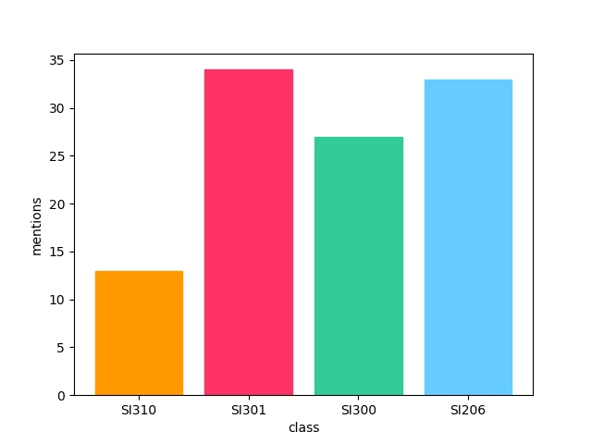

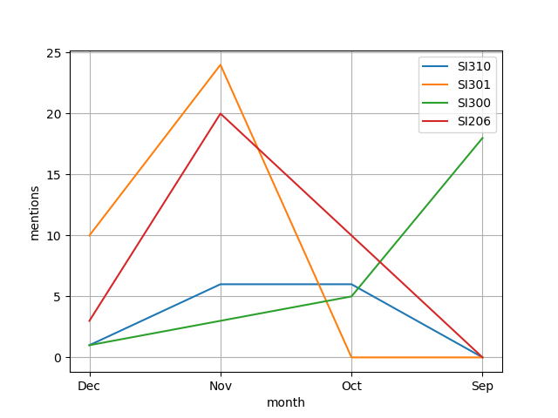

1. The code first uses the client_secret and api key to access their inbox. Then, a table is created in sqlite. The function gmailDB searches the client’s inbox and stores the emails’ subject, author, and date to the database. Function dataProcess pulls emails by class and the date they were sent. It returns data as a list of dictionaries. This is done for all four SI classes. WriteData takes a list of dictionaries to create a file and write its data to a text file. This is done for all four classes. MessagesByMonth takes the list of dictionaries from dataProcess and returns a dictionary of emails sent by month. This is done for all four classes. BarGraph takes the four lists from DataProcess to display a bar graph of the number of mentions by each class. LineGraph takes four lists from months messagesByMonth to display a line graph of the number of messages sent per month by each class.
2. Documentation of code:

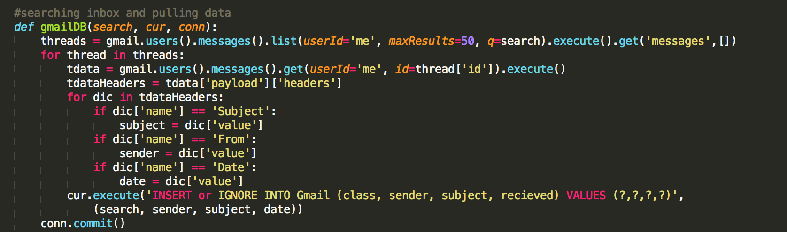

Input: class to search (string), cursor, connection

Output: SQlite table

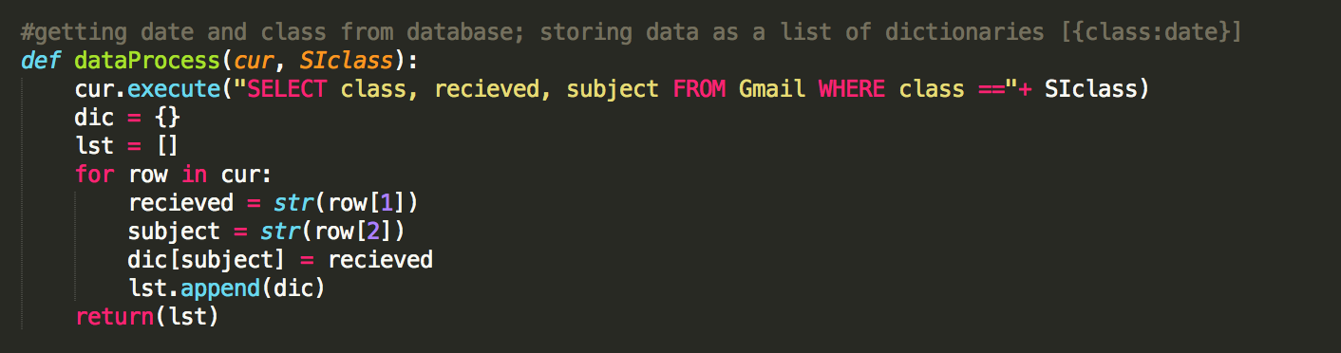

Input: cursor, class to search (string)

Output: Returns a list of dictionaries class as value and date as key

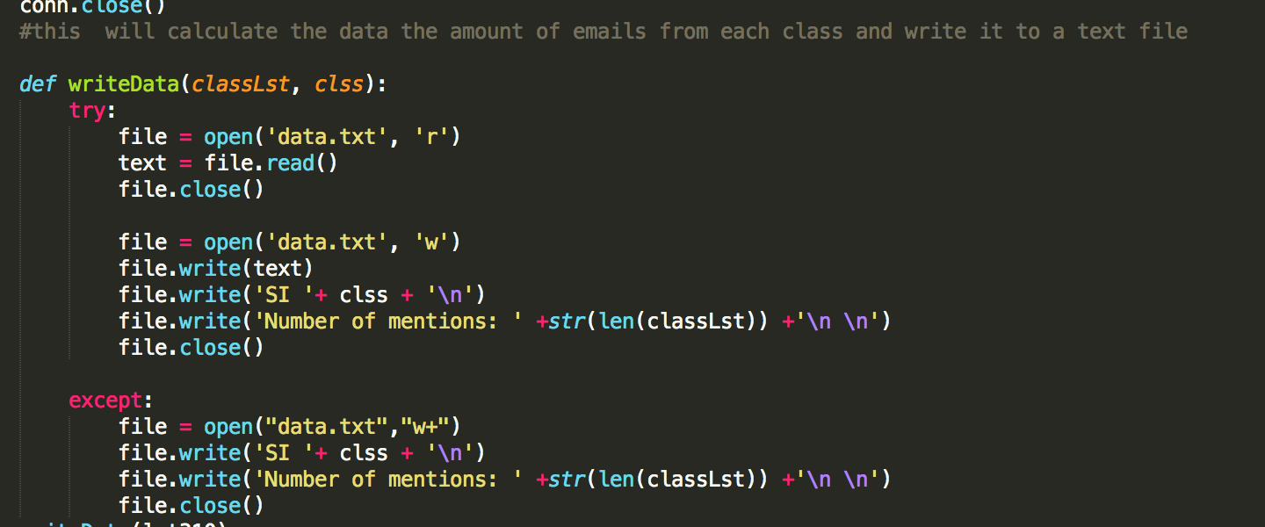

Input: List of dictionaries from dataProcess, class name (string)

Output: Text file that calculates the amount of mentions from given class

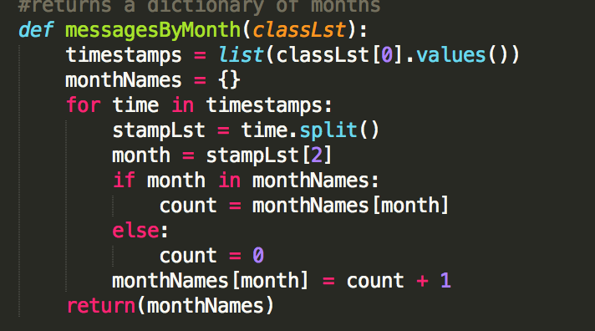

Input: List of dictionaries from dataProcess

Output: List of dictionaries with months as keys and number of mentions as values

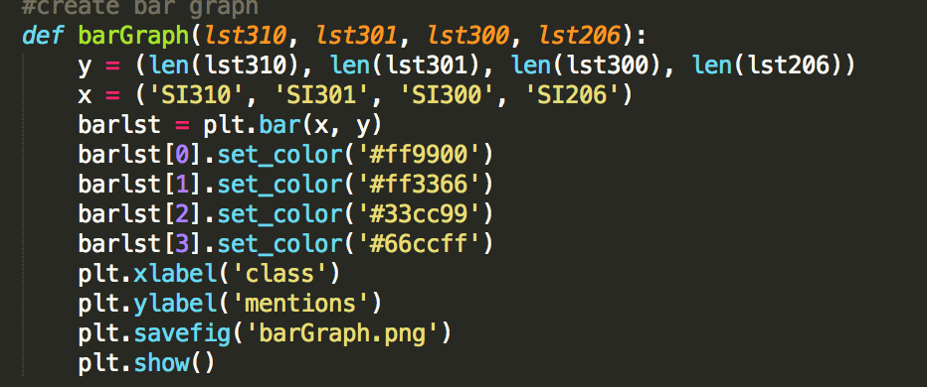

Input: Four List of dictionaries from dataProcess

Output: Bar graph that shows the number of mentions by class

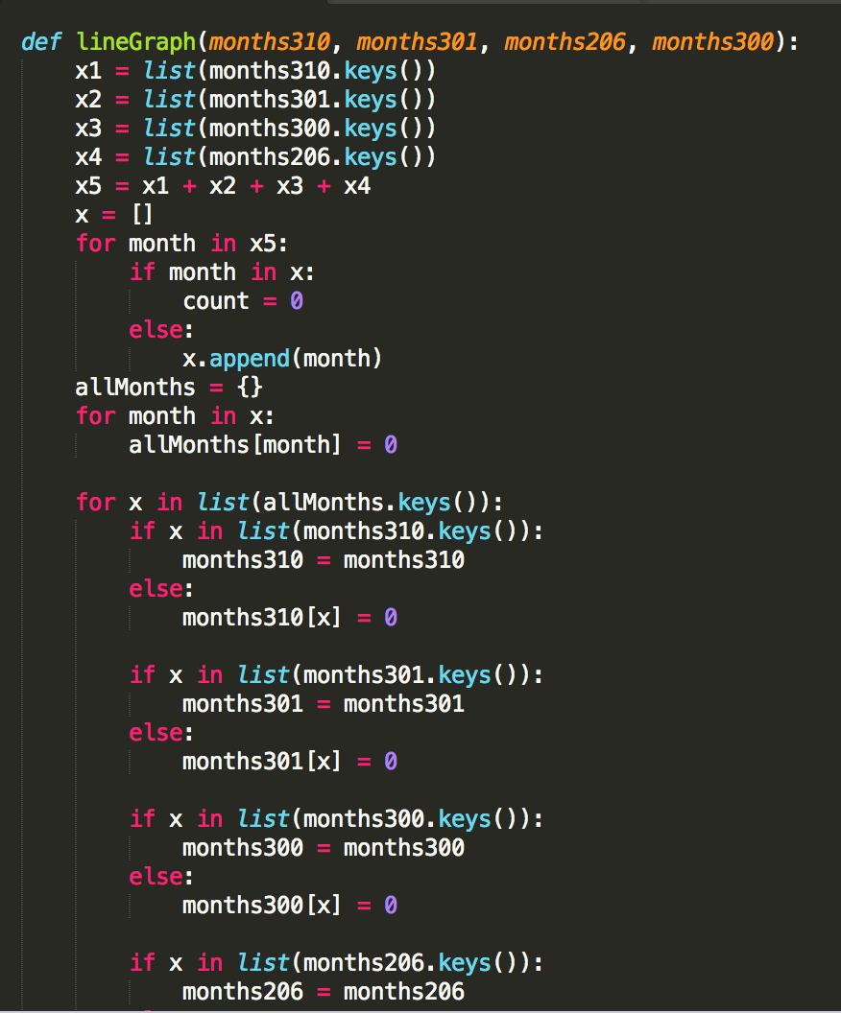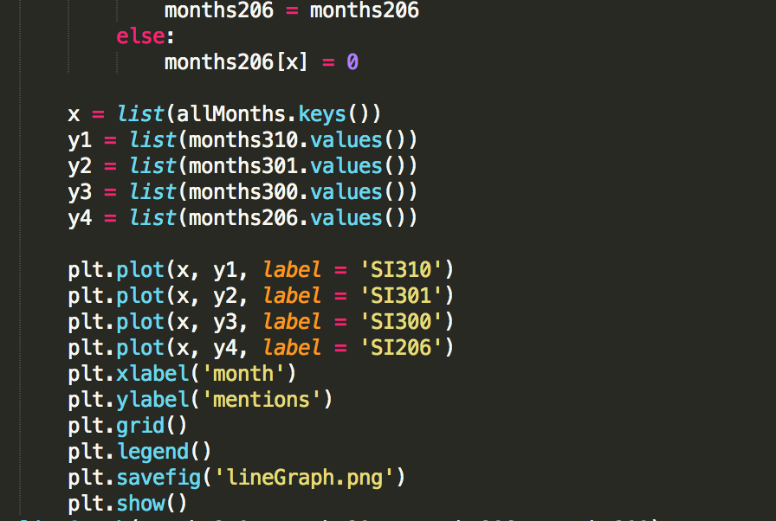

Input: Four list of dictionaries from messages by month

Output: Line graph that shows the number of mentions sent each month by each class

1. Resources

|  |  |  |  |
| --- | --- | --- | --- |
| Date | Issue Description | Location of Resource | Result |
| 12/1/2018 | Accessing inbox | [Blog](http://wescpy.blogspot.com/2015/08/accessing-gmail-from-python-plus-bonus.html) | Gave documentation how to search through inbox |
| 12/2/2018 | How to access gmail api | [YouTube video](https://www.youtube.com/watch?v=L6hQCgxgzLI&feature=youtu.be&list=PLOU2XLYxmsILOIxBRPPhgYbuSslr50KVq&index=11&linkId=16190771) | Helped me to access Gmail API |
| 12/3/2018 | Gmail API reference | [Google Develop](https://developers.google.com/gmail/api/v1/reference/users/messages)ers | Listed methods to access certain data |