Solvent
Abbreviation | Chemical Name | Molecular Formula | Structure
ACN | Acetonitrile | C2H3N | 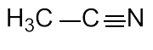
AcOH | Acetic acid | C2H4O2 | 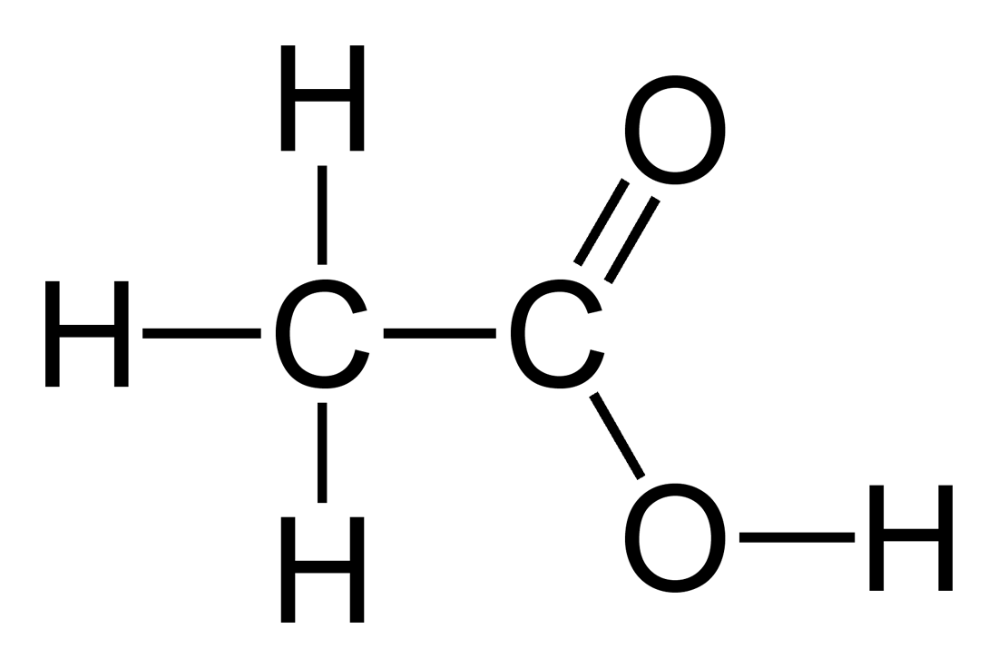
t-BuOH | Tert-Butyl alcohol | C4H10O | 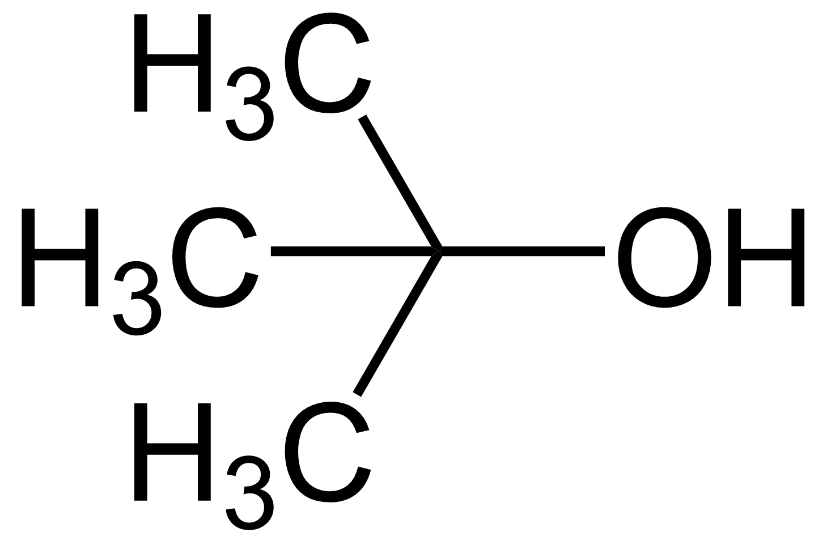
DCM | Dichloromethane | CH2Cl2 | 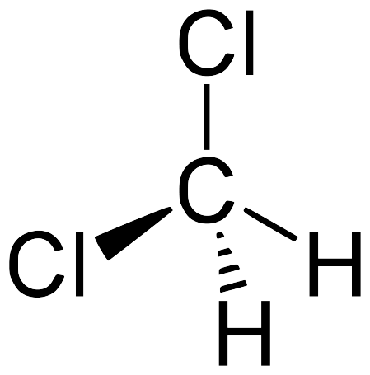
DMA | Dimethylacetamide | C4H9NO | 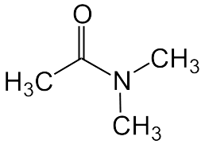
DMF | Dimethylformamide | C3H7NO | 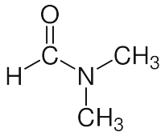
DMPU | 1,3-Dimethyl-3,4,5,6-tetrahydro-2(1H)-pyrimidinone | C6H12N2O | 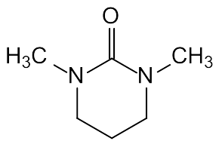
DMSO | Dimethyl sulfoxide | C2H6OS | 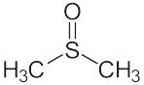
EtOH | Ethanol | C2H6O | 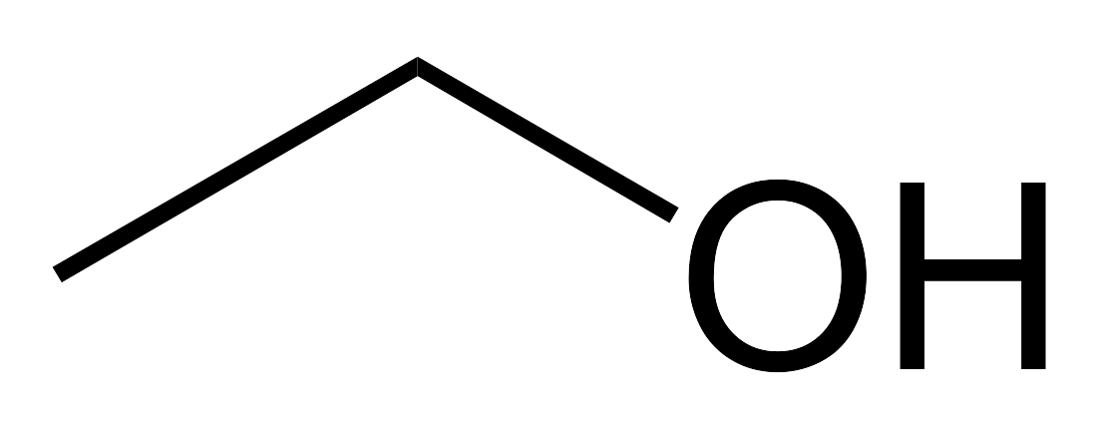
HMPT | Hexamethylphosphoramide | C6H18N3OP | 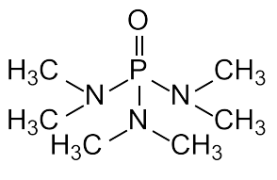
MeOH | Methanol | CH4O | 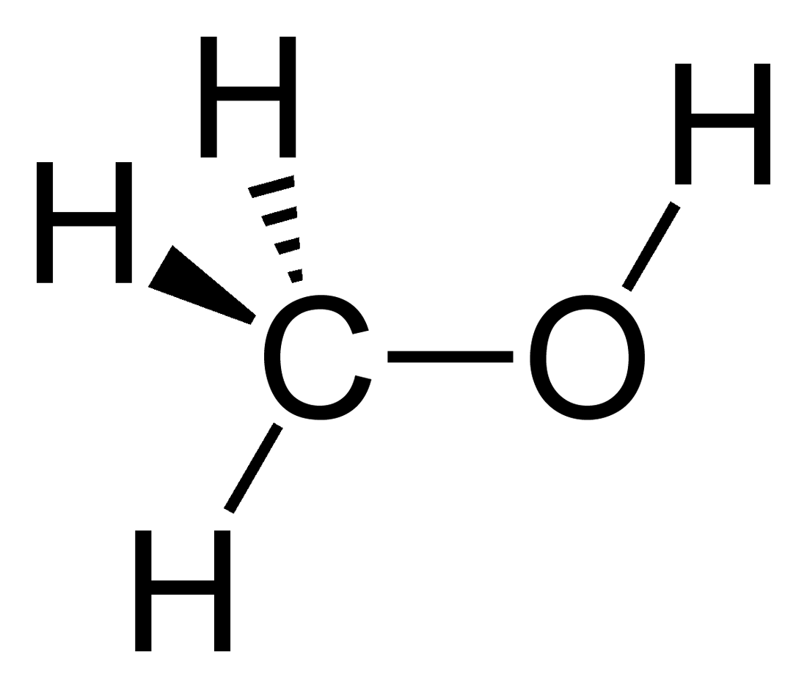
MTBE, TMBE | Methyl tert-butyl ether | C5H12O | 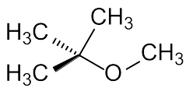
PEG-r | Polyethylene glycol repeating unit | C2H4O | 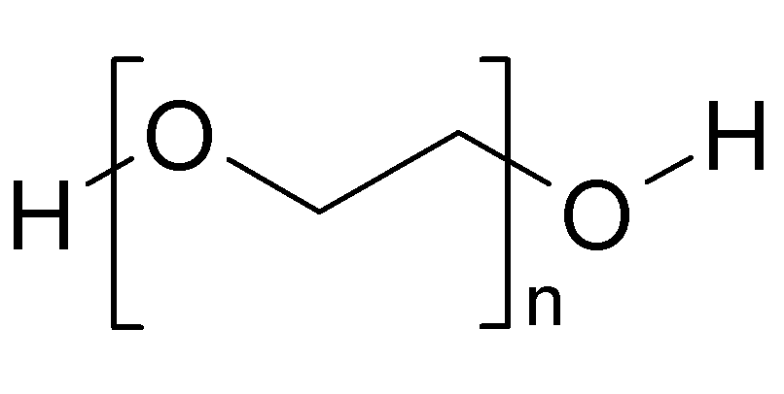  (NOTE: This is the FULL PEG molecule.)
TFA | Trifluoroacetic acid | C2HF3O2 | 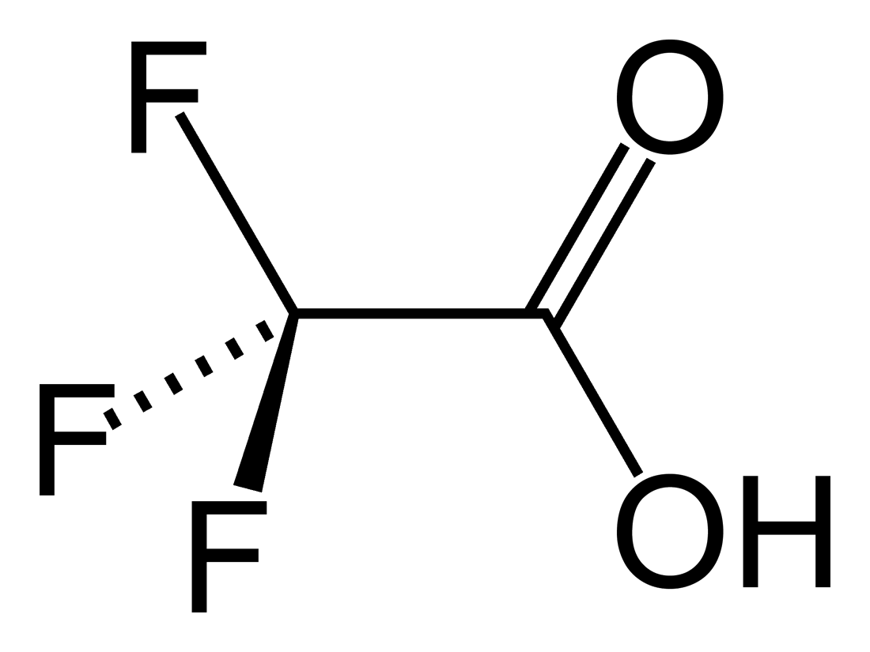
THF | Tetrahydrofuran | C4H8O | 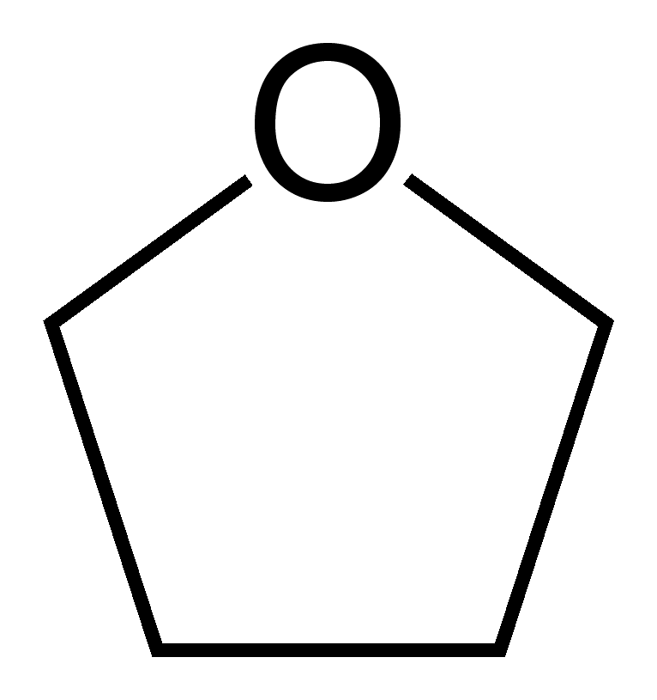
Reagents
Abbreviation | Chemical Name | Molecular Formula | Structure
9-BBN | 9-Borabicyclo(3.3.1)nonane | C16H30B2 | 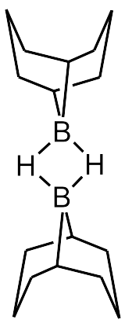
ACAC | Acetylacetone | C5H8O2 | 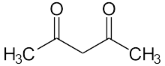
AIBN | Azobisisobutyronitrile | C8H12N4 | 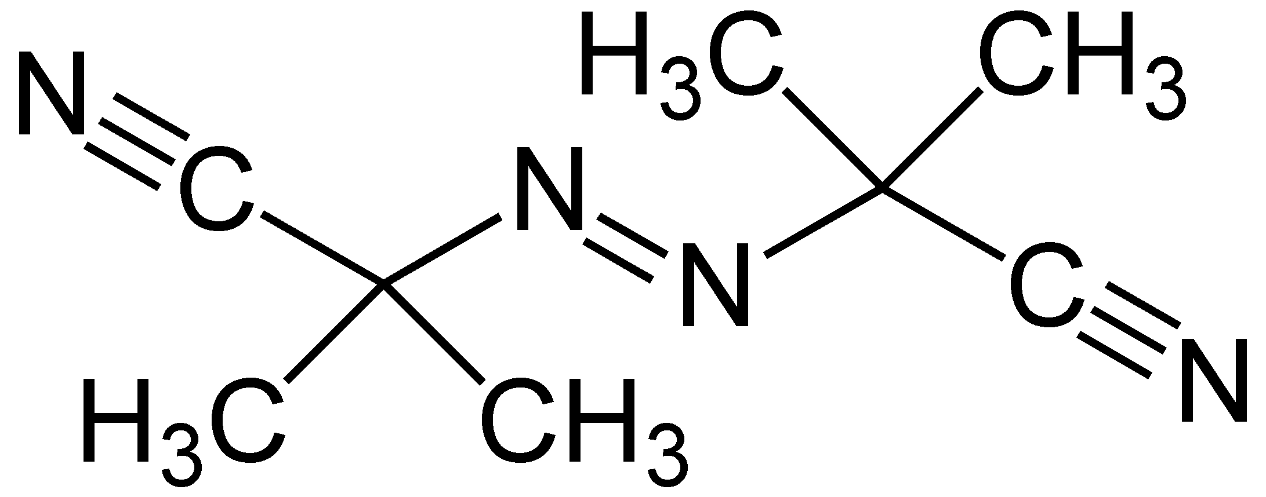
BTI | (Bis(trifluoroacetoxy)iodo)benzene | C10H5F6IO4 | 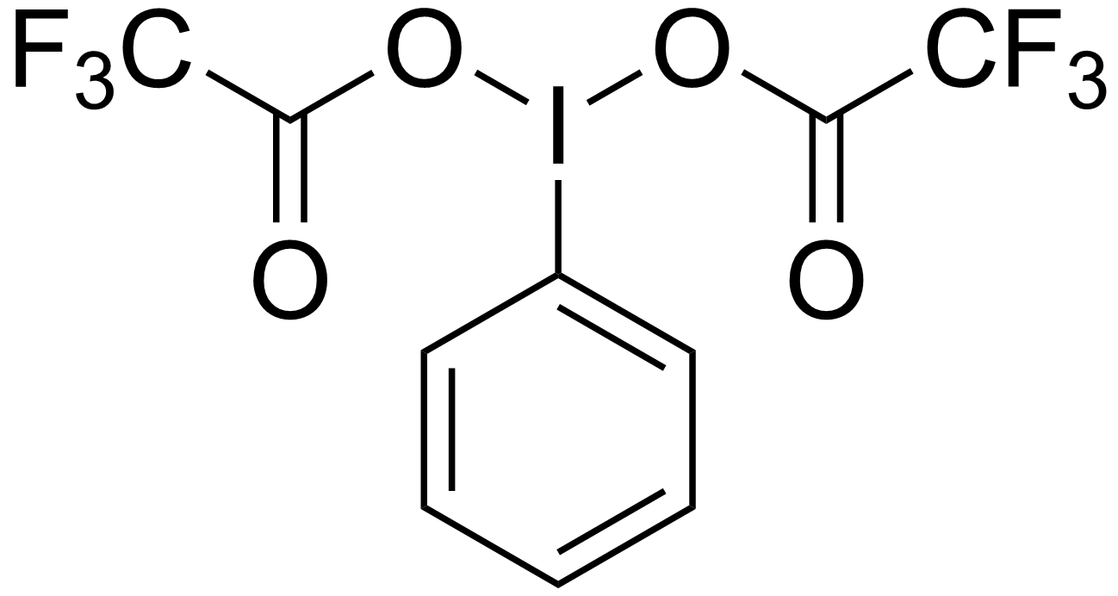
BuLi | N-Butyllithium | C4H9Li | 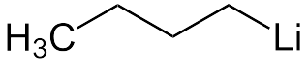
BOP | BOP reagent | C12H22F6N6OP2 | 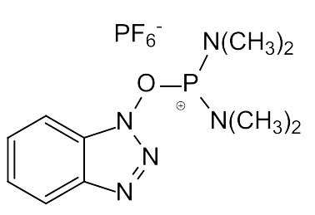
CDI | Carbonyldiimidazole | C7H6N4O | 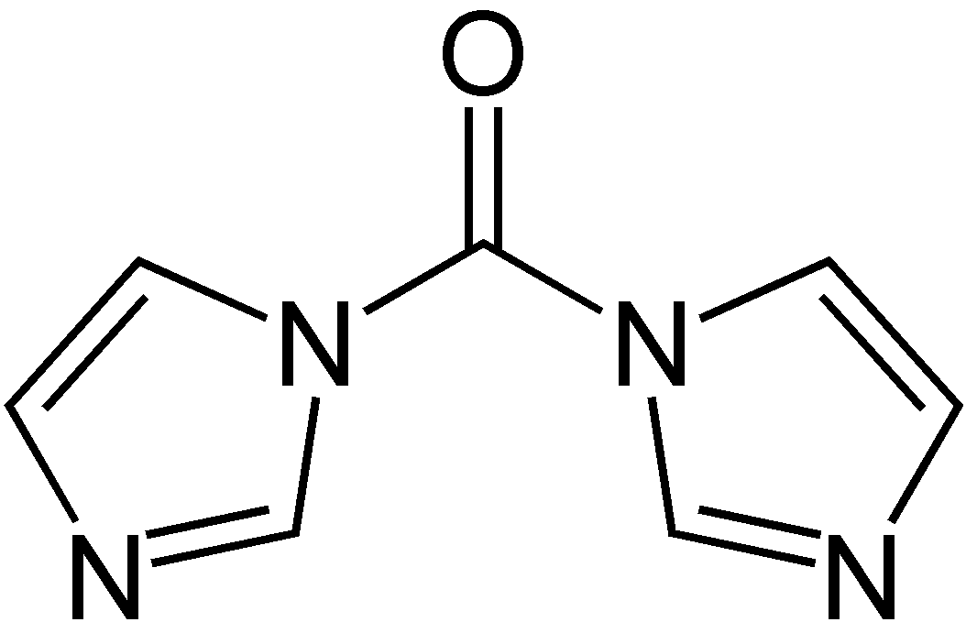
COD | 1,5-Cyclooctadiene | C8H12 | 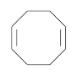
COT | Cyclooctatetraene | C8H8 | 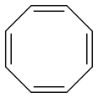
CPD | Cyclopentadiene | C5H6 | 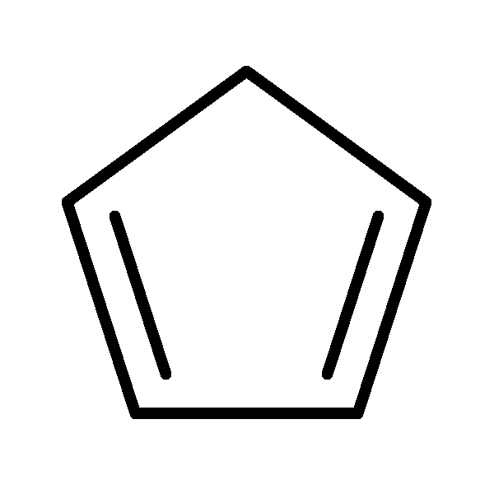
CSA | Camphorsulfonic acid | C10H16O4S | 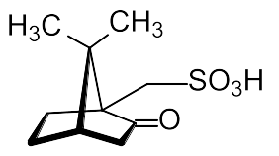  Another one:  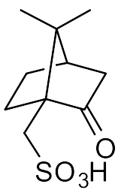
DABCO | 1,4-diazabicyclo[2.2.2]octane | C6H12N2 | 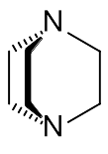
DADO | Dimethylglyoxime | C4H8N2O2 | 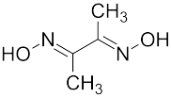
DIBAH, DIBAL, DIBAL-H | Diisobutylaluminium hydride | C16H38Al2 | 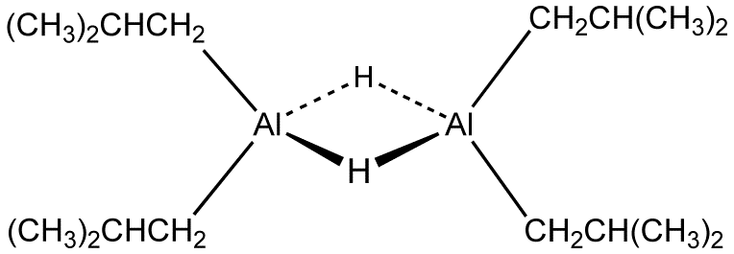
DBU | 1,8-Diazabicycloundec-7-ene | C9H16N2 | 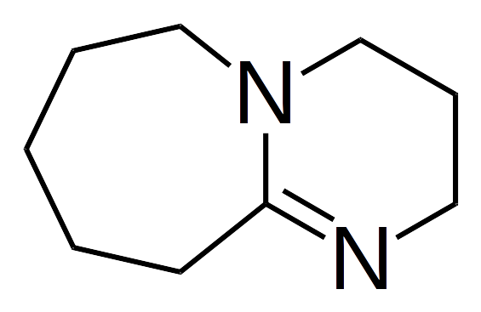
DBN | 1,5-Diazabicyclo(4.3.0)non-5-ene | C7H12N2 | 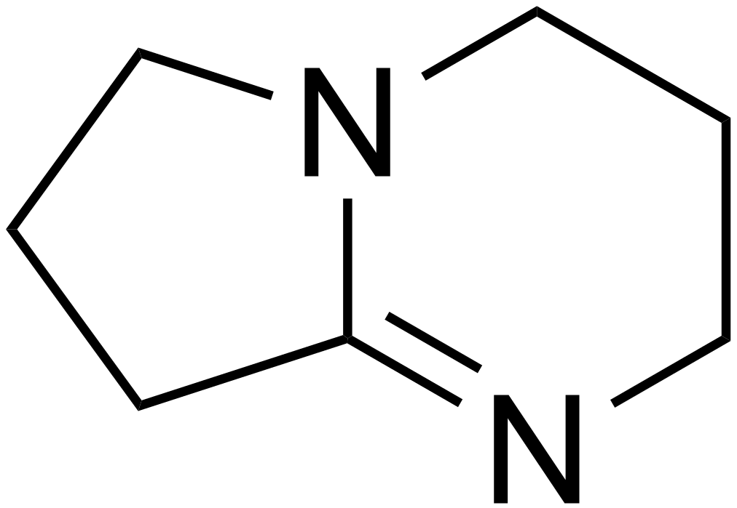
DBPO, BPO | Benzoyl peroxide | C14H10O4 | 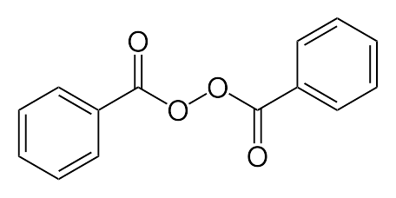
DCC | N,N'-Dicyclohexylcarbodiimide | C13H22N2 | 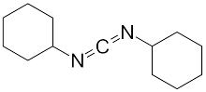
DIC | N,N'-Diisopropylcarbodiimide | C7H14N2 | 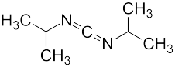
DEAD | Diethyl azodicarboxylate | C6H10N2O4 | 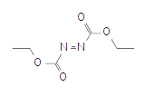
DIAD | Diisopropyl azodicarboxylate | C8H14N2O4 | 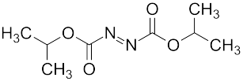
DMAP | 4-Dimethylaminopyridine | C7H10N2 | 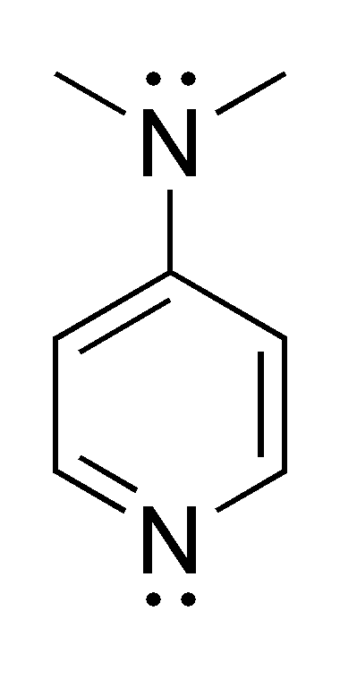
DNPH | 2,4-Dinitrophenylhydrazine | C6H6N4O4 | 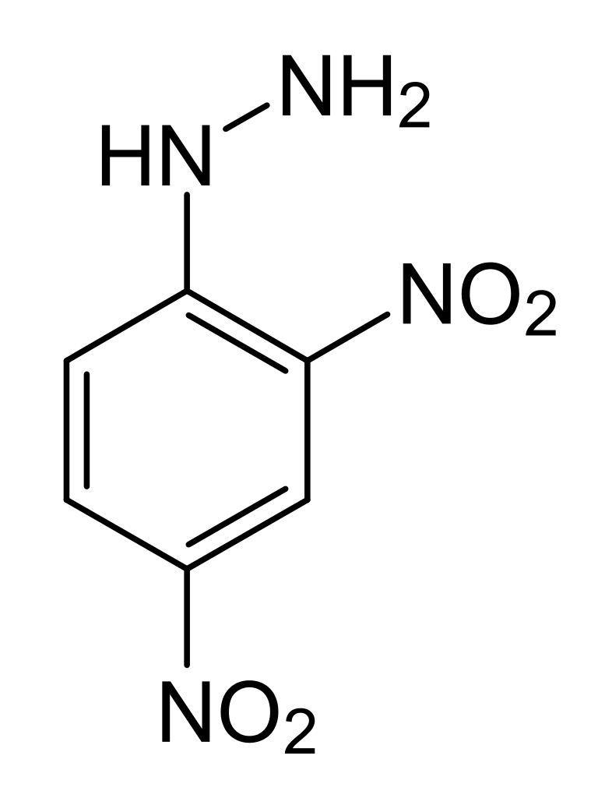
EDC | 1-Ethyl-3-(3-dimethylaminopropyl)carbodiimide | C8H17N3 | 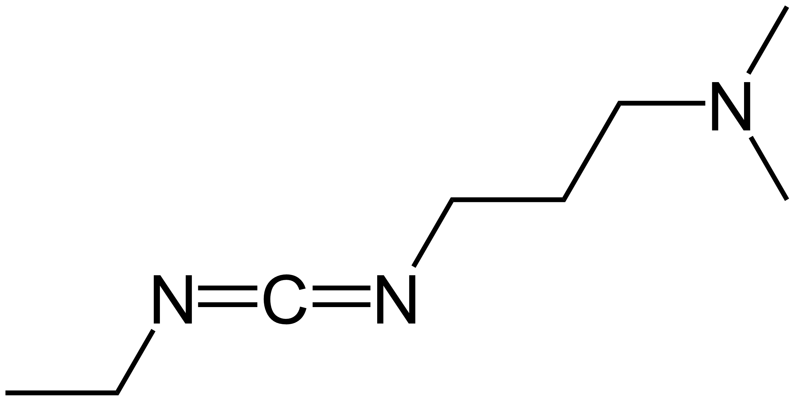
HATU | 1-[Bis(dimethylamino)methylene]-1H-1,2,3-triazolo[4,5-b]pyridinium 3-oxid hexafluorophosphate | C10H15F6N6OP | 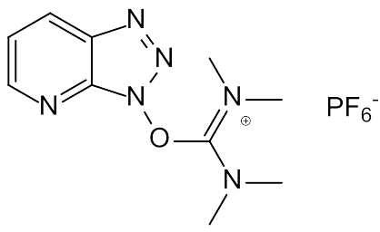
HexLi | Hexyllithium | C6H13Li | 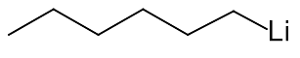
HMDS | Bis(trimethylsilyl)amine | C6H19NSi2 | 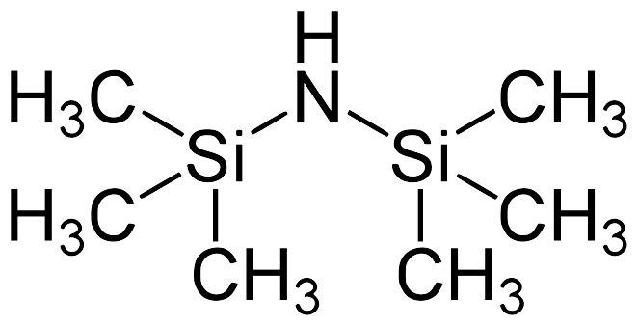
HOBt | Hydroxybenzotriazole | C6H5N3O | 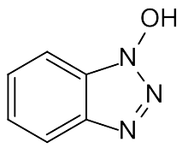
IDCP | Iodonium di-sym-collidine perchlorate | C16H22N2O4ICl | 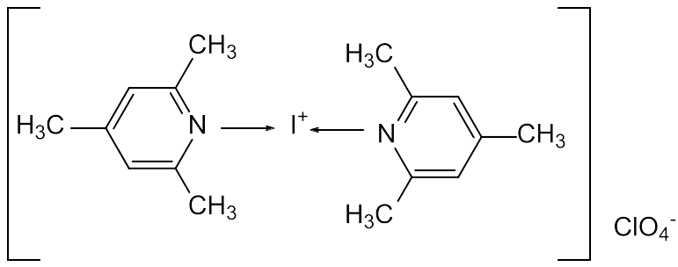
LAH | Lithium aluminium hydride | LiAlH4 | 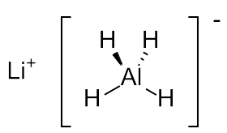
LDA | Lithium diisopropylamide | C6H14LiN | 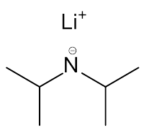
mCPBA | meta-Chloroperoxybenzoic acid | C7H5ClO3 | 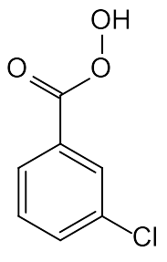
MeLi | Methyllithium | CH3Li | 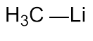
MoOPD | Oxodiperoxymolybdenum (Pyridin)(Dimethylpropylenharnstoff) | C11H17O6N3Mo | 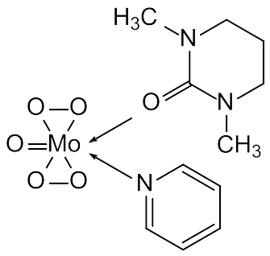
MoOPH | Oxodiperoxymolybdenum (Pyridin)(Hexamethylphosphorsäuretriamid) | C11H23MoN3O6P | 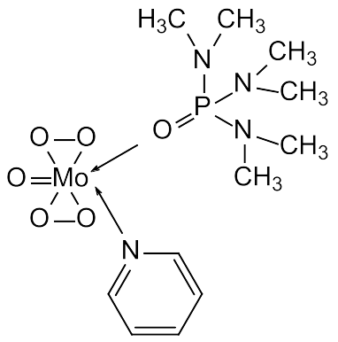
NBS | N-Bromosuccinimide | C4H4BrNO2 | 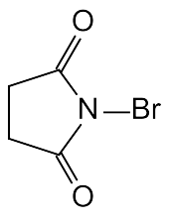
NCS | N-Chlorosuccinimide | C4H4ClNO2 | 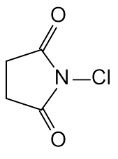
NHS | N-Hydroxysuccinimide | C4H5NO3 | 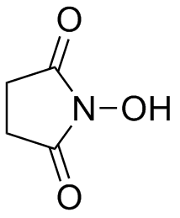
PCC | Pyridinium chlorochromate | C5H5NHClCrO3 | 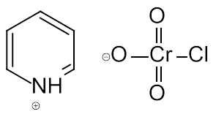
PIFA | (Bis(trifluoroacetoxy)iodo)benzene | C10H5F6IO4
PyBOP | benzotriazol-1-yl-oxytripyrrolidinophosphonium hexafluorophosphate | C18H28F6N6OP2 | 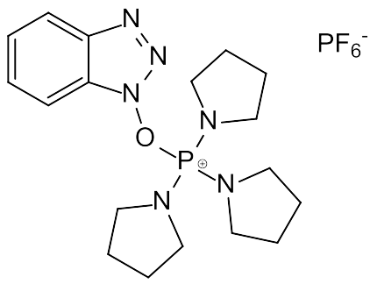
sec-BuLi | sec-Butyllithium | C4H9Li | 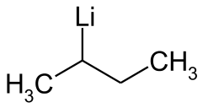
TADDOL | α,α,α′,α′-Tetraaryl-1,3-dioxolan-4,5-dimethanol | C31H30O4 | 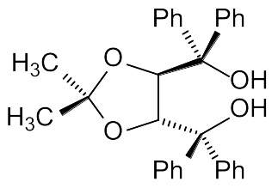
TBTU | O-(Benzotriazol-1-yl)-N,N,N′,N′-tetramethyluronium tetrafluoroborat | C11H16N5OBF4 | 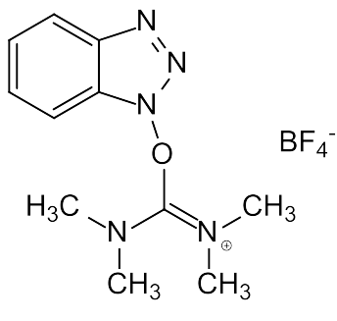
TEMPO | 2,2,6,6-Tetramethylpiperidin-1-yl)oxy, or (2,2,6,6-tetramethylpiperidin-1-yl)oxidanyl | C9H18NO | 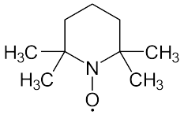
tert-BuLi, t-BuLi | tert-Butyllithium | LiC4H9 | 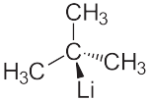
TESOTf | Triethylsilyl-O-Trifluoracetat | C8H15O2F3Si | 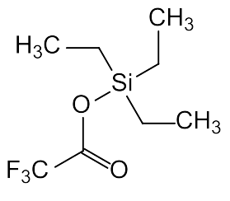
TMEDA | Tetramethylethylenediamine | C6H16N2 | 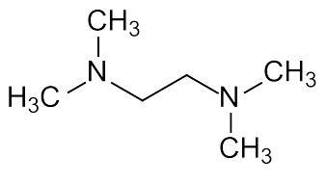
TosMIC | Toluenesulfonylmethyl isocyanide | C9H9NO2S | 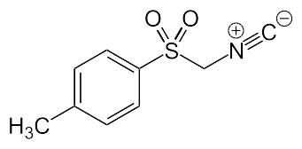
Compounds - Amino acids
Abbreviation | Chemical Name | Molecular Formula | Structure
Ala | Alanine | C3H7NO2 | 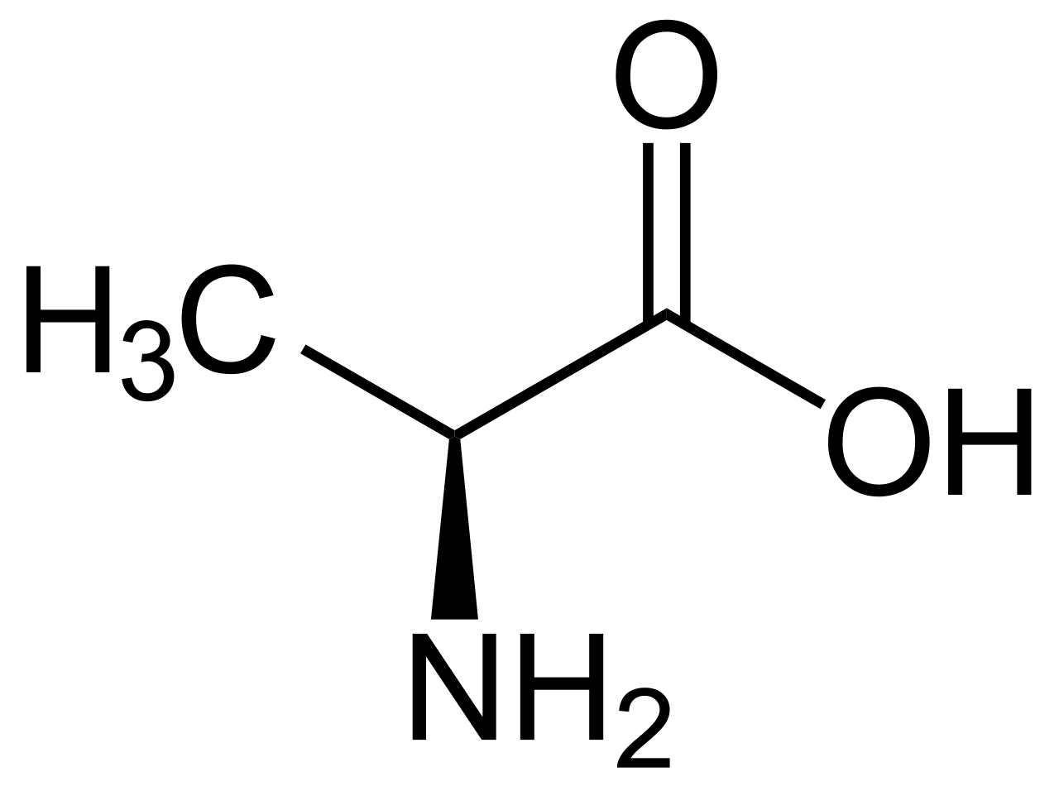
Arg | Arginine | C6H14N4O2 | 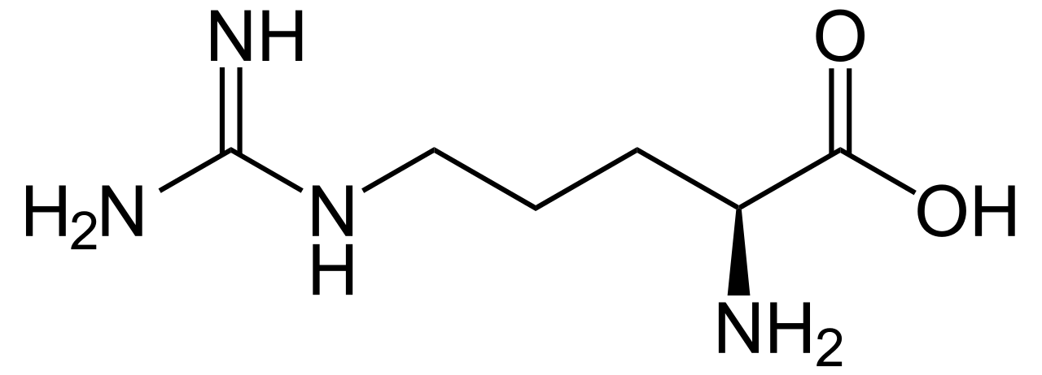
Asn | Asparagine | C4H8N2O3 | 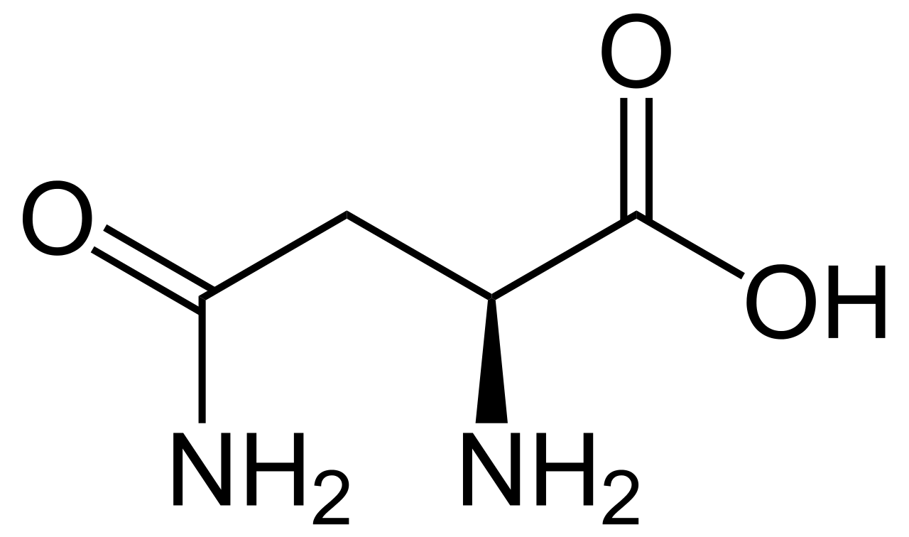
Asp | Aspartic acid | C4H7NO4 | 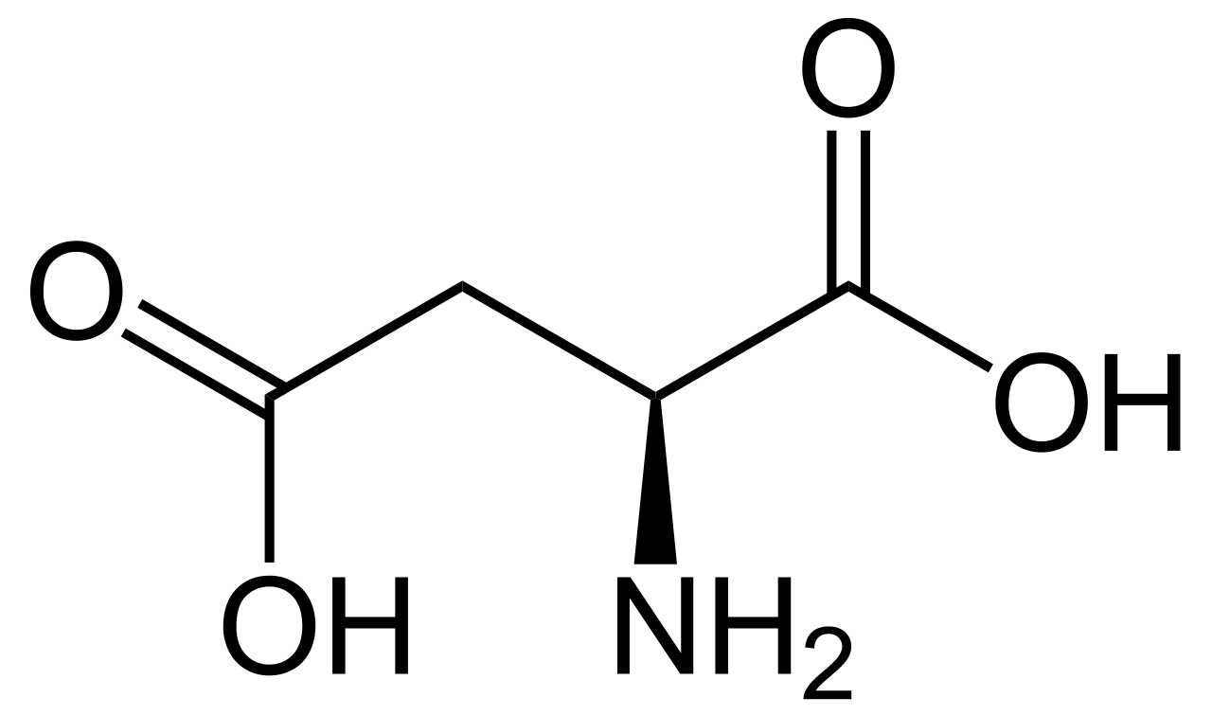
Cys | Cysteine | C3H7NO2S | 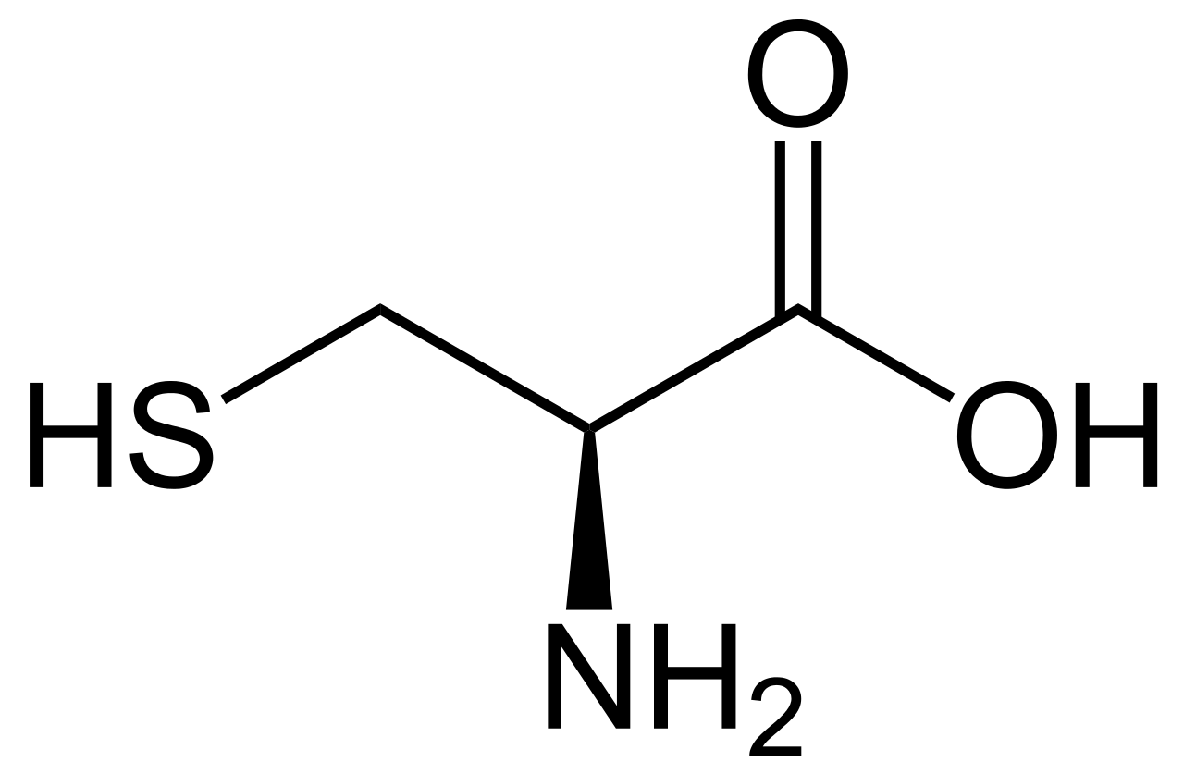
Gln | Glutamine | C5H10N2O3 | 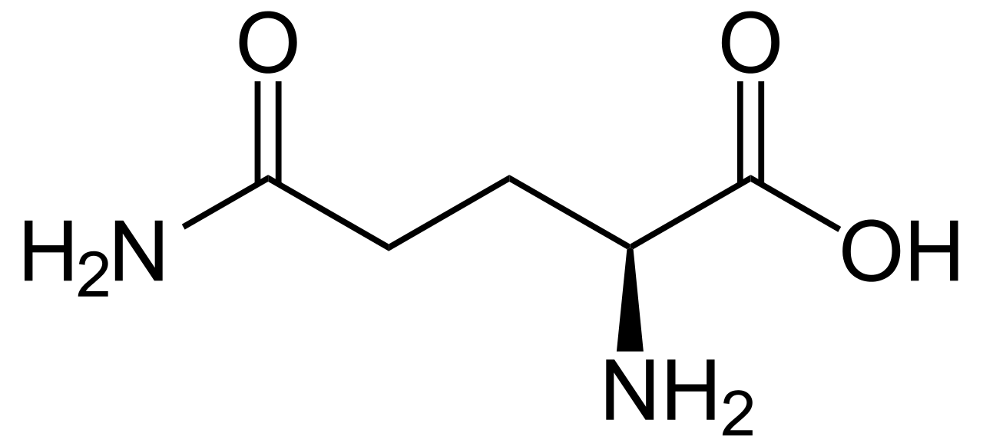
Glu | Glutamic acid | C5H9NO4 | 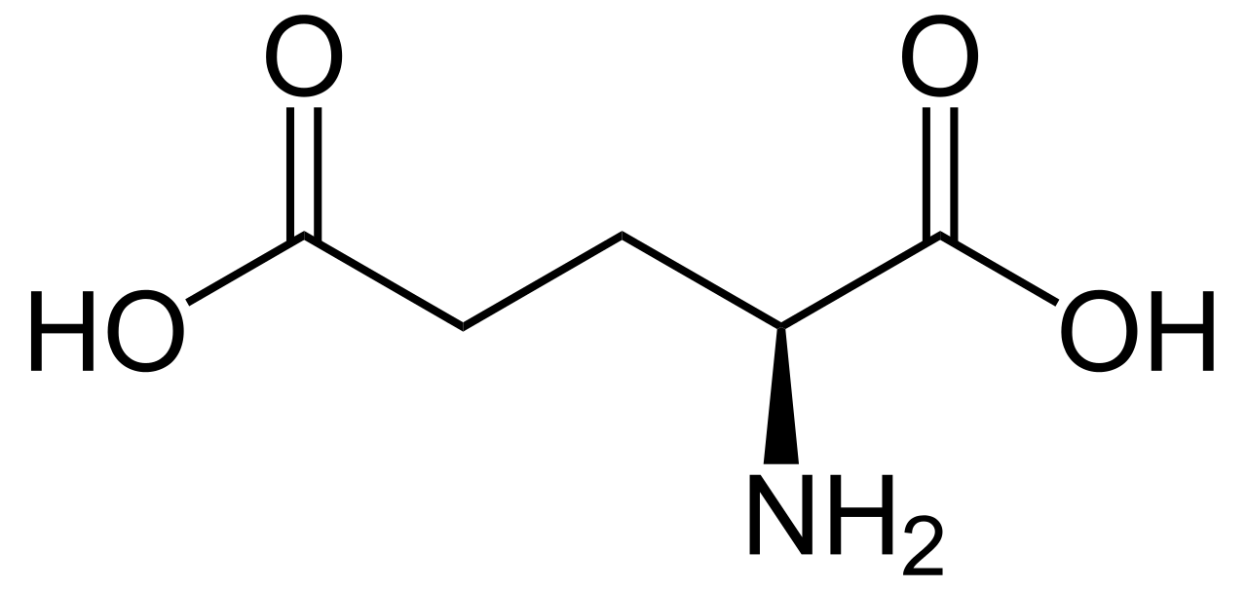
Gly | Glycine | C2H5NO2 | 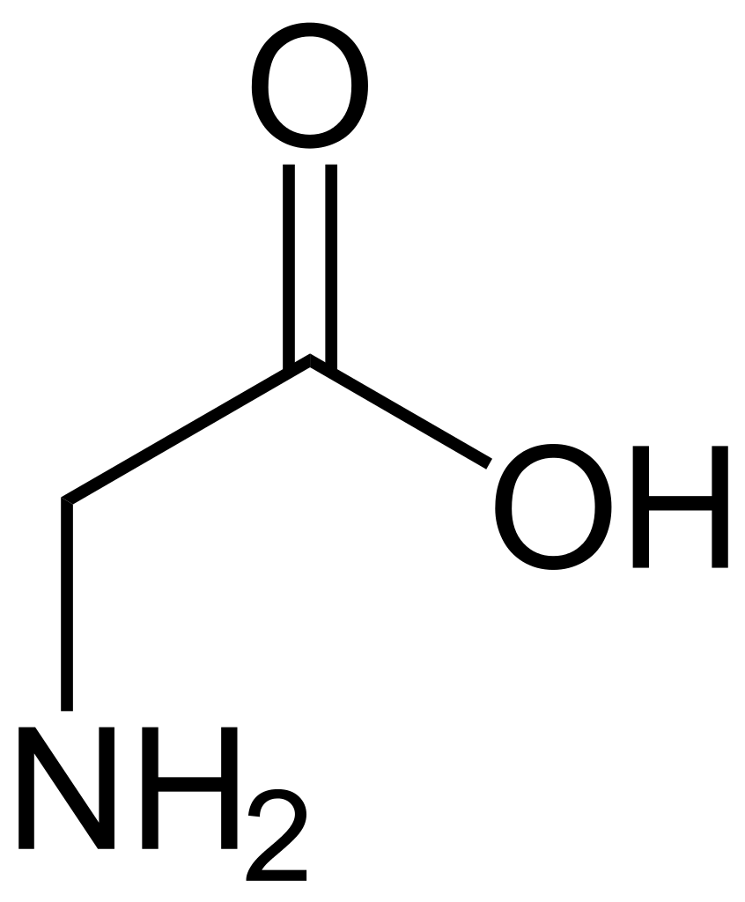
His | Histidine | C6H9N3O2 | 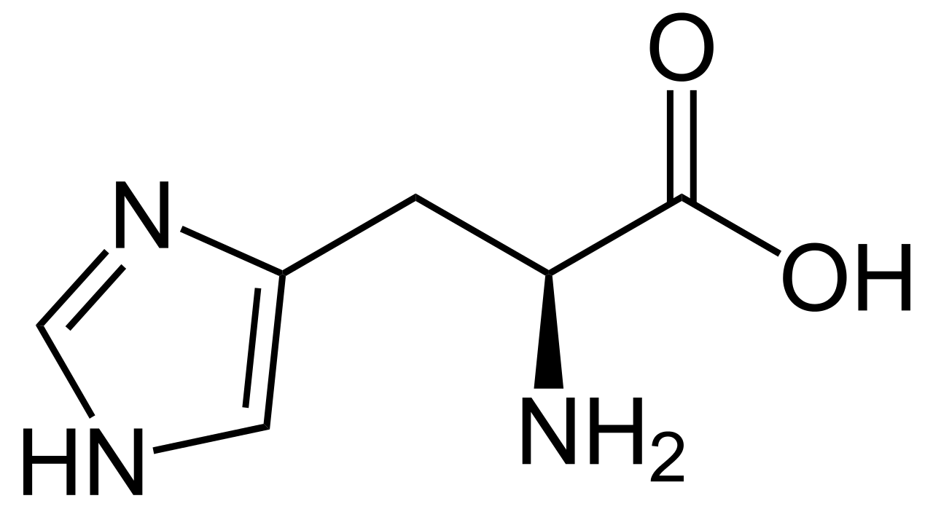
Ile | Isoleucine | C6H13NO2 | 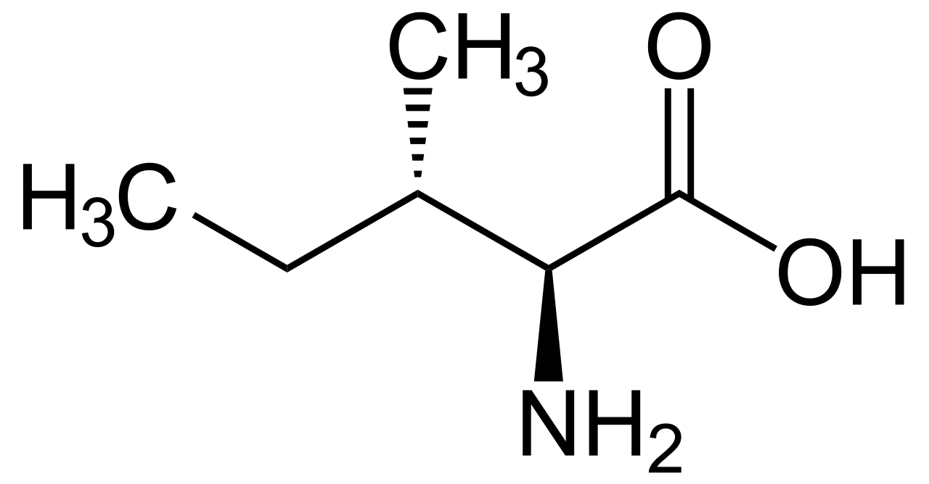
Leu | Leucine | C6H13NO2 | 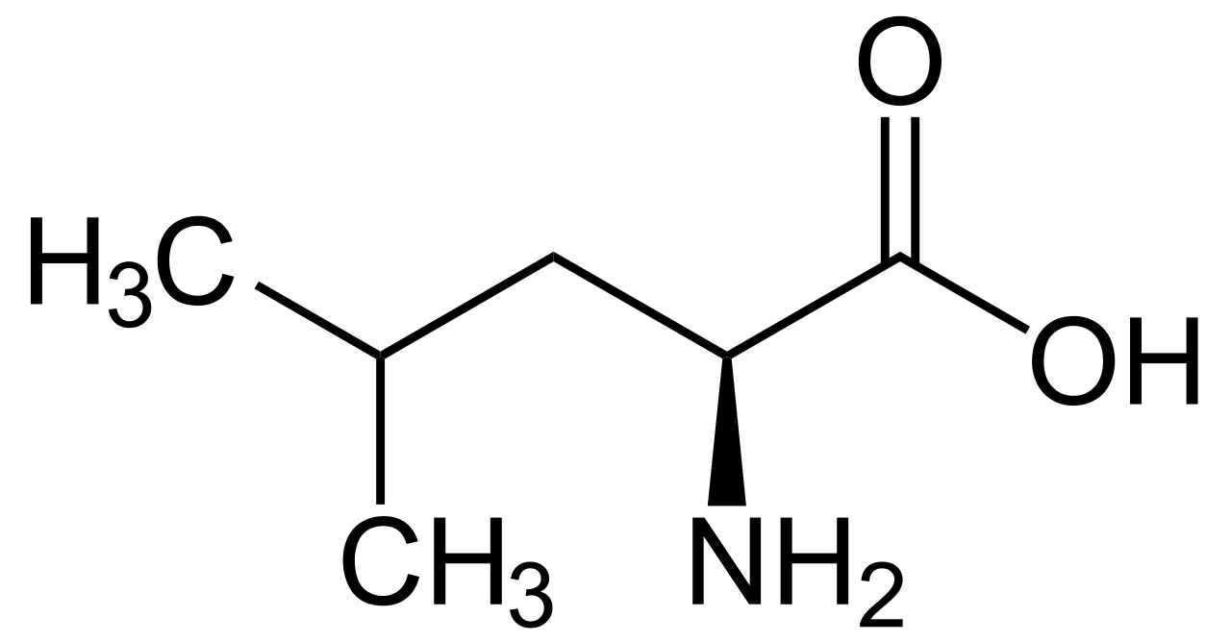
Lys | Lysine | C6H14N2O2 | 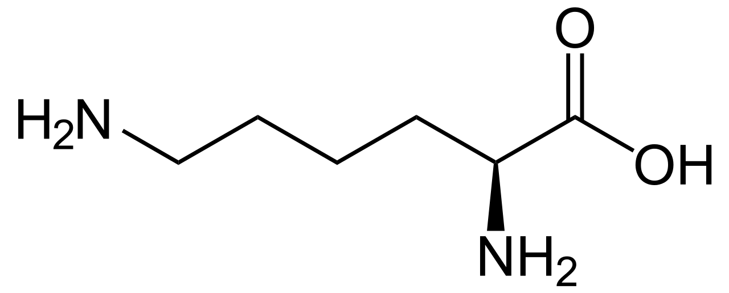
Met | Methionine | C5H11NO2S | 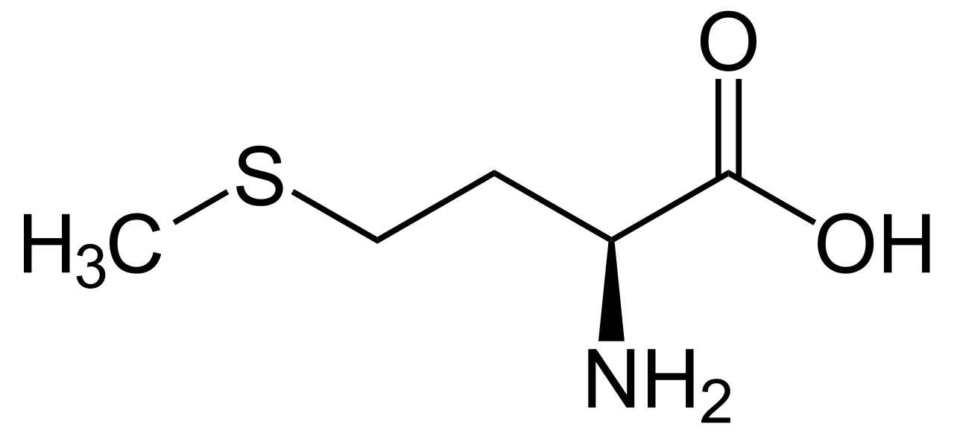
Phe | Phenylalanine | C9H11NO2 | 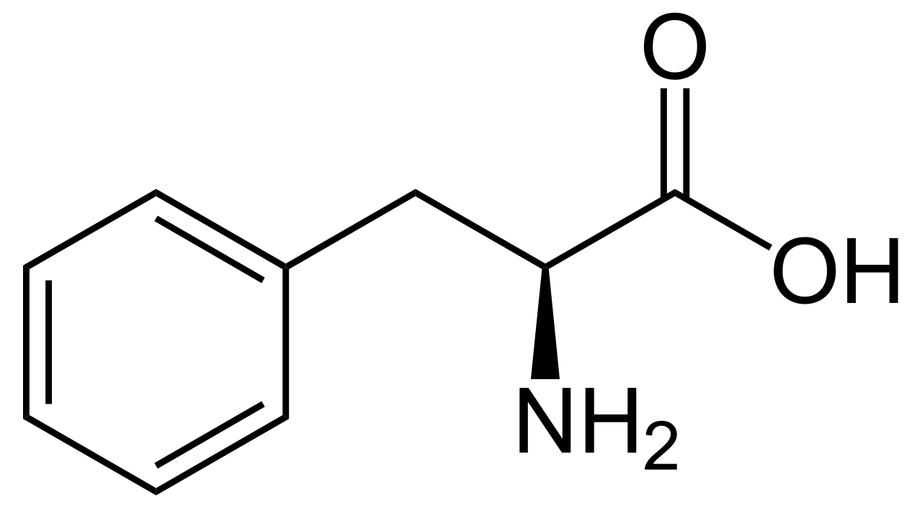
Pro | Proline | C5H9NO2 | 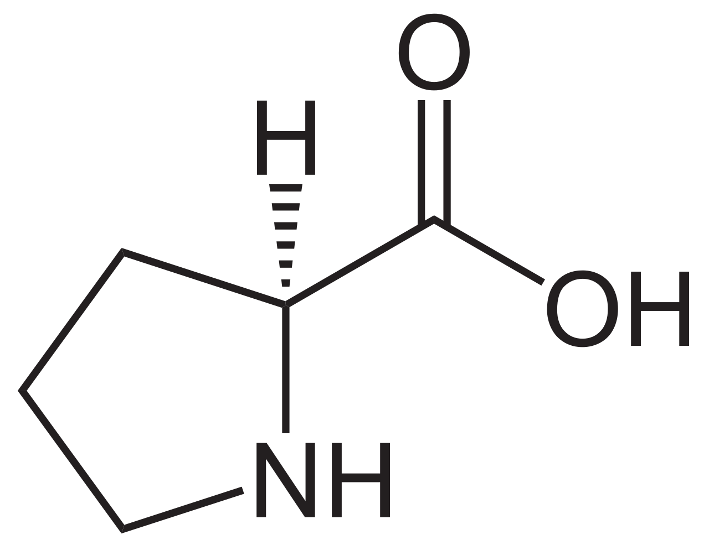
Pyl | Pyrrolysine | C12H21N3O3 | 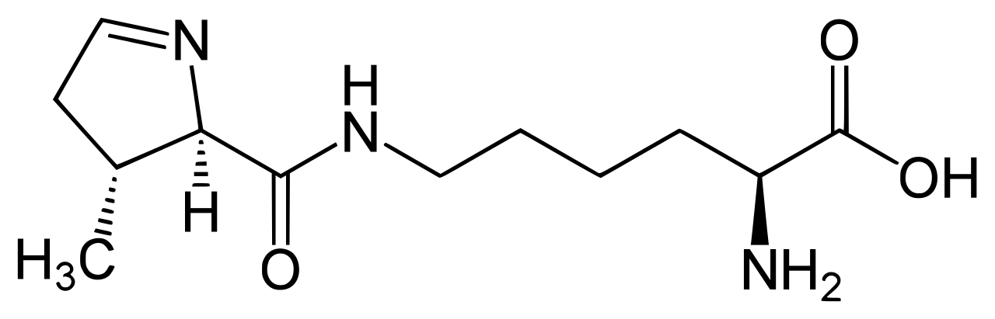
Sec | Selenocysteine | C3H7NO2Se | 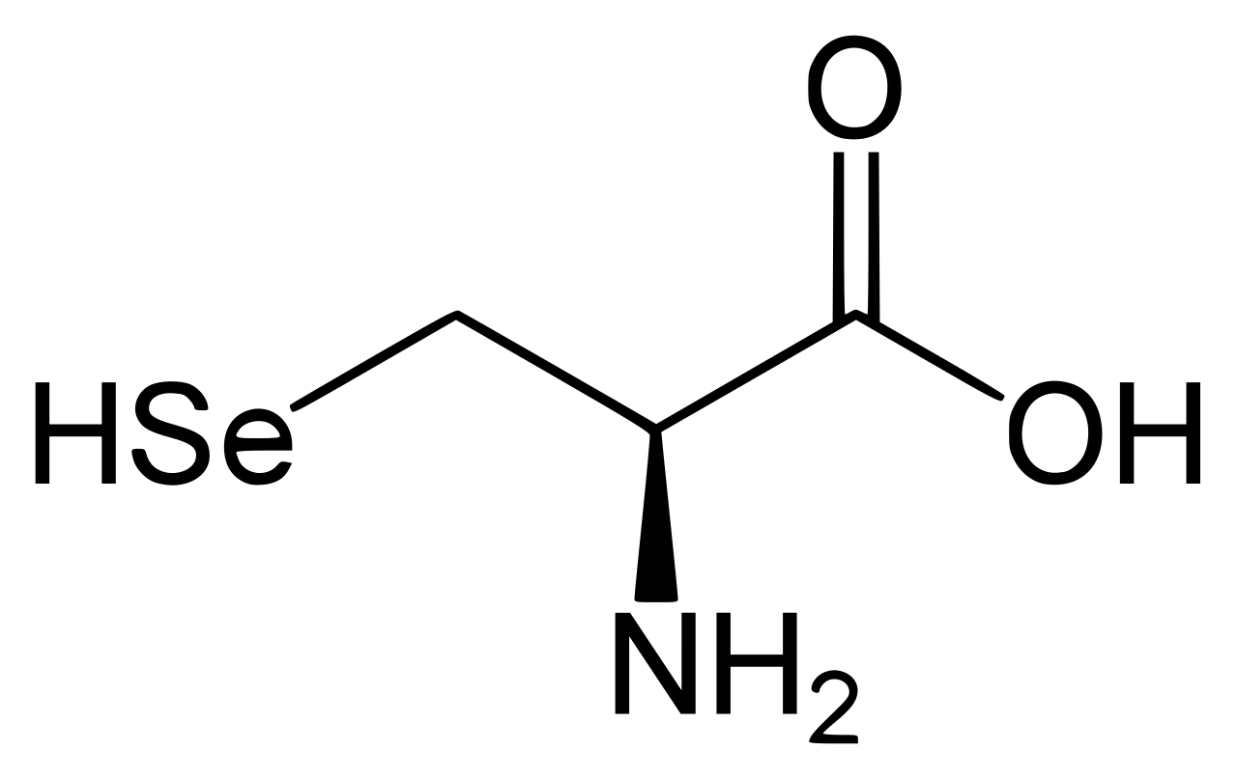
Ser | Serine | C3H7NO3 | 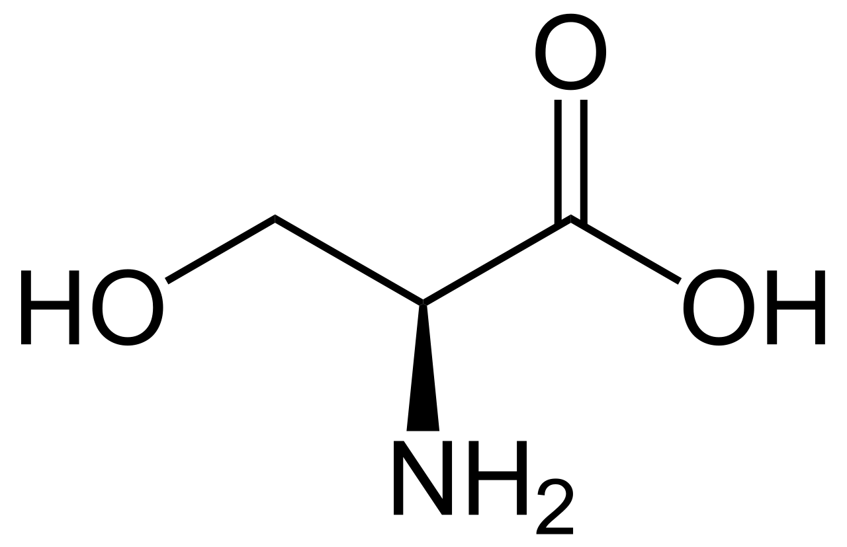
Thr | Threonine | C4H9NO3 | 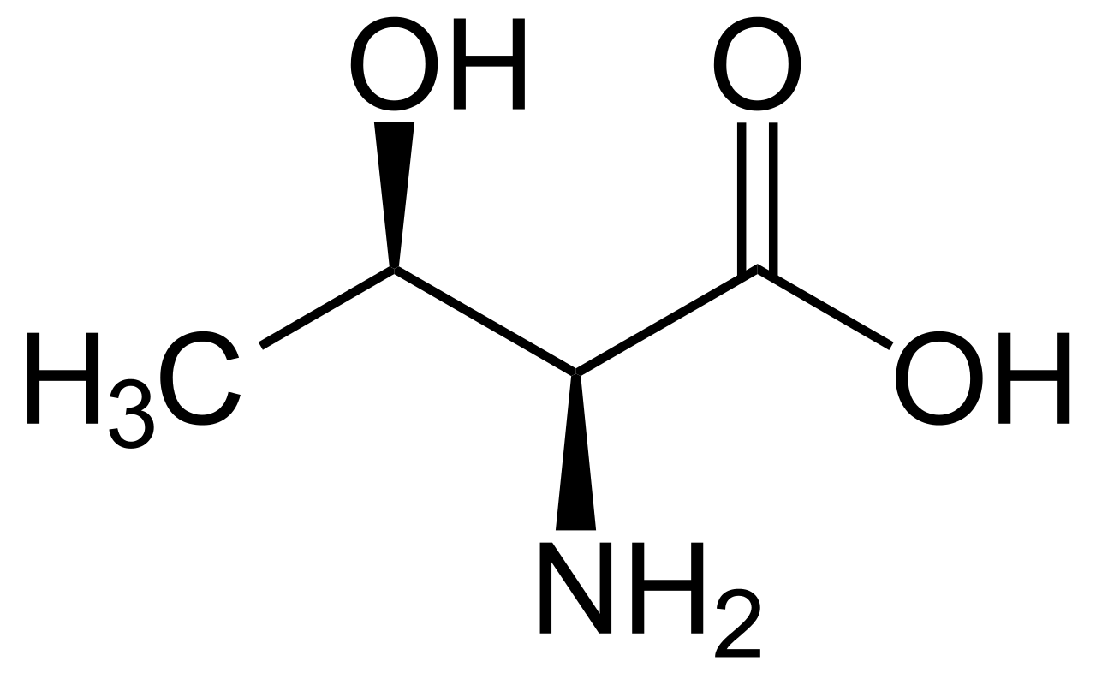
Trp | Tryptophan | C11H12N2O2 | 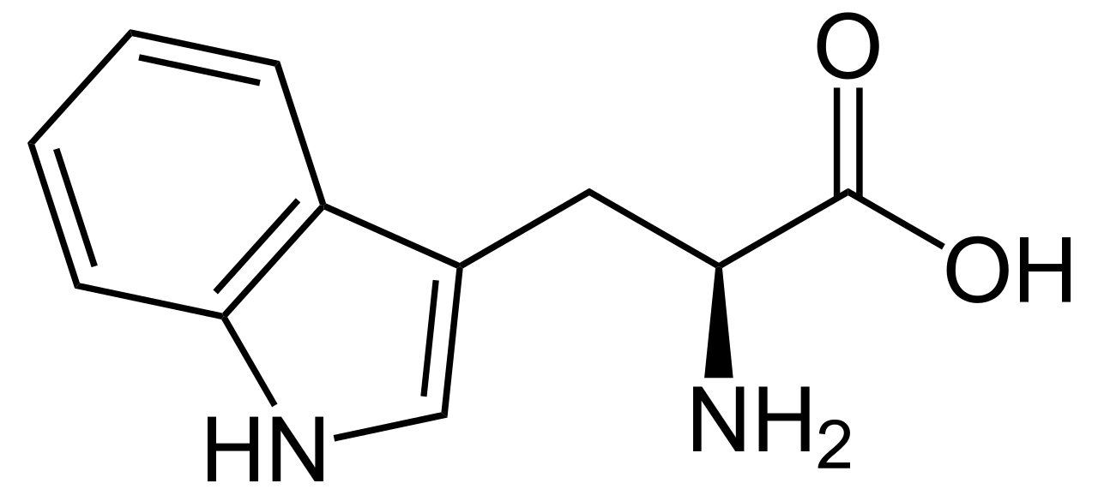
Tyr | Tyrosine | C9H11NO3 | 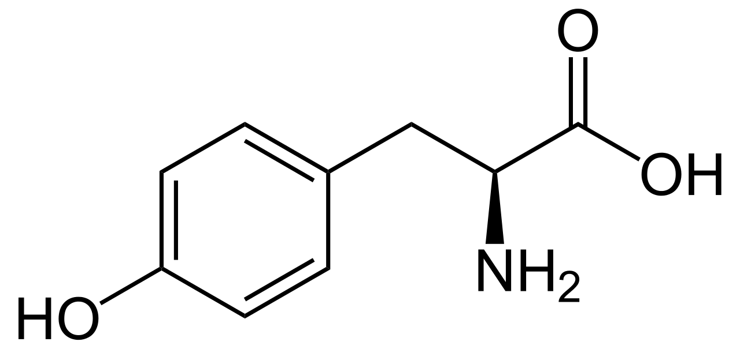
Val | Valine | C5H11NO2 | 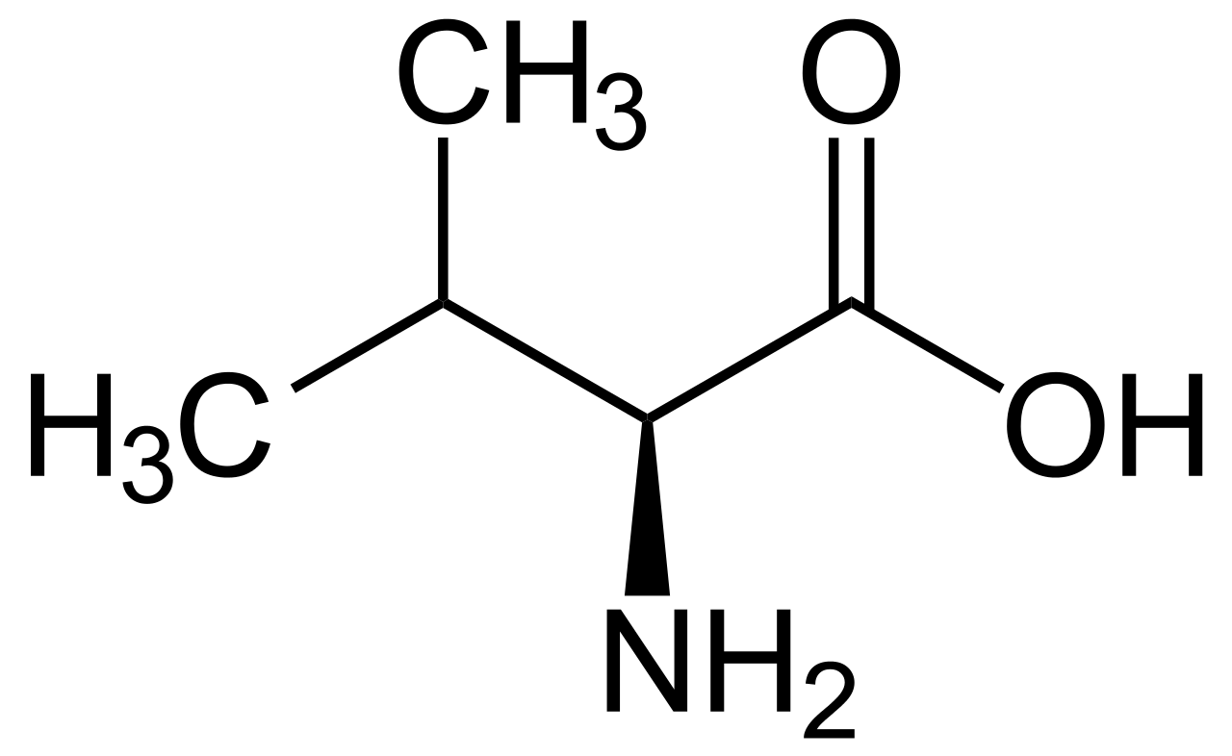
Compounds - Nucleoside
Abbreviation | Chemical Name | Molecular Formula | Structure
A | Adenosine | C10H13N5O4 | 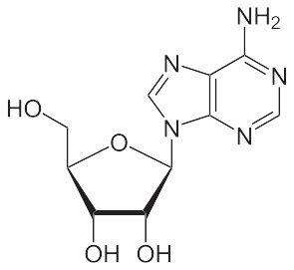
dA | Deoxyadenosine | C10H13N5O3 | 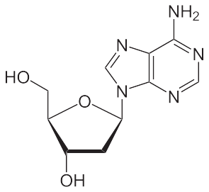
G | Guanosine | C10H13N5O5 | 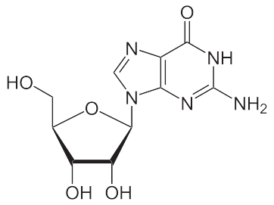
dG | Deoxyguanosine | C10H13N5O4 | 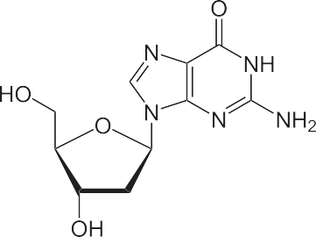
C | Cytidine | C9H13N3O5 | 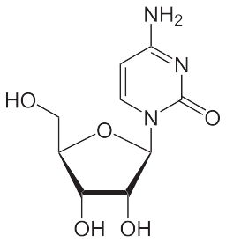
dC | Deoxycytidine | C9H13N3O4 | 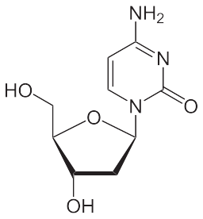
T | 5-Methyluridine | C10H14N2O6 | 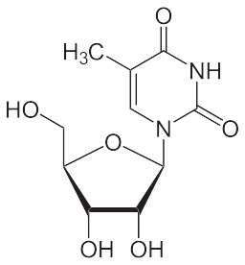
dT | Thymidine | C10H14N2O5 | 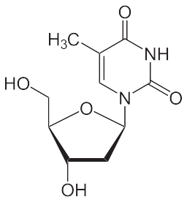
U | Uridine | C9H12N2O6 | 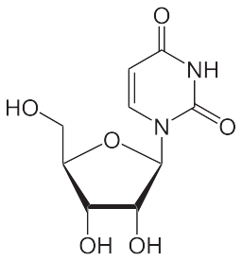
dU | Deoxyuridine | C9H12N2O5 | 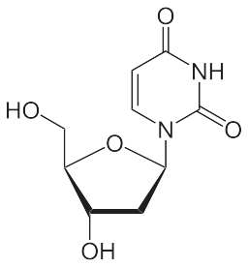
Compounds - Biochemical buffer
Abbreviation | Chemical Name | Molecular Formula | Structure
BICINE | 2-(Bis(2-hydroxyethyl)amino)acetic acid | C6H13O4N | 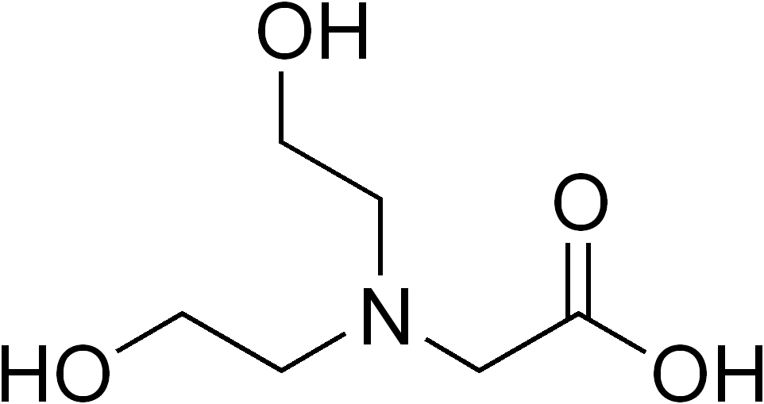
BisTris | Bis-tris methane | C8H19NO5 | 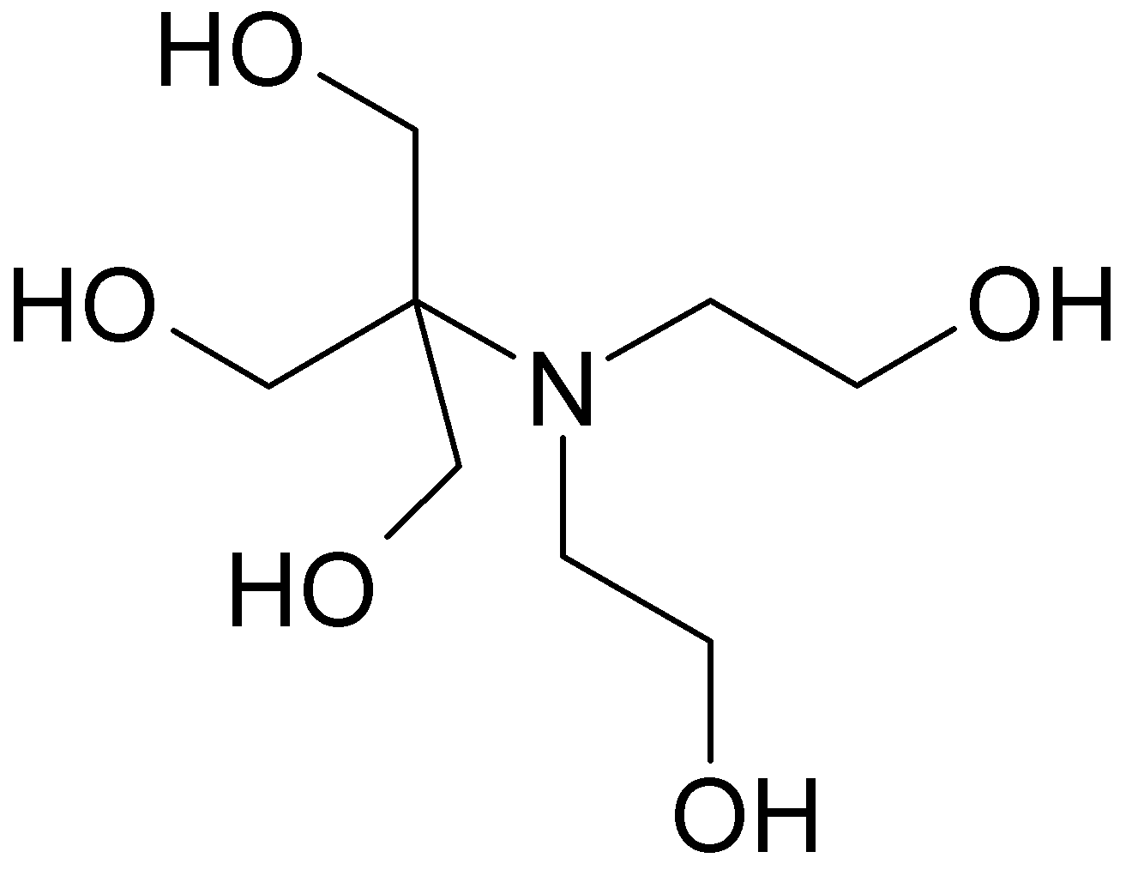
CAPS | N-cyclohexyl-3-aminopropanesulfonic acid | C9H19NO3S | 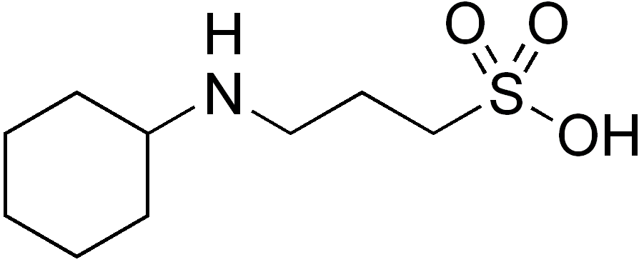
CHES | N-Cyclohexyl-2-aminoethanesulfonic acid | C8H17NO3S | 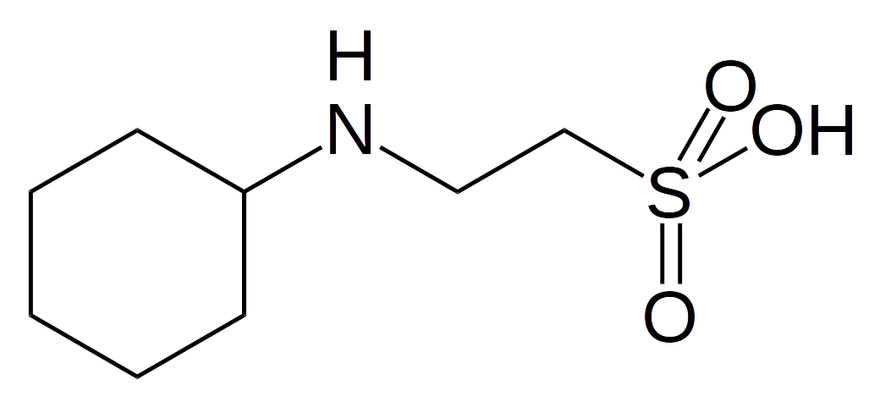
HEPES | 4-(2-hydroxyethyl)-1-piperazineethanesulfonic acid | C8H18N2O4S | 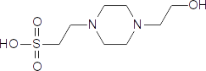
MES | 2-(N-morpholino)ethanesulfonic acid | C6H13NO4S | 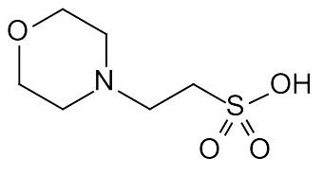
MOPS | 3-(N-morpholino)propanesulfonic acid | C7H15NO4S | 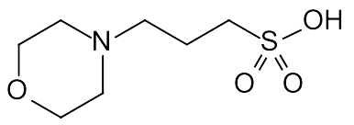
TES_fa | 2-[[1,3-dihydroxy-2-(hydroxymethyl)propan-2-yl]amino]ethanesulfonic acid | C6H15NO6S | 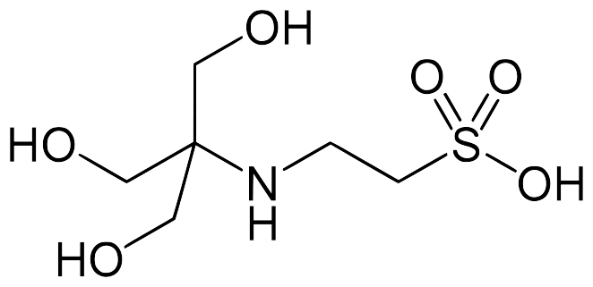
TRICINE | N-(2-Hydroxy-1,1-bis(hydroxymethyl)ethyl)glycine | C6H13NO5 | 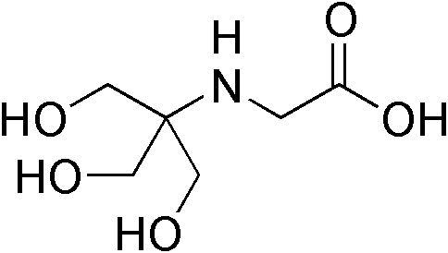
TRIS | 2-Amino-2-hydroxymethyl-propane-1,3-diol | C4H11NO3 | 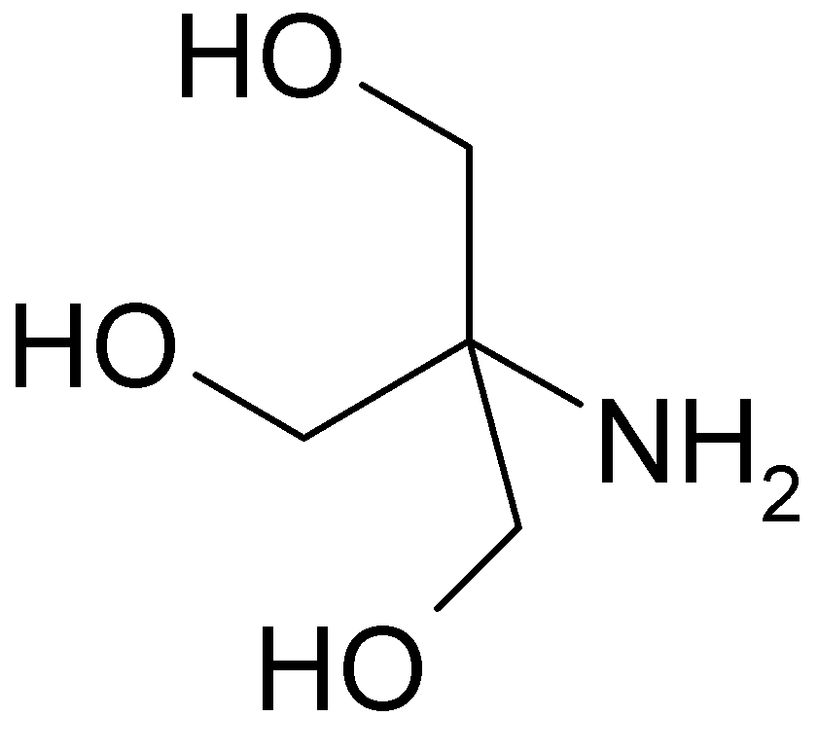
Functional Groups
Abbreviation | Chemical Name | Molecular Formula | Structure
Bu | n-Butyl | C4H9 | 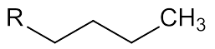
Cy | Cyclohexyl | C6H11 | 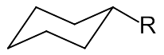
Et | Ethyl | C2H5 | 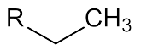
Me | Methyl | CH3 | 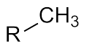
Mes | Mesyl (methylsulfonyl) | CH3SO2 | 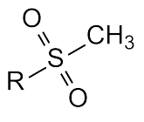
OSu | O-succinimide | C4H4O3N | 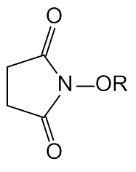
Ph | Phenyl | C6H5 | 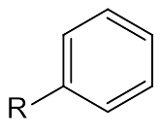
Pr | Propyl | C3H7 | 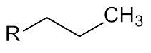
Py | Pyridyl | C5H4N | 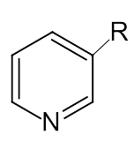
Tol | Toloyl | C7H7 | 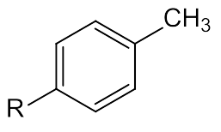
Tos | Tosyl (P-Toluolsulfonyl) | C7H7SO2 | 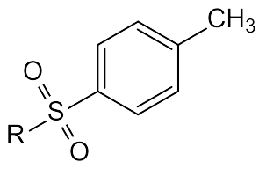
Ac | Acetyl | C2H3O | 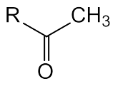
Alloc | Allyloxycarbonyl | C4H5O2 | 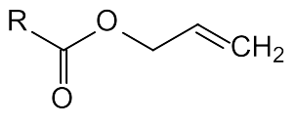
Bn, Bzl | Benzyl | C7H7 | 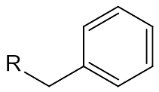
Boc | tert-Butyloxycarbonyl | C5H9O2 | 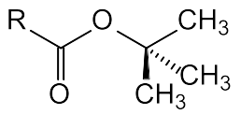
Bz | Benzoyl | C7H5O | 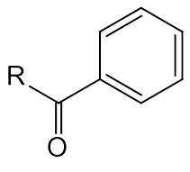
DMT | Dimethoxytrityl | C21H19O2 | 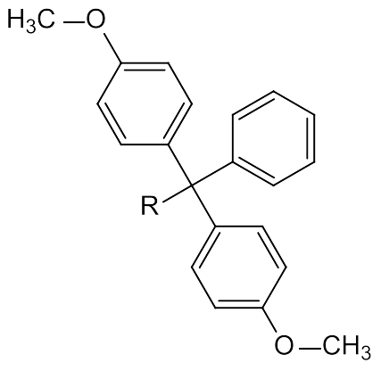
Fmoc | Fluorenyloxycarbonyl | C15H11O2 | 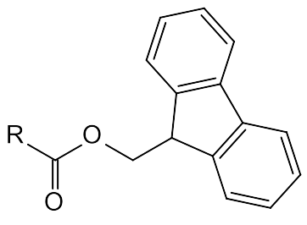
MEM | 2-Methoxyethoxymethyl | C4H9O2 | 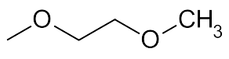
MOM | Methoxymethyl | C2H5O | 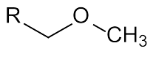
Piv | Pivaloyl | C5H9O | 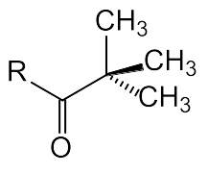
PMB | p-Methoxybenzyl | C8H9O | 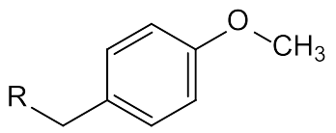
SEM | β-(Trimethylsilyl)ethoxymethyl | C6H15OSi | 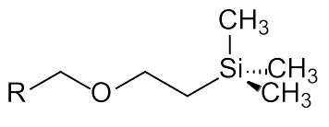
TBDMS, TBS | tert-Butyldimethylsilyl | C6H15Si | 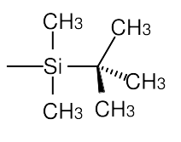
TES | Triethylsilyl | C6H15Si | 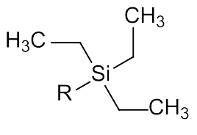
THP | Tetrahydropyranyl | C5H9O | 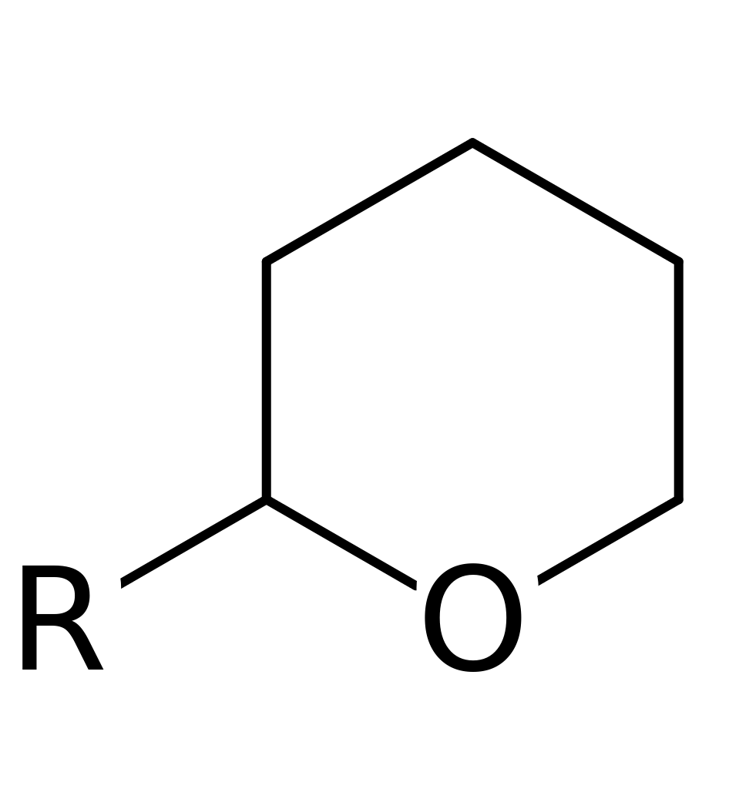
TMS | Trimethylsilyl | C3H9Si | 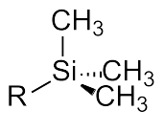
Tr, Trt | Trityl (Triphenylmethyl) | C19H15 | 