Brendan Celii

35103176

5/9/15

**Final Project: Triathlon Club App**

App Description: The app is supposed to supplement the Triathlon website in that it will provide a fast lookup for members of the triathlon team, prospective members or sponsors to look up the practice information for the current week. The practice information will include the following:

1. Type (Ex: Run, Bike, Swim)
2. Description of the workout
3. Location
4. Time
5. Member of Triathlon Team leading the workout

The App is connected to Parse account for the server side functionality. The Parse account stores two classes: userInfo (which stores usernames, emails, names, and passwords) and Workouts (which stores all info for workouts of current week Monday to Sunday). Basic flow starts with a functional login page that will verify the email and password are in the database, and if not option to register, which is function and corrects for errors in incomplete submission. From a correct log in or registration the main page will come up, which has the option to select any day of the week. On selection a new activity with the specifics of the workout for that day will appear (data for workout is pulled from database). For functionality tests use [bcelii@smu.edu](mailto:bcelii@smu.edu) as email and Password1 as the password (for log in), or create own account.

Technology:

1. Simulator: Nexus_5_API_21_x86
2. Parse Accout: <https://www.parse.com/apps/triathlon_app/collections#class/Workouts>

**User Profiles:**

1. **Triathlon Club Members**: For those in the club to quickly check the app for workout info (activity,time,place) or to get the exact workout so they could practice by themselves if need be
2. **Coach/Captain:** Use App to communicate indirectly with members and set workout schedule remotely without individual contact
3. **Prospective Triathlon member**: Those interested in signing up/joining the club can check the workout schedule to get an idea of the intensity and practice schedule of the team
4. **Sponsors**: If a current or prospective sponsor for the team wanted to check what club is doing for practices or check location if looking to stop by at practice.

**Basic Flow:**

**Login**:

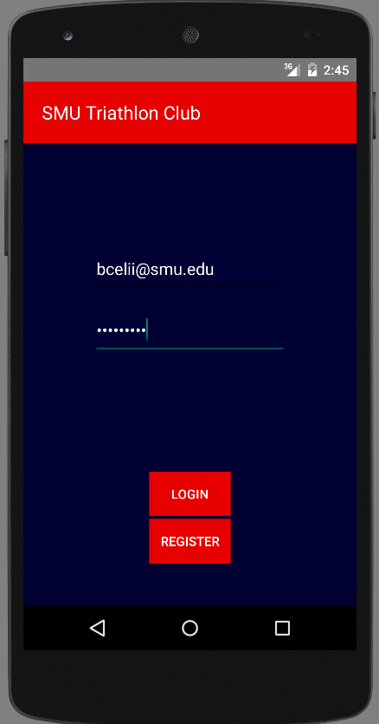

**Main Page**:

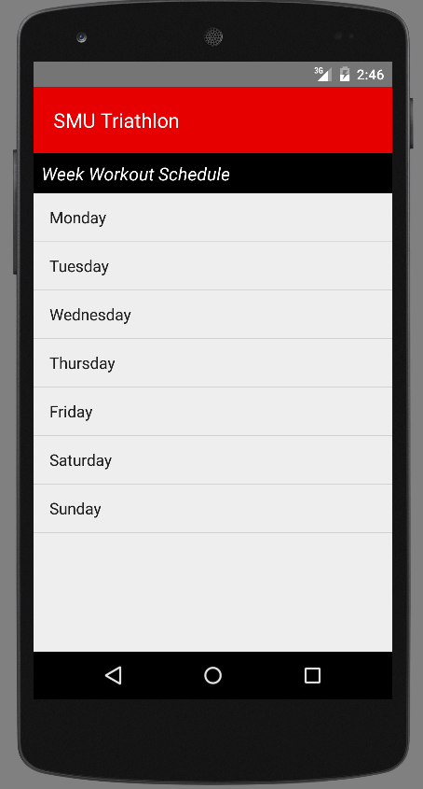

Registration:

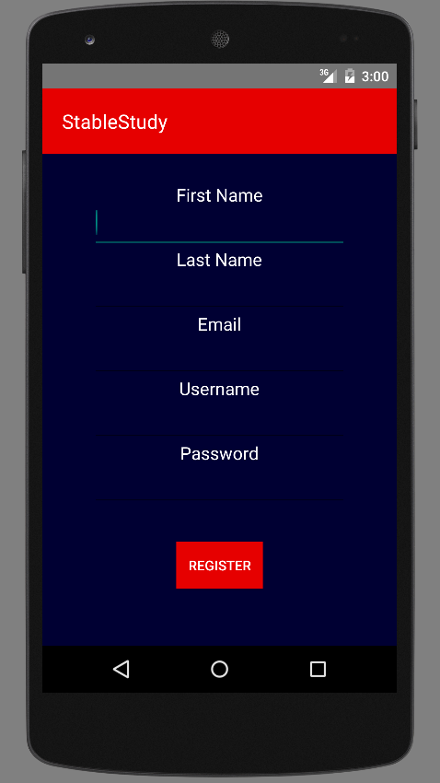

**Specific Day’s Workout:**

