**Scheduler**

Semester course scheduler developed for the Math & Computer Science department at Penn State Harrisburg.

**Installation**

You will need at least Java 8 as well as any additional packages you may need for JavaFX, dependant on OS. Alternatively, you can download prebuilt Eclipse packages [here](https://www.eclipse.org/efxclipse/install.html). After cloning the repo, you can import the project into Eclipse and either run it there or make an executable jar.

**Usage**

**Importing Schedules**

The Scheduler assumes that the file to be imported is in comma separated format (CSV) and that it has been sanitized to remove any headers and or blank lines. The expected number of commas per line is described in the ClassParser.java and ClassNode.java files.

The import button is at the top left of the application window:

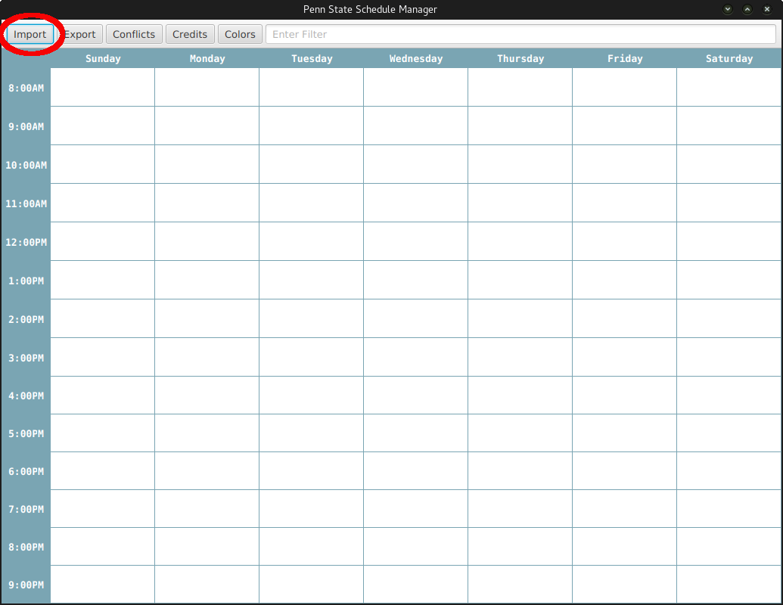

Clicking on Import will bring up the following window to allow you to choose the file to import:

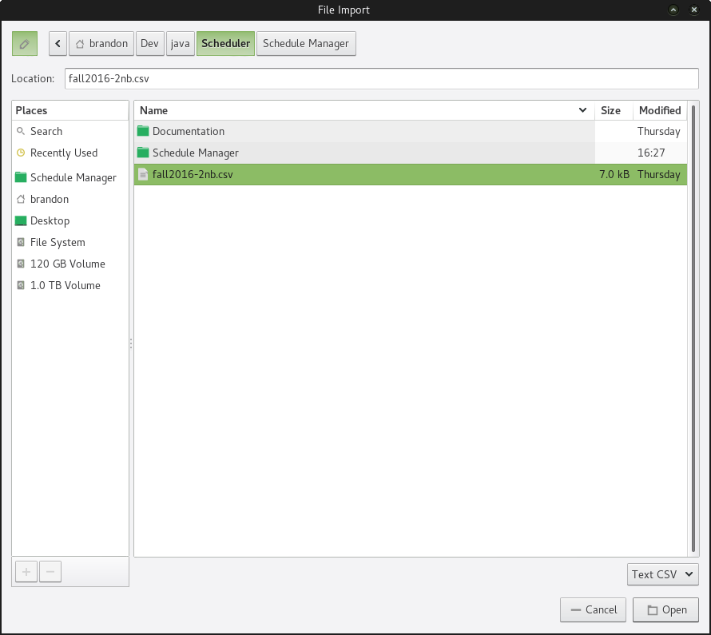

Once a file is selected to import, the file is parsed and the classes are added to the schedule. The schedule will then look something like this:

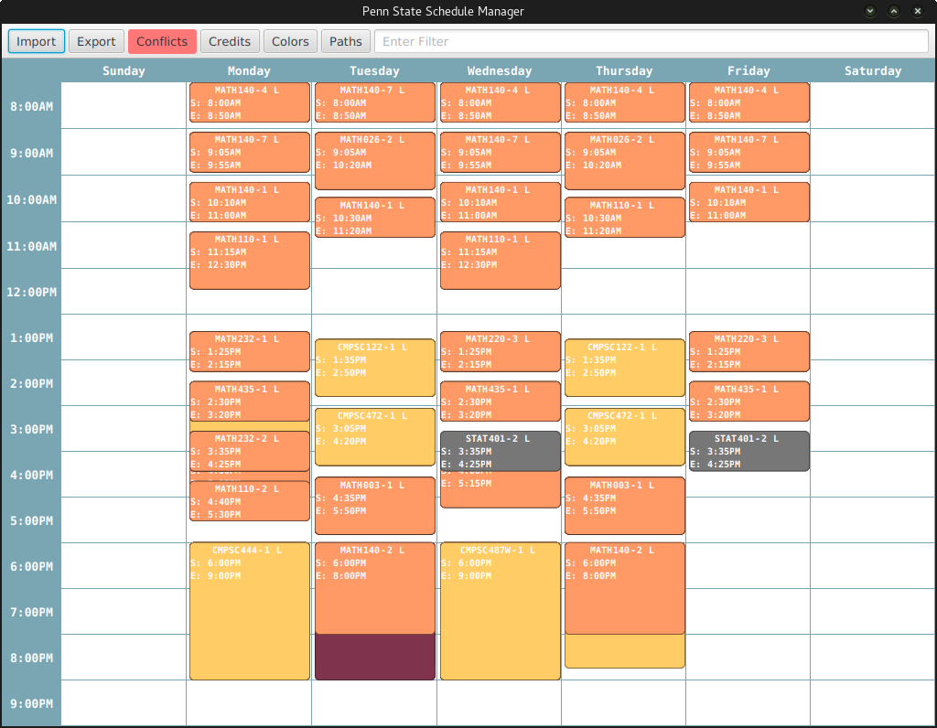

**Conflicts**

After importing a schedule for the first time or after moving a class, if conflicts exist the Conflict button will turn red. The Conflict button will remain red until all conflicts have been fixed or ignored by the user.

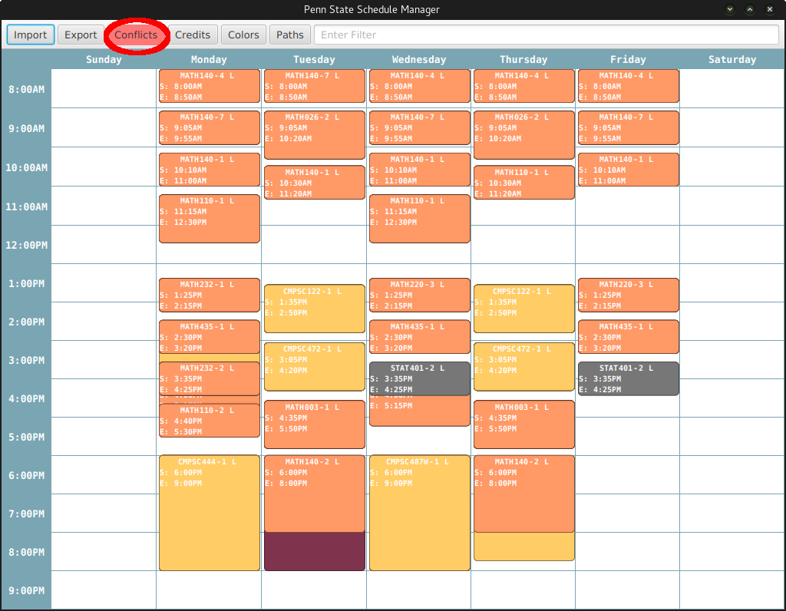

Clicking on the Conflict button will bring up the following window:

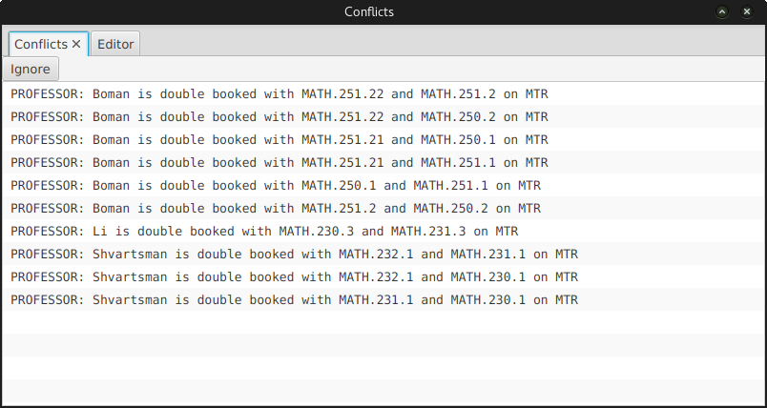

The above window displays the list of current conflicts. To clear up conflicts, the user can either ignore them which adds a line to the conflict file or move the classes that are causing the conflict. The user can also edit current conflicts by clicking on the Editor tab in the conflicts window:

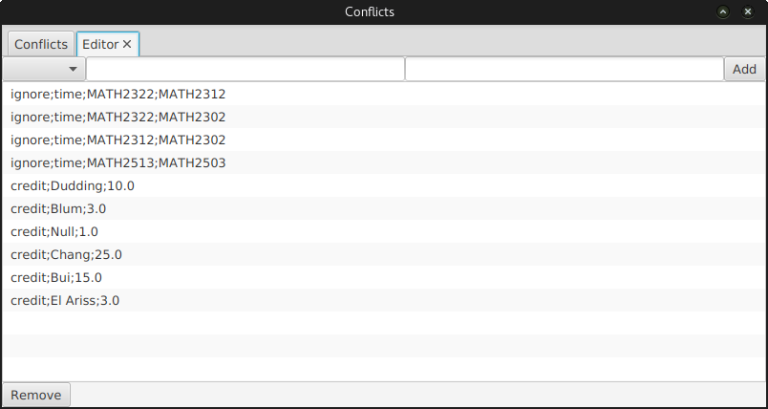

Ignore lines are created by ignoring conflicts in the previous window. New time conflicts are created with the form:

time;<class1>;<class2>;

This states that class1 should not occur at the same time as class2, if it does then the user will be notified.

Credit conflicts are created with the form:

credit;<professor>;<float>;

This states the expected number of credits for the given professor. If the professor is under or overloaded, the user will

be notified.

**Credits**

We construct a number of lists for professor credit information. There is a Credits button at the top of the main window:

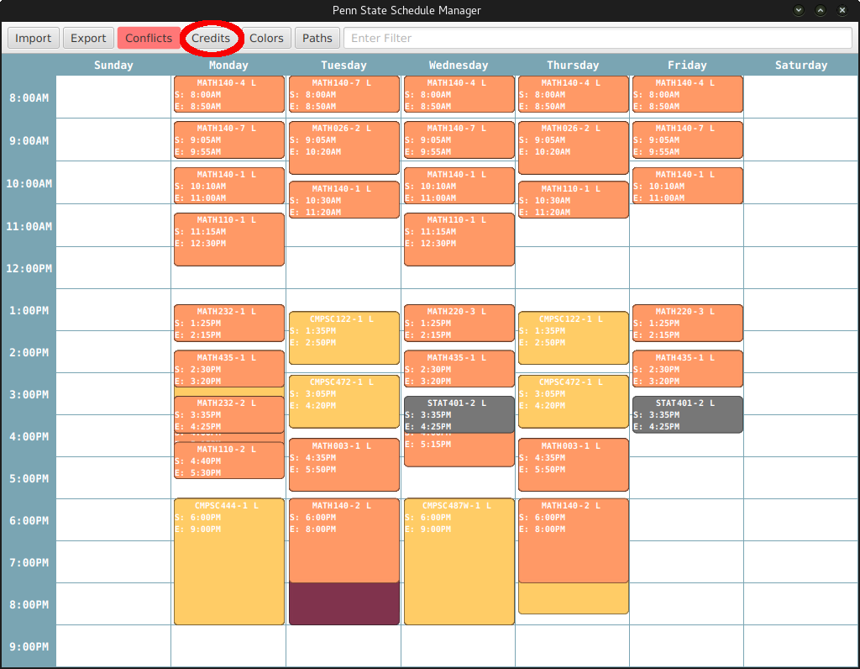

Clicking on the Credits button displays the following window:

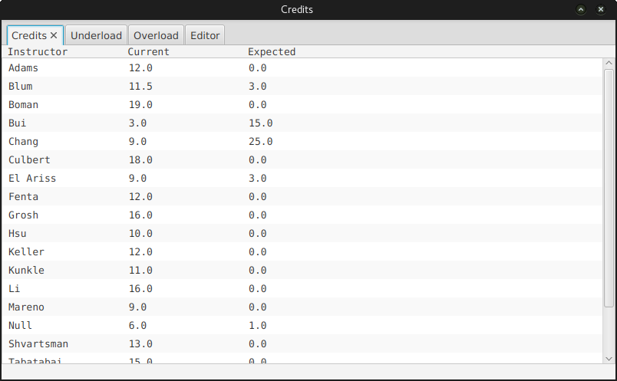

The above window lists the professor's name, current credits, and expected credits. There are two other lists that are generated: underload and overload. Clicking on one of those tables will display the following window:

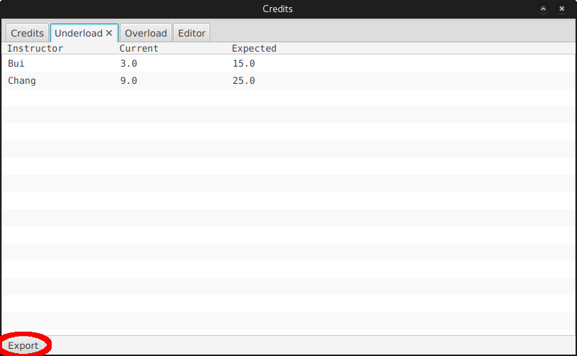

Clicking on the export button in that window will allow the user to write the respective list to a file of their choosing.

**Colors**

There is a Colors button at the top of the main window which allows the user to change the class colors:

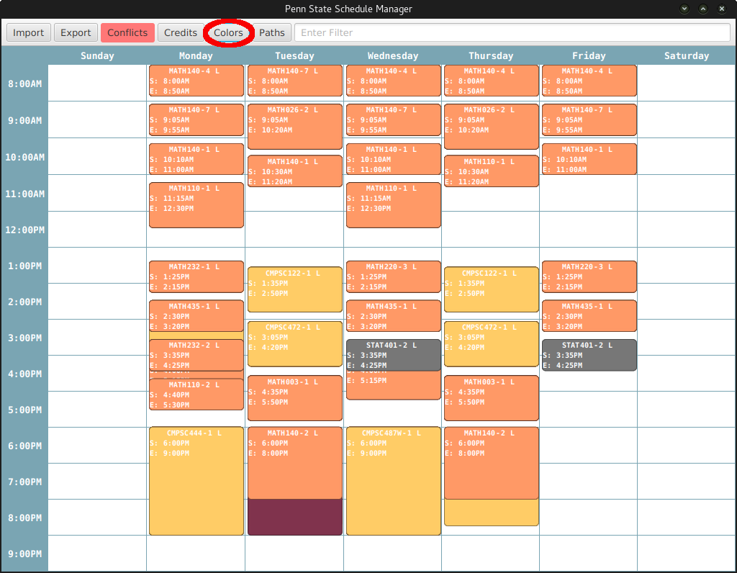

Clicking on the Colors button will display the following window:

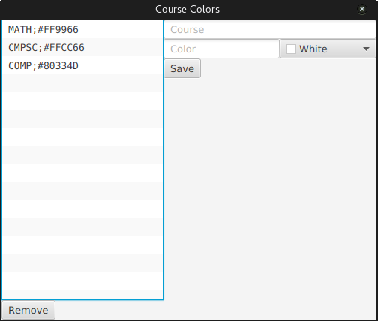

In the above window, the user is allowed to either alter a current color selection or create a new one by entering the course prefix and selecting a color from the color picker.

**Path**

We allow the user to select a default path, done with the Paths button at the top of the main window:

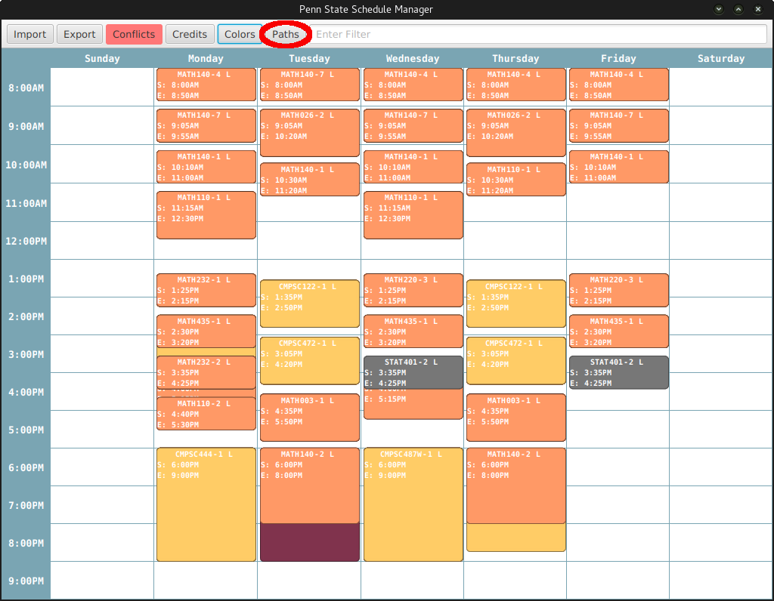

Once the Paths button is clicked, the following window is displayed:

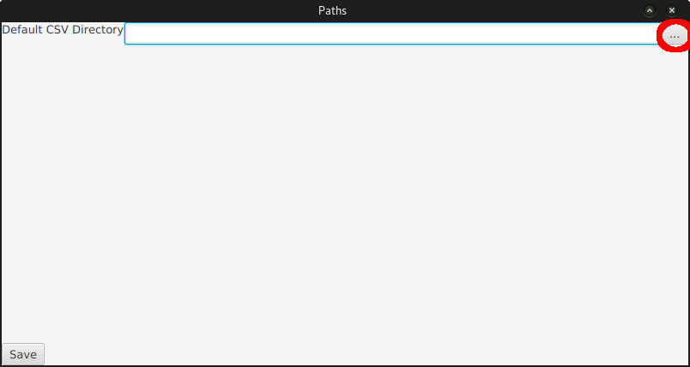

In the above window, the user can select the default path by cling on the "..." button. Once set, the scheduler will look there for schedule files by default.

**Filter**

The filter function allows the user to filter out the courses to only see what they want to at a given time. It is done by entering a filter query in the text field at the top of the main window:

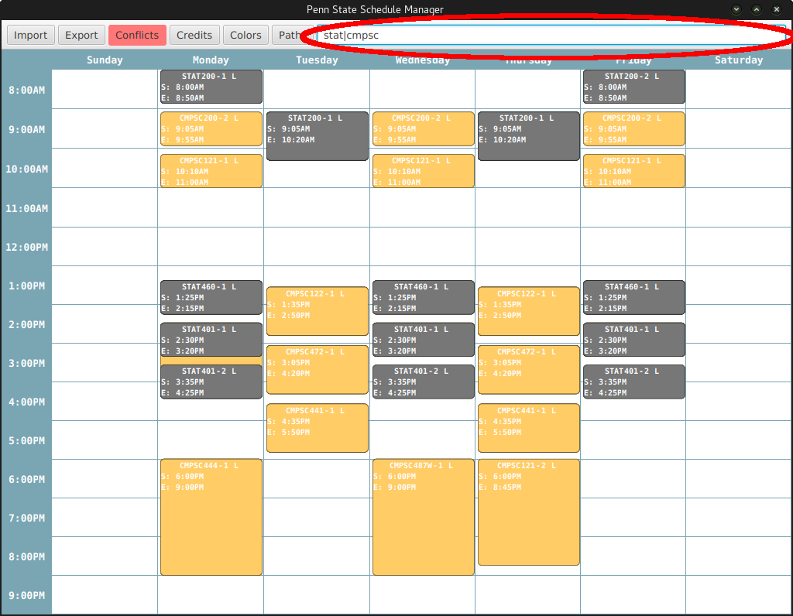

In the above window, the query "stat|cmpsc" has been entered. This will display all the courses with either a STAT or CMPSC prefix.

The filter uses the following logical operators:

! -- NOT

& -- AND

| -- OR

Filter queries are split in the following order: OR, AND, NOT. The resulting course set is built recursively in the order: NOT, AND, OR. The user can filter on: course prefix, course prefix and number, number, professor name. So for example if the user wanted to see all the 400 level CMPSC courses taught by Dr. Null OR all 500 level courses taught by Dr. Blum the filter query would be:

cmpsc&4&null|5&blum

The filter is not case sensitive, however, spaces should only be included if they appear in a professor's name. To display all CMPSC460 sections taught by Dr. El Ariss the filter query would be:

cmpsc460&el ariss

**Course Interaction**

**Course Tooltip**

Hovering over a course will display a tooltip with additional information about that course such as professor, soft, hard, etc.

**Course Movement**

Courses can be dragged to different schedule times. They will snap to the day(s) they are closest to. Clicking and dragging on the near the bottom of a class will extend that classes time period.

**Course Right Click Menu**

Right clicking on a course displays the following menu:

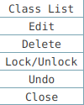

Clicking on Class List will display all the classes that are in the same time slot as the class clicked on:

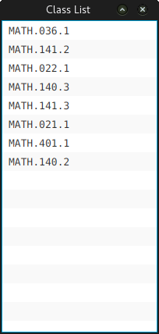

Clicking on Edit will display the edit window allowing the user to edit that classes information:

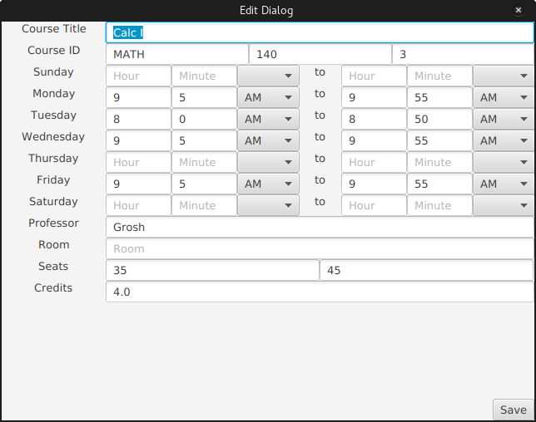

Clicking on Delete will remove that course from the schedule.

If a course spans multiple days, it can be in one of two states: locked or unlocked. If is it locked, dragging one course cell will also drag the others. If a course is unlocked, course cells can be moved independently of one another. Clicking on Lock/Unlock will toggle this state.

Clicking on Undo will move the course to where it previously was before it was last moved. This includes dragging to

extend a class.

**Open Cell Right Click Menu**

Right clicking on an open cell in the schedule will display the following menu:

open_cell_right_click_sc.png

Clicking on Create will display the course creation window:

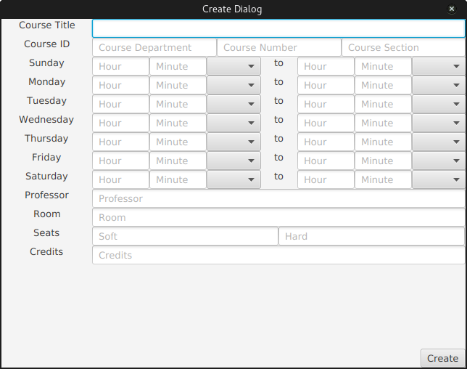

Once the user has entered all the required information for a new class, that class will be added to the schedule. If the user has not entered enough information, the field(s) in question will be highlighted in red.

**Exporting Schedules**

Once the user is done editing the schedule, they may export it to a file by clicking on the Export button located at the top of the main window:

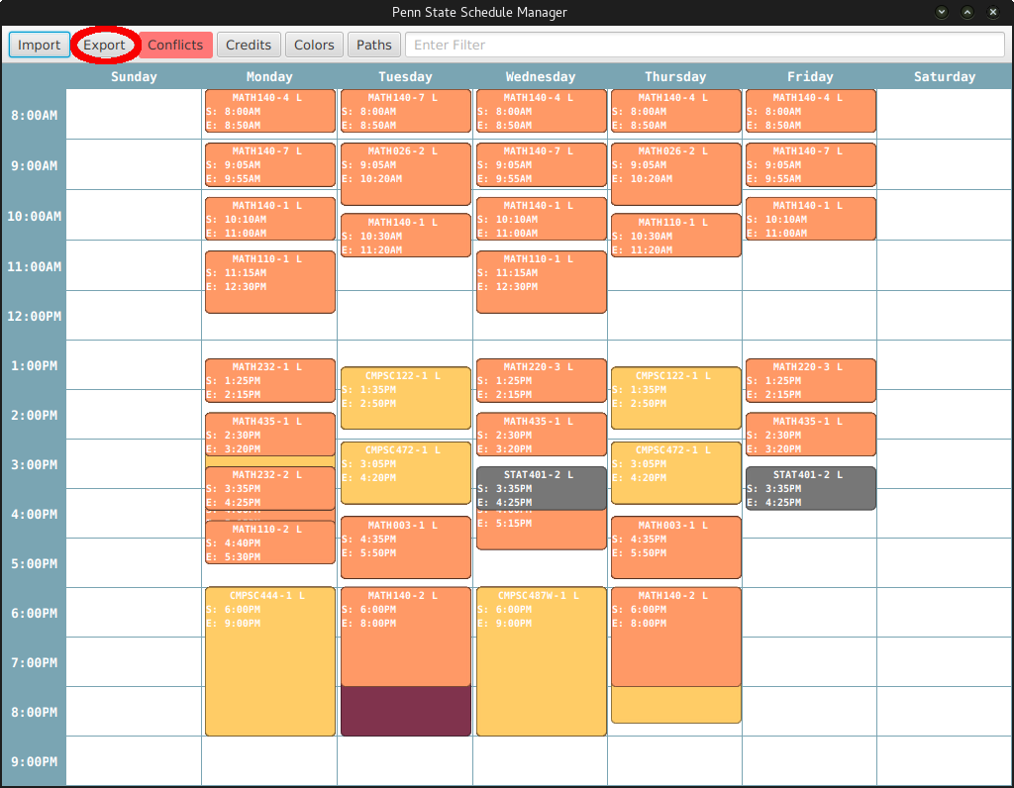

Clicking on the Export button displays the following window:

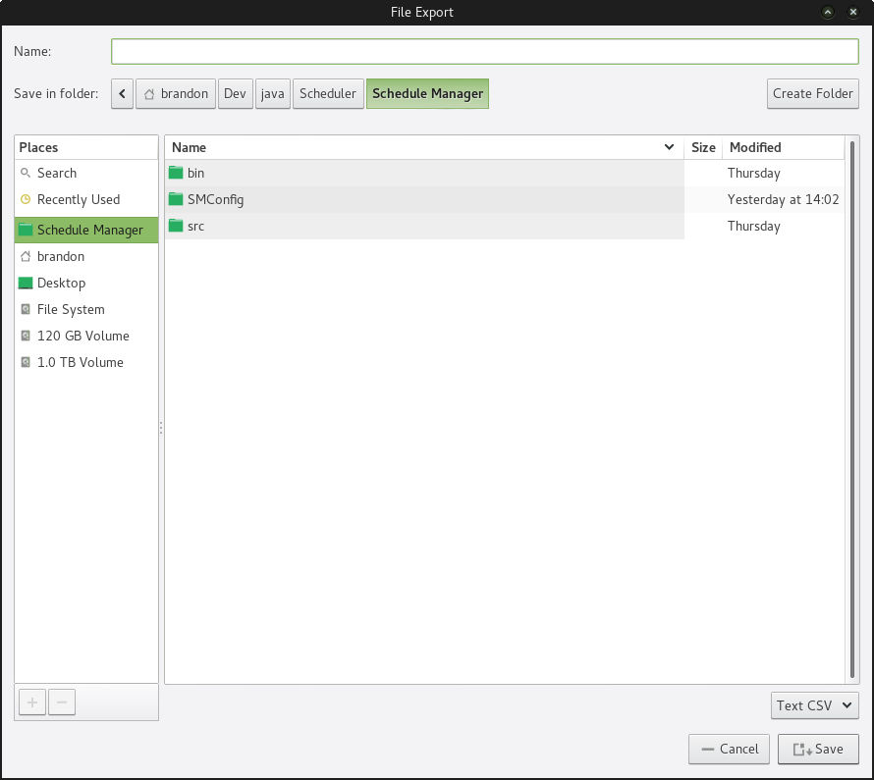

Once the user has named the file and selected its location, the schedule will be written to a CSV file with the selected path.