4.2 Climate [Author: Colin Mahony]

Relative to other regions in western North America, Coastal BC has a wet climate with mild winters and cool summers. However, the climates of the coast region are diverse: ranging from the warm, summer-dry Georgia Basin on the south coast: to the cool, rainy north coast: and to the cold, snowy subalpine regions of the Coast Mountain Ranges (Figure 1 and Figure 2). These variations in climate are driven by ocean proximity, atmospheric circulation patterns, physiography, elevation, and latitude.

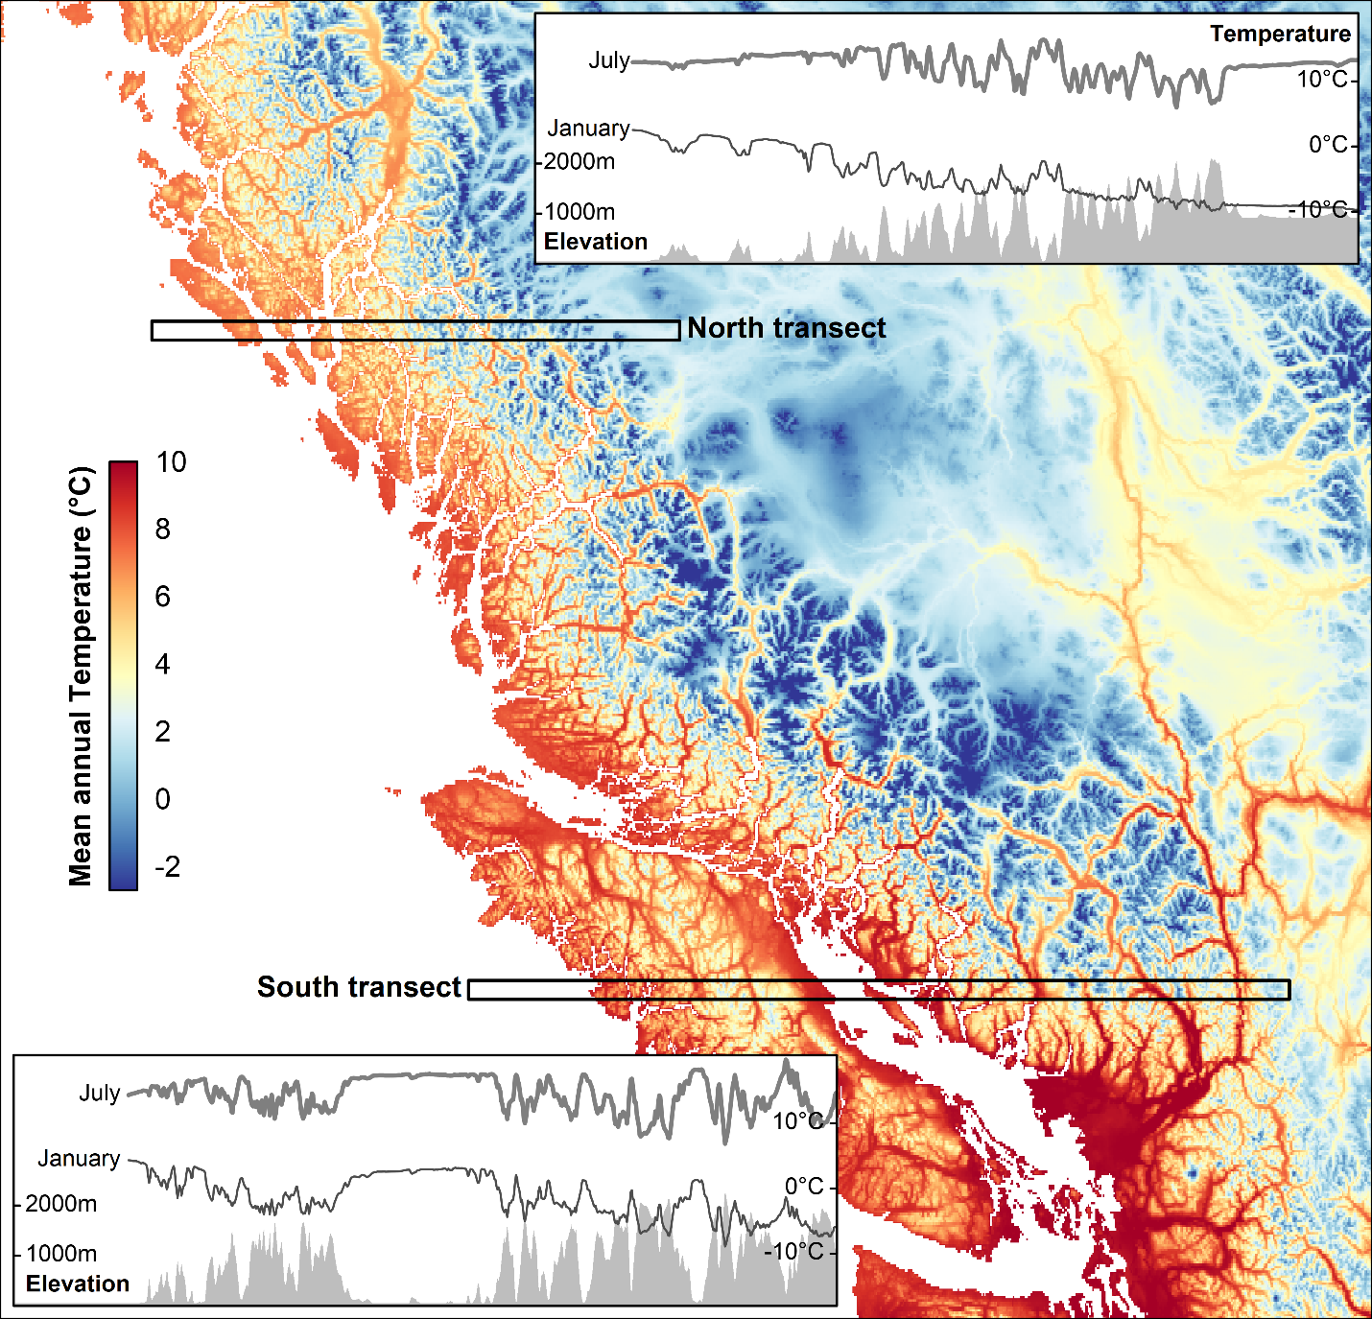
Figure 1: Map of mean annual temperature for the BC coast. Insets show spatial variation in January and July mean temperature and elevation along two transects of the north and south coasts. Grey fill at the bottom of the plot represents elevation and grey line at the top of the plot represents mean monthly (July and January) temperature. Source data: 1981-2010 PRISM climate normals (Pacific Climate Impacts Consortium 2014).
Ocean proximity
The thermal inertia of the ocean moderates the seasonal temperature cycle, producing a lower contrast in summer vs. winter temperatures in coastal areas. This effect is evident in the latitudinal transects of Figure 1, which show increasing July temperature and declining January temperature with distance from the Pacific Ocean. At larger scales, the thermal moderation effect is especially strong during winter, when there is a bigger difference between water temperatures and continental air temperatures (Figure 1, north transect).

Atmospheric circulation
The north-south gradients in coastal climate are strongly affected by the relative influence of the North Pacific High and Aleutian Low circulation systems (Moore et al. 2010). The North Pacific High, which recurrently forms west of California, shifts north during summer, pushing storm tracks northward and producing a higher frequency of clear skies and warm temperatures on the south coast of British Columbia. The cloudiness and precipitation associated with a persisting influence on the Aleutian Low pressure circulation contributes to lower mean annual temperatures of the north coast.

Physiography
The Vancouver Island and Coast Mountain Ranges are pivotal to the coastal climate. First, they act as a barrier to continental air masses, increasing the relative influence of oceanic vs continental air masses coastal temperature regimes. Second, they intercept westward-moving air masses, which cool and release moisture as they rise to pass over the mountains. As shown in the latitudinal transects of Figure 2, this release of moisture is most intense in the initial (westward) portion of the windward side of mountains, and typically declines before peak elevations are reached. Orographic (mountain-produced) rainfall also influences temperature patterns: water vapour releases heat as it condenses in clouds and raises temperatures on the leeward (eastern) side of mountains. These rain-shadow effects on both temperature and precipitation are most pronounced in the Georgia Basin and the valleys of the coast-interior transition (south transect in Figure 1 and Figure 2).

Elevation
At local scales, temperature generally declines and precipitation increases with elevation. The simple temperature gradient occasionally is disrupted by thermal inversions, in which cold air settles at low elevation. Inversions are more frequent during the winter, producing weaker average gradients evident in Figure 1 as lower elevational variation in January temperatures along both transects.

Latitude
BC’s coast is large enough that reduced incoming solar radiation due to the lower sun angle at higher latitudes is a contributing factor to cooler temperatures on the north coast.
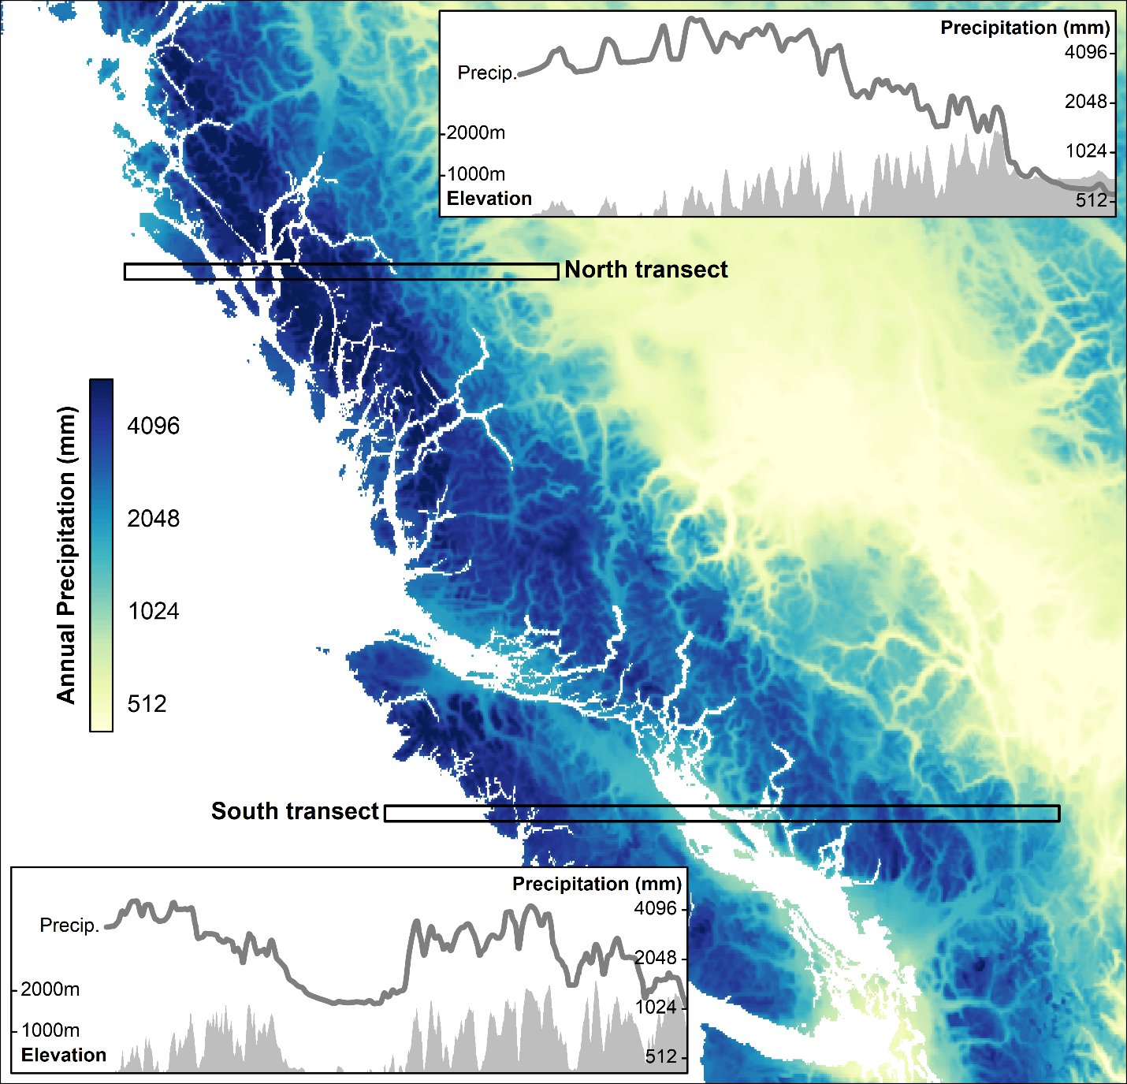
Figure 2: Map of annual precipitation for the BC coast. Insets show spatial variation in annual precipitation and elevation along two transects of the north and south coasts. Source data: 1981-2010 PRISM climate normals (Pacific Climate Impacts Consortium 2014).

Pacific Climate Impacts Consortium 2014. High resolution 1981-2010 climatologies of temperature and precipitation for British Columbia. https://www.pacificclimate.org/data/prism-climatology-and-monthly-timeseries

Moore, D.L. Spittlehouse, P.H. Whitfield, and K. Stahl. 2010. Chapter 3: Weather and Climate. in Pike, R.G., T.E. Redding, R.D. Moore, R.D. Winker and K.D. Bladon (editors). 2010. Compendium of forest hydrology and geomorphology in British Columbia. B.C. Min. For. Range, For. Sci. Prog., Victoria, B.C. and FORREX Forum for Research and Extension in Natural Resources, Kamloops, B.C. Land Manag. Handb. 66. www.for.gov.bc.ca/hfd/pubs/Docs/Lmh/Lmh66.htm

